CUI Quick Tips

Click the links below to jump to each topic. Click here to go to Marking Quick Tips

Protecting | Emailing | Printing
Storing | Mailing | Faxing
Destroying | Reporting Incidents | Self-Inspection
Marking | Waivers
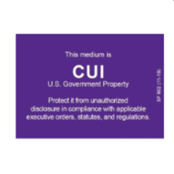

Protecting CUI
- Be aware of your surroundings and take steps to ensure others can’t overhear what you are saying.
- Guard your surroundings to prevent shoulder-surfing. Don't allow CUI to be viewed by unauthorized people while you work with CUI documents that are printed or displayed on a screen.
- Verify that you are sharing only with someone who has Lawful Government Purpose to view the information.
- Lawful Government Purpose (LGP) is the standard for deciding when to share and when not to share CUI with coworkers, Executive Branch agencies, or non-Federal partners. CUI should only be shared when it will help achieve the goals of a common project.
- Watch this video for additional information.

Emailing CUI
- CUI being emailed outside the GSA network (gsa.gov) must be sent as a FIPS-compliant encrypted attachment.
- The following are all outside the GSA network, thus requiring that CUI be sent as an encrypted attachment to their email addresses:
  - Other Federal agencies
  - GSA contractors
- The body of the email must not contain any CUI but must include the applicable CUI markings at the top of the email message. See this CUI Registry page for more details on email markings.

Printing CUI
- Printed CUI documents must be kept under direct control of an authorized holder and protected by at least one physical barrier such as a cover sheet or a locked cabinet/door.
- Do not send CUI to the printer unless you are able to be at the printer when it prints.
- Do not let CUI documents sit on the printer where unauthorized people can have access to the information.
- If possible, use a printer that requires you to enter a code before printing.
- Ensure proper marking, including:
  - CUI documents must have the CUI marking on each printed page.
  - A CUI cover sheet may be used in lieu of banner markings when it is impractical to individually mark every page due to its quantity, legacy status, or the nature of the information.
  - The CUI cover sheet (Standard Form 901) is available through the GSA forms library or can be downloaded and printed from the CUI Registry.

Storing CUI
- CUI must be stored in controlled environments that prevent or detect unauthorized access.
- Printed CUI documents must be protected by at least one physical barrier, such as a cover sheet or a locked bin/cabinet.
- CUI may only be digitally stored in an authorized IT system/application that is:
  - configured at no less than the Moderate Confidentiality impact value
  - has limited access based on need, and
  - meets the requirements of GSA’s IT Security Policy.
- CUI must be protected at all times. This includes having approved CUI markings on printed pages and/or a CUI cover sheet to clearly identify the information as CUI when stored or when being used.

Mailing CUI
- Address the envelope/package to a specific recipient (not to an office or organization).
- Do not put CUI markings on the outside of the envelope/package.
- Use automated tracking on the package to ensure it was delivered to the correct recipient.
- You may use the following methods to transport CUI:
  - The US Postal Service (USPS)
  - Any commercial delivery service (FedEx, UPS)
  - Interoffice mail delivery
  - Interagency mail delivery

Faxing CUI
- Before faxing CUI documents be sure the recipient has a Lawful Government Purpose for access:
  - Lawful Government Purpose is the standard for deciding when to share and when not to share CUI with coworkers, Executive Branch agencies, or non-Federal partners.
  - CUI should only be shared when it will help achieve the goals of a common project.
- Confirm the authorized recipient is available to receive the fax as it arrives and have them confirm that they did indeed receive it.
- Do not leave the documents unattended in the fax machine or anywhere that unauthorized people might access the information.

Destroying CUI
- CUI must be destroyed in a manner that makes it unreadable, indecipherable, and irrecoverable. To achieve that, there are two options:
  - Use only CUI-approved shredders that pulverize paper into tiny (1x5mm) particles. Regular cross-cut shredders aren't sufficient.
  - Place CUI documents in locked bins that are marked acceptable for CUI. Authorized companies will remove the CUI and verify it is destroyed in a CUI-compliant manner.
- Do not print CUI when teleworking or working at a site that is not equipped with a shredder or locked bin. If printing is absolutely necessary, the printed CUI documents must be marked and protected at all times. When no longer needed, the documents must be returned to a facility with proper destruction capabilities.

Reporting CUI Incidents
- You must report all known or suspected CUI incidents to the GSA IT Service Desk as soon as you become aware of a possible CUI incident.
- A CUI incident can come in many different forms. Examples include:
  - finding papers with CUI markings left unattended,
  - knowing information in a document or system is CUI but is not marked properly, or
  - emailing unencrypted CUI outside of the GSA network.
GSA Order CIO 2100.1 IT Security Policy discusses the process for reporting all types of incidents, and these procedures should be followed for CUI incidents.

CUI Self-Inspection Program
- An agency Self-Inspection Program is required to internally manage and ensure compliance with the CUI Program’s implementing directive, 32 CFR 2002.
- The Self-Inspection program evaluates:
  - the effectiveness of our CUI Program;
  - how we are complying with the requirements for protecting, marking, and destroying CUI;
  - that training is carried out as required; and
  - that there are management oversights in place.
- Self-Inspection will also allow GSA to determine best practices and lessons learned, and to take corrective actions where necessary.

Marking CUI
- A CUI cover sheet may be used if marking every page is excessively burdensome. The CUI cover sheet, Standard Form 901, can be downloaded and printed (in black and white or color) from the GSA Standard Forms Library.
- Standard Forms 902 and 903 are CUI Media Labels that may be used to mark various forms of media such as external drives or CDs and may be purchased from GSA Advantage.
- The CUI Registry holds the official Government-wide CUI Marking Handbook that provides even more details about marking CUI including information on Portion Marking when co-mingling CUI with classified information or uncontrolled unclassified information.
- Contact the CUI Program Management Team at cui@gsa.gov for additional assistance.

Waivers to CUI Marking
- In certain limited situations, the requirement of marking all CUI may be waived.
- Waivers may only be approved by the GSA CUI Senior Agency Official (SAO), and a record of all waivers is maintained and included in GSA’s Annual Report to the CUI Executive Agent.
- A waiver may be granted if:
  - It is determined that marking CUI would be excessively burdensome, as long as the information remains under GSA control.
  - Under emergency circumstances, when an agency shares the information with other agencies or non-Federal entities.
  - Legacy information is marked with previously authorized markings (SBU, FOUO, etc.), unless and until that information is to be used again, in which case CUI markings must then be applied (this waiver may be granted without special permission in accordance with GSA CUI Policy).
- If a waiver is granted, the authorized holders must make sure the recipients are aware that the information is CUI.
- If a waiver is granted, all parties must ensure that the information is still protected and handled as CUI.
- To request a waiver, email the CUI team at cui@gsa.gov.

CUI Marking Quick tips

Click the links to jump to each topic.

Banner Marking | Limited Dissemination | Portion Marking
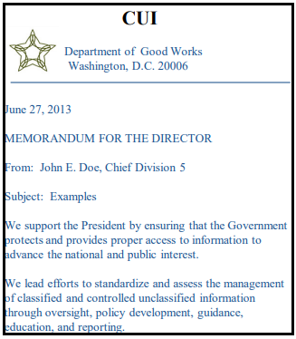 |  | 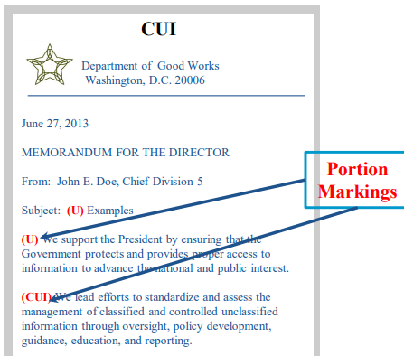
Administrative Markings | Coversheets | Labels
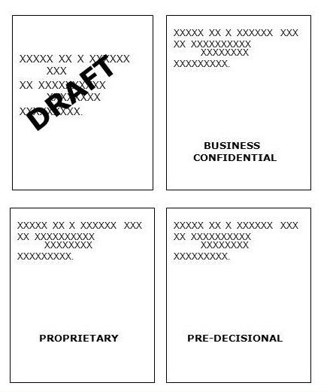 | 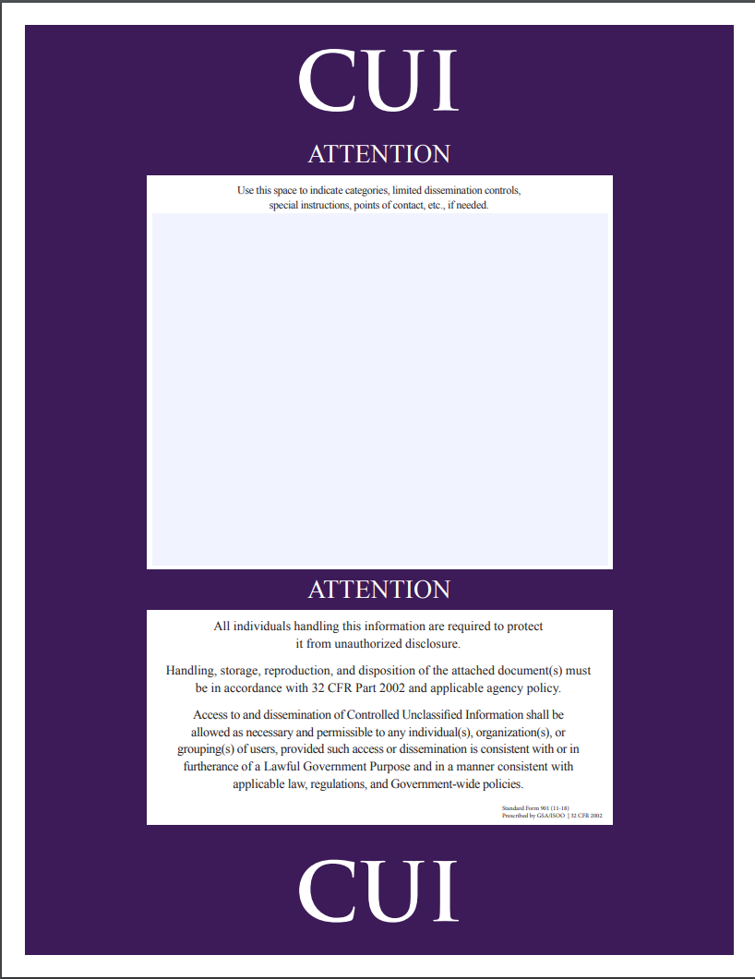 | 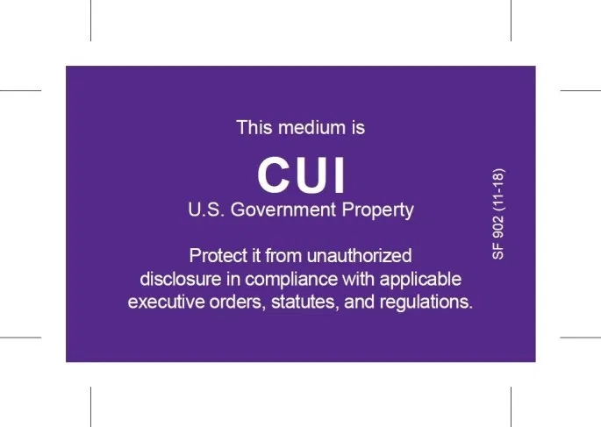
Waivers | IT Systems | Email
Shipping/Mailing | Transmittal Documents | Slides/Briefings
 | 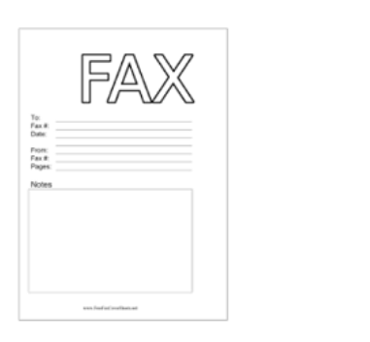
Forms | Spreadsheets | Storage Locations
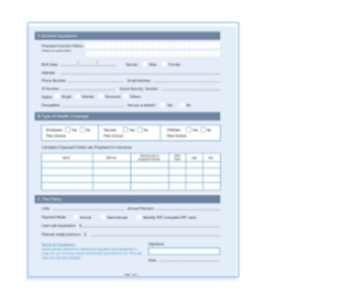 | 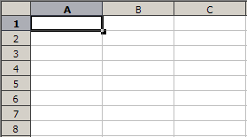

CUI Banner Marking
The primary marking for all CUI is the CUI Banner. This is the main marking that appears at the top of documents that contains CUI. The Banner Marking should appear as bold capitalized text, be centered at the top of the page, and show on every page of a document that contains CUI. Even if there is CUI only on one page, the entire document must be marked.

A CUI coversheet may be used when it is deemed impractical to individually mark each page due to its quantity or the nature of the document. Any Specified categories, limited dissemination controls, or requirements called for by underlying, related laws, regulations, or government wide policies must be noted on the Coversheet. See the CUI Coversheet section for additional details.

All documents containing CUI must also contain a Designation Indicator to notify the holder of the agency that originated the document. This may be accomplished through the use of letterhead, a signature block with the agency name, and/or the use of a “Controlled by” line. Best practice is to also include contact information such as a group email address or central phone number.

The CUI Banner Markings must be as follows (see Examples section at the end of this doc for more details):

CUI BASIC
The letters CUI shall be used as the banner marking on every page of a GSA-owned CUI Basic document.
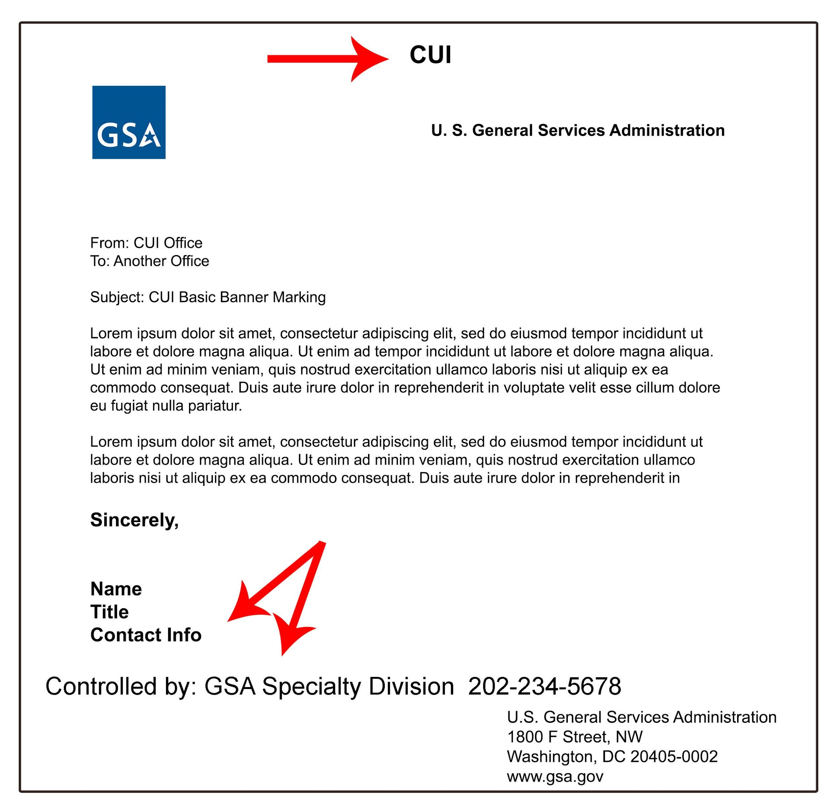
Sample Designation Indicator with Contact information:

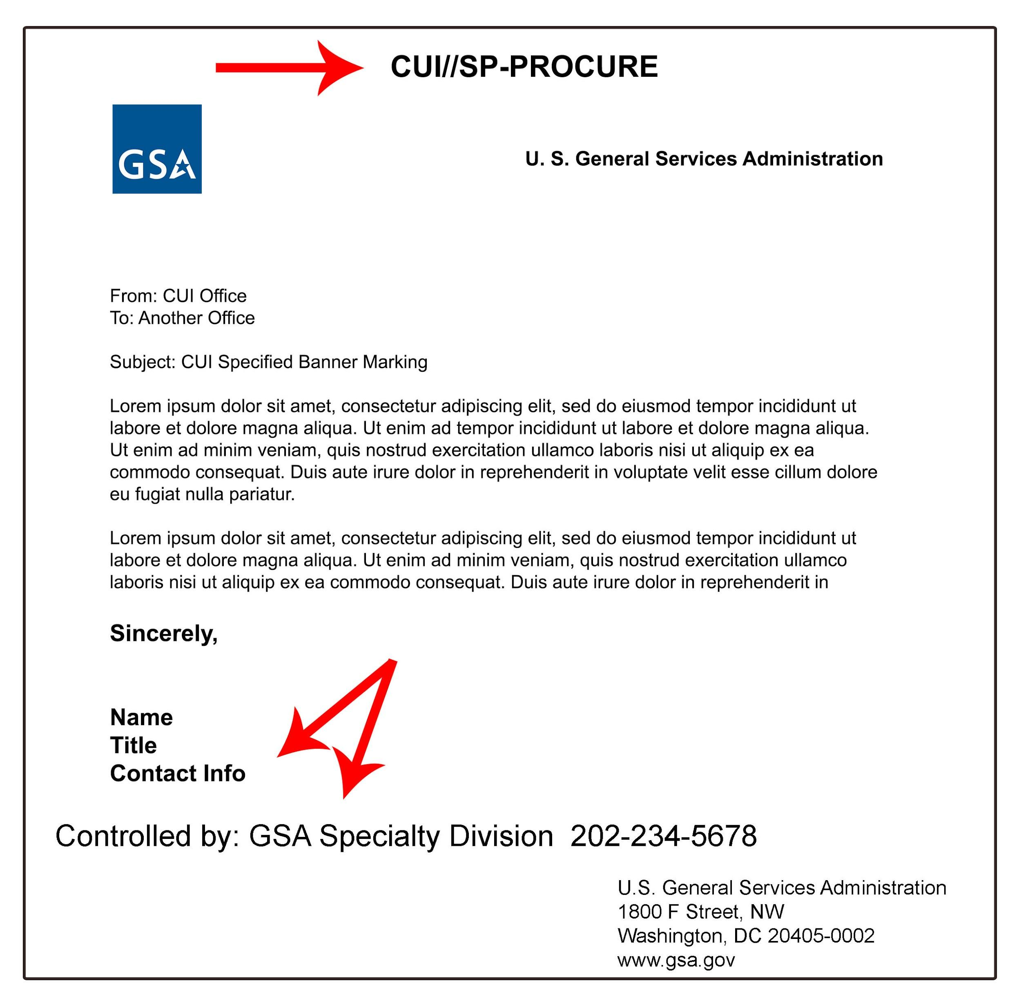
CUI SPECIFIED
The letters CUI plus 2 slashes, plus SP- followed by the CUI Category abbreviation shall be used on every page of a CUI Specified document owned by GSA. If more than one category applies, the category abbreviations should be in alphabetical order separated by a single slash.

Sample Designation Indicator with Contact information:

NOTE:
- To understand the difference between CUI Basic and CUI Specified, please refer to GSA’s CUI Guide.
- Executive Branch agencies can use either CUI or CONTROLLED for the banner marking, therefore information received from an outside agency with CONTROLLED as the banner marking is also CUI. GSA is choosing to use CUI as the default instead of CONTROLLED.
- The Banner Marking for CUI Basic may also include the category abbreviation if desired for clarification. For example, CUI//CRIT (there is no “SP-” since CRIT is a Basic Category).

Limited Dissemination Markings
Limited Dissemination Markings can prevent a document from being shared with certain parties or notify that only certain parties should view it. They should only be used to further a Lawful Government Purpose or when required by CUI Specified authorities.
For example, the Limited Dissemination Control “NOFORN” prevents the information from being shared with non-US citizens and governments. The following limited dissemination markings are the only ones authorized for CUI:
Limited Dissemination | CUI Marking
No foreign dissemination | NOFORN
Federal Employees Only | FED ONLY
Federal Employees and Contractors Only | FEDCON
No dissemination to Contractors | NOCON
Dissemination List Controlled | DL ONLY
Authorized for release to certain nationals only | REL TO [USA, LIST]
DISPLAY ONLY | DISPLAY ONLY
Attorney Client | Attorney-Client
Attorney Work Product | Attorney-WP
Deliberative Process | Deliberative

The Banner Marking that includes Limited Dissemination Controls should have two slashes preceding the abbreviation so it looks like this:
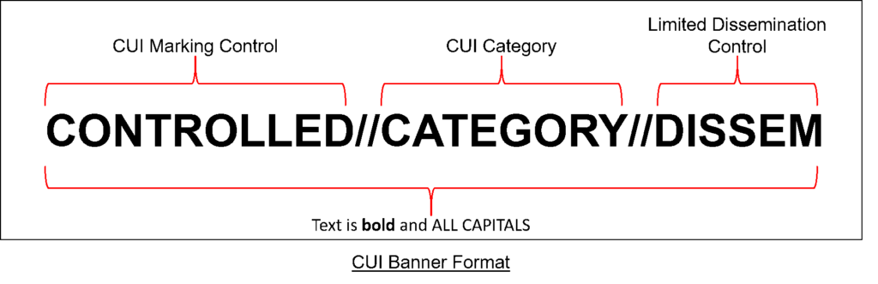
The CUI Registry has additional details.

Portion Marking
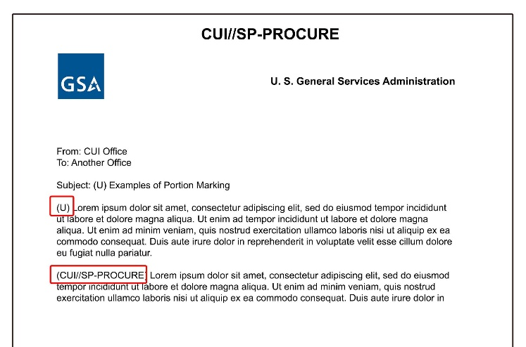

Portion marking of CUI is optional in a fully unclassified document, but is permitted to facilitate information sharing and proper handling of the information. For information on co-mingling CUI with classified material, see pages 34 and following in the CUI Marking Handbook found in the CUI Registry.

When CUI portion marking is used, these rules must be followed:
- CUI portion markings are placed at the beginning of the paragraph to which they apply and must be used throughout the entire document.
- CUI portion markings are contained within parentheses and may include these elements:
- The CUI Control Marking: This is mandatory when portion marking is used, and the acronym “CUI” must be used (the word “Controlled” will not be used in the portion markings).
- If used, CUI Category markings are separated from the CUI Control marking by a double forward slash (//).
- If including multiple categories in a portion, CUI Category markings are separated from each other by a single forward slash (/) and should be in alphabetical order.
- Limited Dissemination Control Markings: If dissemination control markings are used in the banner marking, they should also be used in the portion marking. They are separated from preceding CUI markings by a double forward slash (//). When including multiple Limited Dissemination Control Markings, they must be alphabetized and separated from each other by a single forward slash (/).
- When CUI portion markings are used and a portion does not contain CUI, a “U” is placed in parentheses to indicate that the portion contains uncontrolled unclassified information. Then if the CUI paragraphs are removed, the document can be uncontrolled and no longer treated as CUI.
- The document’s Banner Marking must be shown on each page even if portion marking is used and even if not all pages contain CUI.
- As a best practice, keep the CUI and uncontrolled information in separate portions to the greatest extent possible to allow for maximum information sharing if the CUI portions are removed.

Administrative/Supplemental Markings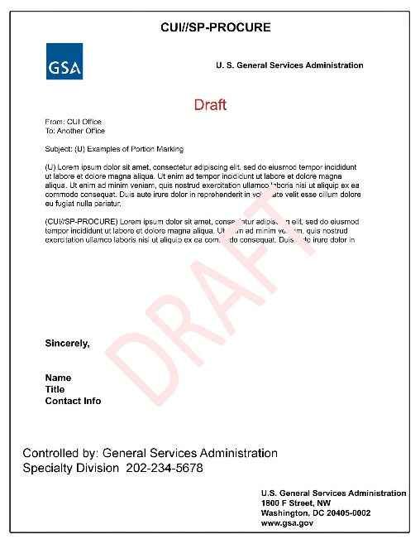
- Extra administrative markings such as Draft, Deliberative, Pre-decisional, or Provisional may be used in documents containing CUI to inform recipients of the non-final status of documents. However, these words cannot appear as part of the CUI banner. Best practice is to have them shown as a watermark behind the text of the document. If that is not possible, they may be shown elsewhere in the document as long as they are separate from the CUI Banner Marking.
- Certain authorities may require other markings, information, warnings, etc. These markings cannot interfere with the CUI Banner Markings but should be included elsewhere on the page to comply with the governing authority.

CUI Coversheet
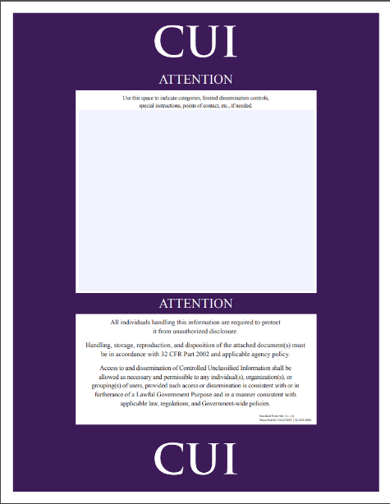
A CUI coversheet may be used instead of markings when it is deemed impractical to individually mark each page due to its quantity, nature, or when a limited CUI marking waiver has been granted. Be sure to list on the coversheet any Specified categories, limited dissemination controls, or requirements called for by underlying, related laws, regulations, or government wide policies.
It is required to use either CUI Banner Markings or a CUI Coversheet in order to protect CUI; using both is a best practice.
The CUI coversheet (Standard Form 901) is available at https://www.archives.gov/cui/additional-tools or through GSA’s Forms Library.

Labels

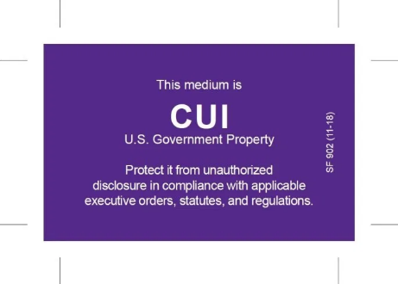
Electronic Media such as USB sticks, hard drives, and CDs must be marked to alert holders to the presence of CUI stored on the device. Due to space limitations, it may not be possible to include CUI Category, Subcategory, or Limited Dissemination Control Markings. At a minimum, mark media with the CUI Control Marking CUI, and if possible, include GSA as the designating agency and contact information.

Labels are available for purchase if desired:
- SF 902 (approximate size 2.125 inches X 1.25 inches) is appropriate for hard drives and is available for purchase from GSA Advantage. NSN 7540-01-679-3318.
- SF 903 (approximate size 2.125 inches X .625 inches) is appropriate for USB drives and is available for purchase from GSA Advantage. NSN: 7540-01-679-3319.
- See CUI Notice 2019-01 for additional information.

Waivers to Marking CUI
GSA’s Senior Agency Official may grant waivers of some or all of the CUI marking requirements while that CUI remains within GSA control unless specifically prohibited by applicable laws, regulations, or Government-wide policies. Waivers apply only while GSA continues to possess that CUI; no waivers may accompany CUI when disseminated outside GSA.
Reasons a waiver may be needed include:
- Legacy documents. Legacy information is unclassified information that was marked as restricted from access or dissemination in some way prior to the CUI Program; markings such SBU, FOUO, etc. CUI markings do not need to be added to legacy information, provided it is stored in a manner that protects the information, and it is only accessible to GSA. If legacy information is to be used again, or shared outside of GSA, it must be reviewed to see if it qualifies as CUI, and if so, must be re-marked as CUI. A waiver request is not needed for Legacy documents when the above criteria is met, as set forth in the CUI Policy.
- Excessive burden. When it is impractical to individually mark CUI due to quantity or nature of the information (e.g., forms, blueprints, etc.), a waiver for excessive burden may be granted. Information still needs to be protected according to CUI requirements and a cover sheet used to notify viewers of the presence of CUI.
- Exigent circumstances. Exigent circumstances exist when following proper procedures would cause an unacceptable delay due to the urgency of the situation. Information still needs to be protected according to CUI requirements.

The waiver request must explain which type of CUI is covered by the waiver, what safeguarding provisions or requirements are being waived for that CUI, and the alternate or compensatory protection methods that will be employed instead to protect that CUI. This information will be included in GSA’s CUI Annual Report to the Executive Agent.

IT Systems
Viewers must be made aware of the presence of CUI using a method that is readily apparent. For IT systems containing CUI, the following standard text for splash screens has been established for GSA applications/systems:
* The first paragraph is required by CIO 2100.1 IT Security Policy;
* The second paragraph must be added when there is CUI in the IT system;
* The third paragraph is optional but a best practice.

* The first paragraph is required by CIO 2100.1 IT Security Policy;
* The second paragraph must be added when there is CUI in the IT system;
* The third paragraph is optional but a best practice.

IT Systems may also have user access agreements, and/or banners on each screen.

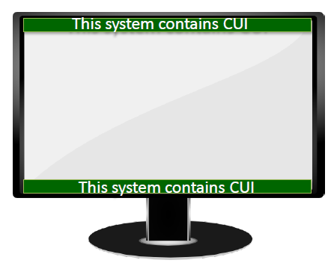
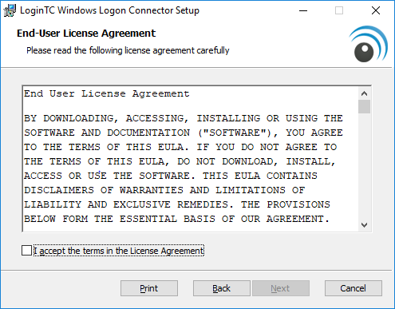

Emailing CUI
- The body of the email must not contain any CUI; it must be in an encrypted attachment.
- The applicable CUI marking must be included at the top of each email.
- If the email is forwarded, the Banner Marking must be moved or copied to the top of the forwarding email.
- It is best practice to include an indicator marking such as “Contains CUI” at the end of the subject line.
- CUI being emailed outside the GSA network must be in an attachment encrypted with FIPS-compliant WinZip.
- The name of the attached file may contain a CUI indicator.

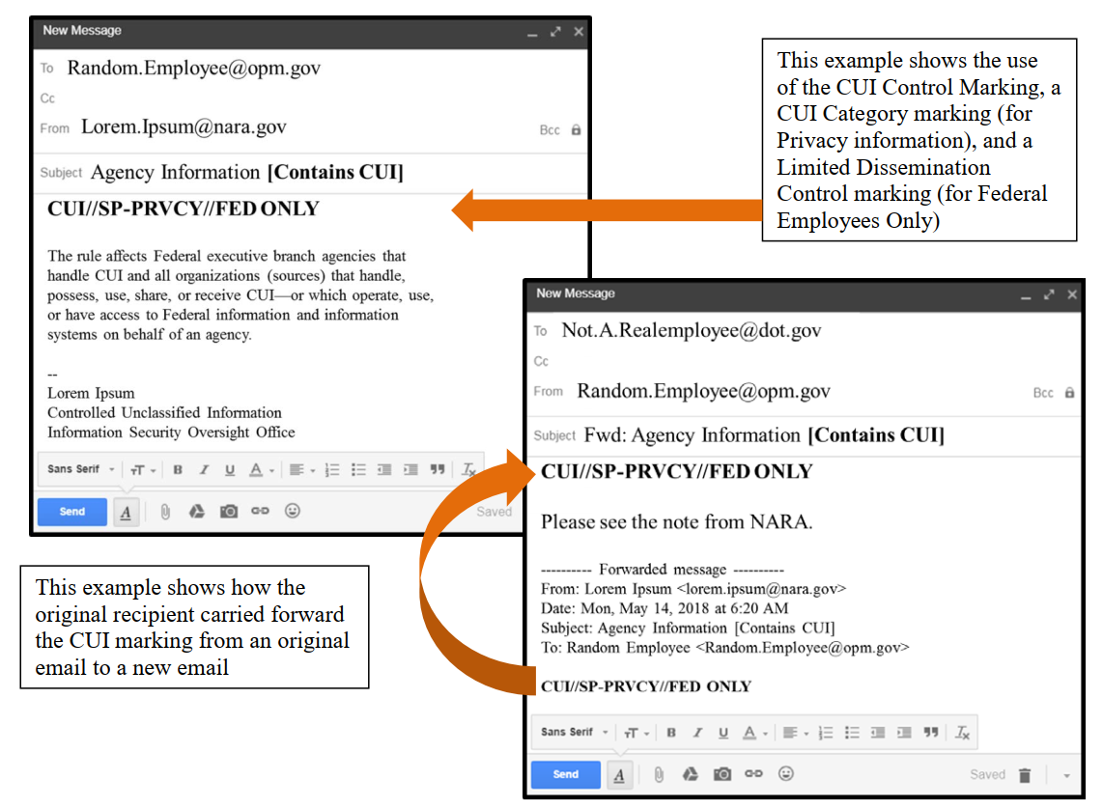

Shipping and Mailing
- Address packages that contain CUI for delivery ONLY to a specific recipient, and require a signature.
- DO NOT put CUI markings on the outside of an envelope or package for mailing/shipping.
- Always use in-transit automated tracking and accountability tools to know where a package is at any time, and when it is received.
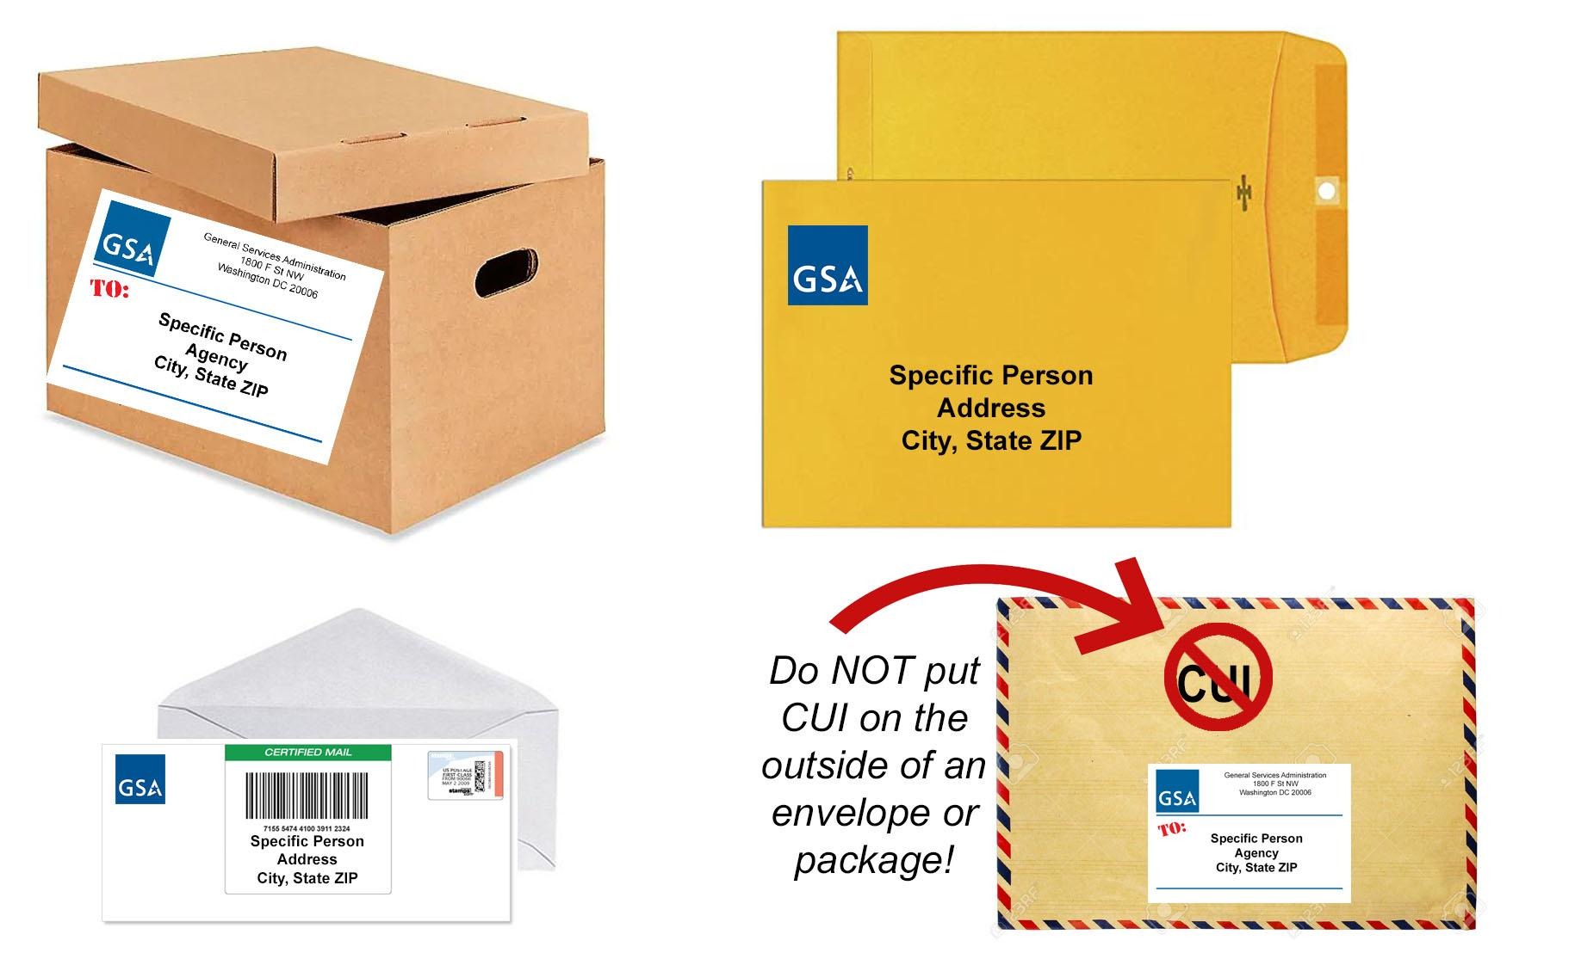

Marking Transmittal Documents

- When a transmittal document accompanies CUI, the transmittal document must indicate that CUI is attached or enclosed.
- The transmittal document must also include, conspicuously on its face, the following or similar instructions, as appropriate:

  - “When enclosure is removed, the document is Uncontrolled Unclassified Information”, or
  - “When the enclosure is attached, this document is CUI (include Specified Category markings as applicable); upon removal, this document is uncontrolled unclassified information.”
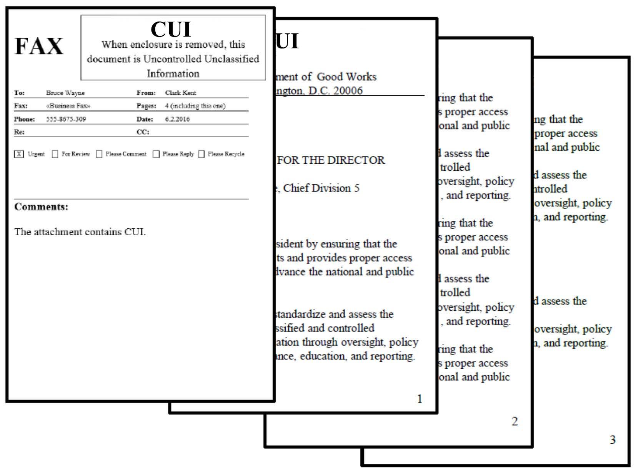

Slides/Briefings
To alert viewers that the presentation has CUI:
- Include a notice on the first slide that the briefing includes CUI.
- Apply the CUI banner marking to the top of each slide.
- Include in the filename that the document contains CUI if sending it out.

Spreadsheets
When a spreadsheet contains CUI it should provide warnings to potential viewers. Some options include:
- Use a header with the CUI Banner Marking.
- Use a footer to show the owner of the document.
- Include in the filename that it contains CUI.
- Use a Coversheet when printing.

Marking Forms with CUI
- Forms that contain CUI when filled in must be marked accordingly.
- If space on the form is limited, cover sheets can be used for this purpose.
- Include a statement that indicates the form is CUI when filled in.
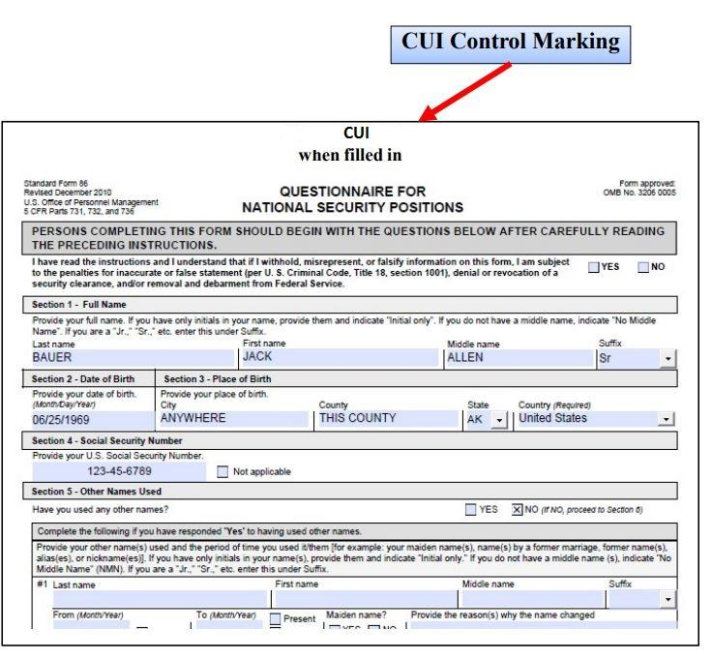

Storage Locations
When it is impractical to individually mark CUI due to quantity or nature of the information, or when a CUI marking waiver has been issued, authorized holders must make recipients aware of the information's CUI status using an alternate marking method that is readily apparent.

Locked cabinets or drawers that contain CUI should be marked as containing CUI. If documents are kept inside these containers they do not need to be individually marked as CUI, but coversheets are encouraged, and the container must remain locked when not in use.

Waivers to normal marking requirements may be requested via email to cui@gsa.gov.

Rooms
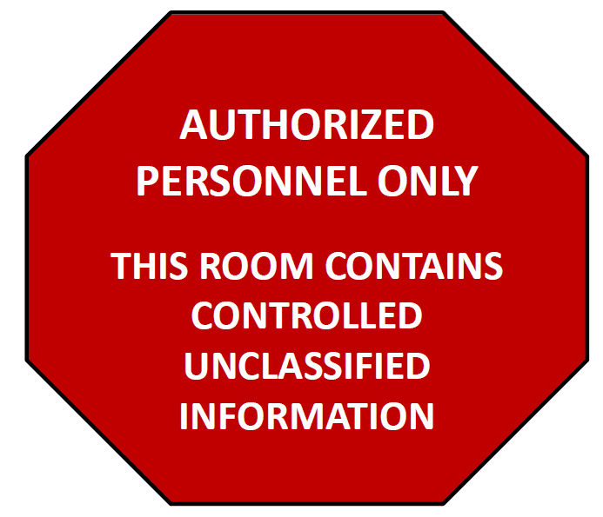
In areas containing CUI, it may be necessary to alert personnel who are not authorized to access it by posting a sign similar to:

Containers
When storing CUI, authorized containers should be marked to indicate that they contain CUI.

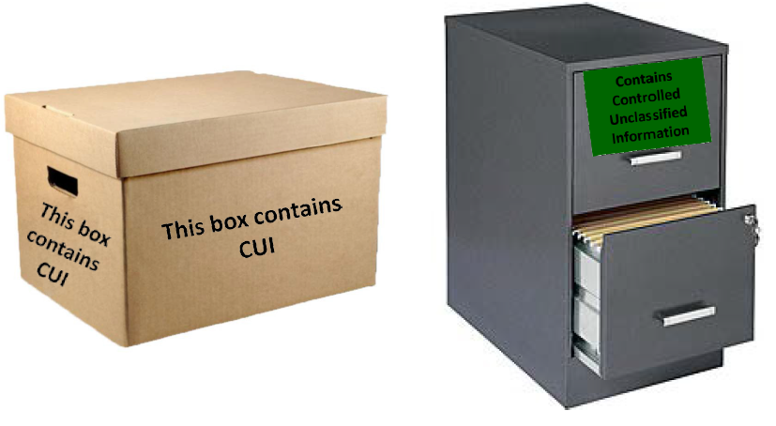

EXAMPLES

Example 1: Marking a CUI Basic Document

NOTE: This is an example of a CUI Basic document with portion marking. Since Portion Marking is not required, many CUI Basic documents will have no portion marking. Also, the Basic and dissemination markings in the banner are optional; just shown for illustrative purposes.

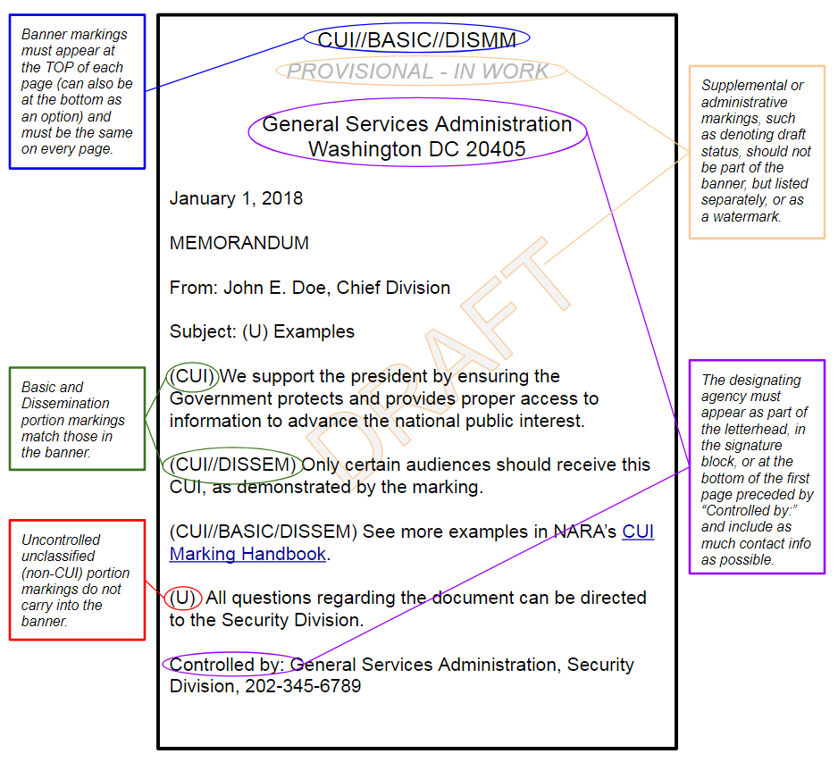
NOTE: The above example uses the word “DISSEM” as a substitute for a Limited Dissemination Control Marking. Refer to NARA’s CUI page and Limited Dissemination Controls for details.
If no dissemination is required, the banner can be just the letters “CUI”.

Example 2: Marking a CUI Specified Document

NOTE: This is an example of a CUI Specified document with portion marking. Since Portion Marking is not required, many CUI Specified documents will have no portion marking. Also, the dissemination markings in the banner are optional; just shown for illustrative purposes.
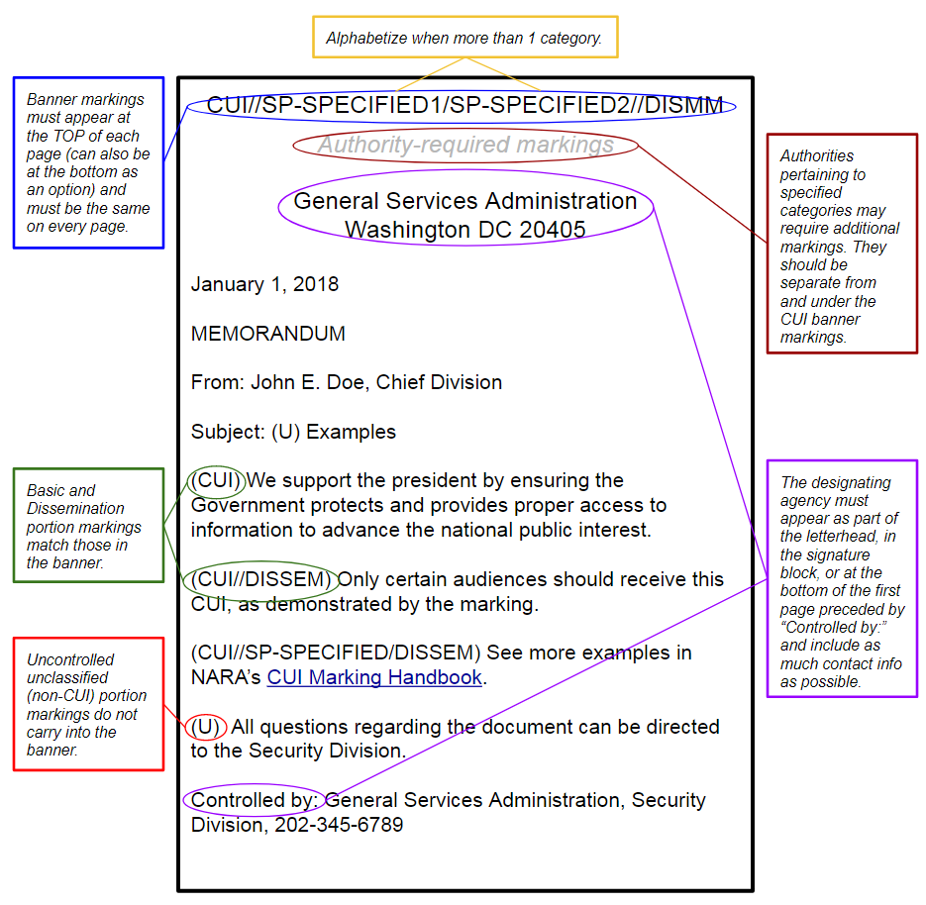
NOTE: The above example uses “SP-SPECIFIED” as a substitute for CUI Category Marking and “DISSEM” as a substitute for Limited Dissemination Control Markings. Refer to NARA’s CUI page and Limited Dissemination Controls for details. To gather actual markings for CUI Categories click on the following link https://www.archives.gov/cui. On the left hand side of the page choose Category List. Find the Category that fits your needs and click on the name.

Multiple Category Banner Markings: Basic & Specified

- CUI Specified Markings must precede CUI Basic Category Markings.

- CUI Category markings must be alphabetized within CUI type (Basic or Specified).

- Alphabetized Specified CUI categories MUST precede alphabetized Basic CUI categories.

