General Services Administration
2015 Strategic Sustainability Performance Plan

July 9, 2015

Kevin Kampschroer
Chief Sustainability Officer
sustainability@gsa.gov

Policy Statement
The U.S. General Services Administration (GSA) is committed to ensuring the long-term viability, security, responsiveness, and efficiency of the Federal Government. As part of this commitment, GSA recognizes a fiduciary obligation to provide Federal agencies with the spaces, services, products, and vehicles they need to carry out their missions today, while advancing the economic, social, and environmental well-being of the United States tomorrow. GSA also understands its responsibility to the citizens and businesses of the United States, and remains committed to operating in a fair, efficient, open, and transparent manner.
In fiscal year (FY) 2015, GSA extended its commitment to sustainability under Executive Order 13693, Planning for Federal Sustainability in the Next Decade. In response to the Executive Order, GSA set new goals for greenhouse gas (GHG) reduction, renewable and clean energy, water reduction, and vehicle fleet efficiency. This year, for the first time, GSA measured and committed to reducing fugitive high-global-warming-potential GHG emissions such as refrigerants, and launched a major new initiative to work with product and service contractors to reduce GHG emissions. Next year, in FY 2016, GSA will begin tracking and reducing GHG emissions from leased office space, and will set new portfolio-wide targets for green and net-zero buildings.
As an integral aspect of GSA’s operations, sustainability performance is managed by a strategic advisory council chaired by our Chief Sustainability Officer, Mr. Kevin Kampschroer, and consisting of senior representatives from the Federal Acquisition Service, Office of Administrative Services, Office of the Chief Information Officer, Office of Government-wide Policy, and Public Buildings Service.
GSA has demonstrated year after year that “Going Green Saves Green” through the savings and efficiencies generated by its sustainability initiatives. (As one example, between FY 2008 and 2014, GSA saved over $250 million in energy and water costs from efficiency improvements implemented since 2003). GSA employees understand that they serve as stewards: of the taxpayers’ dollars, of the environment, of Federal buildings, and of this nation and its Government. GSA understands its responsibility for the sustainability of the Government, and looks forward to continuing to work towards a prosperous and sustainable future with other Federal agencies, businesses and non-profit organizations, and the American people.

Denise Turner Roth
Acting Administrator

Executive Summary

Goal 1: Greenhouse Gas (GHG) Reduction
The international scientific community recognizes climate change as a global threat to human health and well-being. GSA is working to reduce our emissions of greenhouse gases (GHG) that drive climate change. Scope 1 includes emissions from burning fuel in GSA-owned buildings and vehicles, Scope 2 includes indirect emissions from purchased electricity, steam, and hot water, and Scope 3 includes other indirect emissions.

Scope 1 & 2 GHG Emissions
As the leading provider of real estate, acquisition, and technology services to the Federal Government, GSA is crucial to meeting Governmentwide carbon reduction goals. On March 17, 2015, President Obama committed to reduce the Federal Scopes 1 and 2 GHG footprint to 40 percent below 2008 levels by 2025. Having already surpassed the 40 percent reduction level by the end of 2013, GSA will maintain our leadership in the Federal sector by reducing GHG emissions by up to 73 percent from 2008 levels by 2025.

Reducing GHG from Buildings and Vehicles
GSA tracks Scopes 1 & 2 GHG emissions from our internal vehicle fleet and from buildings that GSA occupies and manages for other Federal agencies. Over 99 percent of GSA’s Scope 1 and 2 GHG emissions are from buildings. To meet its GHG reduction goal, GSA will continue improving building energy efficiency, installing advanced and renewable energy technologies, and purchasing renewable energy, as described below in the Sustainable Buildings and Clean and Renewable Energy sections. GSA will also continue to reduce vehicle emissions by right-sizing our fleet and investing in hybrid, electric, and other types of alternative-fuel vehicles (AFV).

Shrinking Our Footprint
To cut building-related emissions cost-effectively, GSA is shrinking our real estate footprint through innovative new workplace solutions. GSA is on track to reduce space per employee (excluding specialized offices) by over 27 percent from 2012–2015. The “shrink the footprint” model—prototyped at GSA’s Central Office building at 1800 F Street, NW in Washington, DC—is paving the way for other agencies to avoid costs and reduce GHGs, while offering their employees attractive, modern office layouts and technology-enabled, flexible work options.

Tracking Fugitive Emissions
In 2014, GSA estimated and reported fugitive hydrofluorocarbon emissions for the first time. These powerful GHGs accounted for 1.7 percent of our Scopes 1 and 2 emissions inventory in 2014. GSA will continue to monitor these emissions, with a focus on preventing leaks and promoting the future use of low-Global Warming Potential (GWP) refrigerants where feasible.

Scope 3 GHG Emissions
Since 2008, GSA has worked to reduce four categories of Scope 3 GHG emissions: employee business travel, employee commuting, electrical transmission and distribution, and waste-related emissions, including from solid waste and wastewater management. By 2014, GSA had reduced emissions in these categories by over 50 percent, far exceeding our original goal of 14.8 percent.
From now through 2017, GSA will be working to add two major categories—leased space and product and service supply chains—to its management of indirect (Scope 3) GHG emissions. GSA will reduce Scope 3 emissions by up to 83 percent from 2008 levels by 2015.

Leased Space Emissions Reporting
GSA has completed a baseline (2008) estimate of Scope 3 emissions from leased office space, an important component of both our and other Federal agencies’ carbon footprints. In 2016, GSA will begin to collect lease-allocated emissions (or utility data needed to calculate emissions) from commercial landlords for all leases over 10,000 rentable square feet. GSA, in turn, is working to provide other Federal agencies with estimates of the emissions related to their assigned GSA-managed space, for inclusion in their own Scope 3 baselines and inventories.

Supply Chain Emissions Disclosure
In 2015, GSA launched a pilot program with the nonprofit CDP Supply Chain initiative to research the emissions and management practices of over 100 of our largest suppliers of products and services. This research will help GSA continue to add and refine carbon management and disclosure requirements within our Governmentwide product and service contracts. GSA is confident that these initiatives will reduce contract costs and advance GHG goals in the long term, although precise quantification of supply chain impacts remains a challenge because most GSA contractors are not yet able to cost-effectively report emissions at a per-contract level.

Shared GHG Accounting Services
In addition to managing the building-related GHG impacts of the over 1.1 million employees in GSA-managed Federal buildings, GSA provides shared GHG accounting services to 34 other Federal agencies via our Carbon Footprint Tool (CFT). The CFT assists agencies in calculating, reporting, and reducing GHG. The tool calculates Scope 3 GHG related to employee commuting, and allows agencies to set GHG reduction goals and see GHG data trends over time. From the CFT, agencies can download GHG inventory data directly into the required format for their annual Federal reporting.

Goal 2: Sustainable Buildings
The GSA Public Buildings Service (PBS) owns or leases over 8,700 assets, comprising more than 376.9 million square feet of workspace used by 1.1 million Federal employees, and is the steward for 486 historic properties.

Energy Use Intensity
The Federal Government’s primary measure of energy efficiency is portfolio-wide energy usage intensity (EUI) in BTUs (British thermal units) per gross square foot. GSA has reduced its EUI by over 30 percent since 2003, and will reduce EUI by another 25 percent by 2025, for a total reduction of 47.5 percent below the 2003 baseline.
GSA will use a variety of tools to achieve this goal—including its repair and alterations program, operations and maintenance practices, building monitoring and audits, and energy savings performance contracts. EUI remains perhaps the most challenging of GSA’s sustainability goals, due to the expense of transforming physical infrastructure and the difficulty of changing tenant behavior while maintaining comfort and satisfaction.

Gauging and Cutting Energy Use
GSA uses a variety of tools and techniques to monitor its progress in reducing energy use, and pinpoint areas for improvement.

Rapid Building Assessments
The Energy Independence and Security Act (EISA) sec. 432 requires GSA to identify facilities responsible for 75 percent of portfolio energy use and audit 25 percent of them each year to identify cost-effective efficiency measures. Rapid Building Assessment technology allows GSA to evaluate facilities at a fraction of the price of a traditional audit.

Fault Detection
GSAlink is a networked building analytics, fault detection, and diagnostic tool that allows GSA to reduce energy consumption by automatically flagging potentially wasteful system failures. By the end of 2016, GSA plans to integrate GSAlink with its National Computerized Maintenance Management System, allowing automatic generation of work orders when faults are detected.

Re/Retrocommissioning
“Commissioning” is a process to ensure that new buildings operate as intended and staff are prepared to operate and maintain systems and equipment. Each year, GSA selects a number of facilities for re- and retrocommissioning (applying commissioning procedures to existing buildings). GSA conducts such projects through the U.S. Department of Energy’s (DOE) Energy Efficiency Expert Evaluations program and is working towards developing an in-house re-tuning program.

High-Performance and Sustainable Buildings
The Guiding Principles for High-Performance and Sustainable Buildings define minimum green building standards for all new Federal facilities. In addition, the Council on Environmental Quality (CEQ) requires all agencies to ensure that 15 percent of existing buildings and building leases meet the Guiding Principles by the end of 2015. In exceeding this 15 percent goal by the end of 2014, GSA leads the Federal Government in the percentage of agency buildings meeting the Guiding Principles. GSA will set a new goal in 2016 after the CEQ releases updated Guiding Principles.
GSA’s Office of Federal High-Performance Green Buildings (OFHPGB) provides the best practices, tools, standards, and information to help Federal agencies green their building portfolios. OFHPGB has recently provided guidance about daylighting, deep energy retrofits and energy savings performance contracts (ESPCs), green roofs, integrated project delivery, plug load management, submetering, and water conservation, among other topics. OFHPGB also publishes the Sustainable Facilities Tool, a comprehensive resource for cost-effective strategies to make workplaces more sustainable.

Technology Evaluations
GSA’s Green Proving Ground (GPG) program evaluates pre- and early-commercial stage building technologies, accelerating the transition from bench-scale technology to commercial viability. GPG has completed 23 technology assessments to date, and identified 13 of these technologies as having broad deployment potential. Examples of some of the most recent reports include electro-chromic windows for land ports-of-entry, wireless advanced lighting controls, and wireless soil-moisture sensors for irrigation control. GSA has deployed 5 GPG-evaluated technologies in 215 locations nationwide, resulting in annual energy savings of 170 billion BTUs.

Sustainable Workplaces and Locations
Through its Total Workplace program, GSA supports customer agencies’ Reduce the Footprint efforts to reduce costs and GHGs, by offering attractive, modern office layouts and technology-enabled, flexible work options. GSA set up green teams and participates in the U.S. Environmental Protection Agency’s (EPA) Federal Green Challenge. These are volunteer-driven efforts to engage tenants on practices like recycling, bicycle commuting, energy efficiency, and reuse/donation of unwanted items.
GSA worked with EPA’s Office of Sustainable Communities to develop a quantitative measure for evaluating location efficiency of GSA’s real estate portfolio and proposed locations. Using GIS tools, GSA can evaluate GHG implications of potential locations to encourage improvement over the status quo when selecting new locations. GSA will use these tools when making location decisions for owned and leased buildings. Recently, GSA incorporated these tools into our Leasing Desk Guide and Request for Lease Proposal documents, and we are exploring opportunities to use these tools in client portfolio planning.

Healthy Buildings
GSA is partnering with the U.S. Department of Health and Human Services—Centers for Disease Control and Prevention (HHS), and New York City (NYC) agencies, to develop a voluntary certification program called FITWEL to promote health and wellness through the design of workplace environments. Buildings with healthy indoor air and food options, designs that facilitate active occupant behaviors, and similar programs can prevent or control chronic diseases. The FITWEL certification will initially be available to facilities owned or managed by GSA, HHS, and NYC, but is being designed for other facilities, including schools, hospitals, businesses, and retail outlets.

Goal 3: Fleet Management

GSA Internal Fleet
GSA maintains a fleet of approximately 980 vehicles for the use of GSA employees. While this fleet is small compared to the fleets GSA manages for other Federal agencies, it allows GSA to demonstrate leadership in fleet management and pilot innovative technologies and practices on a small scale.
GSA’s top priorities for internal fleet management, for several years and continuing in 2015–16, are to eliminate unnecessary or non-essential vehicles from the agency's fleet inventory, and to increase the proportion of hybrid, electric, low-GHG, and other AFVs in our fleet.

Federal Fleet Offerings
GSA Fleet maintains the second largest non-tactical Federal fleet in the U.S. Government, with over 200,000 vehicles leased to over 55 Federal agency customers. GSA Fleet is committed to providing low-cost, high-efficiency vehicle options to its customer agencies in an effort to facilitate meeting their missions in the most sustainable manner possible.

Greening the Federal Fleet
GSA actively partners with vehicle providers and maintains an open contract solicitation in order to offer the widest possible array of alternative fuel / low GHG vehicles and solutions, and introduce emerging technologies as soon as they become available. Currently, in addition to seeking fleet electrification and efficiency opportunities, GSA is working with manufacturers to encourage the reduction and elimination of all hydrofluorocarbon (HFC) refrigerants from vehicle air conditioning systems.

Electric Vehicle (EV) Pilot
GSA collaborated with 21 customer agencies to incorporate over 300 Electric Vehicles (EVs) and 169 charging stations into the Federal fleet by 2014. Agencies received a mix of Ford CMAX Energi Plug-ins, Chevy Volt Plug-ins, and Ford Focus BEVs. In FY 2015, GSA is working with the GSA Fleet charge card vendor Wright Express (WEX) and the charging station vendor (ChargePoint) to obtain WEX card acceptance at all pilot stations. WEX acceptance will allow for the automatic transfer of vehicle level charging data from the charging station to GSA Fleet’s information management system.

New Alternative Fuel Vehicle (AFV) Tool
In 2014, GSA implemented a new AFV Tool—a complete acquisition/decision tool needed to right-size and optimize agency fleets. The tool helps customers compare models and find the vehicle they need taking fuel, availability, carbon dioxide (CO2) grams per mile, size and price into account. The tool also provides overall GHG emissions saved for each hypothetical acquisition, providing customers with a full picture of the acquisition’s environmental impact. In FY 2015, GSA is offering training and conducting customer user interviews to identify future enhancements to the tool based on customer feedback.

Compressed CNG Light Truck Initiative
During GSA’s 2015 annual vehicle replacement cycle, GSA covered the incremental cost of acquiring 62 bi-fuel CNG pickup trucks for five Federal agencies—Army, NASA, Marine Corps, Navy and Veterans Affairs. The goal of the initiative is to support customers in their efforts to acquire AFVs in the pickup truck category while furthering the Administration’s goal of decreasing U.S. dependence on foreign fuel sources.

Car Sharing
This year, GSA is kicking off a commercial car-sharing pilot to test the overall effectiveness of car sharing across the Federal fleet utilizing a commercial product that allows customers to reserve vehicles by the hour. GSA is also conducting a second car-sharing pilot to examine the use of car-sharing technology tools on existing GSA Fleet vehicles located in the downtown Chicago area. Car sharing will help agencies save taxpayer money by managing their motor vehicle fleets with an alternative local mode of transportation.

GSA Short Term Rental Program
The Short Term Rental (STR) program assists Federal agencies with short-term rental needs for vehicles and equipment and reduces redundant procurement support across agencies. The STR program provides agencies with an option to manage their fleet utilization by removing vehicles or equipment in their owned or leased fleets and renting vehicles that are needed only on a short-term or one-time basis.

Goal 4: Water Use Efficiency & Management
GSA is committed to reducing water usage in its facilities and capturing and reusing water where possible. From 2007–2014, GSA reduced its water use intensity (gallons per square foot) by nearly 30 percent. As with energy efficiency, water efficiency creates significant savings for GSA. GSA would have paid $8.6 million more for water in 2014 if water intensity were still at 2007 levels.
Nevertheless, water remains one of GSA’s greatest long-term challenges, especially in the Western United States. The persistent, historic drought in 2015 led to new demands for even greater water reduction. GSA is responding to these pressures with a range of short-term to long-term conservation measures.

Drought-tolerant landscaping
GSA is assessing greenscapes in Western states and replacing them with drought-tolerant landscaping, including xeriscaping, as funds become available. Xeriscaping is a type of landscaping that uses drought tolerant plants to reduce the need for supplemental watering. GSA is also actively planning and assessing future xeriscaping strategies. At the Fort Worth Federal Center, GSA is collaborating with a non-profit to use test plots to determine the best combinations of plants that are water-reducing, pollinators, native, and aesthetically pleasing.

Preventing leaks through advanced metering
GSA is installing advanced water meters when feasible and has seen great success with improving water efficiency through leak detection and corrective actions. To date, GSA installed advanced water meters in 277 buildings, representing 45 percent of annual water consumption. GSA’s Pacific Rim Region, covering Arizona, California, Hawaii, Nevada, and U.S. territories and bases the Pacific Rim, has uncovered significant savings by finding and fixing leaks; for example, in 2014, correcting just one irrigation leak at a campus in Menlo Park, California, yielded a 60 percent savings for the facility.

Stormwater management and reuse
GSA’s planning process requires consideration of stormwater management and reuse. These efforts have increased the use of planted roofs, rain gardens, non-potable irrigation, and reuse for toilet flushing and makeup water. Where feasible, GSA is also installing systems to capture and use condensate water from heating, ventilation, and air conditioning (HVAC) systems for irrigation and other non-potable uses.

Performance Contracting
GSA is using ESPCs and Utility Energy Savings Contracts (UESCs) to fund cost-effective water efficiency projects where not feasible via capital budgets. ESPC projects awarded by GSA’s Northeast and Caribbean Region (including New York City), valued at approximately $80 million, are expected to reduce the Region’s water consumption by 25 percent.

Goal 5: Pollution Prevention & Waste Reduction

Waste Diversion
In 2014, GSA diverted 52 percent of its non-hazardous municipal solid waste away from landfills through its recycling and composting programs, including composting 2,265 tons of organic waste from 47 facilities across the country. Through negotiated recycling sales contracts, GSA distributed over $550,000 of recycling revenue to Federal tenant agencies and GSA’s Child Care Tuition Assistance Program.
In 2014, GSA also launched a new municipal solid waste data management tool to measure and track waste diversion, as well as to link building waste diversion activities to U.S. Green Building Council Leadership in Energy and Environmental Design (LEED) Existing Buildings Operations and Maintenance (EBOM) certification. GSA also initiated a nationwide tracking system for Construction and Demolition (C&D) waste diversion for prospectus-level projects, and diverted 94 percent of construction & demolition debris from these projects completed in 2014, and 65 percent of such waste in the first half of 2015. GSA continues to gather available C&D waste diversion data on completed prospectus projects, and on small projects in every Region. GSA expects to continue exceeding the Governmentwide 50 percent waste diversion goals.

GSAXcess
GSAXcess supports the second step in the “Reduce, Reuse, Recycle” waste management hierarchy with a system for agencies to offer and acquire excess and surplus personal property like furniture, motor vehicles, computers, and other equipment. Property can be reused internally or transferred to other Federal agencies, state and local agencies, and qualified non-Federal organizations. In FY 2014 alone, GSAXcess enabled the reuse within the Federal community of over 43,000 line items worth more than $1.07 billion, giving this property new life and stretching taxpayer dollars. GSAXcess also enabled the reuse of over 31,000 line items worth more than $557 million to state and local agencies and eligible non-Federal organizations.

Goal 6: Sustainable Acquisition
As the Government’s one-stop shop for product and service acquisition, GSA offers a wide variety of product and services contracts, policy support, and information services to help Federal agencies meet their sustainability goals.

Product and Services Contracts
GSA reviews each of its contract vehicles as they are awarded and renewed to ensure their support for statutory and Executive Order sustainability mandates. Then, wherever possible, we add cost-effective features to ensure that acquiring green products and services through GSA is as easy as possible. In addition to the existing Print Management strategic sourcing blanket purchase agreements (BPAs), three new recently awarded strategic sourcing solutions offer green products.

Office Supplies 3 IDIQ
The OS3 IDIQ contracts offer recycled content products such as paper and toner cartridges. OS3 contractors report green product sales at the line-item level so agencies can gauge their green purchasing performance. OS3 is expected to provide more than $90 million in annual savings across all products, captured through lower prices.

Janitorial and Sanitation (JanSan) BPAs
The JanSan BPAs offer products such as biobased cleaning products and recycled content tissue and towel products. JanSan also offers agencies an opportunity to meet the new E.O. 13693 requirement to set targets for purchasing only biobased products. GSA expects that the use of the JanSan solution can result in $8 million saved across all products purchased in the first year.

Maintenance, Repair, and Operation Products BPAs
The MRO BPAs offer a wide range of green products such as biobased and recycled content paints, WaterSense sink fixtures, and Energy Star room air conditioners. MRO also offers Federal agencies an opportunity to meet the new E.O. 13693 requirement to set targets for purchasing only biobased products. In the first half of 2015, Federal agencies purchased $867,333 worth of green products from the MRO contractors.

Print Management BPAs
GSA’s Print Management BPAs offer access to Energy Star and EPEAT-registered imaging devices and maintenance contracts. Service contractors are required to set cost-saving, green features such as double-sided and black and white printing by default.

GSA Multiple Award Schedules
Ten GSA Multiple Award Schedules include green-only requirements, such as Energy Star imaging equipment. In addition, Special Item Numbers within more than a dozen schedules now contain notes identifying where products meeting environmental attributes such as Energy Star or biobased content might be available.

Supply Chain GHG Management
From 2009–2015, GSA pioneered the inclusion of Supply Chain GHG management in Federal contracts under E.O. 13514. Now that it is required of other large purchasing agencies under E.O. 13693, GSA is ready to help by offering access to its contracts and sharing its experience in developing the most advanced contractual GHG management features in the Federal Government.

Package Delivery
GSA’s 2014 Domestic Delivery Services 3 (DDS3) package delivery contract was the first strategic sourcing contract in the Federal Government to evaluate and consider the carbon footprint of services proposed. In addition to providing cost-effective delivery services, it includes free Scope 3 reporting to help customer agencies manage their shipping emissions.

Professional Services
Our OASIS (One Acquisition Source for Integrated Services) professional services solution enables GHG reporting and evaluation at the task order level, allowing customers to meet their E.O. 13693 GHG pilot requirements via OASIS task orders.

Reducing GHGs from Business Air Travel
City Pairs is GSA’s Governmentwide travel solution providing agencies access to low negotiated rates on airline tickets. The City Pairs Program awards a significant number of non-stop flights, where cost effective, thus reducing GHGs associated with multiple flights.

Future Initiatives
GSA has identified potential GHG management features for its next-generation Alliant 2 (IT services), NS2020/EIS (telecom services), and Human Capital and Training Solutions (HCaTS) strategic sourcing contracts, which are slated for award in FY 2016 or later.

Policy Support and Information Services
Beyond our product and services contracts, GSA supports agencies’ sustainability goals through information services and policy support.

Green Procurement Compilation
The Green Procurement Compilation (GPC) is a comprehensive sustainable acquisition resource for Federal purchasers. It consolidates and organizes information from multiple Federal environmental programs in one place, allowing easy identification of all Federal green purchasing requirements for a given product or service. The GPC also provides sample solicitation language for both products and services, and optional green practices for services contracts. Links are included to purchase compliant products and services from Governmentwide sources such as GSA Advantage, GSA Schedules, and Federal Strategic Sourcing Initiative (FSSI) solutions. Beginning in 2014, agencies were able to create GPC pages for agency-specific product requirements, with the Departments of Defense and Energy and GSA’s Public Buildings Service leading the way.

Acquisition Gateway
GSA is collaborating with other large Federal purchasing agencies to create a sustainable acquisition community of practice and contribute expert articles in the new Acquisition Gateway, a shared workspace designed to improve access to knowledge and expertise about Federal purchasing and acquisition.

Transactional Data
To improve contract management and better inform price negotiations, GSA is working with OMB and other agencies to improve reporting of per-transaction data for purchases from GSA Schedules. As part of this initiative, GSA also plans to pilot green product data reporting where feasible, to improve management and reporting of green products purchased under these contracts.

Acquisition Policy
GSA supports sustainable acquisition Governmentwide through numerous policy initiatives, such as:
- Co-chairing several interagency working groups established by the CEQ, including the Sustainable Acquisition and Materials Management Working Group, Data Quality, Collection, and Reporting Working Group, and Supply Chain GHG Emissions Working Group
- Supporting Environmental Protection Agency efforts to develop policy for Government use of third-party standards and ecolabels, and incorporating the results into GSA’s contract and information offerings, including the Green Procurement Compilation
- Participating in the development of NSF 391.1, a voluntary consensus, multi-attribute, life cycle sustainability standard for professional services
- Finalizing a joint GSA-DOE Verification Guide for Purchasers of Sustainable Products to provide guidance on ensuring contractor compliance with sustainability requirements
- Providing Sustainability Coding Guidelines to ensure accurate use of the Federal Procurement Data System (FPDS) environmental attribute data elements to track sustainable purchasing Governmentwide

Internal Initiatives
GSA has internal initiatives in place in 2015 and 2016 to improve sustainable acquisition within our agency. The Public Buildings Service’s Key Sustainable Products initiative focuses on 10 of the highest-volume, highest-impact product types purchased. In addition, GSA will continue building and updating a comprehensive sustainable acquisition section on the GSA Acquisition Portal to provide our acquisition workforce with sustainable acquisition tools and guidance. GSA is also finalizing a new internal sustainable acquisition policy (GSAM Subpart 523.1) and will train our workforce on the new policy once it is published.

Goal 7: Electronics Stewardship & Data Centers
Information Technology products contribute significantly to GSA’s energy and waste footprints. Tenant agencies operate 21 data centers in space leased from GSA, occupying 8.8 million square feet (excluding server closets with areas less than 500 square feet). GSA offers energy efficient electronics to Federal agencies, provides responsible and cost-effective solutions for their disposal, and develops Governmentwide e-waste policy. GSA also provides solutions for transitioning data management and computing services to the Cloud.

Internal Policies

Acquisition
GSA’s internal policy is to purchase only electronic products that are Federal Energy Management Program (FEMP)-designated, Energy Star qualified, and/or meet the Electronic Product Environmental Assessment Tool (EPEAT) Silver or Gold standard.

Management
Since FY 2007, and continuing in 2014, 100 percent of GSA’s computers were power-management enabled. GSA has eliminated nearly all use of personal printers, and shared printers are set to print double-sided by default.

Reuse and End-of-life
GSA is a member of the United States Post Office (USPS) Blue Earth initiative to assist offices with disposing of used electronics in an environmentally sustainable manner. The USPS picks up un-needed electronics from registered users and delivers them to a certified recycling facility at no cost to the agency. In FY 2013, all GSA e-waste was disposed of using Blue Earth, GSAXcess, Computers for Learning, UNICOR, or an R2 or E-stewards certified private recycler.

Data Centers
In accordance with recent Federal Data Center Consolidation Initiative Program Management Office guidance, GSA IT has identified 3 of 125 data centers as “core” data centers. Of its 122 non-core data centers, 66.3 percent (81 data centers) are slated to be closed, which exceeds OMB’s Governmentwide goal of 40 percent by FY 2015.

Policy Support and Information Services
In support of the National Strategy for Electronics Stewardship, GSA will release a Governmentwide e-waste regulation for review and interagency comment by the end of calendar 2015. GSA will then develop training and outreach materials, and is exploring new contract offerings to help Federal agencies comply with the regulation.
GSA offers several options for agencies to manage their e-waste, including GSAXcess (discussed above under Pollution Prevention and Waste Reduction) and the Computers for Learning donation program. The Agency Asset Management System (AAMS) allows Federal agencies to easily transfer used electronics within their own agencies before offering them to other agencies. This tool improves information sharing on used electronics and increases the reuse of equipment within agencies.

Goal 8: Renewable Energy
Generation, purchases, and sales of cost-effective renewable energy are central to GSA’s carbon reduction strategy. GSA is striving to use 100 percent renewable electricity by 2025.
GSA will continue to install on-site renewable energy generation and to incentivize new renewable generation by utility companies with purchases of grid-supplied renewable energy, stand-alone renewable energy credits (RECs), and energy produced by specific off-site renewable energy projects.

Internal Initiatives

On-Site Renewables
Photovoltaic and other renewable energy sources located on dozens of GSA properties supply over 28,000 MWh of electricity annually, with more coming online every year. GSA is aggressively pursuing financing options including ESPCs and Power Purchase Agreements (PPAs) to expand its on-site renewable generating capacity.

Competitive Renewable Power Buying
In states with competitive electricity markets, GSA purchases additional renewable power through competitive electricity procurements. GSA assists Federal agencies with electricity procurements that specify a percentage of renewable power.

RECs and REC Swaps
GSA purchases renewable energy credits to supplement on-site and competitive renewable power procurements. GSA continually monitors renewable power markets. In many cases, GSA is able to cost-effectively “swap” on-site renewable energy generation for a larger quantity of off-site renewable energy, while helping other entities meet local mandates.

Demand Response
Since 2011, GSA earned over $1.1 million in rebates from utility demand response programs. Under these programs, GSA reduces electricity consumption at peak load times, reducing the risk of blackouts and the need for utilities to build less-efficient “peaker” power plants. GSA reinvests its demand response rebates in energy and water savings projects, adding to the environmental benefits and taxpayer savings.

Renewable Project Assistance
When it comes to renewable energy, GSA’s impacts are being felt far beyond its own buildings. Increasingly, GSA’s power market expertise is enabling new, utility-scale solar installations and helping other Federal agencies meet their own aggressive renewable power goals.

New Solar Installation through GSA Areawide Contracts
GSA played a critical role in the U.S. Department of Defense — Army’s recently announced “Georgia 3x30” project to develop three, 30 MW solar installations at Forts Benning, Gordon, and Stewart. Collectively, these projects will cover 250 acres and produce 18 percent of the Army’s power needs in the state of Georgia. GSA also assisted the Army with its 68-acre, 18 MW solar installation at Fort Huachuca, Arizona, which became operational in December 2014. In both cases, GSA negotiated long-term contracts with local utilities to build the solar facilities and supply the Army with 100 percent renewable power at near or below standard electricity rates.

Aggregated On-Site Solar PPAs
GSA partnered with the U.S. Department of Agriculture — Forest Service, DOE, and EPA to develop the Federal Aggregated Solar Procurement Project, the Nation’s first Federal partnership to purchase solar power. The project will take advantage of economies of scale and use a single PPA (Power Purchase Agreement) contract to build up to 5 MW of rooftop, ground-mounted, and parking lot solar generation at multiple Federal sites in northern California and Nevada. GSA anticipates the overall utility rates for the combined locations will not exceed regular utility rates for the individual sites.

Off-Site Wind and Solar Power Procurement
In October 2014, GSA announced a first-of-its-kind agreement to buy 140 MW of wind power from a wind farm currently in development in northwest Illinois. This procurement, if completed pending environmental reviews, would be the largest wind energy purchase from a single source in Federal contracting history.
GSA has also signed two contracts for output from a 6 MW solar array and a 75 MW solar array located on the Eastern Shore of Maryland. GSA is assisting in investing in a cleaner power grid through these energy procurements. GSA will not, however, own the renewable attributes from the solar arrays.

Goal 9: Climate Change Resilience
The U.S. Government Accountability Office (GAO) has identified climate change as a high fiscal risk due to the potential for changing climate and weather patterns to negatively impact Federal properties, programs, and operations. According to GAO, “One way to reduce the potential impacts of climate change is to enhance resilience. The National Academies define resilience as the ability to prepare and plan for, absorb, recover from, and more successfully adapt to adverse events.”
GSA developed a vulnerability analysis regarding incremental climate change in 2011, and, since then, has implemented and updated, as necessary, a Climate Change Risk Management (CCRM) plan. GSA’s climate change risk management actions support mission continuity for the broader Federal community in response to extreme weather incidents or incremental climate change. These actions are flexible and increase GSA's agility to respond to the emergent nature of climate risk management. The anticipatory actions of the CCRM build short- and long-term capacity to ensure that GSA’s offerings of real estate, supplies, and services remain relevant and fit for purpose over time in a changing climate. For example, in collaboration with agency partners, GSA identified telecommunications and data centers as two mission critical infrastructures vulnerable to climate change. In 2014, GSA contracted for a literature search of telecom and data center risk and adaptation actions. GSA also developed regional fact sheets about the risks to telecom and data centers, which are being shared with customers and vendors.
GSA is adding targeted climate change adaptation and related scientific support services to our professional services offerings in 2016–2017. These actions position GSA to help agencies avoid costs through effective management of their own climate change risks, and decrease the costs of contracting for adaptation services through quality assurance, best cost, and geographic bundling.

Goal 10: Energy Performance Contracts
To reduce energy and water use via building upgrades that are life-cycle cost-effective—but beyond currently limited capital budgets—GSA is using performance contracting methods, including ESPCs and UESCs. These contracts leverage private-sector financing for upfront project costs, and are paid for using funds previously budgeted to pay for utility bills (i.e., some of the savings in energy and water costs generated by the upgrade are used to pay for the upgrade over time). GSA can thus reduce energy and water use at no upfront cost, and still reap significant savings.
As part of the President’s Performance Contracting Challenge (PPCC), GSA committed to awarding a total of $344.5 million in ESPCs and UESCs by December 2016. As of December 2013, at the end of the first phase of the PPCC, GSA had awarded $191.5 million toward this goal. GSA is also providing assistance and expertise to help other agencies maximize their use of energy performance contracts.

Deep Energy Retrofits
GSA is using performance contracts to perform deep energy retrofits, pushing for greater energy savings wherever possible. The first 10 projects awarded under GSA’s National Deep Energy Retrofit program identified, on average, over 38 percent energy savings.

TABLE OF CONTENTS

Cover Page
Policy Statement
Executive Summary
Size & Scope of Agency Operation – Table 1: Agency Size & Scope
Agency Progress toward (Prior) Sustainability Goals in E.O. 13514 and E.O. 13423
Goal 1: Greenhouse Gas (GHG) Reduction
Agency Progress toward Scope 1 & 2 GHG Goal
Agency Progress toward Scope 3 GHG Goal
Goal 2: Sustainable Buildings
Agency Progress toward Facility Energy Intensity Reduction Goal
Agency Progress toward Total Buildings Meeting the Guiding Principles
Goal 3: Fleet Management
Agency Progress toward Fleet Petroleum Use Reduction Goal
Agency Progress toward Fleet Alternative Fuel Consumption Goal
Goal 4: Water Use Efficiency & Management
Agency Progress toward Potable Water Intensity Reduction Goal
Goal 5: Pollution Prevention & Waste Reduction
Agency Progress toward Pollution Prevention & Waste Reduction
Goal 6: Sustainable Acquisition
Agency Progress toward Sustainable Acquisition Goal
Goal 7: Electronic Stewardship & Data Centers
Agency Progress toward EPEAT, Power Management and End of Life Goals
Goal 8: Renewable Energy
Agency Renewable Energy Percentage of Total Electricity Usage
Goal 9: Climate Change Resilience
Agency Climate Change Resilience
Goal 10: Energy Performance Contracts
Agency Progress in Meeting President's Performance Contracting Challenge (PPCC) Goal
Agency Strategies to Meet Goals of E.O. 13693
Goal 1: Greenhouse Gas (GHG) Reduction
Goal 2: Sustainable Buildings
Building Energy Conservation, Efficiency, and Management
Building Efficiency Performance, and Management
Goal 3: Clean & Renewable Energy
Agency Clean Energy Share of Total Electric and Thermal Energy Goal
Agency Renewable Energy Share of Total Electricity Consumption Goal
Goal 4: Water Use Efficiency & Management
Potable Water Consumption Intensity Reduction Goal
ILA Water Consumption Reduction Goal
Goal 5: Fleet Management
Agency Progress toward Fleet Per-Mile Greenhouse Gas Emissions Goal
Goal 6: Sustainable Acquisition
Sustainable Acquisition Goal - Biobased
Goal 7: Pollution Prevention & Waste Reduction
Agency Progress toward Pollution Prevention & Waste Reduction
Goal 8: Energy Performance Contracts
Agency Progress on Energy Performance Contracting
Goal 9: Electronic Stewardship
Agency Progress on Electronic Stewardship
Goal 10: Climate Change Resilience
Appendices

Size & Scope of Agency Operation – Table 1: Agency Size & Scope

 | FY 2013 | FY 2014
Total Number of Employees as Reported in the Agency’s Budget | 11,885 | 11,502
Total Acres of Land Managed | 170,608 | 15,928
Total Number of Buildings Owned | 1,576 | ​1,574
Total Number of Buildings Leased (GSA and Non-GSA Lease) | 7,435 | ​7,147
Total Building Gross Square Feet (GSF) | 422,826,064 | ​423,132,651
Operates in Number of Locations Throughout U.S. | 9,011 | ​8,721
Operates in Number of Locations Outside of U.S. | 0 | 0
Total Number of Fleet Vehicles Owned | 0 | 0
Total Number of Fleet Vehicles Leased | 1,040 | 1,005
Total Number of Exempted-Fleet Vehicles (Tactical, Law Enforcement, Emergency, Etc.) | 177 | 125
Total Amount Contracts Awarded as Reported in FPDS ($ Millions) | 8,045 | 9,095

Agency Progress toward (Prior) Sustainability Goals in E.O. 13514 and E.O. 13423
This section provides an overview of agency progress towards the sustainability goals established in E.O. 13514 and E.O. 13423. The subject of many of these goals has been carried over into E.O. 13693, and a review of past performance is useful to determine program effectiveness and development of strategies for future implementation.

Goal 1: Greenhouse Gas (GHG) Reduction

Agency Progress toward Scopes 1 & 2 GHG Goal
E.O. 13514 required each agency to establish Scopes 1 & 2 GHG emission reduction targets to be achieved by FY 2020. The red bar represents the agency's FY 2008 baseline. The green bar represents the FY 2020 target reduction. The blue bars represent annual agency progress towards achieving this target. The percentage at the top of each bar represents the reduction or increase from the FY 2008 baseline. A negative percentage value indicates that the emissions have decreased compared to the 2008 baseline.

Figure 1-1
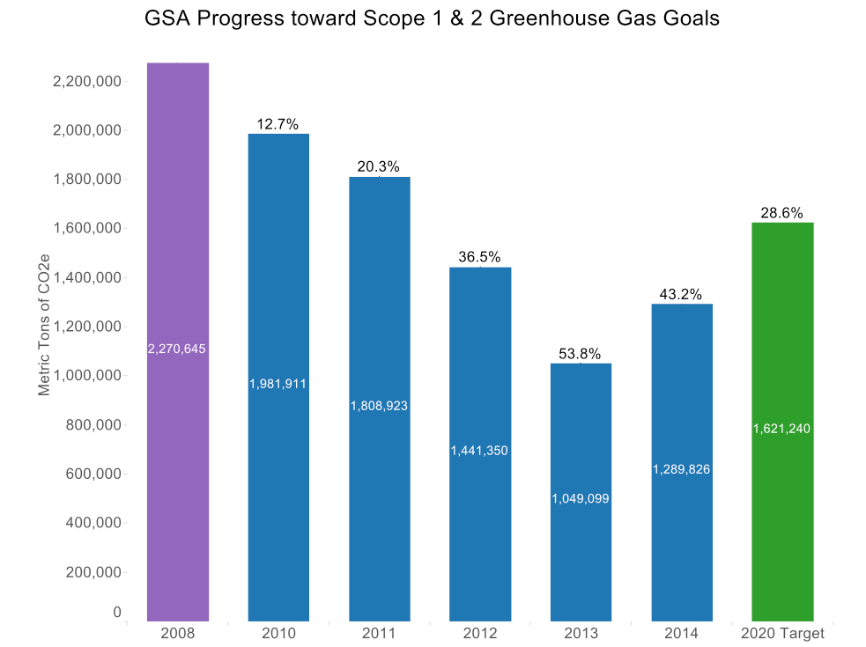

Agency Progress toward Scope 3 GHG Goal
E.O. 13514 required each agency establish a Scope 3 GHG emission reduction target to be achieved by FY 2020. The red bar represents the agency's FY 2008 baseline. The green bar represents the FY 2020 reduction target. The blue bars represent annual agency progress on achieving this target. The percentage at the top of each bar represents the reduction or increase from the FY 2008 baseline. A negative percentage value indicates that the emissions have decreased compared to the FY 2008 baseline.

Figure 1-2
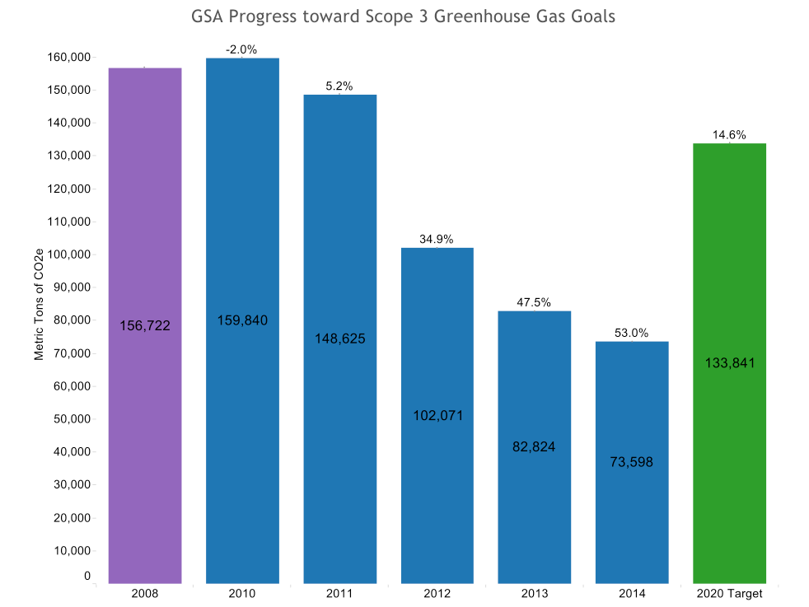

Goal 2: Sustainable Buildings

Agency Progress toward Facility Energy Intensity Reduction Goal
E.O. 13514 section 2 required that agencies consider building energy intensity reductions. Further, the Energy Independence and Security Act of 2007 (EISA) requires each agency to reduce energy intensity 30 percent by FY 2015 as compared to the FY 2003 baseline. Agencies are expected to reduce energy intensity by 3 percent annually through FY 2015 to meet the goal. The red bar represents the agency's FY 2003 baseline. The green bar represents the FY 2015 target reduction. The blue bars show annual agency progress on achieving this target. The percentage at the top of each bar represents the reduction or increase from the FY 2003 baseline. A negative percentage value indicates that the energy intensity has decreased compared to the FY 2003 baseline.

Figure 2-1
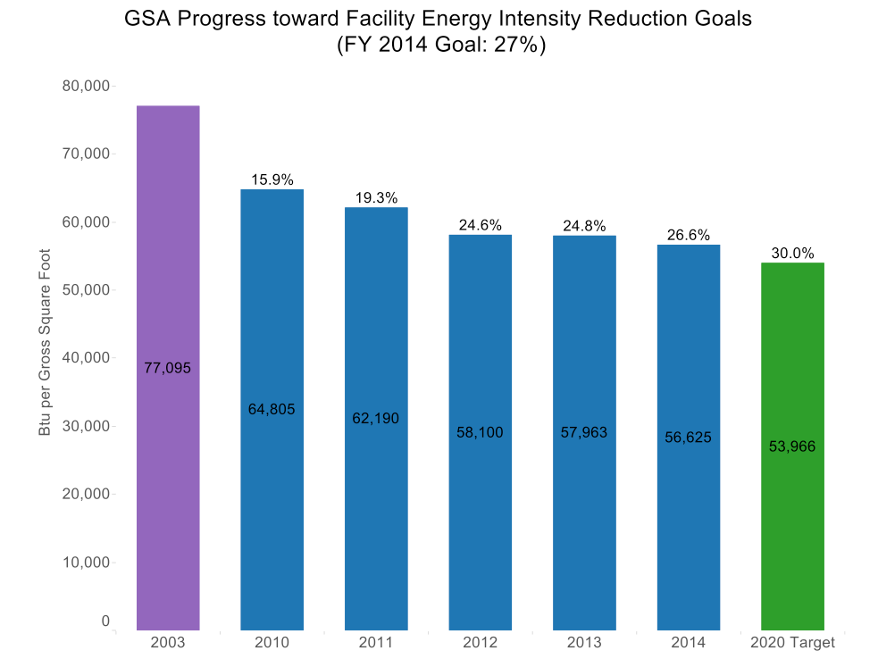

Agency Progress toward Total Buildings Meeting the Guiding Principles
E.O. 13514 required that by FY 2015, 15 percent of agencies' new, existing, and leased buildings greater than 5,000 square feet meet the Guiding Principles. In order to meet the FY 2015 goal, agencies should have increased the percentage of conforming buildings by approximately 2 percent annually from their FY 2007 baseline. The green bar represents the FY 2015 target. The blue bars represent annual agency progress on achieving this target.

Figure 2-2

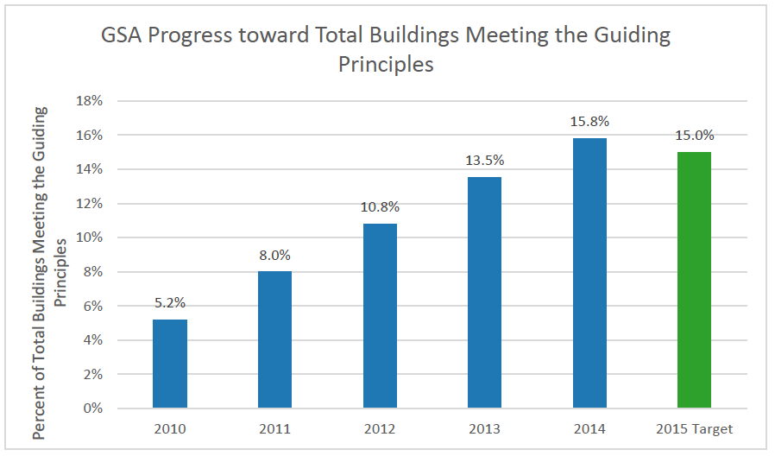

Goal 3: Fleet Management

Agency Progress toward Fleet Petroleum Use Reduction Goal
E.O. 13514 required and the Energy Independence and Security Act of 2007 (EISA) requires that by FY 2015 agencies reduce fleet petroleum use by 20 percent compared to a FY 2005 baseline. Agencies were expected to achieve at least a 2 percent annual reduction. The red bar represents the agency's FY 2005 baseline. The green bars represent the FY 2015 target reduction. The blue bars represent annual agency progress on achieving these targets. The percentage at the top of each bar represents the reduction or increase from the FY 2005 baseline. A negative percentage indicates a decrease in fleet petroleum use.

Figure 3-1
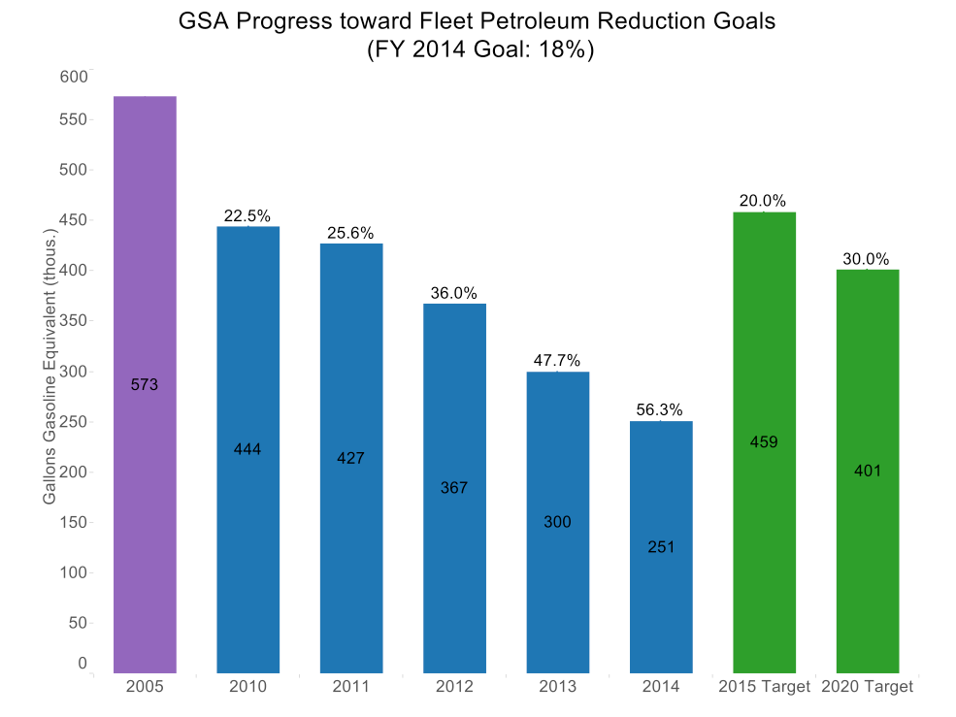

Agency Progress toward Fleet Alternative Fuel Consumption Goal
E.O. 13423 required that agencies increase total alternative fuel consumption by 10 percent annually from the prior year starting in FY 2005. By FY 2015, agencies must have increased alternative fuel use by 159.4 percent, relative to FY 2005. The red bar represents the agency's FY 2005 baseline. The green bar represents the FY 2015 target. The blue bars represent annual agency progress on achieving this target. The percentage at the top of each bar represents the reduction or increase from the FY 2005 baseline. A negative percentage indicates a decrease in fleet alternative fuel use.

Figure 3-2
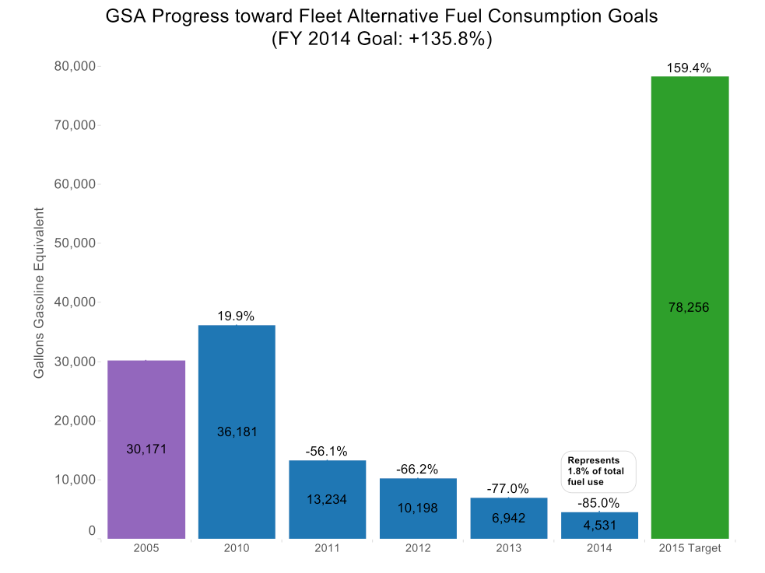

Goal 4: Water Use Efficiency & Management

Agency Progress toward Potable Water Intensity Reduction Goal
E.O. 13514 required agencies to reduce potable water intensity by 2 percent annually through FY 2020 compared to an FY 2007 baseline. A 16 percent reduction was required by FY 2015 and a 26 percent reduction was required by FY 2020. The red bar represents the agency's FY 2007 baseline. The green bars represent the FY 2015 and FY 2020 target reductions. The blue bars represent annual agency progress on achieving these targets. The percentage at the top of each bar represents the reduction or increase from the FY 2007 baseline. A negative percentage value indicates that potable water use intensity decreased compared to the FY 2007 baseline.
Agency data for progress towards the industrial, landscaping and agricultural water use reduction target is not available.

Figure 4-1
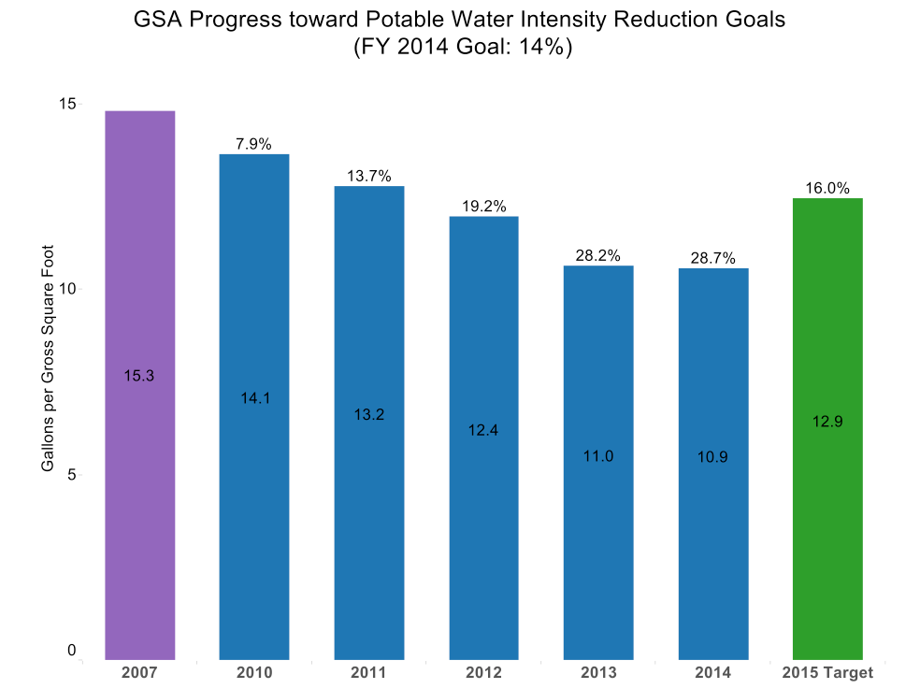

Goal 5: Pollution Prevention & Waste Reduction

Agency Progress toward Pollution Prevention & Waste Reduction
E.O. 13514 required that Federal agencies promote pollution prevention and eliminate waste. The E.O. required agencies to minimize the use of toxic and hazardous chemicals and pursue acceptable alternatives. It also required agencies minimize waste generation through source reduction, increase diversion of compostable materials, and by the end of FY 2015 divert at least 50% of non-hazardous and 50% of construction and demolition debris.
Agency Data For This Goal Is Not Available.

Goal 6: Sustainable Acquisition

Agency Progress toward Sustainable Acquisition Goal
E.O. 13514 required agencies to advance sustainable acquisition and ensure that 95 percent of applicable new contract actions met federal mandates for acquiring products that are energy efficient, water efficient, biobased, environmentally preferable, non-ozone depleting, recycled content, or are non-toxic or less toxic alternatives, where these products meet performance requirements. To monitor performance, agencies perform quarterly reviews of at least 5 percent of applicable new contract actions to determine if sustainable acquisition requirements are included.

Figure 6-1
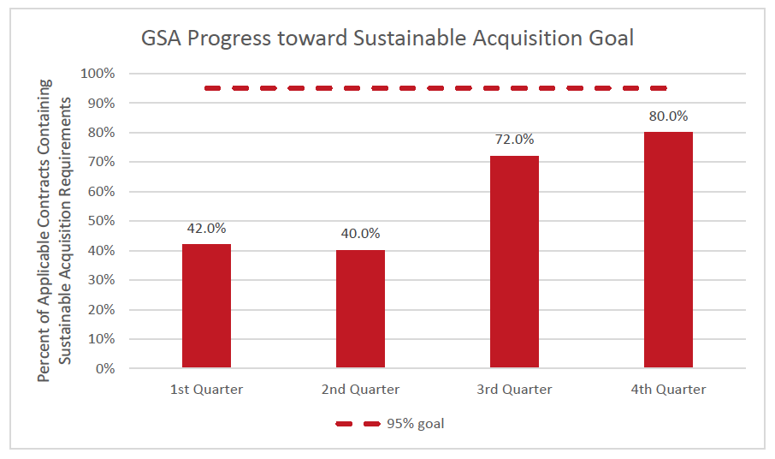

Goal 7: Electronic Stewardship & Data Centers

Agency Progress toward EPEAT, Power Management and End of Life Goals
E.O. 13514 required agencies to promote electronics stewardship by: ensuring procurement preference for EPEAT-registered products; implementing policies to enable power management, duplex printing, and other energy-efficient features; employing environmentally sound practices with respect to the disposition of electronic products; procuring Energy Star and FEMP designated electronics; and, implementing best management practices for data center operations.

Figure 7-1
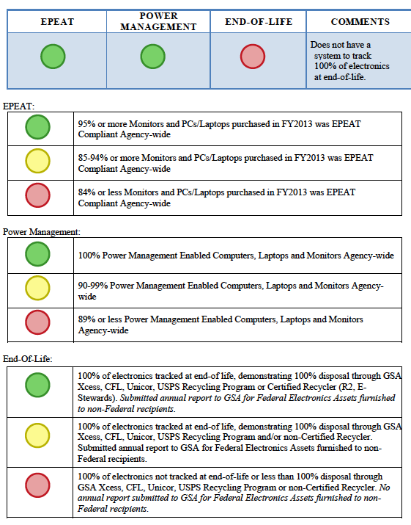
Goal 8: Renewable Energy

Agency Renewable Energy Percentage of Total Electricity Usage
E.O. 13514 requires that agencies increase use of renewable energy. Further, EPACT 2005 requires agencies to increase renewable energy use such that 7.5 percent of the agency's total electricity consumption is generated by renewable energy sources for FY 2014 and beyond. For FY 2012, the required target was 5 percent of an agency's total electricity consumption. In 2013, a Presidential Memorandum entitled Federal Leadership on Energy Management revised the Federal agency target for agency renewable energy percentage of total electricity usage to reflect a goal of 20% by 2020.

Figure 8-1
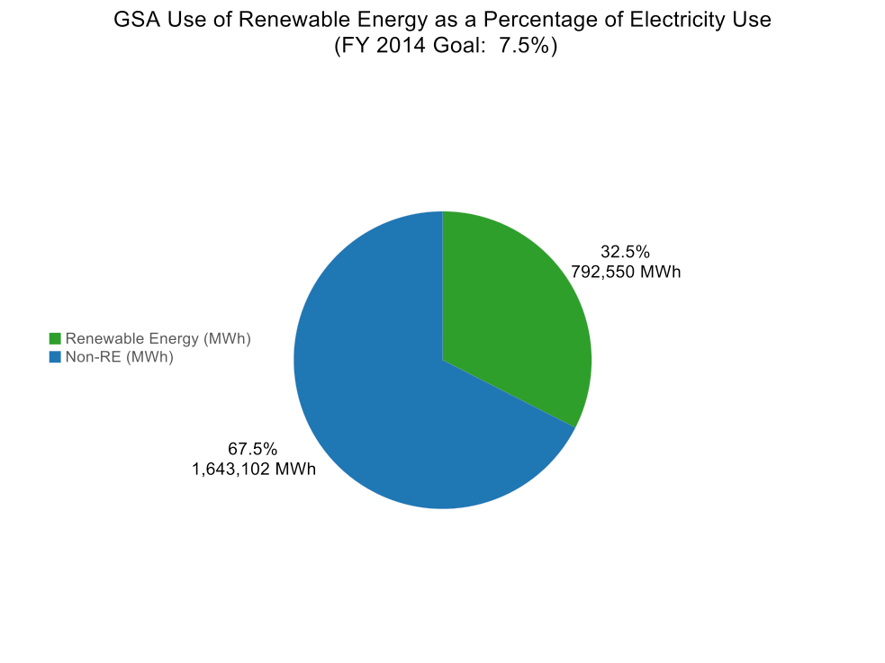

Goal 9: Climate Change Resilience

Agency Climate Change Resilience
E.O. 13514 required each agency to evaluate agency climate change risks and vulnerabilities to identify and manage the effects of climate change on the agency's operations and mission in both the short and long term.
This goal is addressed through qualitative commitments on the part of each agency and a summary of progress may be found in the Executive Summary at the beginning of this document.

Goal 10: Energy Performance Contracts

Agency Progress in Meeting President's Performance Contracting Challenge (PPCC) Goal
Energy Performance Contracts, including both Energy Savings Performance Contracts (ESPCs) and Utility Energy Service Contracts (UESCs), enable agencies to obtain energy efficiency investments in buildings and deploy on-site renewable energy through long-term contracts with the private sector, which are in turn paid through savings derived from those investments.

Figure 10-1
The chart below (left) represents the agency's performance contracting commitment and progress toward that commitment as reported through April 15, 2014 (for agencies subject to the 2011 President's Performance Contracting Challenge). The bar graph shows the total dollar value (in millions) of (1) already awarded projects, (2) projects in the pipeline but not yet awarded, and (3) the pipeline shortfall or surplus depending on whether the agency has reached their commitment goal.
Note: All agencies were expected to meet or exceed their initial target no later than June 30, 2014.
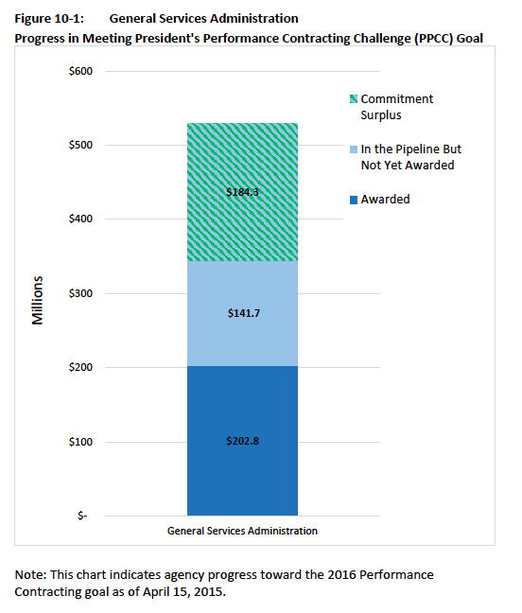

Agency Strategies to Meet Goals of E.O. 13693
To facilitate agency planning and reporting, the majority of the goals for E.O. 13693 take effect in the beginning of fiscal year 2016 (October 1, 2015) and are therefore appropriate for inclusion in this document. As noted previously many of the goals that agencies pursued under the previous executive orders have been carried over into E.O. 13693.
This section provides certain goal areas where "Required Strategies" are identified. Where an agency does not adopt those required strategies as an FY 2016 priority, the agency should explain the rationale for that decision in the strategy narrative. Also included are recommended strategies that represent strategies that have been successfully implemented by the Federal community and may also be adopted as priority strategies.

Goal 1: Greenhouse Gas (GHG) Reduction
Table 1-1: Goal 1 Strategies – Scope 1 & 2 GHG Reductions
Instructions: In Table 1-1 below, list ONLY the top five priority strategies that the agency will implement in FY2016 to pursue Goal 1 Scope 1 & 2 GHG reductions. For each agency-level strategy listed below, select the appropriate response from the drop-down menu. If the selection is not applicable ("NA") or "No", an explanation must be provided in the Strategy Narrative column (C) as to why the agency will not implement this strategy. If the selection is "Yes", provide in column (C) a description on how the strategy will be implemented and in column (D) provide specific targets/metrics and milestones to measure agency progress/success. DO NOT DELETE ANY STRATEGIES LISTED IN COLUMN (A). Agencies may make minor changes to a column (A) strategy if needed to enable the agency to select that strategy as a FY 2016 priority. If necessary, agencies may add additional strategies into the blank rows provided in column (A) in order to present five priority strategies.

(A)  Strategy | (B)  Top Five?  Yes/No/NA | (C)  Strategy Narrative  (100 word limit) | (D)  Specific targets/metrics to measure success including milestones in next 12 months
(A) Required Strategy Under E.O. 13693
Use the FEMP GHG emission report to identify/target high emission categories and implement specific actions to resolve high emission areas identified. | Yes | Building energy use is GSA’s largest emissions category, with subcategories being electricity, natural gas, steam, chilled water, and heating oil. GSA prioritizes strategies to reduce emissions in each of these categories roughly in order of their scale, starting with renewable electricity. | GSA will meet or surpass agency-level annual and FY25 targets for Scope 1 and 2 GHG reduction, as set forth in this plan’s Executive Summary.
Identify alternative sources of data or alternative methods of analysis not set forth in E.O. 13693, but with the potential to support its goals. | Yes | GSA monitors and analyzes building and facility energy use data through a variety of systems and practices including building automation systems, advanced meters, Energy Use Analysis System, national and regional building level dashboards, monthly regional energy progress report, and GSA Link. | GSA will meet or surpass agency-level annual and FY25 targets for Scope 1 and 2 GHG reduction, as set forth in this plan’s Executive Summary.
Identify and support management practices or training programs that encourage employee sustainability and greenhouse gas consideration. | No | GSA uses this strategy but not among top five priorities. GSA benefits from a strong base of employee expertise in sustainability, including related to critical GHG reduction opportunities such as high performance green buildings and renewable energy. GSA incorporates GHG reduction strategies in standard policy and training for all employees, such as the P100 building standards.
Conceptualize the goals of E.O. 13693 within a projected cost-benefit framework to identify low-hanging fruit. | Yes | GSA analyzes emissions categories and prioritizes reduction opportunities in order of the cost (including FTE costs) per ton of avoided GHG emissions, starting with renewable energy and building energy efficiency improvements. By Q3 FY 2016, GSA will apply this conceptualization to create a comprehensive, building-level prioritization of energy reduction opportunities. | GSA will meet or surpass agency-level annual and FY25 targets for Scope 1 and 2 GHG reduction, as set forth in this plan’s Executive Summary.
Isolate successful measures applied toward the goals of E.O. 13514 that could be expanded to meet the goals of E.O. 13693. | No | GSA uses this strategy but not among top five priorities. GSA’s most successful GHG avoidance strategy under E.O. 13514 was the installation and purchase of renewable energy.
Determine unsuccessful programs or measures to be discontinued to better allocate agency resources, human and otherwise. | No | GSA uses this strategy but not among top five priorities. GSA lacks defined criteria or processes for determining and comparing the success of programs and measures.
Determine which goals set forth in E.O. 13693 represent unambitious targets given past agency performance, identify by how much they could be exceeded, and establish new within-agency target. | Yes | GSA has successfully achieved E.O. 13514 targets. GSA has applied this strategy comprehensively in setting new targets in response to E.O. 13693. | This plan establishes stretch targets for renewable energy, GHG emissions, and other measures which are well beyond the performance levels required under E.O. 13963, subject to successful resolution of litigation.
Employ operations and management best practices for energy consuming and emission generating equipment. | Yes | In FY 2015, GSA will continue to conduct building operation audits using Rapid Building Assessments and metering technology and implement identified energy conservation measures that can be achieved through operations and maintenance practices. Practices such as reducing nighttime base load of buildings, reducing external nighttime lighting, and validating temperature setpoints will be implemented inventory-wide. | Energy savings from each measure will be tracked and will contribute to GSA’s Energy Use Intensity (EUI) reduction target of 47.5 percent below 2003 levels by 2025.

Table 1-2: Goal 1 Strategies – Scope 3 GHG Reductions
Instructions: In Table 1-2 below, list ONLY the top five priority strategies that the agency will pursue in FY 2016 to achieve Goal 1 Scope 3 GHG reductions. For each agency-level strategy listed below, select the appropriate response from the drop-down menu. If the selection is not applicable ("NA") or "No", an explanation must be provided in the Strategy Narrative column (C) as to why the agency will not implement this strategy. If the selection is "Yes", provide in column (C) a description on how the strategy will be implemented and in column (D) provide specific targets/metrics and milestones to measure agency progress/success. DO NOT DELETE ANY STRATEGIES LISTED IN COLUMN (A). Agencies may make minor changes to a column (A) strategy if needed to enable the agency to select that strategy as a FY 2016 priority. If necessary, agencies may add additional strategies into the blank rows provided in column (A) in order to present five priority strategies.

(A)  Strategy | (B)  Top Five?  Yes/No/NA | (C)  Strategy Narrative  (100 word limit) | (D)  Specific targets/metrics to measures success including milestones in next 12 months
(A) Required Strategy Under E.O. 13693
Reduce employee business ground travel. | No | GSA has reduced travel emissions by approximately 84 percent since FY 2008 and these emissions were approximately 2 percent of GSA’s FY 2014 Scope 3 GHG emissions. Further reductions in travel would impede core agency functions such as project supervision and management.
Reduce employee business air travel. | No | GSA has reduced travel emissions by approximately 84 percent since FY 2008 and these emissions were approximately 2 percent of GSA’s FY 2014 Scope 3 GHG emissions. Further reductions in travel would impede core agency functions such as project supervision and management.
Develop and deploy employee commuter reduction plan. | Yes | Employee commuting accounted for almost 32 percent of GSA’s FY 2014 Scope 3 GHG emissions, making it the second-largest single category after electric T&D losses. | GSA will meet or surpass agency-level annual and FY 2025 targets for Scope 3 GHG reduction, as set forth in this plan’s Executive Summary.
Use employee commuting survey to identify opportunities and strategies for reducing commuter emissions. | Yes | See response under “develop and deploy employee commuter reduction plan” above. | GSA will meet or surpass agency-level annual and FY 2025 targets for Scope 3 GHG reduction, as set forth in this plan’s Executive Summary.
Increase number of employees eligible for telework and/or the total number of days teleworked. | Yes | GSA strongly encourages telework for its own employees and provides flexible workspace and technology solutions to enable increased telework for other agencies. | GSA will meet or surpass agency-level annual and FY 2025 targets for Scope 3 GHG reduction, as set forth in this plan’s Executive Summary.
Develop and implement bicycle commuter program. | No | GSA uses this strategy but not among top five priorities. See response under “develop and deploy employee commuter reduction plan” above.
Provide bicycle commuting infrastructure. | No | GSA uses this strategy but not among top five priorities. See response under “develop and deploy employee commuter reduction plan” above.
Plan to begin FY 2016: Report scope 3 greenhouse gas emissions for leases over 10,000 E.O. 3(h)(v) rentable square feet | No | GSA uses this strategy but not among top five priorities. GSA occupies minimal leased space and expects its leased space GHG emissions to be a minor component of its Scope 3 inventory.
Purchase grid-supplied renewable electricity to reduce Scope 3 emissions from transmission and distribution (T&D) losses | Yes | In FY 2014, GSA reduced its Scope 3 emissions by almost 35,000 MT CO2e, or approximately 32 percent of its pre-reduction Scope 3 inventory, through purchases of grid-supplied renewable energy. | GSA will meet or surpass agency-level annual and FY 2025 targets for Scope 3 GHG reduction, as set forth in this plan’s Executive Summary.
Increase municipal solid waste diversion | Yes | In FY 2014, GSA’s Scope 3 emissions from municipal solid waste (MSW) disposal were over 17,000 MT CO2e, or over 20 percent of total Scope 3 emissions. In FY 2014, GSA will continue to improve tracking and reduction of MSW disposal. | GSA will meet or surpass agency-level annual and FY 2025 targets for Scope 3 GHG reduction, as set forth in this plan’s Executive Summary. GSA will also meet or surpass E.O. 13693 annual targets for waste diversion.

Goal 2: Sustainable Buildings
Building Energy Conservation, Efficiency, and Management
Section 3(a) of E.O. 13693 states that agencies will promote building energy conservation, efficiency, and management. Section 3(a)(i) requires agencies to reduce building energy intensity by 2.5% annually through the end of FY 2025 (measured in British thermal units per square foot), relative to a FY 2015 baseline and taking into account agency progress to date, except where revised pursuant to section 9(f) of E.O. 13693.
Building Efficiency Performance, and Management
Section 3(h) of E.O. 13693 states that agencies will improve building efficiency, performance, and management.
Section 3(h)(iii) requires that agencies identify, as a part of the planning requirements of section 14 of this order, a percentage of the agency's existing buildings above 5,000 gross square feet intended to be energy, waste, or water net-zero buildings by FY 2025 and implementing actions that will allow those buildings to meet that target.
CEQ recognizes that any FY 2016 agency projections for this goal are rudimentary estimates. Agencies will be only expected to share lessons learned in implementing this goal and will not be scored or graded on outcomes towards the target established for FY 2016.
Please input the percentage here 2%.
Table 2-1: Goal 2 Strategies – Sustainable Buildings
Instructions: In Table 2-1 below, list ONLY the top five priority strategies that the agency will pursue in FY 2016 to achieve Goal 2. For each agency-level strategy listed below, select the appropriate response from the drop-down menu. If the selection is not applicable ("NA") or "No", an explanation must be provided in the Strategy Narrative column (C) as to why the agency will not implement this strategy. If the selection is "Yes", provide in column (C) a description on how the strategy will be implemented and in column (D) provide specific targets/metrics and milestones to measure agency progress/success. DO NOT DELETE ANY STRATEGIES LISTED IN COLUMN (A). Agencies may make minor changes to a column (A) strategy if needed to enable the agency to select that strategy as a FY 2016 priority. If necessary, agencies may add additional strategies into the blank rows provided in column (A) in order to present five priority strategies.

(A)  Strategy | (B)  Top Five?  Yes/No/NA | (C)  Strategy Narrative  (100 word limit) | (D)  Specific targets/metrics to measures success including milestones in next 12 months
(A) Required Strategy Under E.O. 13693
Use remote building energy performance assessment auditing technology 3(a)(A) | Yes | The Energy Independence and Security Act (EISA) sec. 432 requires GSA to identify facilities responsible for 75 percent of portfolio energy use and audit 25 percent of them each year to identify cost-effective efficiency measures. Rapid Building Assessment technology allows GSA to evaluate facilities at a fraction of the price of a traditional audit. GSA was the first agency to implement this strategy in 2013. | GSA will meet E.O. 13693’s annual quantitative targets for energy use intensity.
Participate in demand management programs 3(a)(B) | No | GSA uses this strategy but not among top five priorities. GSA actively participates in programs offered by ISO and Utilities to effectively manage utility costs and monitors progress when able via advanced metering.
Ensure that monthly performance data is entered into the Environmental Protection Agency (EPA) ENERGY STAR Portfolio Manager 3(a)(C) | No | GSA uses this strategy but not among top five priorities. Other available strategies have more substantial impacts on financial savings and attainment of E.O. 13693 goals.
Where feasible: Incorporate Green Button data access system into reporting, data analytics, and automation processes 3(a)(D) | No | GSA uses this strategy but not among top five priorities. Other available strategies have more substantial impacts on financial savings and attainment of E.O. 13693 goals.
Implement space utilization and optimization practices and policies 3(a)(E) | Yes | GSA has aggressively reduced space utilization per employee, most visibly via open plan and hoteling implementation in GSA’s recent Central Office renovation. GSA continues to implement space-efficient practices in GSA spaces as to assist tenant agencies with this strategy. | GSA will meet E.O. 13693’s annual quantitative targets for energy use intensity and separately reported space efficiency targets under OMB’s Reduce the Footprint initiative.
Identify opportunities to transition test-bed technologies to achieve the goals of this section 3(a)(F) | No | GSA uses this strategy but not among top five priorities. GSA’s Green Proving Ground (GPG) program evaluates pre- and early-commercial stage building technologies, accelerating the transition from bench-scale technology to commercial viability. GSA has deployed five GPG-evaluated technologies to date.
Where feasible: Conform to city energy performance benchmarking and reporting requirements 3(a)(G) | No | GSA uses this strategy but not among top five priorities. Other available strategies have more substantial impacts on financial savings and attainment of E.O. 13693 goals.
Begin planning for FY 2020 requirement: Ensure all new construction of Federal buildings greater than 5,000 gross square feet that enters the planning process be designed to achieve energy net-zero and, where feasible, water or waste net-zero by FY 2030 3(h)(i) | Yes | GSA has already built or renovated several buildings to meet energy net-zero or near-net-zero specifications. | GSA will continue to study and refine net-zero design and construction techniques and will continue to aggressively pursue net-zero project opportunities where possible in new construction, major renovations, and ESPCs.
In all new agency lease solicitations over 10,000 rentable square feet, include criteria for energy efficiency as a performance specification or source selection evaluation factor 3(h)(iv) | No | GSA uses this strategy but not among top five priorities.  More than 30 mandatory green paragraphs aligning with Guiding Principle compliance continue to be incorporated in GSA leases, including requirements related to energy efficiency, water conservation, reduced resource use, and indoor air quality.
In all new agency lease solicitations over 10,000 rentable square feet, include requirements for building lessor disclosure of carbon emission or energy consumption data for leased portion of building 3(h)(iv) | No | GSA uses this strategy but not among top five priorities. GSA has included such reporting requirements in new leases for several years and is now focused on activating these provisions and build-out of associated data reporting infrastructure.
In planning new facilities or leases, include cost-effective strategies to optimize sustainable space utilization and consideration of existing community transportation planning and infrastructure, including access to public transit 3(h)(vi) | No | GSA uses this strategy but not among top five priorities. GSA’s Good Neighbor Program conducted 22 meetings with local governments and stakeholders across all 11 GSA regions in FY 2013 and will complete another 22 in FY 2014. These meetings open communication with local planners and stakeholders and identify projects, areas, best practices and ideas of mutual interest outside of the timeframe of specific Federal real property actions.
Ensure that all new construction, major renovation, repair, and alteration of agency buildings includes appropriate design and deployment of fleet charging infrastructure 3(h)(vii) | No | GSA uses this strategy but not among top five priorities. Other available strategies have more substantial impacts on financial savings and attainment of E.O. 13693 goals.
Include climate resilient design and management into the operation, repair, and renovation of existing agency buildings and the design of new buildings 3(h)(viii) | No | GSA uses this strategy but not among top five priorities. Other available strategies have more substantial impacts on financial savings and attainment of E.O. 13693 goals.
(B) Recommended Strategy
Install and monitor energy meters and sub-meters as soon as practicable. | No | GSA uses this strategy but not among top five priorities. GSA has already installed advanced electricity meters covering >75 percent of portfolio electric consumption.
Collect and utilize building and facility energy use data to improve building energy management and performance. | Yes | GSA monitors and analyzes building and facility energy use data through a variety of systems and practices including Energy Use Analysis System, national and regional building level dashboards, monthly regional energy progress report, and GSA Link. | GSA will meet E.O. 13693’s annual quantitative targets for energy use intensity.
Incorporate green building specifications into all new construction and major renovation projects. | No | GSA uses this strategy but not among top five priorities. Limited scope of current construction and major renovation activities mean that GSA has greater energy reduction opportunities in O&M activities and smaller retrofits.
Redesign or lease interior space to reduce energy use by implementing daylighting, space optimization, sensors/control system installation, etc. | No | GSA uses this strategy but not among top five priorities. GSA includes these strategies in its P100 building standards.
Develop and deploy energy and sustainability training for all facility and energy managers. | Yes | GSA provides extensive internal and external training opportunities for building and energy managers. Over 3,000 employees have participated in approximately 400 classes over the past 6 years through Penn State University alone. These trainings are focused on Facilities Infrastructure, Fundamentals of High Performance Buildings, and Smart Buildings Operation. GSA also delivers training on implementation of the Guiding Principles for Sustainable Existing Buildings and its Energy Use Reduction program to all relevant positions and requires contractor O&M workforce to attend Building Retuning training. | GSA will meet or surpass all related annual quantitative targets under E.O. 13693. Training will help support meeting these targets.
Include in every construction contract all applicable sustainable acquisition requirements for recycled, biobased, energy efficient, and environmentally preferable products. | No | GSA uses this strategy but not among top five priorities. GSA has identified 10 frequently-used construction and custodial products and has developed easy-to-understand sustainability standards for them that address all applicable Federal requirements. These Key Sustainable Products standards have been added to the P100 Facility Standards; the national Custodial Statement of Work; and lease templates. They will also be added to construction contract templates.

Table 2-2: Goal 2 Strategies – Data Center Efficiency
Section 3(a)(ii) of E.O. 13693 states that agencies must improve data center efficiency at agency facilities. Section 3(a)(ii)(C) requires that agencies establish a power usage effectiveness target in the range of 1.2-1.4 for new data centers and less than 1.5 for existing data centers.
Instructions: In Table 2-2 below, list ONLY the top five priority strategies that the agency will pursue in FY 2016 to achieve Goal 2. For each agency-level strategy listed below, select the appropriate response from the drop-down menu. If the selection is not applicable ("NA") or "No", an explanation must be provided in the Strategy Narrative column (C) as to why the agency will not implement this strategy. If the selection is "Yes", provide in column (C) a description on how the strategy will be implemented and in column (D) provide specific targets/metrics and milestones to measure agency progress/success. DO NOT DELETE ANY STRATEGIES LISTED IN COLUMN (A). Agencies may make minor changes to a column (A) strategy if needed to enable the agency to select that strategy as a FY 2016 priority. If necessary, agencies may add additional strategies into the blank rows provided in column (A) in order to present five priority strategies

(A)  Strategy | (B)  Top Five?  Yes/No/NA | (C)  Strategy Narrative  (100 word limit) | (D)  Specific targets/metrics to measures success including milestones in next 12 months
(A) Required Strategy Under E.O. 13693
Ensure the agency chief information officer promotes data center energy optimization, efficiency, and performance 3(a)(ii)(A) | Yes | GSA’s chief information officer is personally involved in decisions about data center energy optimization, efficiency, and performance. | GSA will meet or surpass E.O. 13693’s quantitative targets for PUE in new and existing data centers.
Install and monitor advanced energy meters in all data centers by fiscal year 2018 3(a)(ii)(B) | Yes | GSA has already installed and monitors advanced energy meters in its core data centers and selected non-core data centers where feasible. GSA will continue to meter, decommission or consolidate remaining non-core data centers. | GSA will meet or surpass E.O. 13693’s quantitative targets for PUE in new and existing data centers.
(B) Recommended Strategy
Optimize agency Data Centers across total cost of ownership metrics. | Yes | GSA is deploying technologies in its data centers to allow for improved PUE. GSA also ensures that all servers and other data center equipment are disposed of in a cost-effective and environmentally sound manner at end of life. | GSA will meet or surpass E.O. 13693’s quantitative targets for PUE in new and existing data centers and will continue to deploy cost-effective energy management technologies and dispose of decommissioned data center equipment in accordance with the National Strategy for Electronics Stewardship (NSES).
Improve data center temperature and air-flow management. | No | GSA uses this strategy but not among top five priorities. This strategy is most applicable to new data center construction or major renovations, which are infrequent occurrences for GSA.
Identify and consolidate obsolete and underutilized agency computer servers into energy efficient data centers. | Yes | Of its 122 non-core data centers, 66.3 percent (81 data centers) are slated to be closed, which is in excess of OMB’s Government-wide goal of 40 percent by FY 2015. | GSA will meet or surpass E.O. 13693’s quantitative targets for PUE in new and existing data centers.
Continue to identify and decommission inefficient and low-utilization servers and virtualize servers where possible. | Yes | GSA will continue to identify and decommission inefficient and low-utilization servers and virtualize servers where possible. | GSA will meet or surpass E.O. 13693’s quantitative targets for PUE in new and existing data centers.

Goal 3: Clean & Renewable Energy
Agency Clean Energy Share of Total Electric and Thermal Energy Goal
E.O. 13693 3(b) requires that, at a minimum, the percentage of an agency's total electric and thermal energy accounted for by renewable and alternative energy shall be not less than: 10% in FY 2016-17; 13% in FY 2018-19; 16% in FY 2020-21; 20% in FY 2022-23; and 25% by FY 2025.
Agency Renewable Energy Share of Total Electricity Consumption Goal
E.O. 13693 3(c) sets a second schedule that addresses specifically renewable energy. It requires that renewable energy account for not less than 10% of total electric energy consumed by an agency in FY 2016-17; 15% in FY 2018-19; 20% in FY 2020-21; 25% in FY 2022-23; and 30% by 2025.
Table 3: Goal 3 Strategies – Clean and Renewable Energy
Instructions: In Table 3 below, list ONLY the top five priority strategies that the agency will pursue in FY 2016 to achieve Goal 3. For each agency-level strategy listed below, select the appropriate response from the drop-down menu. If the selection is not applicable ("NA") or "No", an explanation must be provided in the Strategy Narrative column (C) as to why the agency will not implement this strategy. If the selection is "Yes", provide in column (C) a description on how the strategy will be implemented and in column (D) provide specific targets/metrics and milestones to measure agency progress/success. DO NOT DELETE ANY STRATEGIES LISTED IN COLUMN (A). Agencies may make minor changes to a column (A) strategy if needed to enable the agency to select that strategy as a FY 2016 priority. If necessary, agencies may add additional strategies into the blank rows provided in column (A) in order to present five priority strategies.

(A)  Strategy | (B)  Top Five?  Yes/No/NA | (C)  Strategy Narrative  (100 word limit) | (D)  Specific targets/metrics to measures success including milestones in next 12 months
(B) Recommended Strategy
Install agency-funded renewable on-site and retain corresponding renewable energy certificates (RECs) or obtaining replacement RECs 3(d)(i) | Yes | GSA pursues several strategies to install PV on-site including in conjunction with new construction and major renovations, standalone PPAs, and ESPCs. However, due to financing and space constraints, GSA has much larger opportunities to procure renewable energy off-site. | GSA will meet or surpass all of EO 13693’s annual quantitative targets for clean and renewable energy.
Contract for the purchase of energy that includes installation of renewable energy on or off-site and retain RECs or replacement RECs for the term of the contract 3(d)(ii) | Yes | GSA aggressively pursues this strategy. | GSA will meet or surpass all of EO 13693’s annual quantitative targets for clean and renewable energy.
Purchase electricity and corresponding RECs or obtaining equal value replacement RECs 3(d)(iii) | Yes | GSA aggressively pursues this strategy. | GSA will meet or surpass all of EO 13693’s annual quantitative targets for clean and renewable energy.
Purchase RECs 3(d)(iv) | Yes | GSA pursues this strategy as needed to meet targets while prioritizing the above three strategies. | GSA will meet or surpass all of EO 13693’s annual quantitative targets for clean and renewable energy.
Install thermal renewable energy on-site at Federal facilities and retain corresponding renewable attributes or obtain equal value replacement RECs 3(e)(i) | Yes | GSA aggressively pursues this strategy where available and appropriate. | GSA will meet or surpass all of EO 13693’s annual quantitative targets for clean and renewable energy.
Install combined heat and power processes on-site at Federal facilities 3(e)(ii) | No | GSA pursues this strategy where available, most recently at the White Oak complex in Maryland.
Identify opportunities to install fuel cell energy systems on-site at Federal facilities 3(e)(iii) | No | GSA is investigating this strategy and will pursue it where appropriate but not among top five priorities.
Identify opportunities to utilize energy from small modular nuclear reactor technologies 3(e)(iv) | No | GSA’s larger energy-using locations are located in urban areas where GSA does not believe it would be feasible to install this technology.
Identify opportunities to utilize energy from a new project that includes the active capture and storage of carbon dioxide emissions associated with energy generation 3(e)(v) | No | GSA believes there are currently few available opportunities to use this strategy.
Implement other alternative energy approaches that advance the policy set forth in section 1 and achieve the goals of section 2 of E.O. 13693 3(e)(vii) | No | GSA has not yet identified specific examples of this strategy.
Consider opportunities to install or contract for energy installed on current or formerly contaminated lands, landfills, and mine sites. | No | GSA is not aware of opportunities to pursue this strategy on-site within GSA’s portfolio. For off-site installations, statutory incentives make it more cost-effective for GSA to prioritize contracting for energy generation on Federal or Tribal land.

Goal 4: Water Use Efficiency & Management
Potable Water Consumption Intensity Reduction Goal
E.O. 13693 section 3(f) states that agencies must improve water use efficiency and management, including stormwater management. E.O. 13693 section 3(f)(i) requires agencies to reduce potable water consumption intensity by 2% annually through FY 2025 relative to an FY 2007 baseline (measured in gallons). A 36% reduction is required by FY 2025.
ILA Water Consumption Reduction Goal
E.O. 13693 section 3(f)(iii) also requires that agencies reduce their industrial, landscaping and agricultural (ILA) water consumption measured in gallons by 2% annually through FY 2025 relative to a FY 2010 baseline.
Table 4: Goal 4 Strategies – Water Use Efficiency & Management
Instructions: In Table 4 below, list ONLY the top five priority strategies that the agency will pursue in FY 2016 to achieve Goal 4. For each agency-level strategy listed below, select the appropriate response from the drop-down menu. If the selection is not applicable ("NA") or "No", an explanation must be provided in the Strategy Narrative column (C) as to why the agency will not implement this strategy. If the selection is "Yes", provide in column (C) a description on how the strategy will be implemented and in column (D) provide specific targets/metrics and milestones to measure agency progress/success. DO NOT DELETE ANY STRATEGIES LISTED IN COLUMN (A). Agencies may make minor changes to a column (A) strategy if needed to enable the agency to select that strategy as a FY 2016 priority. If necessary, agencies may add additional strategies into the blank rows provided in column (A) in order to present five priority strategies.
(A)  Strategy | (B)  Top Five?  Yes/No/NA | (C)  Strategy Narrative  (100 word limit) | (D)  Specific targets/metrics to measures success including milestones in next 12 months
(A) Required Strategy
Install appropriate green infrastructure features to help with storm- and wastewater management (such as rain gardens, rain barrels, green roofs, or impervious pavement) 3(f)(iv) | Yes | GSA aggressively pursues this strategy, for example, by installing over 2 million square feet of green roofs to date. | GSA will meet or surpass EO 13693’s annual quantitative targets for water intensity reduction.
Install and monitor water meters; collect and utilize building and facility water data for conservation and management 3(f)(ii) | Yes | GSA monitors and analyzes building and facility water use through a variety of systems and practices including Energy Use Analysis System, national and regional building level dashboards, and monthly regional water progress reports. | GSA will meet or surpass EO 13693’s annual quantitative targets for water intensity reduction.
(B) Recommended Strategy
Install high efficiency technologies (e.g., WaterSense). | Yes | GSA includes these strategies in its P100 building standards and via sustainable acquisition policies, guidance, and training. | GSA will meet or surpass EO 13693’s annual quantitative targets for water intensity reduction.
Prepare and implement a water asset management plan to maintain desired level of service at lowest life cycle cost (for best practices from the EPA, go to http://go.usa.gov/KvbF). | No | n/a
Minimize outdoor water use and use alternative water sources as much as possible. | Yes | GSA is assessing greenscapes and replacing them with drought-tolerant landscaping where feasible, especially in Western states. | GSA will meet or surpass EO 13693’s annual quantitative targets for water intensity reduction.
Design and deploy water closed-loop, capture, recharge, and/or reclamation systems. | No | n/a
Install advanced meters to measure and monitor (1) potable and (2) industrial, landscaping and agricultural water use. | Yes | Advanced water meters in GSA facilities are identifying leaks and providing GSA with a means to monitor repairs and corrections along with water savings achieved. GSA will continue to install advanced water meters where cost-effective and link them to facility and centralized monitoring systems to detect irregular use, including irrigation system leaks. | GSA will meet or surpass E.O. 13693’s annual quantitative targets for water intensity reduction.
Develop and implement programs to educate employees about methods to minimize water use. | No | n/a
Assess the interconnections and dependencies of energy and water on agency operations, particularly climate change's effects on water which may impact energy use. | No | n/a
Consistent with State law, maximize use of grey-water and water reuse systems that reduce potable and ILA water consumption. | No | n/a
Consistent with State law, identify opportunities for aquifer storage and recovery to ensure consistent water supply availability. | No | n/a
Ensure that planned energy efficiency improvements consider associated opportunities for water conservation. | No | n/a
Where appropriate, identify and implement regional and local drought management and preparedness strategies that reduce agency water consumption including recommendations developed by Regional Federal Executive Boards. | No | n/a

Goal 5: Fleet Management
Agency Progress toward Fleet Per-Mile Greenhouse Gas Emissions Goal
E.O. 13693 section 3(g) states that agencies with a fleet of at least 20 motor vehicles will improve fleet and vehicle efficiency and management. E.O. 13693 section 3(g)(ii) requires agencies to take actions that reduce fleet-wide per-mile greenhouse gas emissions from agency fleet vehicles relative to a new, FY 2014 baseline and sets new goals for percentage reductions: not less than 4% by the end of FY 2017; not less than 15% percent by the end of FY 2020; and not less than 30% by then end of FY 2025.
E.O. 13693 section 3(g)(i) requires that, as a part of the Sustainability Planning process agencies should determine the optimum fleet inventory, emphasizing eliminating unnecessary or non-essential vehicles. This information is generally available from the agency Vehicle Allocation Methodology (VAM) process that is completed each year. To satisfy this requirement for 2015, please include the VAM results and the appropriate agency fleet management plan to the appendix of this document. Future versions of this plan will require similar submissions by agencies.
Table 5: Goal 5 Strategies – Fleet Management
Instructions: In Table 5 below, list ONLY the top five priority strategies that the agency will pursue in FY 2016 to achieve Goal 5. For each agency-level strategy listed below, select the appropriate response from the drop-down menu. If the selection is not applicable ("NA") or "No", an explanation must be provided in the Strategy Narrative column (C) as to why the agency will not implement this strategy. If the selection is "Yes", provide in column (C) a description on how the strategy will be implemented and in column (D) provide specific targets/metrics and milestones to measure agency progress/success. DO NOT DELETE ANY STRATEGIES LISTED IN COLUMN (A). Agencies may make minor changes to a column (A) strategy if needed to enable the agency to select that strategy as a FY 2016 priority. If necessary, agencies may add additional strategies into the blank rows provided in column (A) in order to present five priority strategies.

(A)  Strategy | (B)  Top Five?  Yes/No/NA | (C)  Strategy Narrative  (100 word limit) | (D)  Specific targets/metrics to measures success including milestones in next 12 months
(A) Required Strategy
Collect and utilize agency fleet operational data through deployment of vehicle telematics – as soon as is practicable, but not later than two years after date of order 3(g)(iii) | Yes | GSA internal fleet allocates leased vehicles from GSA Fleet for internal use. By Q2 FY 2017, all newly acquired passenger and light duty vehicles will include telematics. | During FY 2015 and 2016, GSA will evaluate the availability of compliant vehicles and begin acquiring them as soon as practicable.
Ensure that agency annual asset-level fleet data is properly and accurately accounted for in a formal Fleet Management System as well as submitted to the Federal Automotive Statistical Tool reporting database, the Federal Motor Vehicle Registration System, and the Fleet Sustainability Dashboard (FLEETDASH) system 3(g)(iv) | No | GSA uses this strategy but not among top five priorities. GSA has a robust FMIS in place for GSA Fleet vehicles and it offers this FMIS to agencies for use in their owned vehicles at no additional cost. The GSA internal fleet consists entirely of GSA Fleet vehicles, so all GSA internal vehicles report information through the GSA FMIS.
Plan for agency fleet composition such that 20% of passenger vehicle acquisitions are zero emission or plug-in hybrid vehicles by 2020, and 50% by 2025. Vehicles acquired in other vehicle classes count double toward this target 3(g)(v) | Yes | GSA will acquire zero-emission or plug-in hybrid vehicles within its internal fleet. | In FY 2015 and 2016, GSA’s internal fleet will conduct a VAM establishing an optimal fleet plan to include zero-emission and/or plug-in hybrid vehicles. GSA will maintain and/or increase these vehicles to attain the optimal fleet composition.
Plan for appropriate charging or refueling infrastructure for zero emission or plug-in hybrid vehicles and opportunities for ancillary services to support vehicle-to-grid technology 3(g)(vi) | Yes | GSA Internal fleet participated in both GSA Fleet EV pilots and plans to continue to actively participate in any future new vehicle technology pilots. Additionally, internal fleet will research the possibility of using the existing 168 charging stations at Federal agency sites across the United States when there is no GSA internal infrastructure available.. | During FY 2015 and 2016, GSA Internal fleet will conduct a VAM, establishing an optimal fleet composition to include zero-emission or plug-in hybrid vehicles including potential future charging station infrastructure utilizing GSA’s schedule program.
(B) Recommended Strategy
Optimize/Right-size the composition of the fleet (e.g., reduce vehicle size, eliminate underutilized vehicles, acquire and locate vehicles to match local fuel infrastructure). | Yes | GSA will continue to reduce the number of vehicles in its internal fleet and replace retiring vehicles with more efficient, alternative fuel vehicles. As of FY 2014, GSA internal fleet reduced the size of its fleet from 1,163 vehicles in FY 2012 to 1,005 in FY 2014. | By the end of FY 2015, GSA’s internal fleet will consist of no more than 1,000 vehicles.
Increase utilization of alternative fuel in dual-fuel vehicles. | No | n/a
Use a Fleet Management Information System to track fuel consumption throughout the year for agency-owned, GSA-leased, and commercially-leased vehicles. | No | n/a
Increase GSA leased vehicles and decrease agency-owned fleet vehicles, when cost effective. | N/A | GSA internal fleet allocates leased vehicles from GSA Fleet for internal use.
Implement vehicle idle mitigation technologies. | No | n/a
Minimize the use of "law enforcement" vehicle exemption and implementing the GSA Bulletin FMR B-33, Motor Vehicle Management, Alternative Fuel Vehicle Guidance for Law Enforcement and Emergency Vehicle Fleets of November 15, 2011. | No | n/a
Where State vehicle or fleet technology or fueling infrastructure policies are in place, conform with the minimum requirements of those policies. | No | n/a
Reduce miles traveled (e.g., share vehicles, improve routing with telematics, eliminate trips, improve scheduling, use shuttles, etc.). | Yes | In FY 2015, GSA Fleet will conduct car-sharing pilots to supplement the Washington, DC based internal GSA fleet and partner with DOT in Providence, RI. The pilots offer customers the ability to use commercially available hourly rentals to meet official business needs. A second car-sharing pilot will examine the use of car-sharing technology tools on existing GSA Fleet vehicles located in the downtown Chicago area. | Completion of two car-sharing pilots by the end of FY 2015.

Goal 6: Sustainable Acquisition
Sustainable Acquisition Goal - Biobased
E.O. 13693 section 3(i) requires agencies to promote sustainable acquisition by ensuring that environmental performance and sustainability factors are considered to the maximum extent practicable for all applicable procurements in the planning, award and execution phases of acquisition.
Sections 3(iv) and 3(iv)(A) also require that agencies act, as a part of the implementation and planning requirements of section 14 of E.O. 13693, until agencies have achieved at least 95 percent compliance with the BioPreferred and biobased purchasing requirement, to establish an annual target for the number of contracts to be awarded with BioPreferred and biobased criteria and dollar value of BioPreferred and biobased products to be delivered and reported under those contracts in the following fiscal year.
To establish this target, agencies shall consider the dollar value of designated BioPreferred and biobased products reported in previous years, the specifications reviewed and revised for inclusion of BioPreferred and biobased products, and the number of applicable product and service contracts to be awarded, including construction, operations and maintenance, food services, vehicle maintenance, and janitorial services.
Please input the number of contracts targeted for FY 2016 here XX and dollar value here XX
Table 6: Goal 6 Strategies – Sustainable Acquisition
Instructions: In Table 6 below, list ONLY the top five priority strategies that the agency will pursue in FY 2016 to achieve Goal 6. For each agency-level strategy listed below, select the appropriate response from the drop-down menu. If the selection is not applicable ("NA") or "No", an explanation must be provided in the Strategy Narrative column (C) as to why the agency will not implement this strategy. If the selection is "Yes", provide in column (C) a description on how the strategy will be implemented and in column (D) provide specific targets/metrics and milestones to measure agency progress/success. DO NOT DELETE ANY STRATEGIES LISTED IN COLUMN (A). Agencies may make minor changes to a column (A) strategy if needed to enable the agency to select that strategy as a FY 2016 priority. If necessary, agencies may add additional strategies into the blank rows provided in column (A) in order to present five priority strategies.

(A)  Strategy | (B)  Top Five?  Yes/No/NA | (C)  Strategy Narrative  (100 word limit) | (D)  Specific targets/metrics to measures success including milestones in next 12 months
(A) Required Strategy
Meet statutory mandates that require purchase preference for recycled content products designated by EPA 3(i)(i)(A) | No | GSA pursues this goal in the context of broader procurement policies, strategies, and programs. See Recommended Strategies.
Meet statutory mandates that require purchase preference for energy and water efficient products and services, such as ENERGY STAR qualified and FEMP-designated products, identified by EPA and DOE 3(i)(i)(B) | No | GSA pursues this goal in the context of broader procurement policies, strategies, and programs. See Recommended Strategies.
Meet statutory mandates that require purchase preference for Biopreferred and biobased designated products designated by the USDA 3(i)(i)(C) | No | GSA pursues this goal in the context of broader procurement policies, strategies, and programs. See Recommended Strategies.
Purchase sustainable or products and services identified by EPA programs such as the ones outlined in 3(i)(ii) | No | GSA pursues this goal in the context of broader procurement policies, strategies, and programs. See Recommended Strategies.
Purchase Significant New Alternative Policy (SNAP) chemicals or other alternatives to ozone-depleting substances and high global warming potential hydrofluorocarbons, where feasible 3(i)(ii)(A) | No | GSA pursues this goal in the context of broader procurement policies, strategies, and programs. See Recommended Strategies.
Purchase WaterSense certified products and services (water efficient products) 3(i)(ii)(B) | No | GSA pursues this goal in the context of broader procurement policies, strategies, and programs. See Recommended Strategies.
Purchase Safer Choice labeled products (chemically intensive products that contain safer ingredients) 3(i)(ii)(C) | No | GSA pursues this goal in the context of broader procurement policies, strategies, and programs. See Recommended Strategies.
Purchase SmartWay Transport partners and Smartway products (fuel efficient products and services) 3(i)(ii)(D) | No | GSA pursues this goal in the context of broader procurement policies, strategies, and programs. See Recommended Strategies.
Purchase environmentally preferable products and services that meet or exceed specifications, standards, or labels recommended by EPA that have been determined to assist agencies in meeting their needs and further advance sustainable procurement goals of this order 3(i)(iii)(A) | No | GSA pursues this goal in the context of broader procurement policies, strategies, and programs. See Recommended Strategies.
Meet environmental performance criteria developed or adopted by voluntary consensus standards bodies consistent with section 12(d) of the National Technology Transfer and Advancement Act of 1995 3(i)(iii)(B) | No | GSA pursues this goal in the context of broader procurement policies, strategies, and programs. See Recommended Strategies.
Ensure contractors submit timely annual reports of their BioPreferred and biobased purchases 3(i)(iv)(B) | No | GSA pursues this goal in the context of broader procurement policies, strategies, and programs. See Recommended Strategies.
Reduce copier and printing paper use and acquiring uncoated printing and writing paper containing at least 30 percent postconsumer recycled content or higher as designated by future instruction under section 4(e) of E.O. 13693 3(i)(v) | No | GSA pursues this goal in the context of broader procurement policies, strategies, and programs. See Recommended Strategies.
(B) Recommended Strategy
Update and deploy agency procurement policies and programs to ensure that federally mandated designated sustainable products are included in all relevant procurements and services. | Yes | In FY 2015, GSA will release consolidated policy and guidance for sustainable acquisitions within the GSA Acquisition Manual. GSA reviews all Multiple Award Schedules and Global Supply on an on-going basis for opportunities to add required or optional green products, and has developed specific guidance focused on the 10 green product categories most commonly purchased by the Public Buildings Service. | GSA will release new sustainable acquisition guidance in FY 2015, add requirements or options for green products to all applicable MAS or Global Supply by end of calendar year 2015, and seek ongoing improvements in the purchasing of PBS’ 10 most common green products as measured by sustainable acquisition review results in FY 2015 and 2016.
Deploy corrective actions to address identified barriers to increasing sustainable procurements with special emphasis on biobased purchasing. | Yes | In FY 2015, GSA will provide training to acquisition workforce on new GSA and DOE guidance for validating contractor compliance with applicable sustainable requirements. | In FY 2015, GSA will provide training to acquisition workforce on new GSA and DOE guidance for validating contractor compliance with applicable sustainable requirements.
Include biobased and other FAR sustainability clauses in all applicable construction and other relevant service contracts. | Yes | GSA is developing a new contract writing system for initial deployment in FY 2016 that will automatically include FAR 52.223-2 (biobased), 52.223-15 (energy-consuming products), and 52.223-17 (recovered content) in all Public Buildings Service construction and building operation contracts. In addition, GSA will include biobased and other FAR clauses in the strategic sourcing Building Maintenance and Operations Services solicitation and contracts. | GSA will transition to the new contract writing system in FY 2016.
Review and update agency specifications to include and encourage biobased and other designated green products to enable meeting sustainable acquisition goals. | Yes | GSA has identified 10 frequently used construction and custodial products and has developed easy-to-understand sustainability standards for each of them that address all applicable Federal requirements. These Key Sustainable Products standards have been added to the P100 Facility Standards; the national Custodial Statement of Work; and lease templates. They will also be added to construction contract templates. | GSA will achieve 100 percent compliance with the 10 standards by Q1Q2 FY 2016, Measured as part of the OMB sustainable purchasing review.
Use Federal Strategic Sourcing Initiatives, such as Blanket Purchase Agreements (BPAs) for office products and imaging equipment, which include sustainable acquisition requirements. | No | GSA uses this strategy but not among its top five priorities. GSA internally purchases relevant products and services from our FSSI and other GSA-managed Government-wide blanket contracts and will continue this strategy in FY 2015 and 2016.
Report on sustainability compliance in contractor performance reviews. | No | GSA uses this strategy but not among its top five priorities. In FY 2014, GSA integrated this requirement into agency-wide policy for all acquisitions as well as into strategic sourcing requirements for parcel delivery, office supplies, and janitorial products. GSA will continue this strategy in FY 2015 and 2016.
Ensure that agency purchase-card holder policies direct the exclusive use of the GSA Green Procurement Compilation where desired products are listed in the Compilation. | No | N/A
Employ environmentally sound disposal practices with respect to agency disposition of excess or surplus electronics. | No | GSA uses this strategy but not among its top five priorities. See Electronic Stewardship section.
Include sustainability requirements in future FSSI, Schedules and IDIQ contracts. | Yes | GSA includes sustainability requirements, including consideration of contractor carbon management practices, in its strategic acquisition programs as appropriate. | In FY 2015 and 2016, GSA will include sustainability requirements in strategic sourcing contracts for human resources services, building maintenance and operations services, complex professional services, and other large acquisition programs, as well as the furniture buyers guide.

Goal 7: Pollution Prevention & Waste Reduction
Agency Progress toward Pollution Prevention & Waste Reduction
E.O. 13693 section 3(j) requires that Federal agencies advance waste prevention and pollution prevention. E.O. 13693 section 3(j)(iii) requires agencies to annually divert at least 50% of non-hazardous construction and demolition debris and section 3(j)(ii) requires agencies to divert at least 50% of non-hazardous solid waste, including food and compostable material, and to pursue opportunities for net-zero waste or additional diversion.
Table 7: Goal 7 Strategies – Pollution Prevention & Waste Reduction
Instructions: In Table 7 below, list ONLY the top five priority strategies that the agency will pursue in FY 2016 to achieve Goal 7. For each agency-level strategy listed below, select the appropriate response from the drop-down menu. If the selection is not applicable ("NA") or "No", an explanation must be provided in the Strategy Narrative column (C) as to why the agency will not implement this strategy. If the selection is "Yes", provide in column (C) a description on how the strategy will be implemented and in column (D) provide specific targets/metrics and milestones to measure agency progress/success. DO NOT DELETE ANY STRATEGIES LISTED IN COLUMN (A). Agencies may make minor changes to a column (A) strategy if needed to enable the agency to select that strategy as a FY 2016 priority. If necessary, agencies may add additional strategies into the blank rows provided in column (A) in order to present five priority strategies.
(A)  Strategy | (B)  Top Five?  Yes/No/NA | (C)  Strategy Narrative  (100 word limit) | (D)  Specific targets/metrics to measures success including milestones in next 12 months
(A) Required Strategy
Report in accordance with the requirements of sections 301 through 313 of the Emergency Planning and Community Right-to-Know Act of 1986 (42 U.S.C 11001-11023) 3(j)(i) | No | GSA Regional Offices will determine EPCRA applicability and continue to comply with the EPCRA reporting requirements for hazardous chemical emergency planning by Federal, State, and local governments. GSA Regional Offices will determine EPCRA Tier II applicability, and report in accordance with EPA and State requirements and procedures.
Reduce or minimize the quantity of toxic and hazardous chemicals acquired, used, or disposed of, particularly where such reduction will assist the agency in pursuing agency greenhouse gas reduction targets established in section 2 of E.O. 13693 3(j)(iv) | Yes | See “Inventory HFC” row below. GSA does not use significant quantities of toxic or hazardous chemicals other than as part of COTS materials and supplies used in our buildings. We are working to procure sustainable alternatives for these materials and products, see Goal 5, Sustainable Acquisition. | GSA will meet or exceed annual quantitative Executive Order and internal targets for Scope 1 & 2 GHG emissions.
(B) Recommended Strategy
Eliminate, reduce, or recover refrigerants and other fugitive emissions. | Yes | See “Inventory HFC” row below. In FY 2014, GSA estimated baseline chiller refrigerants, including excess refrigerants in storage and no longer needed. | In FY 2015, GSA will survey and identify excess refrigerants, no longer needed, for reclamation or destruction in accordance with EPA Clean Air Act regulations.
Reduce waste generation through elimination, source reduction, and recycling. | Yes | In FY 2014, GSA developed and will deliver a suite of internal guidelines on solid waste and recycling for Regional and Field Office personnel. GSA will continue to promote the solid waste system module in SFTool.gov, an online training resource for GSA and other agencies. GSA’s primary internal strategies for waste diversion are recycling and composting. In FY 2015, GSA will launch a national solid waste management database within GSA's Sustainable Operations & Maintenance Tool to track: the amount of solid waste landfilled, recycled, and composted at individual GSA-owned buildings; building waste diversion percentage by weight; and, where feasible, building trash disposal costs and revenues. The data will be linked to buildings pursuing LEED EBOM certification. | GSA will meet or exceed E.O. 13693’s 50 percent annual goals for diversion of non-hazardous solid waste and construction waste.
Implement integrated pest management and improved landscape management practices to reduce and eliminate the use of toxic and hazardous chemicals/materials. | No | GSA’s National Custodial Specification requires that all custodial contractors develop an IPM plan and use IPM practices for both landscaping and interior pest control.
Establish a tracking and reporting system for construction and demolition debris elimination. | Yes | In FY 2014, GSA tracked C&D waste diversion rates for capital projects. In FY 2015, GSA will continue to track diversion rates, and will divert at least 50 percent of C&D waste. The existing tracking on capital projects (which is part of a C&D Key Performance Indicator,) is being complemented by additional tracking of C&D diversion rates for select small (sub-prospectus) projects in every region. In FY 2016, GSA will expand the number of sub-prospectus projects tracking C&D diversion. | GSA will meet or exceed E.O. 13693’s 50 percent annual goals for diversion of non-hazardous solid waste and construction waste.
Develop/revise Agency Chemicals Inventory Plans and identify and deploy chemical elimination, substitution, and/or management opportunities. | No | GSA does not use significant quantities of chemicals other than as part of COTS materials and supplies used in our buildings. We are working to procure sustainable alternatives for these materials and products, see Goal 5, Sustainable Acquisition.
Inventory HFC refrigerants and associated emissions. | Yes | In FY 2014, GSA estimated fugitive HFC emissions from an inventory of chillers across the owned building portfolio. GSA used a simplified screening methodology, developed by the EPA, to calculate HFC emissions as part of the GHG inventory. In FY 2015, GSA will develop a survey to refine a baseline estimate of HFC-containing chillers across the owned building inventory. The survey data will be used to estimate HFC fugitive emissions (as part of the GHG inventory), as well as to update facilities guidance and policy to promote emissions reductions and EPA-approved, low-GWP alternative refrigerants. GSA will also identify a facilities maintenance database to migrate and maintain refrigerant data. | GSA will meet or exceed annual quantitative Executive Order and internal targets for Scope 1 & 2 GHG emissions.
Require high-level waiver or contract approval for any agency use of HFCs. | No | GSA does not have specialized uses of HFCs. These refrigerants are primarily used in commercial refrigeration and air conditioning systems. GSA will investigate procurement of alternative refrigerants identified by EPA’s SNAP program, through acquisition policy, as alternative refrigerants become commercially available.
Ensure HFC management training and recycling equipment are available. | No | GSA's operations and maintenance (O&M) contract specifications require heating, ventilation, and air conditioning (HVAC) technicians to maintain HVAC training and certification, including certification required by the EPA under Section 608 of the Clean Air Act. The O&M contract also requires contractors to recover and recycle refrigerants. GSA will work to incorporate HFC requirements in contract specifications, consistent with EPA regulations and guidance.

Goal 8: Energy Performance Contracts
Agency Progress on Energy Performance Contracting
E.O. 13693 section 3(k) requires that agencies implement performance contracts for Federal buildings. E.O. 13693 section 3(k)(iii) also requires that agencies provide annual agency targets for performance contracting to be implemented in FY 2017 and annually thereafter as part of the planning of section 14 of this order.
Table 8: Goal 8 Strategies – Energy Performance Contracting
Instructions: In Table 8 below, list ONLY the top five priority strategies that the agency will pursue in FY 2016 to achieve Goal 8. For each agency-level strategy listed below, select the appropriate response from the drop-down menu. If the selection is not applicable ("NA") or "No", an explanation must be provided in the Strategy Narrative column (C) as to why the agency will not implement this strategy. If the selection is "Yes", provide in column (C) a description on how the strategy will be implemented and in column (D) provide specific targets/metrics and milestones to measure agency progress/success. DO NOT DELETE ANY STRATEGIES LISTED IN COLUMN (A). Agencies may make minor changes to a column (A) strategy if needed to enable the agency to select that strategy as a FY 2016 priority. If necessary, agencies may add additional strategies into the blank rows provided in column (A) in order to present five priority strategies.
(A)  Strategy | (B)  Top Five?  Yes/No/NA | (C)  Strategy Narrative  (100 word limit) | (D)  Specific targets/metrics to measures success including milestones in next 12 months
(A) Required Strategy
Utilize performance contracting to meet identified energy efficiency and management goals while deploying life-cycle cost effective energy and clean energy technology and water conservation measures 3(k)(i) | Yes | See boxes below for detailed descriptions of GSA’s ESPC program strategies. | GSA will meet or exceed its annual EUI goals and PPCC award commitment and demonstrate regular progress in OMB MAX as required.
Fulfill existing agency performance contracting commitments towards the $4 billion by the end of calendar year 2016 goal established as part of the GPRA Modernization Act of 2010, Climate Change Cross Agency Priority process 3(k)(ii) | Yes | See boxes below for detailed descriptions of GSA’s ESPC program strategies. | GSA will meet or exceed its PPCC award commitment and demonstrate regular progress in OMB MAX as required.
(B) Recommended Strategy
Evaluate 25% of agency's most energy intensive buildings for use with energy performance contracts | Yes | Buildings are sorted by energy intensity for the most recent full fiscal year for all buildings within each region. Then buildings are evaluated by the regions. Regional needs are reviewed and final projects are included based upon energy and regional needs. | GSA will meet or exceed its PPCC award commitment and demonstrate regular progress in OMB MAX as required.
Prioritize projects which will provide greatest energy savings potential | Yes | Regional projects are submitted and a verification of significant energy savings potential is made by central office. Multiple buildings are bundled together for greatest energy savings potential. | GSA will meet or exceed its PPCC award commitment and demonstrate regular progress in OMB MAX as required.
Cut cycle time of performance contracting process by at least 25% | No | GSA uses this strategy but not among top five priorities. Because we have bundled multiple buildings into projects, the time for each project may be longer but the net effect will be far more buildings evaluated under an ESPC contract.
Assign agency lead to participate in strategic sourcing initiatives | No
Devote 2% of new commitments to small buildings (<20k sq. ft.) | No | Although GSA has bundled some smaller buildings in with larger buildings, the majority of buildings are larger than 20,000 square feet.
Identify and commit to include 3-5 onsite renewable energy projects in energy performance contracts | No | GSA uses this strategy but not among top five priorities. GSA is requesting all ESCOs to explore renewable energy in our projects and has listed that as an objective.
Ensure relevant legal and procurement staff are trained by FEMP ESPC/ UESC course curriculum | No | GSA has already completed this action.
Provide measurement and verification data for all awarded projects | No | GSA uses this strategy but not among top five priorities. M&V data will be provided as needed.
Enter all reported energy savings data for operational projects into MAX COLLECT (max.gov) | Yes | GSA will gather all necessary input for Max Collect and enter into OMB Max. | GSA will meet or exceed its PPCC award commitment and demonstrate regular progress in OMB MAX as required.

Goal 9: Electronic Stewardship
Agency Progress on Electronic Stewardship
E.O. 13693 section 3(l) requires that agencies promote electronics stewardship and requires ensuring procurement preference for environmentally sustainable electronic products as established in section 3(i);
(ii) establishing and implementing policies to enable power management, duplex printing, and other energy-efficient or environmentally sustainable features on all eligible agency electronic products; and
(iii) employing environmentally sound practices with respect to the agency's disposition of all agency excess or surplus electronic products.
Table 9: Goal 9 Strategies – Electronic Stewardship
Instructions: In Table 9 below, list ONLY the top five priority strategies that the agency will pursue in FY 2016 to achieve Goal 9. For each agency-level strategy listed below, select the appropriate response from the drop-down menu. If the selection is not applicable ("NA") or "No", an explanation must be provided in the Strategy Narrative column (C) as to why the agency will not implement this strategy. If the selection is "Yes", provide in column (C) a description on how the strategy will be implemented and in column (D) provide specific targets/metrics and milestones to measure agency progress/success. DO NOT DELETE ANY STRATEGIES LISTED IN COLUMN (A). Agencies may make minor changes to a column (A) strategy if needed to enable the agency to select that strategy as a FY 2016 priority. If necessary, agencies may add additional strategies into the blank rows provided in column (A) in order to present five priority strategies.

(A)  Strategy | (B)  Top Five?  Yes/No/NA | (C)  Strategy Narrative  (100 word limit) | (D)  Specific targets/metrics to measures success including milestones in next 12 months
(A) Required Strategy
Establish, measure, and report procurement preference for environmentally sustainable electronic products 3(l)(i) | Yes | The supply of Energy Star or EPEAT products is required in some Multiple Award Schedules or Federal Strategic Sourcing Initiative solutions and optional in others. In 2015, GSA will continue to review its product Multiple Award Schedules for additional opportunities to include Energy Star, EPEAT, and other sustainable product requirements or options. GSA policy is to specify 100 percent environmentally sustainable electronic products for applicable internal purchases. | Inclusion of Energy Star or EPEAT products as optional on additional MAS. 100 percent compliance for applicable GSA internal purchases as demonstrated via OMB Scorecard sustainable purchasing reviews.
Establish, measure, and report policies to enable power management, duplex printing, and other energy-efficient or environmentally sustainable features on all eligible agency electronic products 3(l)(ii) | Yes | GSA requires these settings for all eligible devices agency-wide. GSA will continue to monitor implementation of these settings to ensure 100 percent compliance. | 100 percent compliance as demonstrated via OMB Scorecard electronic stewardship report.
Update and deploy sound policies with respect to the disposition of excess or surplus electronic products 3(l)(iii) | Yes | GSA guides agencies to use recyclers certified to eSteward, R2, or equivalent standards for applicable products in accordance with the National Electronics Stewardship Strategy. | In FY 2015, GSA developed and shared guidance on incorporating product take-back into contracts. The guidance was shared with other Federal agencies through the Federal Electronics Stewardship Working Group. In FY 2015 and 2016, GSA will move towards publishing Final Rule FMR 102-36 on electronics stewardship, GSA is working with the customer agencies to identify Federal criteria which must be included in a Federal electronics recycling standard. These criteria will be included in the Final Rule after public comment.
(B) Recommended Strategy
Update and deploy policies to use environmentally sound practices for disposition of all agency excess or surplus electronic products and monitor compliance. | Yes | GSA guides agencies to use recyclers certified to eSteward, R2, or equivalent standards for applicable products in accordance with the National Electronics Stewardship Strategy. | In FY 2015, GSA developed and shared guidance on incorporating product take-back into contracts. The guidance was shared with other Federal agencies through the Federal Electronics Stewardship Working Group. In FY 2015 and 2016, GSA will move towards publishing Final Rule FMR 102-36 on electronics stewardship, GSA is working with the customer agencies to identify Federal criteria which must be included in a Federal electronics recycling standard. These criteria will be included in the Final Rule after public comment.

Goal 10: Climate Change Resilience
Table 10: Goal 10 Strategies – Climate Change Resilience
Instructions: In Table 10 below, list ONLY the top five priority strategies that the agency will pursue in FY 2016 to achieve Goal 10. For each agency-level strategy listed below, select the appropriate response from the drop-down menu. If the selection is not applicable ("NA") or "No", an explanation must be provided in the Strategy Narrative column (C) as to why the agency will not implement this strategy. If the selection is "Yes", provide in column (C) a description on how the strategy will be implemented and in column (D) provide specific targets/metrics and milestones to measure agency progress/success. DO NOT DELETE ANY STRATEGIES LISTED IN COLUMN (A). Agencies may make minor changes to a column (A) strategy if needed to enable the agency to select that strategy as a FY 2016 priority. If necessary, agencies may add additional strategies into the blank rows provided in column (A) in order to present five priority strategies.

(A)  Strategy | (B)  Top Five?  Yes/No/NA | (C)  Strategy Narrative  (100 word limit) | (D)  Specific targets/metrics to measures success including milestones in next 12 months
(A) Required Strategy
Update agency external programs and policies (including grants, loans, technical assistance, etc.) to incentivize planning for, and addressing the impacts of, climate change. (In column C, identify names of agency programs or policies) | N/A | GSA does not distribute grants, loans or technical assistance.
(B) Recommended Strategy
Update agency emergency response procedures and protocols to account for projected climate change, including extreme weather events. | No | GSA uses this strategy but not among top five priorities. Since 2012, GSA’s Office of Mission Assurance (OMA) has been an integral partner and contributor to the efforts to address incremental climate change adaptation planning. OMA is well positioned to respond to extreme weather events and understands the implications of more frequent occurrences and intensity of these events.
Ensure workforce protocols and policies reflect projected human health and safety impacts of climate change. | No | GSA uses this strategy but not among top five priorities. GSA is incorporating climate change and health impacts into policies as science agencies provide actionable information, especially the CDC. All sites have designated temperature and humidity comfort thresholds for human occupancy per job description work conditions from OPM.
Update agency external programs and policies (including grants, loans, technical assistance, etc.) to incentivize planning for, and addressing the impacts of, climate change. | N/A | GSA does not distribute grants, loans or technical assistance.
Ensure agency principals demonstrate commitment to adaptation efforts through internal communications and policies. | Yes | In response to Senate hearings, and follow on questions, principals have been briefed on agency adaptation efforts as well as barriers and budget implications and updated the agency directive (1095.8 P ADM FY 2014 Climate Change Adaptation Policy Statement ). GSA’s Administrator also interviewed the core adaptation team which was broadcast to the entire agency and recorded for reference as an Agency Priority Spotlight. | Principals will support adaptation as part of agency risk management providing leverage as needed to the adaptation team as it interfaces with each agency business line.
Identify vulnerable communities that are served by agency mission and are potentially impacted by climate change and identify measures to address those vulnerabilities where possible. | No | GSA uses this strategy but not among top five priorities. GSA’s Environmental Justice Policy includes parameters to address the most vulnerable through the lens of changing climate. In FY 2015 and 2016, the climate risk management team will continue its close coordination with GSA Environmental Justice team.
Ensure that agency climate adaptation and resilience policies and programs reflect best available current climate change science, updated as necessary. | Yes | GSA continues its engagement with Federal science agencies directly, the USGCRP Adaptation Science Working Group, the Agency Adaptation Planning Working group, and others to obtain information on climate science, demographic change, mission valuation, and emergent adaptation approaches. | GSA will continue its close partnerships with Federal science agencies and translate relevant findings into GSA programs. GSA will continue to translate pertinent findings to support agency programs most relevant to demand planning and supporting GSA’s business model, processes and strategic priorities.
Design and construct new or modify/manage existing agency facilities and/or infrastructure to account for the potential impacts of projected climate change. | Yes | GSA continues screening proposals for climate change vulnerable mission critical and historical/cultural assets as part of the Capital Investment and Leasing Program. | GSA will support delivery of projects where climate impacts are relevant—currently 10 primary projects. The support is tailored to customer mission, budget, project phase, and location.
Incorporate climate preparedness and resilience into planning and implementation guidelines for agency-implemented projects. | No | GSA uses this strategy but not among top five priorities. GSA continues to tune its internal business processes to include climate risk considerations including the Client Portfolio Planning and the National Account management team. GSA will continue to provide support to the account management team as specific customers engage with climate risks and make requests of GSA.
Ensure climate change adaptation is integrated into both agency-wide and regional planning efforts, in coordination with other Federal agencies as well as state and local partners, Tribal governments, and private stakeholders. | Yes | GSA continues its engagement with customer agencies directly to manage climate change risks. As appropriate, GSA includes local stakeholders and extensively uses local climate change adaptation resources as available. | GSA will continue its close partnerships with customer agencies and translate relevant findings into GSA programs (U.S. Courts, U.S. Attorneys and U.S. Coast Guard) in Boston, MA. GSA will continue to translate pertinent findings to support agency programs most relevant to demand planning and supporting GSA’s business model, processes and strategic priorities.
Assess demand and supply for  climate adaptation support services | Yes | Strategy will be implemented through 1) continuing conversations with customers; and 2) using the outcomes from the Request for Information to inform climate adaptation support services. | GSA is adding climate adaptation support services to its Multiple Award Schedules. GSA will also engage with customers that currently do not have adaptation plans such as the U.S. Courts.

Appendix A: GSA Implementation of E.O. 13693, Sec. 15(b)

E.O. 13693, Sec. 15(b) requires the top seven procuring agencies, including GSA, to begin submitting along with this Plan, starting in FY 2016, “a plan to implement at least five new procurements annually in which the agency may include, as appropriate, contract requirements for vendors or evaluation criteria that consider contractor emissions and greenhouse gas emissions management practices.” Since 2009, GSA has been at the forefront of developing contractual strategies to promote sustainable management practices, including GHG emissions management practices within the Federal supply chain, and GSA will be well-equipped to submit its first formal plan under E.O. 13693 Sec. 15(b) in 2016. GSA’s Federal Acquisition Service (FAS) Office of Acquisition Management (OAM), and Office of Government-wide Policy, Office of Federal High-Performance Green Buildings (OFHPGB) share the lead within GSA for working with individual procurement teams—chiefly in FAS to date—to include requirements or evaluation factors that consider offeror emissions and GHG management in procurements. FAS has already included such strategies in several of its largest procurements, and has committed to continually reviewing (including through active market research and vendor outreach) all new major procurements for potential incorporation of these strategies. By Q2 FY 2016, FAS-OAM and OFHPGB will convene an intra-agency working group including the Public Buildings Service’s (PBS) Office of Acquisition Management and Office of the Chief Information Officer to identify at least five procurements for inclusion in GSA’s Sec. 15(b) plan for FY 2016. GSA will also co-chair with the Department of Defense an interagency Supply Chain Greenhouse Gas Emissions Working Group to develop guidance, information, and resources for Federal agencies to meet Sec. 15(b).

Appendix B: Latest Vehicle Allocation Methodology results and Fleet Management Plan

GSA’s latest (FY 2014) Fleet Management Plan, including Vehicle Allocation Methodology results, is included below.

Table of Contents

A. Introduction. 3
B. Criteria for Justifying and Assigning Vehicles 4
C. Explanation of Fleet Size and Cost Changes Not Meeting Projections 6
D. Initiatives to Control Fleet Size and Cost 7
E. Categorization of Law Enforcement Vehicles 7
F. Justification for Restricted Vehicles 8
G. Vehicle Replacement Strategy and Results 9
H. Vehicle Management Information System Description 10
I. Vehicle Sharing Practices and Plans 11
J. Impediments to Optimal Fleet Management 11
K. Anomalies and Possible Errors 12
L. Summary and Contact Information 13

FY 2014 FLEET MANAGEMENT PLAN (FMP) AND BUDGET NARRATIVE
FOR
GENERAL SERVICES ADMINISTRATION (GSA)
(A) Introduction that describes the agency mission, organization, and overview of the role of the fleet in serving agency missions.
(1) Briefly, what is the agency’s primary/core mission and how is the fleet configured to support it?
The mission of GSA is “to deliver the best value in real estate, acquisition, and technology services to Government and the American people.” GSA consolidates the buying power of the Federal Government to serve other Federal agencies by obtaining quality products and services at the best available price. To fulfill this mission, GSA operates a domestic fleet of 993 vehicles and an overseas fleet of 17 vehicles, according to fiscal year (FY) 2014 inventory data in the Federal Automotive Statistical Tool (FAST). This Fleet Management Plan (FMP) covers only the domestic fleet. Submitted in February 2014, the Attainment Plan for GSA’s internal fleet states what GSA will do to comply with the Presidential Memo of May 24, 2011, on Federal Fleet Performance, and Bulletin FMR B-30, Motor Vehicle Management. The following discussion, our 2014 FMP, describes how GSA will achieve the statistical outcomes.

The primary sub-organizations of GSA-allocated vehicles are the Public Buildings Service (PBS), comprising about 72 percent of the fleet, and the Federal Acquisition Service (FAS), comprising about 18 percent of the fleet. PBS furnishes facility and workspace solutions to more than 60 Federal agencies and is the largest public real estate organization in the United States. FAS is the lead organization for coordinating the acquisition of products and services (other than real property) for Federal customers.
(2) Please describe the organizational structure and geographic dispersion of your fleet.
PBS, FAS, and other sub-organizations deliver GSA’s services to its Federal customers through 11 regions, each with its own regional headquarters and field offices strategically situated within its designated geographic boundary. Consequently, while overseen by the Office of Administrative Services (OAS), the GSA internal fleet is operationally decentralized, extending across the Central Office and the 11 regions and field offices within the respective regions.
(3) What are the ancillary missions, such as administrative functions, and how are they supported?
The PBS mission is “to provide superior workplaces for Federal customer agencies at good economies to the American taxpayer.” PBS is a landlord and therefore must function as a caretaker for Federal properties across the country, including 481 historic properties. This necessitates vehicles for transportation of people and materials. Consequently, each region not only operates passenger vehicles, but also functional vehicles to enable personnel to perform maintenance and repair work (e.g., at heating plants) or to transport materials. This requires stake body trucks and pickups up fitted with utility boxes for tools and work supplies. Pickup trucks become “tool boxes” for personnel at sites where they must work. For these vehicles, utilization must be measured not just in miles, but in hours on the job, which past Vehicle Allocation Methodology (VAM) research achieved.
FAS business operations fall under four portfolios based on the product or service provided: Integrated Technology Services (ITS); Assisted Acquisition Services (AAS); General Supplies and Services (GSS); and Travel, Motor Vehicle, and Card Services (TMVCS). As with PBS, its operations extend across all GSA regions.
Other ancillary missions, comprising 10 percent of the fleet, fall into two categories: administrative functions (3 percent) and Office of the Inspector General (OIG) - law enforcement (7 percent). Fourteen staff offices support GSA.
The OIG is currently allocated 73 vehicles. The OIG is an independent organization within GSA. The head of the OIG is Senate-confirmed and reports directly to Congress. The OIG has 15 offices situated across the respective GSA regions. The Office of Investigations within the OIG consists of special agents with full statutory law enforcement authority; they make arrests, execute search warrants, serve subpoenas, and carry concealed weapons. OIG Special Agents investigate fraud, waste, and abuse involving GSA programs and operations. OIG Special Agents are on call 24/7, 365 days a year.
(4) How are vehicles primarily used, and how do mission requirements translate into the need for particular vehicle quantities and types?
All vehicles in GSA’s internal fleet, with the exception of those overseas, are subject to the VAM study process. Therefore, vehicle use/mission, utilization, and criticality of need are correlated with vehicle type to ensure that the fleet is or will be right-sized and right-typed. The VAM survey database statistically documents the answer to this “mission-requirements” question for each vehicle.
The GSA missions described above require passenger transportation and work vehicles, as demonstrated by the 2014 inventory reported into FAST, as shown below (does not include overseas vehicles).
Vehicle Type | 2014
Sedans/St Wagons | 584
Buses | 2
LD Trucks 4x2 | 197
LD Trucks 4x4 | 176
MD Vehicles | 29
HD Vehicles | 5
*Total: | 993

* FAST data is derived from GSA Drive-thru Reports Carryout FAST report. GSA’s internal fleet program relies on the data captured through GSA Fleet. This data continues to improve. However, it should be noted that this reporting period, FY 2014, revealed some vehicles may have been in transition (+/-) with the annual acquisition process. It is believed that the actual FY 2014 domestic vehicle inventory is 1002 vs. the 993 reported in this plan and FAST for FY 2014. This brings our total GSA internal fleet to 1002 domestic + 17 foreign = 1019.
(B) Criteria for justifying and assigning vehicles (including home-to-work vehicle assignments).
(1) What are the factors and considerations used for assigning vehicles?
Vehicles are assigned to positions, offices, and job classifications. Factors and considerations used to determine assigning vehicles are set forth in overall policy and in greater detail in a recently promulgated acquisition policy document. By policy, when planning to acquire or replace a vehicle, consideration must be given to:
- The need to provide economical and efficient transportation services for authorized programs;
- Energy conservation and total cost to the Government;
- Whether public transportation can be used. Use of public transportation generally results in the most efficient use of energy resources and should be used whenever it is available;
- The number of vehicles required to accomplish the program objective;
- The reasons for use, the cargo or number of passengers to be transported, the frequency and types of trips, and the location of trip destinations;
- The type of vehicle(s) needed to meet the operational requirements of a particular program (determine the minimum capacity and operational performance required);
- Whether a subcompact vehicle or alternative fuel vehicle can provide the best fuel efficiency and complete the mission;
- Whether vehicle(s) can be shared by more than one service or staff office or organization located in a single area or building.

Each region or office separately establishes its vehicle needs. An immediate supervisor or manager determines that a need exists.
The primary and ancillary missions described above always determine vehicle need and assignment. For a mission such as administrative support, for example, a pool of vehicles may furnish necessary transportation. Each OIG special agent is assigned a vehicle, but the type may vary; for example, an agent assigned to computer crimes may be assigned a minivan because equipment will need to be loaded and transported. A few surveillance vans with special equipment are parked and ready for use as needed for investigatory purposes.
Nevertheless, all domestic vehicles in GSA’s internal fleet are subject to the VAM study process, including vehicle use/mission, utilization, and criticality of need. The VAM survey database statistically documents the answer to this question for each vehicle. As a result of the VAM program, utilization has become a key determinant for vehicle assignment and retention.
(2) Are vehicles assigned to individuals, offices, job classifications?
OIG agents fall under the GS 1811 classification as criminal investigators. For that classification, GS 15 and below receive LE availability pay, which includes 24/7, 365 days call-out responsiveness. Agents do not receive overtime compensation because the pay/benefits package already addresses availability. Every agent is properly outfitted and deployable, so each agent has a vehicle.
(3) What alternatives are considered to meet mission requirements before adding a vehicle or vehicles to the fleet?
A vehicle replacement and/or vehicle acquisition request is acknowledgement by the local customer (requestor), local manager/supervisor and local Fleet Manager (FM) that alternatives to vehicle acquisition such as Government Shuttles, public transit, vehicle sharing/pooling, taxi, etc., have been considered and are either not available or are more costly than a Government-leased vehicle.
A vehicle replacement request is also acknowledgement by the local customer (requestor), local manager/supervisor and local FM that the existing vehicle’s current rate of utilization warrants a replacement vehicle. The requestor must be able to justify a full-time vehicle assignment based on utilization guidelines CFR 41 101-39.301 or demonstrate that other options such as vehicle sharing is not viable.
(4) How are home-to-work vehicles justified, assigned, and what steps are taken to limit HTW use?
A complete chapter of the GSA Internal Motor Vehicle Management directive is devoted to policy on HTW, and the policy is accessible on the GSA web portal. The OIG does have HTW approval and conforms to policy: “Employees serving in positions essential to the safe and efficient performance of intelligence, counterintelligence, protective services, or criminal law enforcement duties. A one-time written request is required for the approval of the Administrator.” OIG agents have been authorized for HTW because they are on call 24/7, 365 days a year. See topic E, below, for more information on the OIG’s vehicles.
Currently, the Internal Motor Vehicle Management directive indicates that HTW transportation can be authorized when it will substantially increase the efficiency and economy of the Government. Examples of this are:
1) The number of miles the Government motor vehicle will travel is materially decreased;
2) An employee has been directed to proceed to a point other than his/her official duty station requiring a full day’s work, and only transportation by a Government vehicle to his/her residence permits him/her to spend the full day at such point; there must be a clear distinction made that it is in the best interest of the Government and not the convenience of the employee; and
3) The beginning and ending of an employee’s official trip at his/her residence rather than his/her place of employment has been determined to be in the best interest of the Government.
However, since 2011, HTW transportation has been on a hiatus and requests and approval very limited, during which the GSA internal fleet program reviewed the processes for managing the HTW program. As a result, fleet data reports have been annotated to better identify and track those vehicles that are approved for HTW. In addition, the internal fleet requires more specific justification data in an effort to understand clearly the mission criticality, economy, and efficiency of HTW usage. The justification will also document the tasks associated with the use of the GOV for HTW.
Finally, the GSA internal fleet program encourages the use of alternatives other than HTW, such as public transportation where available, trip planning and car sharing to decrease the number of trips, and desktop technologies such as Meeting Space and Webinar.
(C) Vehicle Allocation Methodology (VAM) target development and explanation for reported fleet size and cost changes or not meeting agency VAM targets.
(1) Provide information on the methods used to produce your agency’s VAM targets. (Recommendation #2 from GAO report: GAO-13-659. See FMR Bulletin B-30 for guidance on conducting a VAM study and developing VAM targets)
(a) From your most recent VAM study, what was the specific utilization criteria used to determine whether to retain or dispose of a vehicle? Provide the miles, hours, vehicle age or other means used to make this determination. If different criteria was used in different bureaus or program areas, provide the criteria for each.
Mileage and access to other GSA internal fleet like vehicles were two primary factors in determining whether to retain and/or replace a vehicle.
(b) From your most recent VAM study, what were the questions used to conduct the VAM survey? If different questions were used in different bureaus or program areas, provide the questions for each.
See the list of VAM questions at the end of this document.
(2) Provide an explanation for any measurable change in fleet size and/or cost or if you are not meeting your annual VAM targets. What are the plans to correct any deficiencies, and indicate factors that hinder attainment of your annual VAM targets (e.g., budgetary, other resource issues, mission changes, etc.)?
As the table below shows, GSA’s internal fleet has already exceeded its fleet-size reduction goal for 2014. Moreover, with plans to conduct another VAM study, GSA will potentially establish an even more aggressive optimal fleet of 960 vehicles for December 2015, a reduction of an additional 40 vehicles. Based upon the FY 2014 FAST inventory, this year’s FMP GSA has set a tentative optimal fleet goal that will achieve this reduction.
Type of Measure | Number
2010 Inventory (actual fleet size submitted in December 2010 FAST data call) | 1,273
2011 Inventory (actual fleet size submitted in December 2011 FAST data call) | 1,217
2011 VAM Non-exempt Baseline (actual fleet size submitted in February 2012 Attainment Plan and FMP) | 1,217
2011 VAM Non-exempt Plan for 2015 (proposed optimal fleet size submitted in FAST in February 2012) | 1,169
2012 Inventory (actual fleet size submitted in December 2012 FAST data call) | 1,163
2012 VAM Plan for 2015 (proposed optimal fleet size submitted in FAST in March 2013) | 1,150
2013 Inventory (actual fleet size submitted in December 2013 FAST data call) | 1,040
2013 VAM Plan for 2015 (proposed optimal fleet size submitted in FAST in March 2013) | 1,040
*2014 Inventory (actual fleet size submitted in December 2014 FAST data call) | 993
2014 Plan for 2015 (proposed optimal fleet size, tentative pending any future VAMs) | 960
* FAST data is derived from GSA Drive-thru Reports Carryout FAST report. GSA’s internal fleet program relies on the data captured through GSA Fleet. This data continues to improve. However, it should be noted that this reporting period, FY 2014, revealed some vehicles may have been in transition (+/-) with the annual acquisition process. It is believed that the actual FY 2014 domestic vehicle inventory is 1002, not the 993 reported in this plan and FAST for FY 2014. This brings our total GSA internal fleet to 1002 domestic + 17 overseas = 1019.
(D) Description of efforts to control fleet size and cost.
(1) How and why have the size, composition, and cost of your agency’s fleet changed, and how are they projected to change in the future?
In response to Presidential Memorandum – Federal Fleet Performance dated May 24, 2011; GSA developed a VAM that outlined an overall reduction in the GSA internal fleet. As inventory reported in FAST demonstrates, GSA has aggressively reduced the size of its fleet, from a high of 1,273 vehicles in 2010 to the baseline of 1,217 in 2011 (a 4 percent reduction), to 1,163 in 2012 (a 4 percent reduction), to 1,040 in 2013 (a 10.6 percent reduction) and to 993 in 2014 (5 percent reduction). Costs declined 31.6 percent between 2011 and 2014, as reported in FAST.
GSA will continue to conduct VAM studies to justify every vehicle in the internal fleet. We will continue to meet or exceed any newly revised Attainment Plans, which statistically documents planned changes in fleet size and composition through December 31, 2015.
(2) Does the agency ever acquire vehicles from other than the most cost-effective source and, if so, explain why?
No. In accordance with internal policy, every acquisition goes through GSA Fleet, and the assumption is that it is the “most cost-effective source.” GSA’s internal fleet is 100 percent leased from GSA Fleet.
(3) Discuss any trends toward larger, less fuel-efficient vehicles and the justifications for such moves.
No trend toward larger, less fuel-efficient vehicles is expected.
(4) Discuss the basis used for your reported future cost projections (published inflation estimates, historical trends, flat across-the-board percentage increases, mission changes, etc.)
Projections are based on GSA Fleet data and replacement standards because the internal fleet is 100 percent GSA Fleet leased.
(E) Explanation of how law enforcement vehicles are categorized within the agency (See FMR Bulletin B-33).
(1) Does your agency use the law enforcement (LE) vehicle classification system described in GSA Bulletin FMR B-33?
GSA’s OIG has LE vehicles, but does not use the B-33 classification system.
(2) Does your agency exempt only Level 1 LE vehicles from Energy Policy Act and VAM reporting?
GSA’s OIG has LE vehicles, but does not use the B-33 classification system.
(3) If your agency does not use the LE vehicle classification system, explain how LE vehicles are categorized and which are exempted from Energy Policy Act and VAM requirements.
OIG agents fall under the GS 1811 classification as criminal investigators. For that classification, GS 15 and below receive LE availability pay, which includes 24/7, 365 days call-out responsiveness. Agents do not receive overtime compensation because the pay/benefits package already addresses availability. Every agent is properly outfitted and deployable, so each agent has a vehicle. Although the LE vehicles do not fall under Energy Policy Act, the OIG works with the GSA OAS Fleet Manager to green the fleet. In FY 2014, inventory data indicated that the OIG had approximately 73 vehicles: Of those vehicles, 2 are subcompact, and 37 are compact; from those, 20 are hybrid electric, and 9 are Ethanol.
The midsize or larger vehicles are 2 Hybrid Electric and 17 Ethanol.
As vehicles are being replaced, the OIG selects replacements from a list of appropriate vehicles furnished by FAS and works with GSA Fleet’s Fleet Service Representative (FSR). In addition, the designated mid-level review in OIG works directly with the local internal fleet customer and the FSR. Finally, the OAS Fleet Manager at the Headquarter level will review and approve the vehicle replacements before the final order is placed with GSA Fleet.
(F) Justification for restricted vehicles.
(1) If your agency uses larger than class III (midsize) vehicles, is the justification for each one documented?
GSA’s internal fleet follows an internal acquisition guidance policy whereby “passenger vehicles will be limited to sub-compact size vehicles that also qualify as low GHG-emitting, and achieve maximum fuel efficiency.” For vehicles other than sedans, “all SUVs and 4x4 trucks require a compelling mission related justification that is approved through the internal chain of command and FSR. This is forwarded through the GSA Office of Motor Vehicle Management; Customer Acquisition Module (CAM) process to the agency fleet manager for final approval.” A functional needs exemption is required before final approval can be made. A recent enhancement to the CAM will allow any/all supporting documentation to accompany the vehicle request.
The OIG has justification for larger vehicles for surveillance purposes (e.g., vans) and for firearms instructors (SUVs) and for computer crimes agents (minivans).
Through the VAM study survey, GSA documents use/mission, utilization, and criticality of need by vehicle type to ensure that its internal fleet is or will be right-sized and right-typed. Consequently, through the survey information, GSA has documented justification for each vehicle in its internal fleet.
(2) Are executive fleet vehicles posted on your agency’s website as required by the Presidential Memorandum of May 2011?
GSA’s internal fleet does not have executive fleet vehicles.
(3) If your agency reports limousines in its inventory, do they comply with the definition in GSA Bulletin FMR B-29?
GSA’s internal fleet does not include limousines in its inventory.
(4) For armored vehicles, do you use the ballistic resistance classification system of National Institute of Justice (NIJ)
Standard 0108.01, and restrict armor to the defined types?
GSA’s internal fleet does not have any armored vehicles in its inventory.
(5) Are armored vehicles authorized by appropriation?
GSA’s internal fleet does not have any armored vehicles in its inventory.
(G) Description of vehicle replacement strategy and results.
(1) Describe the schedule the agency will follow to achieve its optimal fleet inventory, including plans for acquiring all light duty Alternative Fueled Vehicles (AFVs) by December 31, 2015.
The Attainment Plan has been completed and statistically details the GSA plan for its internal fleet based upon currently available information. The Attainment Plan shows acquisitions and disposals by vehicle type and by fuel type (conventional vs. alternative) through 2015. GSA will revise its plan, as necessary, upon completion of any future VAM studies.
(2) Describe agency plans and schedules for locating AFVs in proximity to AFV fueling stations.
All covered vehicles due for replacement through December 2015 will undergo a structured process of evaluation by the GSA OAS Fleet Manager to ensure that they meet GSA’s acquisition policies, which include locating AFVs in proximity to AFV fueling stations. GSA’s goal is to acquire the most fuel efficient, least GHG-emitting vehicles possible.
The GSA internal fleet has actively used the FY 2012 VAM analysis. While not following the recommendations explicitly, the GSA OAS Fleet Manager has used the VAM analysis as a guide when reviewing and approving vehicle replacement requests from the fleet’s internal customers. The analysis looks at each vehicle in the internal fleet and recommends a replacement vehicle to help maximize reductions in petroleum use and GHG emissions. The analysis takes into account the available alternative fuel infrastructure in its recommendations.
(3) What is the agency’s approach in areas where alternative fuels are not available?
Essentially, no matter location, the GSA internal fleet seeks to deploy the most fuel efficient, least GHG-emitting vehicle possible. Consequently, the GSA internal fleet takes a two-pronged approach for the deployment of vehicles in locations where alternative fuels are not available. First, the GSA internal fleet is focusing on reducing the size of the vehicles in these locations by deploying the smallest vehicle/smallest engine size possible to meet the mission. Second, the GSA internal fleet strives to deploy vehicles that are advanced lean-burn technology vehicles with low GHG emissions that qualify as alternative fuel vehicles under Section 2862 of the National Defense Authorization Act of 2008.
Another concrete action that the GSA OAS Fleet Manager is taking is increased use of the DOE Fleet Sustainability Dashboard, or Fleet DASH, which tracks participating Federal agencies’ fleet fuel consumption, greenhouse gas emissions, and vehicle inventories. The dashboard’s interactive graphs show, for example, instances where alternative fuel is well utilized and opportunities for improvement. The GSA OAS Fleet Manager will use the tool to communicate with vehicle users to educate them and help them understand the steps that they can take to increase their use of alternative fuels.
Additionally, the Fleet DASH now provides automated missed opportunities notifications. "Missed Opportunities" occur when drivers of alternative fuel vehicles purchase regular gasoline or diesel when alternative fuel is available at nearby stations that accept the Wright Express (WEX) card.
These notifications also include additional information about the fuel use and provides resources to assist in the further increase of the internal fleet customer’s alternative fuel use.
(4) Are AFVs that are not dependent on infrastructure, such as electric vehicles and qualifying low greenhouse gas (LGHG) vehicles, being placed in such areas?
As mentioned, the internal fleet’s acquisition policy is to acquire the most fuel efficient, least greenhouse gas emitting vehicles possible. Consequently, LGHG vehicles are deployed if they are available in vehicle sizes/configurations that meet the mission/need of the vehicle user.
In addition, because PBS is the landlord for GSA’s buildings, installing EV electrical outlets to plug-in is possible. Consequently, the GSA OAS Fleet Manager will work with the regions to acquire hybrids, PHEVs, and EVs where appropriate. For example, the internal fleet has participated in the past two GSA Fleet’s EV pilot programs and currently has two EVs and eleven PHEVs in the fleet. This is an increase of approximately six PHEVs from the previous year.
(5) Describe the agency’s vehicle sourcing decision(s) for purchasing/owning vehicles compared with leasing vehicles through GSA Fleet or commercially. When comparing cost of owned vehicles to leased vehicles, compare all direct and indirect costs projected for the lifecycle of owned vehicles to the total lease costs over an identical lifecycle. Include a rationale for acquiring vehicles from other than the most cost effective source.
The GSA fleet is 100 percent GSA Fleet leased. A comparison to ownership and rationale for acquiring vehicles has not been developed because the fleet is 100 percent GSA Fleet leased.
(H) Description of the agency-wide Vehicle Management Information System (See FMR 102-34.340)
(1) Is there a vehicle management information system (MIS) at the Department or Agency level that:
(a) Identifies and collects accurate inventory, cost, and use data that covers the complete lifecycle of each motor vehicle (acquisition, operation, maintenance, and disposal); and
(b) Provides the information necessary to satisfy both internal and external reporting requirements, including:
· Cost per mile;
· Fuel costs for each motor vehicle; and
· Data required for FAST reporting (see FMR 102-34.355.)
Yes, GSA internal fleet uses the GSA Fleet’s Drive-thru system as its FMIS.
(2) If the agency does not have such a system, what is being used to capture vehicle information, or is there no MIS at all?
Data on all vehicles leased through GSA Fleet are available through GSA Fleet’s Drive-thru Reports Carryout tool.
(3) If there is no MIS, what obstacles are preventing implementation and compliance with §102-34.340, “Do we need a fleet management information system?”
GSA uses the GSA Fleet’s Drive-thru system as its FMIS.
(I) Plans to increase the use of vehicle sharing.
(1) Describe efforts to share vehicles internally or with other Federal activities.
Each region and regions’ offices determine whether a formal pool is appropriate. An example of a regional program is the National Capital Region (NCR), which has a formal motor pool for its headquarters office, and three of its field offices have formal motor pools. Moreover, NCR has developed a motor pool management software program, which is available to other regions.
Additionally, the Federal Acquisition Service (FAS) is leading a commercial car-sharing pilot with the agency internal fleet program and a designated group of internal fleet customers located at NCR Regional Office Building.
Sharing with other Federal agencies occurs infrequently and typically due to special or emergency circumstances.
(2) Describe pooling, car sharing, and shuttle bus consolidation initiatives.
The GSA OAS Fleet Manager continues to identify more opportunities to advance vehicle sharing. Recently, the Federal Acquisition Service (FAS) at the Central Office building began using the new Dispatch & Reservation Module for approximately three vehicles. Further car sharing may be possible when the proposed consolidation of several hundred employees at the National Capital Region (NCR) relocate to the Central Office building. This may occur in the Spring/Summer of 2015 and will potentially offer an opportunity to reduce the number of shuttles and/or vehicles supporting these sites activities via vehicle sharing.
(3) Describe efforts to reduce vehicles assigned to a single person.
VAM research and utilization data is being used aggressively to reduce fleet size, particularly when a vehicle is assigned to a single person. More vehicle sharing is being instituted as a result. The GSA OAS Fleet Manager continues to work with the regions to encourage and implement more vehicle sharing. In addition, a hiatus of the Home-to-Work (HTW) in FY 2011 resulted in requiring specific business cases to justify the need for HTW transportation in an effort to understand clearly the mission criticality, economy, and efficiency of HTW usage. The justification will also document the tasks associated with the use of the Government-owned vehicle for HTW.
Those organizations that continue to need HTW have worked diligently to practice smart trip planning and car sharing, and to seek out Federal facilities to garage the vehicle rather than a private residence, thereby reducing the need for HTW authorizations.
(J) Impediments to optimal fleet management.
(1) What obstacles does the agency face in optimizing its fleet?
Although cooperation across the regionally dispersed fleet continues to improve, the VAM and focus on changes to fleet composition represent a significant cultural challenge. The challenge extends to individual employees, who are asked to use public transportation, choose teleconferencing over driving, etc. These are behavioral adjustments that take time and ongoing communication.
Control of the budget is a significant barrier to fleet optimization. The OAS Fleet Manager lacks insight into the regional budgets, which—like the fleet itself—are decentralized. GSA internal fleet continues to work with the Office of Budget to develop an internal policy to address the fleet budget process.
(2) In what ways is it hard to make the fleet what it should be, operating at maximum efficiency?
The upfront cost for hybrids cannot always be met within budget limits, and the GSA OAS Fleet Manager and GSA Fleet continue to work to find the appropriate AFV surcharge.
(3) If additional resources are needed, have they been documented and requested?
The GSA OAS Fleet Manager is working toward having knowledgeable and empowered regional VCOs who are focused on management of the internal fleet in place. The goal is for regional VCOs to have the authority to take a more active role in implementing rules and regulations. NCR is an example insofar as it has emphasized the importance of utilization to justify vehicle retention and approved replacement.
(4) Do you feel hampered by specific laws, Executive Orders, GSA’s government-wide regulations or internal agency regulations, budget issues, or organizational obstacles? What exactly are they and how do they constrain you? Be specific and include examples. If you have a solution, describe it and indicate whether we can share the solution with other agencies as a potential best practice.
Some mandates conflict. The situation has been improving but more needs to be done. This has been documented by many agencies in a variety of venues.
FMR Bulletin B-33 does not work effectively for OIG fleets. A fourth category needs to be added for this unique governmental entity. Moreover, the law is clear that exemption for HTW applies for GS 1811s.
(K) Anomalies and possible errors.
(1) Explain any real or apparent problems with agency data reported in FAST.
FAST data is derived from GSA Drive-thru Reports Carryout FAST report. GSA’s internal fleet program relies on the data captured through GSA Fleet. This data continues to improve. However, it should be noted that this reporting period, FY 2014, revealed some vehicles may have been in transition (+/-) with the annual acquisition process. It is believed that the actual FY 2014 vehicle inventory is 1002 vs. the 993 reported in this plan and FAST for FY 2014. This brings our total GSA internal fleet to 1002 + 12 = 1014.
(2) Discuss any data fields highlighted by FAST as possible errors that you chose to override rather than correct. Examples would be extremely high annual operating costs or an abnormal change in inventory that FAST considers outside the normal range, or erroneous data in prior years causing an apparent discrepancy in the current year.
The GSA OAS Fleet Manager did not override any possible errors. One manual entry was input relative to EV consumption. See below.
(3) Any flagged, highlighted, or unusual-appearing data within FAST should be explained.
Only one informational area has been manually inputted: EV consumption. This data was requested from FAS and entered in FAST. EV consumption data is not available through GSA Fleet’s Drive-thru Reports Carryout FAST report.
Sum of Energy (kWh) = 131.223
Sum of GHG Savings (kg) = 55.114
Sum of Gasoline Savings (gallons) = 16.466
(L) Summary and contact information.
Who should be contacted with questions about the agency fleet? Provide the name and contact information for the agency headquarters fleet manager and the budget office reviewing official. Indicate whether the budget officer participated in the VAM and A-11 processes.
Maureen McKenna
General Services Administration (GSA)
Office of Administrative Services (H)
1800 F Street, NW
Washington, DC 20405
(202) 501-0024 Office
maureen.mckenna@gsa.gov

General Services Administration (GSA)
Office of the Chief Financial Officer (CFO)
Office of Budget (BB)
1800 F Street, NW
Washington, DC 20405

1 | Please enter your contact information. (Person who is filling out this survey) : Name
2 | Please enter your contact information. (Person who is filling out this survey) : Title/Position
3 | Please enter your contact information. (Person who is filling out this survey) : Email
4 | Please enter your contact information. (Person who is filling out this survey) : Zip
5 | To which region are you assigned?
6 | Can this vehicle be turned in to GSA?
7 | What is the current odometer reading? (No comma)
8 | When was this odometer reading taken (note specific date format required)?
9 | How many weeks per year is this vehicle typically used? (Based on past three years of operations)
10 | When in use, how many days per week is this vehicle typically used?
11 | When in use, how many hours per day is this vehicle typically used? (This is the entire time that the vehicle is away from its normal parking area.)
12 | How many trips per week does this vehicle average? (A trip begins when the vehicle leaves the parking area at the location where it is normally based or stored overnight and ends upon its return to that location).
13 | How many hours does a typical trip take for this vehicle?
14 | How many vehicles of this type are at your location? (For example, if this is a passenger van, how many other passenger vans are there at this location?)
15 | Is this a backup or spare vehicle?
16 | What types of work are typically supported by this vehicle? (Mark all that apply) : General Purpose and/or Administration
17 | What types of work are typically supported by this vehicle? (Mark all that apply) : Emergency Response
18 | What types of work are typically supported by this vehicle? (Mark all that apply) : Law Enforcement Activities
19 | What types of work are typically supported by this vehicle? (Mark all that apply) : Inspections
20 | What types of work are typically supported by this vehicle? (Mark all that apply) : Service Delivery
21 | What types of work are typically supported by this vehicle? (Mark all that apply) : Assessments
22 | What types of work are typically supported by this vehicle? (Mark all that apply) : Stakeholder Meetings/Activities
23 | What types of work are typically supported by this vehicle? (Mark all that apply) : Other
24 | Does this vehicle carry tools or equipment that must be carried to perform your job? (Equipment is anything more than a briefcase and/or a laptop case)
25 | Is it feasible to transfer tools and/or equipment carried by this vehicle to another vehicle in less than 15 minutes?
26 | Is pooling/sharing of this vehicle practical at your specific work location? (Select all that apply) : Within your local work group
27 | Is pooling/sharing of this vehicle practical at your specific work location? (Select all that apply) : With another GSA work group
28 | Is pooling/sharing of this vehicle practical at your specific work location? (Select all that apply) : With another Agency
29 | Is pooling/sharing of this vehicle practical at your specific work location? (Select all that apply) : Already a pool vehicle
30 | Is pooling/sharing of this vehicle practical at your specific work location? (Select all that apply) : Pooling/Sharing not possible
31 | If this vehicle were unavailable, would it be practical to: (Check all that apply) : Use some form of public transportation
32 | If this vehicle were unavailable, would it be practical to: (Check all that apply) : Use a short-term rental through GSA Fleet
33 | If this vehicle were unavailable, would it be practical to: (Check all that apply) : Rent a vehicle from a commercial source for routine needs.
34 | If this vehicle were unavailable, would it be practical to: (Check all that apply) : Rent a vehicle from a commercial source at a high demand time (for example for seasonal work, etc.)
35 | If this vehicle were unavailable, would it be practical to: (Check all that apply) : Borrow a vehicle from another GSA work group
36 | If this vehicle were unavailable, would it be practical to: (Check all that apply) : Borrow a vehicle from another Agency
37 | If this vehicle were unavailable, would it be practical to: (Check all that apply) : Utilize a personally owned automobile and receive reimbursement
38 | If this vehicle were unavailable, would it be practical to: (Check all that apply) : Utilize an on-call taxi service
39 | If this vehicle were unavailable, would it be practical to: (Check all that apply) : Utilize a scheduled shuttle
40 | If this vehicle were unavailable, would it be practical to: (Check all that apply) : None of the above
41 | Please select the criticality category that best describes this vehicle:
42 | In your opinion how would elimination of this vehicle affect your mission?
43 | Which of the following do you need?
44 | Please select how this vehicle is used:
45 | Select the cargo/equip normally carried. : briefcase/ laptop/ backpack
46 | Select the cargo/equip normally carried. : light luggage
47 | Select the cargo/equip normally carried. : med/heavy luggage
48 | Select the cargo/equip normally carried. : light law enforcement gear
49 | Select the cargo/equip normally carried. : med/heavy law enforcement gear
50 | Select the cargo/equip normally carried. : training materials/light supplies
51 | Select the cargo/equip normally carried. : Bulky or heavy supplies/equip
52 | How many people does it normally carry? (Normally is more that 50 percent of the time)
53 | Is this vehicle restricted to a campus/base/compound?
54 | Do you need to tow trailers with this vehicle?
55 | What is the weight of the cargo/equipment that is carried?
56 | How bulky is the cargo/equipment that is carried?
57 | Is four-wheel drive required to perform your duties?
58 | Please justify your need for four-wheel drive.
59 | What climate does this vehicle typically operate in?
60 | On what type of terrain does this vehicle typically travel?
61 | What is the current condition of the vehicle?
62 | Estimate how often is this vehicle "out-of-service" in a month, on average:

Survey End. Please add any additional comment(s) that you may have regarding this vehicle (optional).

Unless otherwise noted, references to years in this report are to Federal fiscal years (Oct. 1 – Sept. 30).
GSA plans to achieve 100 percent renewable electricity and a 73 percent Scope 1 and 2 GHG emissions reduction by 2025. Achieving these targets will require the use of off-site renewable energy procurement strategies which are subject to pending litigation. If litigation adds significant cost or delays to these strategies, GSA will achieve a minimum of 30 percent renewable electricity and 54 percent Scope 1 and 2 GHG reduction in 2025 using alternate strategies.
GSA’s Scope 1 emissions inventory now includes estimated fugitive emissions of hydrofluorocarbon refrigerants from HVAC chillers used for air conditioning. Initial analysis suggests that this is GSA’s largest single category of fugitive emissions.
Scope 3 target based on a preliminary estimate of GSA’s 2008 baseline for leased space emissions. This target may need to be adjusted to account for changes to leased space emissions baseline or additional Scope 3 categories. GSA plans to achieve 100 percent renewable electricity and a 83 percent Scope 3 GHG emissions reduction by 2025. Achieving these targets will require off-site renewable energy procurement strategies, which are subject to pending litigation. If litigation adds significant cost or delays to these strategies, GSA will achieve a minimum of 30 percent renewable electricity and 54 percent Scope 3 GHG reduction in 2025 using alternate strategies.
GSA tracks diversion of municipal solid waste from GSA-owned buildings.
GSA plans to achieve 100 percent renewable electricity and a 73 percent Scopes 1 and 2 GHG emissions reduction by 2025. Achieving these targets will require the use of off-site renewable energy procurement strategies which are subject to pending litigation. If litigation adds significant cost or delays to these strategies, GSA will achieve a minimum of 30 percent renewable electricity and 54 percent Scopes 1 and 2 GHG reduction in 2025 using alternate strategies.
Deep energy retrofits take a whole-building approach to analyze and update multiple interacting building systems, as opposed to more traditional energy retrofits that focus on one or a few systems in isolation.
Large difference between FY 2013 and 2014 is due to recent data cleanup efforts. Both numbers agree with previous reporting for that fiscal year.
Waste accounting guidance will be issued in spring of 2015. Agencies will be expected to begin implementation as soon as practicable. Accounting will begin in FY 2016.
Goal 10 section is relevant only to agencies subject to the PPCC.
Pending availability of funds and funding strategies.

