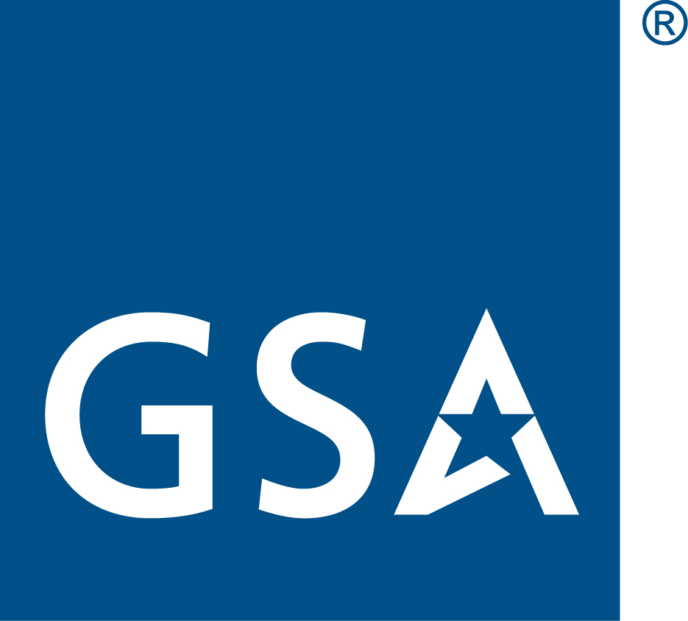

MANAGEMENT & ADVISORY SERVICES

Best Practices Ordering Guide for Management & Advisory Services Under the Federal Supply Schedules

Table of Contents
Acquisition Planning Package Overview 1
Types of Services Available 1
Corresponding MAS SINs 2
Functional Groups and Functional Areas 4
MAS Tips and Guidance 4

Acquisition Planning Package Overview
The purpose of the Management & Advisory Services Acquisition Planning Package is to facilitate Agencies’ use of GSA’s Multiple Award Schedule (MAS) to procure Management and Advisory Services. The MAS program provides ordering activities with a simplified and streamlined process for obtaining commercial services. The Acquisition Planning Package is an information resource and starting point for acquisition professionals seeking contract support through the MAS program. The Acquisition Planning Package highlights best practices and suggests recommendations to consider when securing the delivery of professional services.
The Acquisition Planning Package consists of guidance, samples and template documents including:
- Ordering Guide (this document)
- RFQ templates
- Sample Evaluation factors
- Sample PWS/SOWs
- Sample RFIs
- IGCE tool
- Market Research Report template
Note that this Acquisition Planning Package is specific to Management & Advisory Services.A variety of other Acquisition Planning Packages are available here.

Types of Services Available
MAS contracts can accommodate a wide variety of management & advisory services:
Strategic and organizational planning, business process improvement, acquisition support services, facilitation, surveys, benchmarking, program metrics, assessment and improvement of management systems, program analysis, business program and project management. These services may include, but are not limited to:
- Enterprise Project Management
- Project Management Training
- Public Health/Social/Environmental Consulting
- Human Resources Management Support
- Advisory and Consulting Services
- Inventory Management Services
- Risk Assessment
- Audit Support Services
- Acquisition and Grants Management Support
- Acquisition SME Services
- IGCE Development
- Contract Administration Support
- Policy Support

Corresponding MAS SINs
The below MAS SINs are available to fulfill management and advisory services requirements:
SIN | DESCRIPTION
541211 | Auditing Services - Perform financial-related audits, performance audits, recovery audits, transportation audits, and contract audits in accordance with Generally Accepted Government Auditing Standards (GAGAS) and non-GAGAS. Perform an independent assessment of an audited entity's financial statements in conformity with generally accepted accounting principles, financial information, adherence to financial compliance requirements and internal controls, or organization or program performance to identify areas for improvement.  Recovery audits: identify recoverable funds resulting from overpayments, duplicate payments and underpayments under the authority of public law and regulation, e.g., Section 354 of the National Defense Authorization Act for FY 96 (Public Law 104-106; 110 Stat. 268; 10 U.S.C. 2461),.  Transportation audits: perform administrative reviews and rate examinations on prepayment and post payment  transportation bills to ensure accuracy, completeness, and compliance with established rates, tariffs, quotations, agreements, tenders or other applicable rate authority.  Inherently Governmental services as identified in the Federal Acquisition Regulation (FAR) 7.503 or by the ordering agency are prohibited under this SIN. It is the responsibility of the Contracting Officer placing the order to make this determination. Ordering activities must require prospective contractors to identify potential conflicts of interest and address those, prior to task order award.
541611 | Management and Financial Consulting, Acquisition and Grants Management Support, and Business Program and Project Management Services: Provide operating advice and assistance on administrative and management issues. Examples include: strategic and organizational planning, business process improvement, acquisition and grants management support, facilitation, surveys, assessment and improvement of financial management systems, financial reporting and analysis,due diligence in validating an agency’s portfolio of assets and related support services, strategic financial planning, financial policy formulation and development,special cost studies, actuarial services, economic and regulatory analysis, benchmarking and program metrics, and business program and project management.  Inherently Governmental services as identified in FAR 7.503 or by the ordering agency are prohibited. It is the responsibility of the Contracting Officer placing the order to make this determination. Ordering activities must require prospective contractors to identify potential conflicts of interest and address those, prior to task order award.  Personal services as defined in FAR 37.104 are prohibited.
541614SVC | Supply and Value Chain Management - Includes supply and value chain management, which involves all phases of the planning, acquisition, and management of logistics systems.
541690 | Integrated Logistics Support - Services include providing advice and assistance to businesses and other organizations on scientific and technical issues (except environmental).  Typical associated tasks include, but are not limited to ergonomic/human performance analysis, feasibility analysis, logistics planning, requirements determination, policy standards/procedures development, conducting research studies, long-term reliability and maintainability, training, consulting, conduct acceptance, functional and post acceptance testing, testing, integration of the payload for flight Customer Agency, support provided during launch, orbital maneuvering and satellite separation from the spacecraft.  NOTE: Services under this NAICs can not include architect-engineer services as defined in the Brooks Act and FAR Part 2 or construction services as defined in the Federal Acquisition Regulation Part 36 and Part 2.
541620 | Environmental Consulting Services - Services include providing advice and assistance to businesses and other organizations on environmental issues, such as the control of environmental contamination from pollutants, toxic substances, and hazardous materials; Endangered species, wetland, watershed, and other natural resource management plans; Archeological and/or cultural resource management plans. This includes identifying problems (e.g., inspect buildings for hazardous materials), measure and evaluate risks, and recommend solutions. multi disciplined staff of scientists, engineers, and other technicians with expertise in areas, such as air and water quality, asbestos contamination, remediation, ecological restoration, and environmental law such as Planning and Documentation Services for the development, planning, facilitation, coordination, and documentation of and/or for environmental initiatives (or mandates such as Executive Order 13693 in areas of chemical, radiological, and/or hazardous materials; ISO 14001 Environmental Management System (EMS) and sustainable performance measure development; Environmental Assessment (EA) and Environmental Impact Statement (EIS) preparation under the National Environmental Policy Act (NEPA).  Note: while this SIN provides environmental consulting services requirements have sometimes been determined by the Contracting Officer to align with NAICS 541620; as such, this SIN is included in this guide as it may be appropriate for management, advisory and consulting services requirements.
541910 | Marketing Research and Analysis - Services include customizing strategic marketing plans, branding initiatives, creating public awareness of products, services, and issues; targeting market identification and analysis, establishing measurable marketing objectives; determining market trends and conditions, identifying and implementing appropriate strategies, conducting focus groups, telemarketing, individual interviews, preparing/distributing surveys, and compiling/analyzing results, establishing call centers (in relation to services provided under this schedule).  Note: while this SIN provides market research and analysis services requirements have sometimes been determined by the Contracting Officer to align with NAICS 541910; as such, this SIN is included in this guide as it may be appropriate for management and advisory services or acquisition support requirements.
541990RISK | Risk Assessment and Mitigation Services - Services include: breach mitigation and analysis/forensic services, the deployment of financial risk assessment and mitigation strategies and techniques; improvement of capabilities through the reduction, identification, and mitigation of risks; detailed risk statements, risk explanations and mitigation recommendations; design and development of new business applications, processes, and procedures in response to risk assessments; and ensuring compliance with governance and regulatory requirements. Under this SIN, firms can also assist the Ordering Agency with preventive measures in protecting Personally Identifiable Information (PII) and Protected Health Information (PHI) through the evaluation of threats and vulnerabilities to PII and PHI type of information; training of Government personnel on how to prevent data breaches and identity theft; vulnerability assessments; privacy impact and policy assessments; review and creation of privacy and safeguarding policies; prioritization of threats; maintenance and demonstration of compliance; and evaluation and analysis of internal controls critical to the detection and elimination of weaknesses to the protection of PII and PHI type of information.
611430 | Professional and Management Development Training - 611430 services include offering an array of short duration courses and seminars for management and professional development. Training for career development may be provided directly to individuals or through employers' training programs, and courses may be customized or modified to meet the special needs of customers. Instruction may be provided in diverse settings, such as the establishment's or agency's training facilities, and through diverse means, such as correspondence, television, the Internet, or other electronic and distance-learning methods. The training provided may include the use of simulators and simulation methods. Proposed professional services shall be in support of planning, creating, and/or executing testing and test administration, learning management, internship, or development of new courses or subject matter delivered via an instructor-led (i.e. traditional classroom setting or conference/seminar) and/or web-based (i.e. Internet/Intranet, software packages and computer applications) system.  Examples include Training Services that are instructor led Training or Web Based Training of Education Courses, Course Development and Test Administration, Learning Management, and Internships; Environmental Training Services in order to meet Federal mandates and Executive Orders; training of agency personnel to deal with media and media responses; Logistics Training Services related to system operations, automated tools for supply and value chain management, property and inventory management, distribution and transportation management, and maintenance of equipment and facilities; Audit & Financial training services related to course development and instruction required to support audit, review, financial assessment and financial management activities.

Functional Groups and Functional Areas
In response to Office of Management and Budget (OMB) Memorandum M-19-13, the Category Management Leadership Council (CMLC) established 10 government-wide spend categories for purchasing goods and services. Professional Services is one of the 10 government-wide spend categories and Management and Advisory Services is one of eight subcategories under the Professional Services Category. The management and advisory services subcategory has three (5) functional groups: (1) Other Management and Advisory Services, (2) Program Management, (3) Program Evaluation, (4) Acquisition Support, and (5) Policy Services. These functional groups include, but are not limited to, various functional areas as described below:

- Other Management and Advisory Services
  - Enterprise Project Management, possible SIN(s): 541611
  - Human Resource Management Support Services, possible SIN(s): 541611
  - Privacy Program Management Support, possible SIN(s):541611
  - Peer Review Planning and Support Services, possible SIN(s): 541611
  - Advisory and Consulting Services, possible SIN(s): 541611
  - Integrated Management Consulting Services, possible SIN(s): 541611
  - Public Health/Social/Environmental Consulting, possible SIN(s): 541611 and 541620
  - Inventory Management Services, possible SIN(s): 541611 and 541614SVC

- Program Management
  - Project Management Support, possible SIN(s):541611
  - Program Support Services, possible SIN(s): 541611
  - Program Administration and Management Support, possible SIN(s): 541611
  - Project Management Training, possible SIN(s): 541611 and 611430

- Program Evaluation
  - Program Analysis, possible SIN(s): 541990RISK
  - Business Process Improvement, possible SIN(s): 541611; 541990RISK
  - Risk Assessment and Program Analysis, possible SIN(s): 541990RISK
  - Audit Support Services, possible SIN(s): 541211

- Acquisition Support
  - Contract Administration Support, possible SIN(s): 541611
  - Contract Closeout Support Services, possible SIN(s): 541611
  - Acquisition Support Services, possible SIN(s): 541611; 541614SVC and 541910
  - Acquisition SME Services, possible SIN(s):541611; 541614SVC and 541910
  - Acquisition and Grants Management Support Services, possible SIN(s):541611 and 541910

- Policy Services
  - Policy Training Services, possible SIN(s): 541611; 541690 and 611430
  - SME Policy Support, possible SIN(s): 541611
  - Technical and Policy Programmatic Support, possible SIN(s): 541611; 541620 and 541690
Note that sample requirements documents (SOW/PWS) are in this Acquisition Planning Package for each of the above referenced functional areas.

MAS Tips and Guidance
MAS contracts offer a number of tools and flexibilities to improve and streamline the buying process.
Ordering Flexibility: MAS contracts provide several alternatives to address uncertainties with respect to requirement quantities. Those alternatives are discussed briefly below:
- Blanket Purchase Agreements (BPAs): are a vehicle to fill recurring needs for Schedule services. The benefits of using BPAs include leveraging buying power, saving administrative time, and reducing overall procurement transactions. BPAs allow for substantially quicker turnarounds on orders through the use of streamlined ordering procedures, while reducing administrative burdens of repetitive, individual orders.
  - Multiple-award vs. Single-award BPAs: both multiple-award and single-award BPAs are allowed under MAS. To encourage competition, the FAR establishes a preference for multiple-award BPAs. The number of BPAs to be established is within the discretion of the ordering activity and should maximize the effectiveness of the BPA(s). In determining whether single or multiple BPAs are appropriate, the Agency should consider:
    - The scope and complexity of the requirement(s)
    - The benefits of ongoing competition and the need to periodically compare multiple technical approaches or prices
    - The administrative costs of multiple BPAs
    - The technical qualifications of the Schedule contractor(s)
- Time and Materials (T&M) or Labor Hour (LH) contract/CLIN types: may be used when it’s not possible at the time of placing the contract to estimate accurately the extent or duration of the work or to anticipate costs with any reasonable degree of confidence.
  - Requirements should be structured to maximize the use of FFP CLIN(s) to the maximum extent practicable. This may result in a “hybrid” order that, despite having T&M or LH elements, is classified as FFP for reporting purposes.
  - Order Level Materials (OLMs): OLMs are supplies and/or services acquired in direct support of an individual task or delivery order placed against a GSA Schedules Program contract or Blanket Purchase Agreement (BPA), when the supplies and/or services are not known at the time of contract or BPA award.
    - OLMs are only authorized for inclusion under a T&M or LH CLIN. A determinations and findings (D&F) is required for the T&M or LH portion of the order, regardless of dollar value.
    - The value of OLMs in a task or delivery order, or the cumulative value of OLMs in orders against an FSS BPA, cannot exceed 33.33% (note: travel costs do not count towards this limitation).
    - The OCO should verify that the OLM SIN is awarded on a contractor’s Schedule contract prior to order placement (see gsaelibrary.gsa.gov to obtain this information). Contractors who have not been awarded the OLM SIN are not authorized to receive orders that include OLMs
    - The OCO is responsible for: Defining any known OLM categories (e.g., computer usage charges, office supplies, labor); Establishing an NTE ceiling price for OLMs; Approving proposed OLM indirect cost fixed amount and determining it is fair and reasonable (if applicable)
- Options: Options may be included on orders placed against GSA MAS contracts, provided that the options are clearly stated in the requirement and are evaluated as part of the ordering activity’s “best value” determination.
  - Order options are administered under the procedures outlined at FAR 17.2;
  - Orders must include the applicable clauses prescribed at FAR 17.208 if the ordering activity plans to use options.
  - Note that if a 6 month extension (per FAR 52.217-8) is included, the pricing for that extension should be included in the evaluation.
- Other MAS Features:
  - No requirement to synopsize - GSA Schedules have been synopsized at the contract level in beta.SAM.gsa and satisfy the requirements of the Competition in Contracting Act (Pub. Law 98-369) and FAR Part 5, Publicizing Contract Actions. Ordering activities “shall not” synopsize (see FAR 8.404(a)).
  - Subcontracting plans are issued and administered at the contract level, and are therefore not required for orders issued against GSA Schedules.
  - GSA performs the contractor responsibility determination IAW FAR Part 9 at the contract level. A separate determination of responsibility is not required at the order level.
  - Socioeconomic set asides: COs may, at their discretion, set aside orders or BPAs for small businesses or subcategories of small businesses identified in FAR 19.000(a)(3). It is important to note that 80% of all GSA Schedule holders are small businesses and the simplified ordering procedures for Schedule set-asides are prescribed in FAR 8.405-5, not Part 19.

  - Orders against Schedule contracts are not exempt from:
    - Acquisition planning as required by FAR Part 7
    - Agency specific supplements
    - Bundling requirements (ref FAR 7.107)

Ordering Procedures and Resources:
- GSA Market Research as a Service (MRAS): a free service available to customers to facilitate market research on GSA contract vehicles. The MRAS team issues streamlined, effective Requests for Information (RFI) which: define and identify suppliers and contracts; research and identify supplier capabilities; access hundreds of existing Market Reports; and provide a comprehensive market plan, including contract suggestions, socio-economic considerations, etc.
- Other GSA Market Research Tools include:
  - Discovery
  - eLibrary
  - eBuy: If market research reveals that the number of capable and interested vendors is low, the use of eBuy will serve to notify all vendors on the Schedule of the selected SIN about the requirement
- Contractor Team Arrangement (CTA): two or more GSA Schedule contractors working together to provide a total solution to the ordering activity. The CTA allows the contractor to meet the government agency needs by providing a total solution that combines the supplies and/or services from the team members’ separate Schedule contracts. It permits contractors to complement each other’s capabilities in order to compete for orders for which they may not independently qualify. GSA encourages the use of CTAs to meet buyer’s requirements. Note: FAR 9.6, Contractor Team Arrangements, does not apply to GSA Schedules teaming. Under GSA Schedules, Teaming allows contractors to use their individual GSA Schedules to develop a solution for the government in which each contractor has privity of contract with the Government.
- Evaluation factors: Ordering activities have considerable latitude in structuring their procurement and can consider both price and other factors (e.g., past performance, technical capabilities and qualifications of key personnel) in selecting Schedule contractors. When determining “best value,” an ordering activity may take advantage of the full spectrum of “best value” techniques as defined in FAR 2.101, from lowest-priced technically acceptable (LPTA) through a full trade-off process. When determining which nonprice evaluation factors to include in an RFQ, ordering activities should decide how factors will be considered and their relative importance to other nonprice factors. This procurement guide includes various sample evaluation factors common to professional services contracting.
- Solicitation Methods: FAR 8.405-2(c) allows solicitations for professional services requirements with a statement of work to be solicited:
  - Via GSA eBuy; or
  - By providing the RFQ (e.g., via email) to as many schedule contractors as practicable, consistent with market research, to reasonably ensure that quotes will be received from at least three contractors that can fulfill the requirements (Note: <SAT, must be sent to at least 3)
- Checklist: Use the GSA Schedule Order: Contract File Checklist [PDF - 368 KB] to award task or delivery orders against Schedules and to establish Blanket Purchase Agreements (BPAs) against Schedule contracts.
- Unsuccessful notifications: If an unsuccessful quoter requests information on an award that was based on factors other than price alone, a brief explanation of the basis for the award decision must be provided (refer to FAR 8.405-2(d)). The FAR Part 15 debriefing requirement does not apply.

