INCH-POUND
FED-STD 834A
July 21, 2010
SUPERSEDING
FNEW-83-269E
October 31, 1989

FEDERAL STANDARD
PERFORMANCE TEST METHOD FOR INTENSIVE USE CHAIRS
The General Services Administration has authorized the use of this federal standard by all federal agencies.
1. SCOPE. This test method describes procedures for evaluating performance characteristics of intensive use chairs.

- Intensive use chairs are designed to be used 24 hours per day, 7 days a week in intensive use environments
2. REFERENCED DOCUMENTS. The following documents, of the issue in effect on the date of invitation for bids or request for proposal form a part of this standard to the extent specified herein.

American National Standards Institute (ANSI) Standards:

ANSI/BIFMA X5.1 - General-Purpose Office Chairs - Tests

(Application for copies should be addressed to the American National Standards Institute, 1430 Broadway, New York, NY 10018.)

American Society for Testing and Materials (ASTM) Standards:

ASTM D3597 - Standard Specification for Woven Upholstery Fabrics-Plain, Tufted, or Flocked
ASTM D3884 - Standard Guide for Abrasion Resistance of Textile Fabrics (Rotary Platform, Double-Head Method)
ASTM D4157 – Standard Test Method for Abrasion Resistance of Textile Fabrics (Oscillatory Cylinder Method)

(Application for copies should be addressed to the American Society for Testing and Materials, 1916 Race Street, Philadelphia, PA 19103.)

3. DEFINITIONS.

3.1 Disabling damage – Is described as damage to the chair or component which prevents the chair or component from performing its intended functions or would in any way cause personal injury to the occupant or bystanders.

4. GENERAL REQUIREMENTS. Fixtures and equipment used in the ANSI/BIFMA X5.1 test method may generally be used in these tests. This performance test method for intensive use chairs differs from the ANSI/BIFMA X5.1 test method in the following ways:
In most cases, higher performance values are required to ensure chair survivability in an intensive use environment.
In some tests, cyclic stepped loads are applied. This type of loading provides fatigue loading while keeping the total number of required cycles low by steadily increasing the load on the chair or chair component.
5. DETAILED REQUIREMENTS.

5.1 Cyclic Back and Back Tilt Mechanism Fatigue Test. Applies only to chairs with spring type tension controls. The entire chair shall be attached to a test platform via the base to prevent the chair from sliding backwards or overturning. Loads may be applied with either a pushing load-head or a pulling harness. A front-to-back load shall be applied to the back of the chair at a point 16 inches (406mm) above the seat or to the top of the back if the back is lower than 16 inches (406mm). The load is applied in a manner so the load is normal to the plane of the back at the back stop position. The tilt mechanism shall be adjusted so that the top of the back moves 4 inches ± 1 inch (102mm ± 25mm) rearward under the action of a 40 pound-force (178N) load. The test is carried out at a 50 pound-force (222N) load level at 20 ± 2 cycles per minute and is continued until the back or tilt mechanism suffers disabling damage or meets the required acceptance level.

5.2 Cyclic Increasing Back Load Test. The entire chair shall be attached to a test platform via the base to prevent the chair from sliding or overturning. Loads may be applied with either a pushing load-head or a pulling harness. A front-to-back load shall be applied to the back of the chair at a point 16 inches (406mm) above the seat or to the top of the back if the back is lower than 16 inches (406mm). The load is applied in a manner so the load is normal to the plane of the back at the back stop position at 20 ± 2 cycles per minute. If the chair uses a spring type tension control, the control shall be adjusted to its loosest position. If the chair uses an air cylinder or other mechanism that locks the chair inclination in a fixed position, the control shall be adjusted to the far backward position. The test shall begin at the 75 pound-force (334N) load level with the load increased in increments of 25 pound-force (111N) after 25,000 cycles have been completed at the preceding load level. Testing continues until some type of disabling damage occurs or the chair meets the required acceptance level.

5.3 Cyclic Pneumatic Back Tilt or Seat Inclination Adjustment Mechanism Test. The entire chair shall be attached to the test platform via the base to prevent the chair from shifting position during the test. If a chair has a pneumatic back tilt or pneumatic seat inclination adjustment mechanism, they shall each be tested. The test shall use a four part cycle as follows:

A. Seat or back is loaded with 50 pound-force (222N) normal to the plane of the seat or back. The load shall be applied to the seat or back at the location that will easily cause the seat or back to tilt when the tilt activator is operated.
B. Load is removed.
C. Load is reapplied and adjustment mechanism is activated while chair is under load.
D. Load is removed and adjustment mechanism remains activated until seat or back mechanism returns to normal position whereupon the adjustment is inactivated.

The entire cycle is repeated at a rate of 5 cycles per minute. The test is continued until some part of the adjustment system malfunctions or the chair meets the required acceptance level.

5.4 Cyclic Vertical Load Test on One Arm. The entire chair shall be attached to a test platform via the base to prevent the chair from overturning. A vertical downward load shall be applied to the approximate center of one armrest of a chair at a cyclic rate of 20 cycles per minute. The test is begun at a load level of 100 pound-force (445N) and increased in increments of 50 pound-force (222N) after 25,000 cycles have been completed at the preceding load level. Loads are increased every 25,000 cycles until the chair suffers disabling damage or meets the required acceptance level.

5.5 Cyclic Side Thrust Load Test on Arms. The entire chair shall be attached to a test platform via the seat to prevent it from sliding sideways, overturning or rotating in the direction of the load. The seat shall be restrained in a manner so that the arm is not supported. A cyclic outward side thrust load shall be applied to an arm of the chair at a rate of 20 cycles per minute. The load shall be applied to the approximate midpoint on the length of the arm normal to the vertical plane of the arm. The test shall be begun at the 50 pound-force (222N) load level. Loads are increased in increments of 25 pound-force (111N) after 25,000 cycles have been completed at each preceding load level. Loads are increased every 25,000 cycles until the chair suffers disabling damage or meets the required acceptance level.

5.6 Cyclic Vertical Load Test on Seats, Bases and Casters. The entire chair shall be attached to a test platform. The casters shall be prevented from rolling or rotating. A vertical load shall be applied to the seat at a rate of 20 cycles per minute. Loads are applied 2 inches (51mm) in front of the longitudinal axis of the spindle with a circular load-head 6 to 8 inches (152 to 203mm) in diameter. The test is started at the 200 pound (91kg) load level and loads are increased in increments of 100 pounds (45.4kg) after each 25,000 cycles have been completed at the preceding load level. The casters shall be turned at right angles to the legs so that all legs are subjected to torsional forces. Testing continues until some type of disabling damage occurs or the chair meets the required acceptance level.

5.7 Cyclic Fatigue Test of Swivel Bearings. The chair shall be secured to a platform that is rotated back and forth 360 degrees each cycle. The platform is cycled 10 ± 2 times per minute. A static load of 200 pounds (91kg) is placed on the chair so that its center of gravity is located 4 inches (102mm) in front of the longitudinal axis of the spindle. The load is increased every 25,000 cycles by 25 pounds (11 kg). The rotating platform secured to the chair base is rotated beneath the seat side of the chair control while the seat side of the control is loaded vertically and secured to prevent it from rotating. The amount of torque required to cause the chair to rotate from a stopped position is measured every 25,000 cycles. The static load is also applied when the torque measurement is taken. The testing is continued until the torque rises above the acceptance level or the chair completes the required load level in the acceptance level.

5.8 Cyclic Pneumatic Height Adjustment Durability Test. The entire chair shall be attached to a test platform via the base to prevent the chair from shifting position during the test. The height adjustment mechanism shall be tested using a four part cycle as follows:

A. Seat is loaded with 250 pounds (113kg)
B. Load is removed.
C. Load is reapplied and adjustment mechanism is activated.
D. Load is removed and adjustment mechanism remains activated until seat ascends to highest position whereupon it is inactivated.

The entire cycle is repeated at a rate of 5 cycles per minute. The test is continued until some part of the adjustment system malfunctions or the chair meets the required acceptance level.

5.9 Front Stability Test. The front stability test shall be conducted as follows:

A. Chair is placed on a level test platform at lowest height setting.
B. The base and casters are placed in their most unstable position.
C. A downward vertical load is applied 2.4 inches (60mm) from the front center edge of the seat. The load required to just lift the rear caster off the test platform is recorded as the measure of front stability.

5.10 Back Stability Test. The back stability test shall be conducted as follows:

A. Chair is placed on a level test platform at lowest height setting.
B. The base and casters are placed in their most unstable position.
C. A 1 inch (25.4mm) high obstruction is placed behind the two rearward casters.
D. The front edge of the seat pan is loaded with 50 pounds (23kg) applied 2.4 inches (60mm) from the front edge of the load-bearing surface
E. A horizontal front-to-back load is applied to the top of the back rest. The force required to overturn the chair multiplied by the height from the floor to the top of the backrest is recorded as the measure of back stability.

5.11 Caster and Base Durability Test. A chair or simulating fixture with casters mounted shall be placed on the obstacle layout as indicated in Figure 1. A 300 pound (136kg) load shall be applied to the chair seat as indicated in Figure 1 with the chair spindle fully extended. The chair seat shall be attached to a mechanical device which shall exert a horizontal push and pull of 30 inches (762mm) as illustrated in figure 1. The base and casters shall be free to rotate and swivel. The machine shall operate continuously at a rate of 8 to 10 cycles per minute with a maximum speed of 50 ft/minute (15m/minute). One cycle shall consist of a forward and backward stroke of the mechanical device. Testing continues until the base or a caster suffers structural breakage, loss of serviceability, failure that would in any way cause personal injury to the occupant or bystanders, or meets the required acceptance level.

5.12 Fabric Durability Test. The fabric shall be tested in accordance with the surface abrasion test in ASTM D3597 or ASTM D3884 (using CS #10 wheels and a 1 lb. (454 gram load). If the ASTM D3597 surface abrasion test method is used, delete section 6.4 and substitute ASTM D4157. If this test method is used, the bidder must extend a 5 year (from receipt of chair) warranty on the fabric life. If the fabric wears through while in the anticipated intensive use environment during the warranty period, the contractor shall supply a complete re-upholstery kit as defined in the contract, (for COM, the customer shall specify the desired durability of the fabric).
5.13 Spindle Attachment Tests (does not apply to taper fit designs). The base and spindle shall be detached from the chair and tested as follows:

Test A) Apply a torque of 100 pound-force foot (136N.m) to turn or displace the spindle, from the base by use of a tool such as a wrench.

Test B) Apply a force of 1500 pound-force (6670N) to the spindle, in the direction of its removal from the base at the rate of 0.100 to 0.125 inch per minute (2.5mm to 3mm per minute).

When a free swiveling fitting is used to attach the spindle to the base, Test A may be disregarded.

5.14 Acceptance Levels.

Test | Acceptance Level
5.1 Cyclic Back and Back Tilt Mechanism Fatigue Test | 500,000 cycles
5.2 Cyclic Increasing Back Load Test | Complete 175 pound-force (778N) Load Level
5.3 Cyclic Pneumatic Back Tilt or Seat Inclination Adjustment Mechanism Test | 360,000 cycles for backrest <16 in. (406mm)  332,000 cycles for backrest >16 in. (406mm)
5.4 Cyclic Vertical Load Test on One Arm | Complete 250 pound-force (1112N) Load Level
5.5 Cyclic Side Thrust Load Test on Arms | Complete 200 pound-force (890N) Load Level
5.6 Cyclic Vertical Load Test on Seats, Bases and Casters | Complete 1300 pound (590kg) Load Level
5.7 Cyclic Fatigue Test of Swivel Bearings | Maximum 75 pound-force inch (8.5N.m) at 300 pound (136kg) Load Level
5.8 Cyclic Pneumatic Height Adjustment Durability Test | 125,000 cycles
5.9 Front Stability Test | Min. 125 pounds (57kg)
5.10 Back Stability Test | Min. 1450 pound-force inch (164N.m)
5.11 Caster and Base Durability Test | 36,000 cycles
5.12 Fabric Durability Test | ASTM D 4157 - 30,000 cycles without any noticeable wear  ASTM D 3884 – 15,000 cycles without wearing completely through any warp or fill yarn
5.13 Spindle Attachment Tests | Spindle shall remain unmoved after completion of Test A and Test B

6. TOLERANCES.
- Test weights, forces, ±5%
- Linear measurements ±1/16 in. (1.5mm)
- Cycle requirements are minimums where tolerances are not specified.
Test weights, forces, dimensions and time shall be targeted at the values specified.

7. REPORTING REQUIREMENTS. Upon completion of each test, the official report (Form A) must be completely filled out and documented with photographs as requested.

Preparing Activity:

GSA/FAS/3QSAB

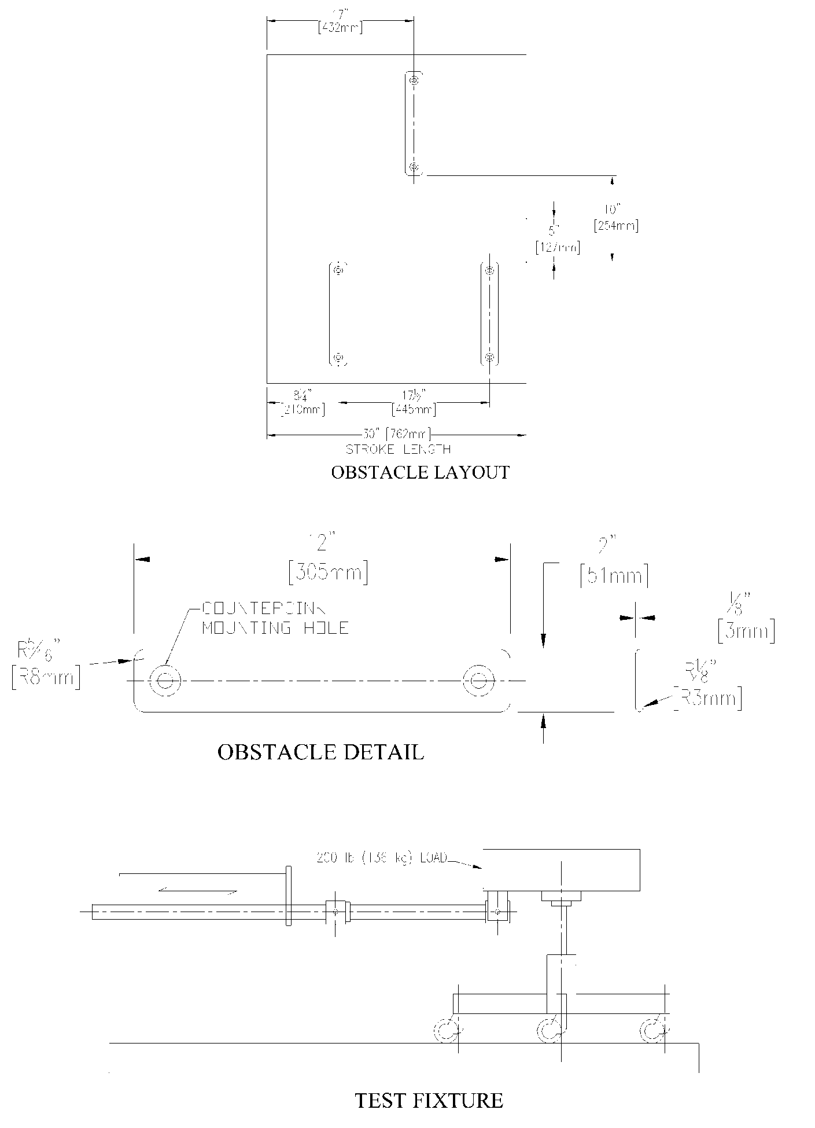
Figure 1 - Caster/Chair Base Durability Test

FORM A. Report of Furniture Performance Test.

Date: ______________________

Manufacturer: _____________________________

Manufacturer’s Model No.:

Name of test performed (submit original photograph of Test Set-up with specimen in place taken before testing began.)

Last successful load level:
Other relevant information:

Testing Laboratory
Laboratory technician Title
Signature
Certified by Title
Signature

