3D Laser Scanning

Quality Management Program Guide
Version 1.0

Contents
INTRODUCTION 4
Notice to Readers 4
OVERVIEW 5
Phase 0 (Pre-Bid) 6
Phase 1 (Project Planning) 6
Phase 2 (Data Acquisition) 7
Phase 3 (Data Processing) 8
Phase 4 (GSA Preliminary Review of Data) 8
Phase 5 (Data Validation) 9
Phase 6 (Final Submission) 9
IMPLEMENTATION GUIDANCE 9
PART 1 - Quality Assurance Program 11
Phase 1 (Project Planning) 11
PART 2 - Quality Control Program 14
SECTION 1 15
Phase 2 (Data Acquisition) 15
SECTION 2 18
Phase 3 (Data Processing) 18
Phase 4 (GSA Preliminary Review of Data) 21
Phase 5 (Data Validation) 21
Phase 6 (Final Submission) 22
Appendix 1 23
Quality Management Program Process Map 23
Appendix 2 32
Quality Management Program Checklists Summary 32
Appendix 3 33
Quality Management Program Checklists 33
Laser Scanning Information Sheet 34
GSA Representative – QA Project Plan Checklist 37
GSA Representative - Project Data Deliverables Checklist 38
Contractor - QA Project Plan Checklist 42
Contractor - Data Acquisition Certification Report Checklist 43
Contractor - Data Processing Certification Report Checklist 44
Contractor – Field Quality Demonstration Report Checklist 46
Contractor – Final Project Data Deliverable Report Checklist 47
Table of Figures 48
Acknowledgements 49

INTRODUCTION
The Office of the Chief Architect established the National 3D-4D-BIM Program in 2003. Since then, over 70 capital projects have been initiated throughout the U.S. using an array of 3D, 4D and Building Information Modeling (BIM) technologies in support of GSA business. The GSA is committed to a strategic and incremental adoption of 3D, 4D and BIM.
One of the important enabling technologies in the adoption of this visionary program is 3D laser scanning. In 2009, the GSA awarded six Indefinite Delivery Indefinite Quantity (IDIQ) contracts for laser scanning services. Two of the critical elements of every successful 3D laser scanning project are quality assurance and quality control - QA/QC. In order to ensure that quality is built into a 3D laser scanning project from the start, it must be fully integrated and embraced by all members of the project team.
The purpose of this “3D Laser Scanning Quality Management Program Guide” is to document the recommended QA/QC process required to streamline the procurement and acceptance of 3D laser scanned (imaging) data and derived deliverables. The Quality Management Program Checklists included as part of this guide will be used by the GSA Project Manager or the technical representative and the contractor to efficiently deliver and accept or reject laser scanning project deliverables using a standardized, open procedure as documented in this guide.

Notice to Readers
Please note that this Quality Management Program Guide has been prepared based on the assumption that the reader has a basic understanding of the principles and use of 3D laser scanning as it applies to the documentation of existing public buildings. This would include both field and office procedures needed to collect and process 3D point cloud data involving the use of tripod-mounted laser scanners. The reader is referred to the GSA BIM Guide Series 03 for 3D Imaging for a detailed introduction to the use of laser scanning and terminology on GSA projects and to the GSA BIM Champion for their region.
In addition, this guide has been prepared as a digital document with hyperlinks to other GSA references. As the technology changes the GSA intends to update the guide as needed to remain current with the stat- of-the-art.

OVERVIEW
The GSA’s philosophy is founded on the premise that quality is not something that gets checked at a point in time before delivery, but is fully integrated and checked by all members of the team at all stages as the project progresses. Every individual working on the project has a direct impact on the quality of the project. Therefore, the QA/QC program should not reside with any single member of the project team, but should be a shared responsibility.
This approach provides redundant checks by multiple team members with at least two members verifying everything. The goal is shared ownership and cooperation between the contractor and the GSA.
At the same time, it should be noted that the GSA expects the contractor to have final responsibility for certifying the quality of the work performed. The contractor shall assume that the GSA representative evaluating the Quality Management Program is generally familiar with 3D laser scanning procedures and the associated deliverables. The GSA representative could be the BIM Champion, the project engineer, the project manager, etc. Ideally they will have a technical, not necessarily laser-scanning specific, background, and should be able to review deliverables as outlined in this document.
The GSA reserves the right to retain the services of an independent third party to support its review of the Quality Management Program and project deliverables, should it deem necessary.
The GSA requires that quality assurance and quality control be considered distinct but related processes. As such, this guide is structured in two parts:
- Part 1 - Quality Assurance, or “QA”, will refer to the overall planning procedures required to establish and maintain quality throughout the entire project. The QA process will take place prior to the start of the actual scanning effort.

- Part 2 – Quality Control, or “QC”, will refer to the procedures that commence with the field work and continue to the point of final deliverables being accepted by the GSA.
The GSA recommends that the overall Quality Management program be implemented in the following phases. (See Appendix 1 for the program process map.)
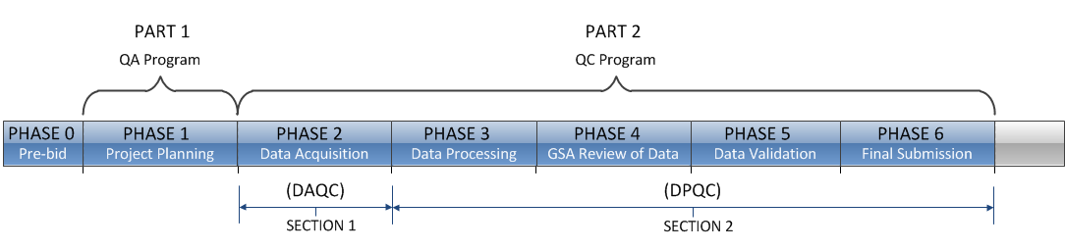
Figure 1 - Phase Diagram

Phase 0 (Pre-Bid)
Ensuring a high quality project starts with properly specifying the required services through the Scope of Work (SOW). In addition to providing a thorough SOW, there is often other important information needed by the contractor to properly bid the project. The GSA Project Team shall complete and provide the contractor with a copy of the Laser Scanning Information Sheet during the bidding period. Thought should be given to how the deliverables will need to be viewed and whether software licenses should be provided by the contractor. If so, that should be stated in the SOW.
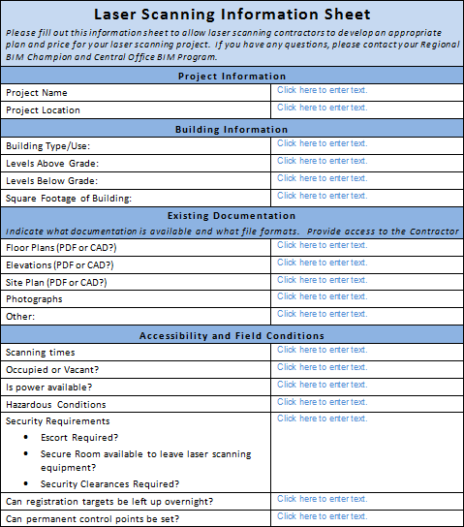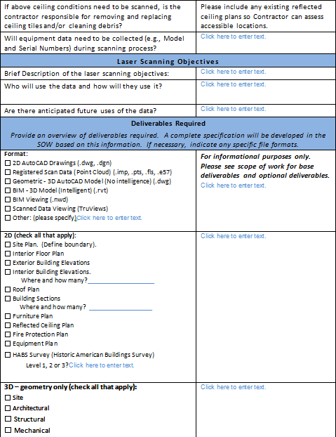
Figure 2 - Laser Scanning Information Sheet on page 34

Phase 1 (Project Planning)
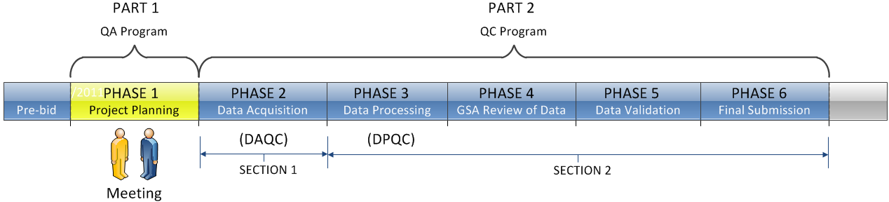
The first phase falls under the Quality Assurance component of the Quality Management Program. Upon award of a project, the GSA representative and the laser scanning contractor are to meet, identify and agree upon the parameters, reports and forms within the Quality Management Program Guide that will govern the subject project. The contractor should provide the expertise to assist the team with this program definition. This requirement will apply to all scanning projects whether the contractor is working directly for the GSA or for another entity.
The Quality Management process should be controlled by a flexible, performance-based standard that is not tied to any proprietary systems, software or vendors. This will ensure that the program can evolve as technology changes. Shared ownership of and cooperation on the project are set by having both the GSA representative and the contractor jointly define the parameters for the QA/QC process.
Prior to commencing field work, the contractor will submit and have accepted by the GSA representative the complete QA Project Plan for the specific project. This plan shall pre-define all QA aspects of the project.

Phase 2 (Data Acquisition)
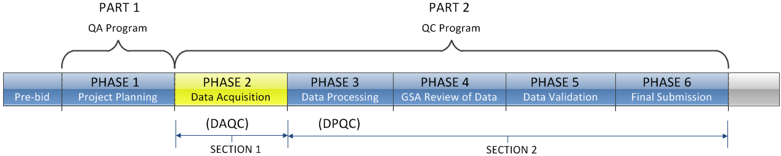
The second phase marks the start of the Part 2 – Quality Control component of the Quality Management Program and involves the contractor performing the initial field work to acquire the data as defined by the contract and the Quality Management Program Guidelines. There are two sections in the QC Program:
1) Data Acquisition Quality Control (DAQC)
2) Data Processing Quality Control (DPQC).
The contractor shall employ the GSA-defined Quality Management procedures as outlined in this guide and certify same. Once the contractor has performed the data acquisition quality control checks, processing the data can begin.
At the beginning of Phase 4, the contractor will submit, and have accepted by the GSA, a Data Acquisition Certification Report which documents all field data acquisition activities. GSA will use the Project Data Deliverables Checklist to track the submission of the required items.

Phase 3 (Data Processing)
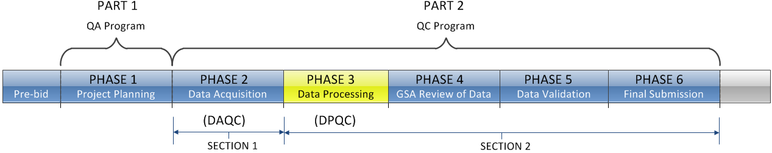
The third phase involves the contractor performing the data processing as defined by the contract. The contractor shall employ the GSA-defined Quality Management procedures as outlined in this guide and certify same. The laser scanning contractor is responsible for certifying that the deliverables meet the project requirements and Quality Management guidelines.
Once the contractor has performed the data processing quality control checks (DPQC), the data can be submitted to the GSA representative for preliminary review according to the project schedule milestones. At the beginning of Phase 4, the contractor is required to submit, and have accepted, a Data Processing Certification Report with the data.

Phase 4 (GSA Preliminary Review of Data)
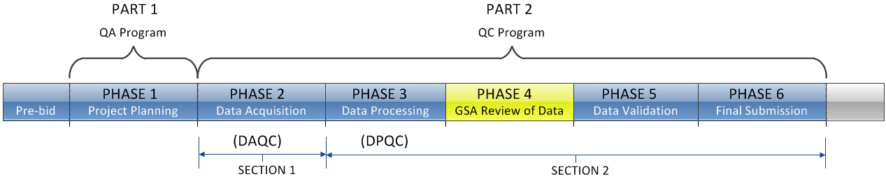
During this phase the GSA representative shall conduct the Quality Management review process on the delivered data and contractor reports. This phase will involve an initial review of the data and reports provided by the contractor in order to validate compliance with the GSA Quality Management procedures and guidelines. The information given to the GSA representative will provide sufficient information to accept or reject the data, including the ability to visually check the scanned data and all derived work products.

Phase 5 (Data Validation)
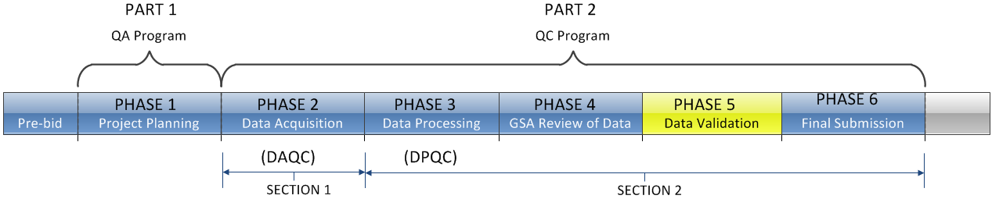
Upon review of the contractor’s data, the GSA representative may accept the data, reject the data, or choose to have the data validated in the field. If a field check is chosen, both the GSA representative and the contractor shall return to the field to validate the checked data and to ensure a unified acceptance of the final product. The QA plan described in Phase 1 will pre-define the methods that will be used for the field validation check.
The contractor can execute any of the required checks desired by the GSA representative, since the contractor possesses the tools, technical expertise and knowledge of the project from the previous data acquisition efforts. With both parties present, any ambiguities that may still exist can be addressed. Upon completion of the field check, any required final adjustments shall be made by the contractor.
The contractor will submit a Field Quality Demonstration Report documenting the field validation check at the conclusion of this task.

Phase 6 (Final Submission)
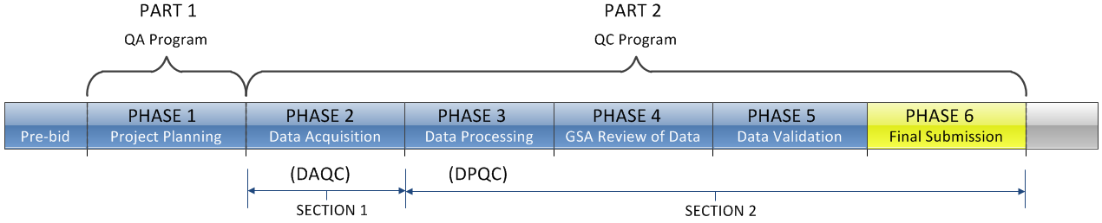
Once all revisions have been made, the contractor shall submit to the GSA representative the final deliverables package that will include a complete set of the official data and a final version of the Project Deliverables Report for final review and acceptance.

IMPLEMENTATION GUIDANCE
- The contractor and the GSA representative shall meet once the contract is awarded and prior to the start of field operations. The contractor will present the written QA Project Plan to the GSA.
This plan will take into account the procedures outlined in the previously mentioned GSA BIM Guide for 3D Imaging, this GSA Quality Management Program Guide, and the items listed in the Contractor - QA Project Plan Checklist.
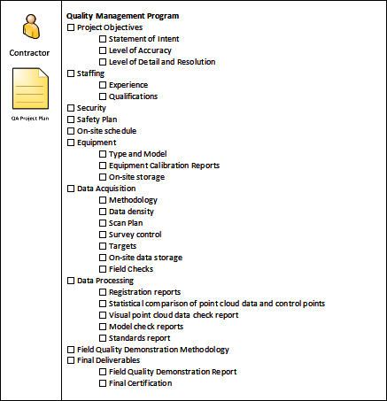
Figure 3 - Contractor - QA Project Plan Checklist on page 42
- The contractor will be fully aware of this 3D Laser Scanning Quality Management Program Guide and use this meeting to identify any items outside the normal scope serving to establish open communications with the GSA representative.
- The written QA Project Plan shall outline the overall approach being taken to ensure that each phase of the subject project will meet the needs of the GSA contract. This plan will address, among other items, equipment selection, field procedures, Area of Interest (AOI), Items of Interest (IOI), staffing, security, data processing and final delivery. The contractor will outline the quality checks that will be performed during each phase of the project.
- The QA Project Plan submitted by the contractor should strive to be as vendor-neutral as possible so as to make its implementation a standard operating procedure that, over time, the GSA can expect from all contractors on similar projects. The QA Project Plan must include vendor-specific references to hardware and software that are going to be used on the project.
- GSA will utilize the GSA Representative – QA Project Plan Checklist to verify that all of the items required by the GSA Quality Assurance Program have been received from the Contractor.
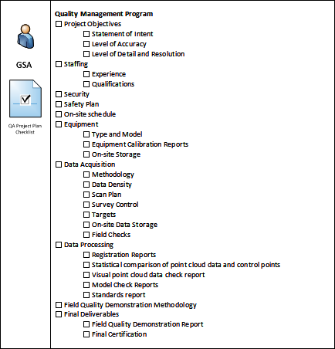
Figure 4 - GSA Representative - QA Project Plan Checklist on page 37

PART 1 - Quality Assurance Program
The QA Program applies to all phases of the project planning, system calibration, data collection, processing, modeling and creation of final deliverables. A written QA Project Plan covering the entire project must be submitted by the contractor as part of the Quality Management Program and be accepted by the GSA prior to beginning field work. It is the contractor’s responsibility to certify that the methods proposed will produce the desired results and that they are in compliance with this 3D Laser Scanning Quality Management Program Guide.
The QA Project Plan will need to address the following:

Phase 1 (Project Planning)
- Statement of Intent – The QA Project Plan shall begin with a statement of intent describing the intended use of the data to be acquired and processed. Establishing and recognizing the intended use of the data will help define the appropriate means and methods that should be used to acquire, process and check the data. This statement will also aid future users of the data to gain a better understanding of the suitability of the data for their intended use. This statement will reflect the data provided to the contractor in the GSA Laser Scanning Information Sheet.

- Level of Accuracy – The laser scanning contractor must describe the methods to be used to achieve the level of accuracy (LOA) as required in the project specifications. The contractor and the GSA representative should discuss the intent of the accuracy requirements and determine the methods needed to satisfy the actual intent.

The level of accuracy for the project will be affected by a number of factors, including the inherent accuracy and calibration of the scanner; methods used for establishing the scanner location; survey control point traverse methods; point density; registration methods used to combine scans; and modeling of the data. All potential sources of error must be considered and combined in determining the procedures that will be employed to achieve the final overall level of accuracy.

The contractor must explain the intended procedure to be used to check the work in progress and the intended means used to demonstrate the accuracy achieved, both in the field and in the office. Specific examples of how artifact size and tolerance have been met should be provided when required. This information should be incorporated into the contractor’s Data Acquisition Certification Report and the Data Processing Certification Report for each phase of the project.

- Level of Detail – The GSA BIM Guide Series 03 provides a Deliverable Selection Matrix in Table 2 that clearly establishes the relationship between the desired level of detail, the deliverable, the required dimensional tolerance and the minimum artifact size. The contractor should review the project requirements with the GSA representative using this table as the preferred solution.

If Table 2 is not used, the contractor and the GSA representative should discuss the required level of detail for the various elements of the building and agree in writing on the approach to be taken to obtain the required results.

- Project Management Issues – The contractor must also provide information concerning staffing, security of personnel, data security, safety and schedule. All of these items must take into account the unique requirements of the project and the overall Quality Management Program.

- Equipment – It is the contractor’s responsibility to ensure that all field equipment is calibrated and operating within manufacturer’s specifications for the duration of the project. The contractor will show compliance with this requirement in the Survey Instrument Calibration Report. At a minimum, per GSA BIM Guide Series 03, section 3.1.1.1.3, the contractor shall submit evidence that the above calibration requirements have been met by producing copies of the calibration certificates.

- Data Acquisition Plan – The contractor will design a data acquisition strategy that outlines the field methods that will be employed to ensure that all necessary data will be collected at the required resolution and accuracy. A method for spot-checking the data in the field will be included.
As part of the Data Acquisition Plan, a Scan Plan shall be submitted showing scanner locations, target locations, target heights and control traverses, if required. Control and survey data points are checked by comparing the scan data to the quality control validation points and through the use of redundant measurements. Redundant measurements with a static LiDAR system can only be accomplished by multiple scans, either from the same set-up or from a subsequent set-up that offers overlapping coverage. Survey data points may be checked by redundant measurements from multiple set-up locations.
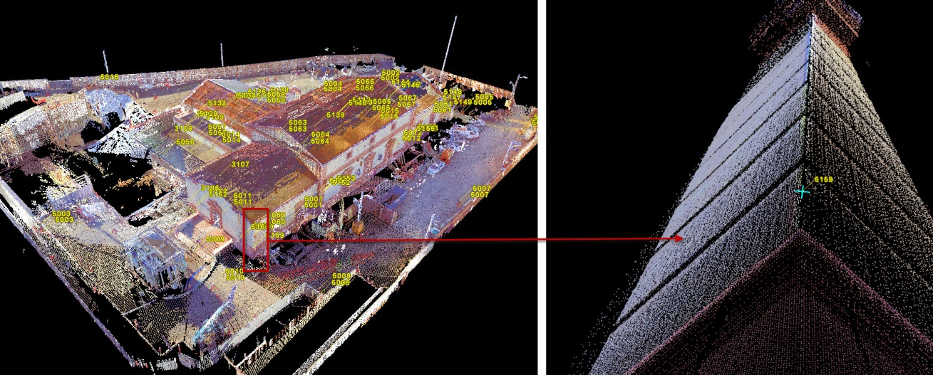
Figure 5 – Control points vs. quality control validation points
Control points are shown [in yellow] within the registered scan data (left image). A quality control validation point shot on the corner of the building (right image) can be used to help validate the accuracy of the registered point cloud data. (Image courtesy of Architectural Resource Consultants – ARC)

Redundant measurements during the survey control of scan targets is a best practice and adds another level of accuracy for the survey control network (e.g., shooting corner points of the building to compare against registered scan data).
- Survey Control – In order to achieve the required accuracy the contractor will need to consider how best to establish the appropriate level of survey control for the project. When a control network is required, it shall be established in conformity with the Federal Geodetic Control Committee Standards and Specifications.

It is the contractor’s sole responsibility to determine the level of control required and the procedures that need to be followed to achieve the desired level of accuracy. A Survey Control Report should detail: the methods used; the error of closure of the control traverse; how an open-end traverse was checked; and any information on the control monumentation, if it was made permanent.

- Monitor Field Data Collection – The contractor will describe the methodology for monitoring the quality of the data being collected and any corrective action that would be taken in the event of a problem. A record of each abnormal event affecting quality and accuracy, and the corrective action taken, must be made. This information should be included in the Data Acquisition Certification Report. The Data Acquisition Certification Report shall provide sufficient detail for an independent third party to duplicate the field work performed. The following checklist can be found in Appendix 3 which outlines all items required to be included in the report.
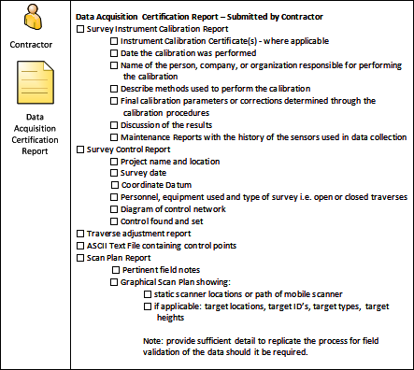
Figure 6 – Contractor - Data Acquisition Certification Report Checklist on page 43
- Data Processing and Validation – The contractor will outline the methodology used to post-process the data and check its integrity. These checks, including Registration Reports detailing the scan registration accuracies, a statistical comparison of the point cloud data, and screen shots comparing point cloud with the derived CAD models and/or BIM will be documented and included as part of the final deliverables. The GSA representative then can review these without the use of proprietary software. The contractor shall also outline the proposed procedure to show/review deliverables with GSA, prior to providing final deliverables.

- Final Deliverables - The contractor will certify through the issuance of a final version of the Project Deliverables Report that the final deliverables have been developed in accordance with the QA Project Plan established at the start of the project and that they meet the required guidelines.
In addition to the required CAD and/or BIM file format, the contractor will also provide a copy of the point cloud data using the standard ASTM E57 data exchange format.

PART 2 - Quality Control Program
The QC Program is comprised of two sections - Data Acquisition Quality Control (DAQC) and Data Processing Quality Control (DPQC). The Data Acquisition component involves all processes and procedures used in the field while the data is being acquired. The Data Processing component involves all processes and procedures used once the field data collection has been completed and the data is ready for processing.

SECTION 1

Phase 2 (Data Acquisition)
The Data Acquisition Quality Control Plan (DAQC) is the first step in implementing and carrying out the routines prescribed by the Quality Management Program. As part of the DAQC Plan the contractor shall provide a structured approach for field technicians and document their methods of data acquisition in order to confirm they are complying with the Quality Management Program.
These routines shall prescribe the means for field-testing acquired data to ensure the data being collected is accurate and a trusted representation of the actual field conditions. These tests shall be taken at the individual scan level and shall be conducted in the field, or at the end of each day of scanning, but prior to the technicians leaving the site, obviating return trips. Validation of control, extent of data capture and the ability to properly register scans are of primary concern.
The contractor shall document the data acquisition methods such that an independent third party could duplicate the results if required.

Survey Instrument Calibration:
The contractor shall establish the methods that field personnel will use to ensure that all survey instruments used on the project are properly calibrated and working within the manufacturer’s specifications whenever data is being collected. A Survey Instrument Calibration Report shall be submitted to the GSA representative certifying that all survey instruments used on the project were operated within the manufacturer’s specifications and calibrations were checked.

Control:
Control is accomplished by placing targets that have been located using standard survey control procedures (see previous section) within the Field of View (FOV) of the scanner. The contractor shall submit a Survey Control Report to the GSA representative certifying the closure accuracies and the methods used. The accuracy of the traverse survey will be reported by a proportional standard, e.g., 1:10,000, which reflects the distance-dependent nature of terrestrial surveying error.

Data Acquisition:
Scan Plan – A careful review of the Scan Plan is an important part of the QC process. Typically, at the time of the bid, the contractor is required to submit a Preliminary Scan Plan for review and approval by the GSA representative. The Preliminary Scan Plan will identify proposed scanner types and scanner locations. Often this plan is created without the contractor having had a chance to visit the jobsite in person.

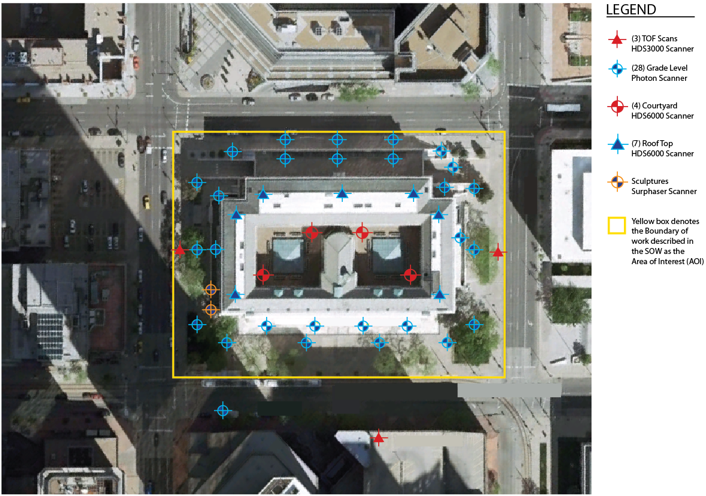
Figure 7 - Sample Preliminary Scan Plan
Upon arrival at the jobsite, the contractor will assess what (if any) adjustments need to be made to the Preliminary Scan Plan. Any required modifications to the Preliminary Scan Plan are typically documented in the scan technician’s field notes. The updated Preliminary Scan Plan shall become known simply as the Scan Plan once actual locations are known and represented. These notes shall serve to document the actual scanner locations as well as target locations, target IDs and target heights in sufficient detail to replicate the process for field validation of the data, should it be required. The Scan Plan will be submitted as the Scan Plan Report component of the Data Acquisition Certification Report.
If a target becomes unusable because the RMS (Root-mean-square) error is too great, a cloud-to-cloud registration process may be acceptable. In such cases, it should be documented which targets were unusable, why they were unusable and which scans relied upon a cloud-to-cloud registration process.
It should also be noted that some technologies utilize feature recognition to capture and register scan data. In these instances, the traditional process of target placement may not be relevant. If scanning is based on targetless registration, sufficient documentation shall be provided such that the data capture can be replicated and checked by an independent third party.
- Site Conditions – Prior to beginning the work, the Area of Interest (AOI) shall be evaluated to determine the best time to collect data. Attention must be paid to identify obstructions and to minimize excessive artifacts that may cast shadows and cause occlusions in the data. For exterior work, it is important to check the weather forecast for rain, snow, fog, smoke, or blowing dust as well as extreme temperatures that may affect the scanner’s performance.

- Scanner Location – The following items should be considered when deciding where the scanner optimally should be located. In addition, safety should always be taken into consideration when selecting setup locations (Refer to GSA BIM Guide Series 03, Section 2.1.4.2.).

  - Useful Range – The accuracy of scan data cannot be relied on beyond its useful range. Point data from a scanner will become more widely spaced as the distance from the scanner increases and less laser energy is returned. At a certain distance the error will exceed acceptable standards and beyond that, no data will be returned. Consideration must be given to ensure that the data outside the useful range of the scanner is not relied upon for the final deliverables. The useful range is determined by factors such as the individual scanner’s accuracy and range specifications as well as the accuracy requirements of the subject project.

  - Point Density – Choosing the proper point density is important since it not only impacts the density of the data, but also the speed at which the data is acquired and processed. If the point density specified is set too low, there may not be sufficient points captured to adequately model the Items of Interest (IOI). If the point density specified is set too high, the data acquisition time may be very long and may make working with the data set very difficult and could severely impact the performance of the computer used to process the data. The contractor shall also ensure that proper overlap of scans is achieved in order to comply with the point density specified for the project.

It is recommended that the project’s point spacing specification be compared to the performance specification of the laser scanner manufacturer in order to select the appropriate scanner resolution for acquisition of the required point density.

  - Positioning – 3D imaging systems are line-of-sight instruments. This makes the selection of scan locations and proper positioning crucial to ensuring proper data capture and efficient processing of the data. Factors to consider when selecting a scan location in order to minimize error and/or noise in the data include:

    - Angle of incidence to the object
    - Environmental conditions

    - Targets – The contractor shall use industry accepted targets and follow manufacturer’s recommended spacing/distance for placement of targets. Targets should not be moved until scanning operations have been completed.

    - Field Data Collection Checks - The contractor will monitor the data being collected and take corrective action as needed to ensure that the data being collected meets the required quality control standards as stated in the QA Project Plan.

SECTION 2

Phase 3 (Data Processing)
Once the completeness of the data has been verified in the field, the data can be transferred to the office for post-processing. The actual post processes used will depend on the required final deliverables. Some common forms of deliverables may include registered point cloud data, 2D line work, 3D geometric models, BIM and/or other 3D imagery. A thorough review of the point cloud and model data is critical to ensure the final quality of the deliverables.
- The following Data Processing Quality Control (DPQC) procedures and checks will be performed by the contractor while processing the data and preparing three reports: (1) Registration Accuracy Report, (2) Visual Data Check Report, and (3) Model Check Report which shall be included in the contractor’s Data Processing Certification Report. Should the contractor who collects the data be different than the contractor who is processing the data, the contractor who collected the data will be responsible to certify and submit the Registration Accuracy Report and the Visual Data Check Report. The following checklist can be found in Appendix 3 which outlines all items required to be included in the report.

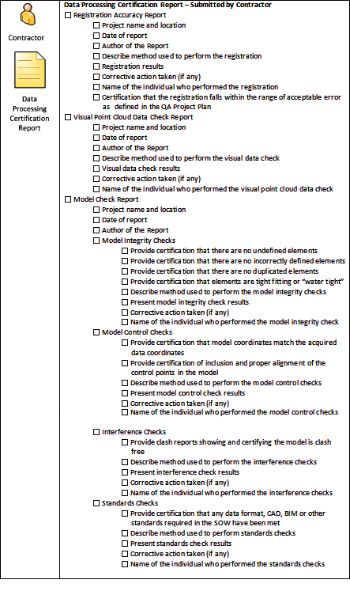
Figure 8 – Contractor - Data Processing Certification Report Checklist on page 44

Registration Accuracy Report:
As part of the process of validating the accuracy of the registration process a Registration Accuracy Report certifying the accuracies of the point cloud registration will be submitted to the GSA. The QA Project Plan should specify what an acceptable registration error is.

Visual Point Cloud Data Check Report:
Visual checks shall be performed on the raw point cloud data. The contractor will check for items that may have been overlooked or improperly processed. Visual checks should be performed by an experienced laser scanning professional on the contractor's team to spot issues that may not be apparent to an untrained eye. The GSA representative can request that the contractor validate through a live (in-person) or on-line web meeting.
A Visual Data Check Report will be prepared certifying the accuracy of the results of the process. If appropriate, screen shots may be used to help illustrate the findings.

Model Check Report:
A Model Check Report will be prepared by the contractor certifying the accuracies obtained and the overall level of quality achieved in the modeling process. This report will include Model Integrity Checks, Model Control Checks, Interference Checks and Standards Checks.

Model Integrity Checks:
Checks shall be performed by the contractor to ensure that the data has no undefined, incorrectly defined or duplicated elements. This is a visual check that is sometimes referred to as a “watertight model” wherein modeled elements are joined properly and are “tight fitting”. This step may also include comparing the raw point cloud data to the modeled data. For validation, the GSA representative can request screen shots be provided by the contractor and/or direct the contractor to present the data through a live (in-person) or on-line web meeting.

Model Control Checks:
The contractor shall certify that the acquired data’s coordinate system matches the modeled data. As an added check the control points shall be included in the modeled data. Control points will be used as a visual comparison to their location in the model vs. their location in the point cloud data. To illustrate how well the modeled data aligns with the acquired data, the contractor will provide screen shots of scan data overlays to the GSA representative.

Interference Checks:
When modeling is required by the SOW, the contractor shall perform interference checks on the modeled data. The purpose of the interference check is to identify modeled elements that are clashing with each other. Clash reports shall be generated and delivered to the GSA representative showing and certifying that the model is clash-free, or that identifies any clashes and justifies their presence.

Standards Checks:
The contractor shall certify that any data format, CAD, BIM or other standards required in the SOW have been met. The contractor will provide a method for demonstrating this. When a model is provided as a deliverable, a model-checking software report may be considered as one acceptable form of showing compliance. Any such reports shall be provided to the GSA representative for review and acceptance.

Phase 4 (GSA Preliminary Review of Data)
Once the data has been processed and quality checked the contractor shall prepare a preliminary submission for review by the GSA. This submission will include the Data Acquisition Certification Report and the Data Processing Certification Report in addition to the required data deliverables in a format that will allow the GSA representative to perform the required quality control checks.
As part of the review process, visual checks will be done by the GSA representative. This will require that the GSA representative have access to the native software used to publish the data or a free data viewer program. When the software or a viewer is not available, the GSA representative can either request that screen shots are provided or that the contractor present the data through a live (in-person) or on-line web meeting.

Phase 5 (Data Validation)
Should the GSA representative have questions about the validity of the data he/she can request that the contractor set up a field validation demonstration. It is critical that the procedures for this process be established at the beginning of the project and that both the contractor and the GSA representative be present during the demonstration.
The contractor shall certify the process, methods and results in the Field Quality Demonstration Report along with any follow-up work that may be required. The following checklist can be found in Appendix 3 which outlines all items required to be included in the report.
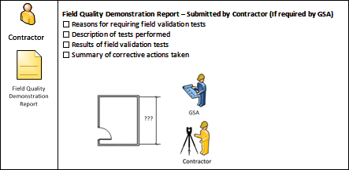
Figure 9 – Contractor - Field Quality Demonstration Report Checklist on page 46
Based on the results of the field validation, the GSA representative may either accept or reject all or portions of the data. This will determine whether the contractor needs to perform additional work in the field and/or the office to resolve any and all issues.

Phase 6 (Final Submission)
Once the GSA representative has indicated that all outstanding issues have been resolved, the contractor will prepare and submit the Final Deliverables Package that will include the completed Project Data and the Project Data Deliverable Report. The contractor will summarize the overall results of the project in terms of quality management in this report. Said report shall be submitted along with final copies of the Data Acquisition Certification Report, the Data Processing Certification Report and, if performed, the Field Quality Demonstration Report. The following checklist can be found in Appendix 3 which outlines all items required to be included in the report.
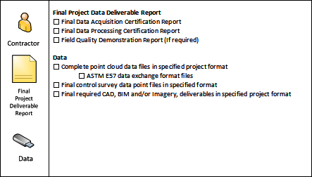
Figure 10 – Contractor - Final Project Data Deliverable Report Checklist on page 47

Appendix 1

Quality Management Program Process Map

        - This page intentionally left blank -

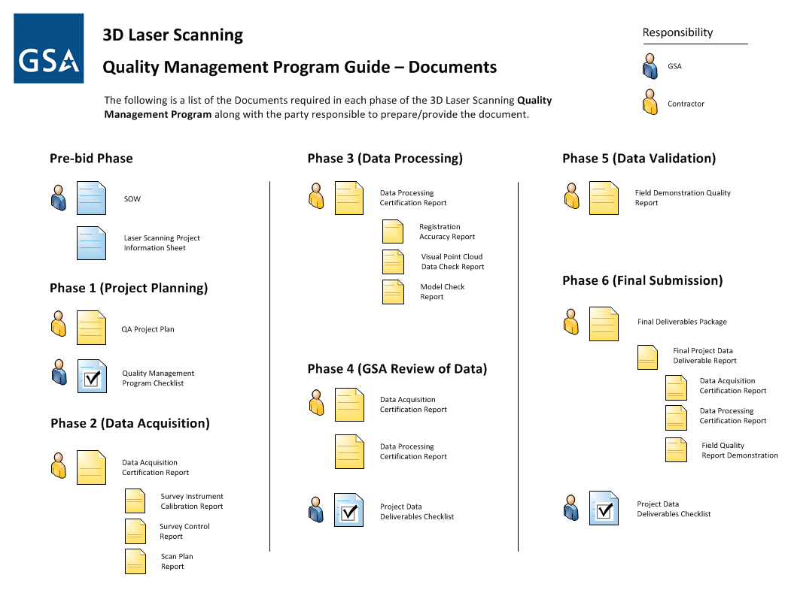
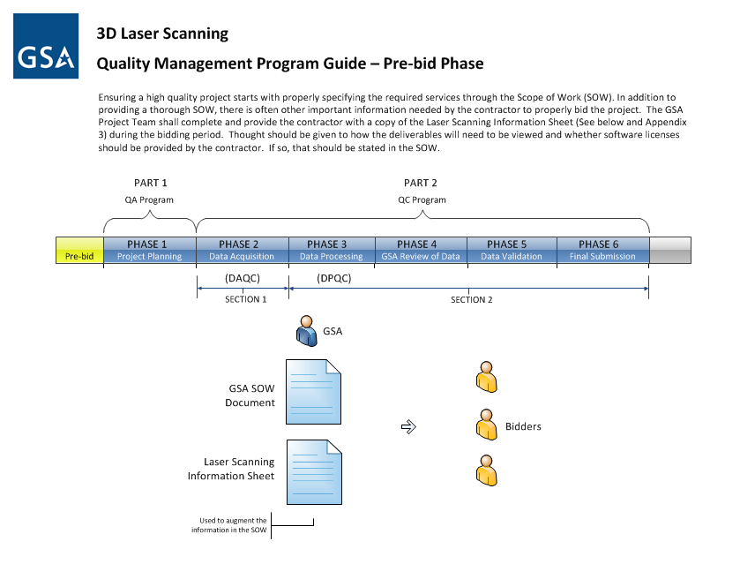

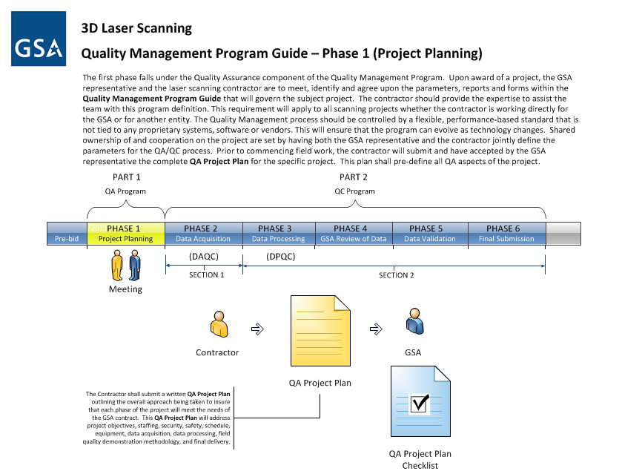
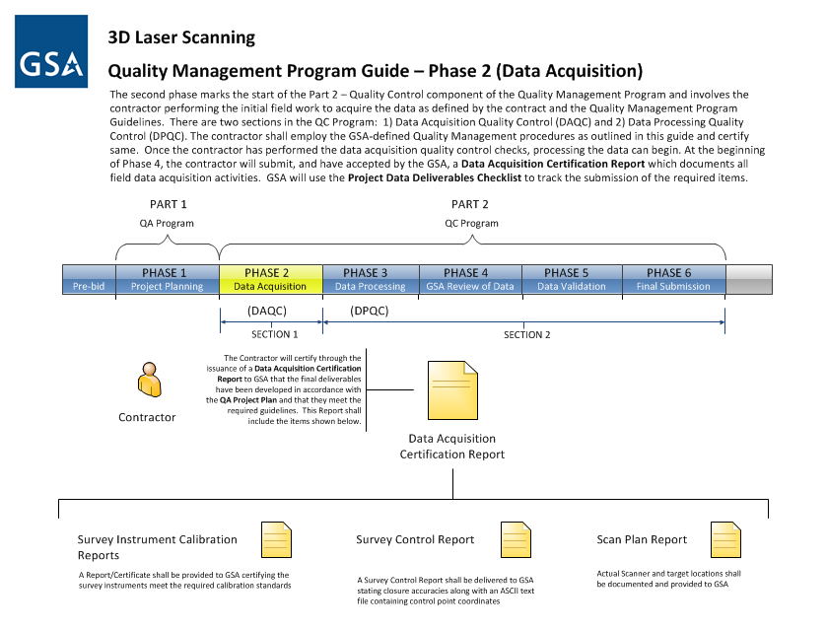

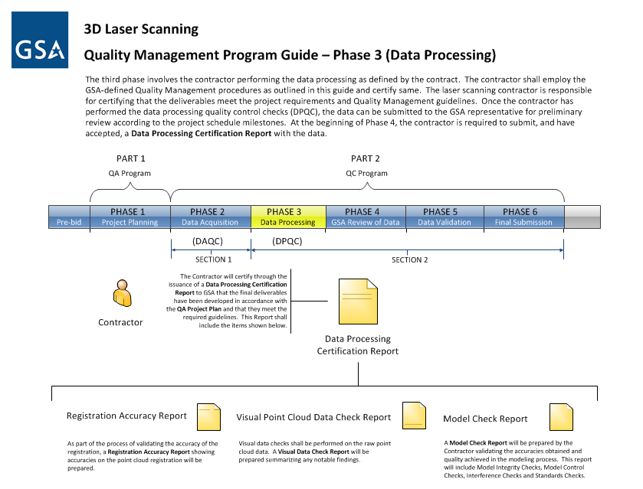
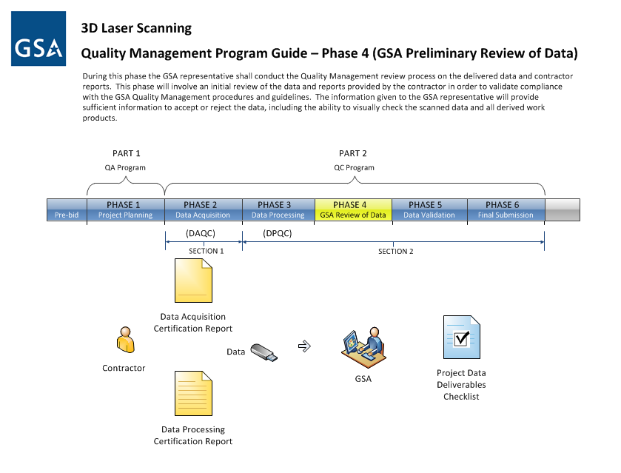
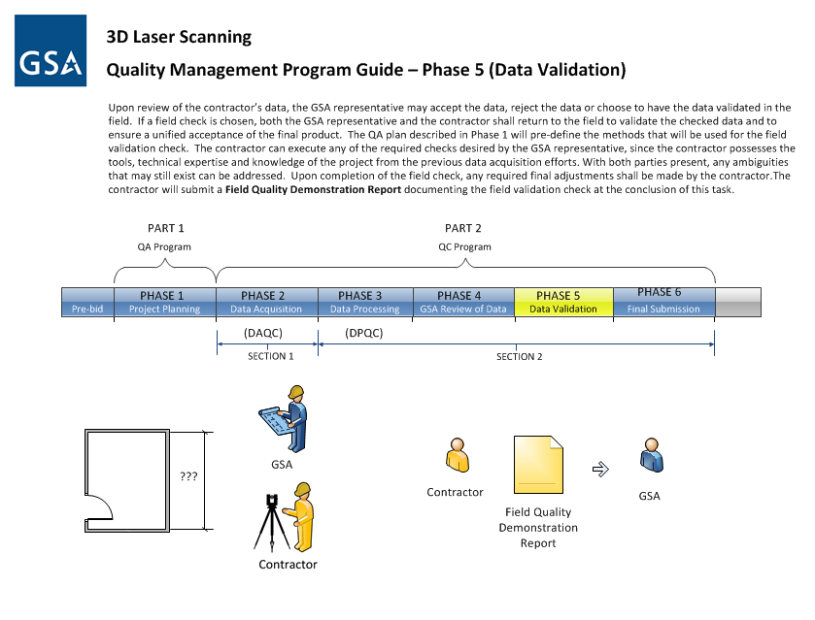
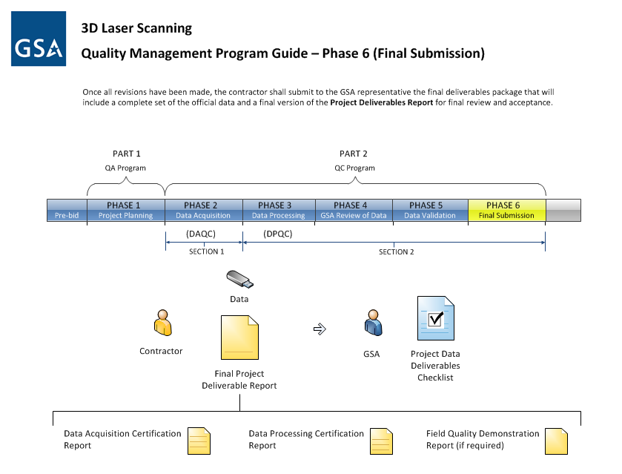

Appendix 2

Quality Management Program Checklists Summary

This is a summary of all of the checklists and reports to be used by both the GSA Representative and the Contractor while executing the Quality Control Program

GSA Representative Checklists
  - Project Information Sheet – to be filled out by the GSA Representative and provided to all bidders - PRE-BID
  - QA Project Plan Checklist - PHASE 1
  - Project Data Deliverables Checklist - PHASE 4 – 6

Contractor Reports
- QA Project Plan (Submitted prior to start of project) – PHASE 1
- Data Acquisition Certification Report – PHASE 2
    - Survey Instrument Calibration Reports
    - Survey Control Report
    - Scan Plan Report
- Data Processing Certification Report – PHASE 3
    - Registration Reports –(Statistical Comparison Of Point Cloud Data)
    - Visual Point Cloud Data Check Report
    - Model Check Report:
      - Model Integrity Checks
      - Model Control Checks
      - Interference Checks
      - Standards Checks
- Field Quality Demonstration Report (if requested) – PHASE 5
- Final Project Deliverable Report – PHASE 6

Appendix 3

Quality Management Program Checklists

        - This page intentionally left blank -

Laser Scanning Information Sheet
This Checklist is intended to be used by the GSA Representative to provide information that will be helpful for the Contractors bidding the work.

Laser Scanning Information Sheet

Please fill out this information sheet to allow laser scanning contractors to develop an appropriate plan and price for your laser scanning project. If you have any questions, please contact your Regional BIM Champion and Central Office BIM Program.

Project Information
Project Name | Click here to enter text.
Project Location | Click here to enter text.

Building Information
Building Type/Use: | Click here to enter text.
Levels Above Grade: | Click here to enter text.
Levels Below Grade: | Click here to enter text.
Square Footage of Building: | Click here to enter text.

Existing Documentation

Indicate what documentation is available and what file formats. Provide access to the Contractor
Floor Plans (PDF or CAD?) | Click here to enter text.
Elevations (PDF or CAD?) | Click here to enter text.
Site Plan (PDF or CAD?) | Click here to enter text.
Photographs | Click here to enter text.
Other: | Click here to enter text.

Accessibility and Field Conditions
Scanning times | Click here to enter text.
Occupied or Vacant? | Click here to enter text.
Is power available? | Click here to enter text.
Hazardous Conditions | Click here to enter text.
Security Requirements  - Escort Required?  - Secure Room available to leave laser scanning equipment?  - Security Clearances Required? | Click here to enter text.
Can registration targets be left up overnight? | Click here to enter text.
Can permanent control points be set? | Click here to enter text.
If above ceiling conditions need to be scanned, is the contractor responsible for removing and replacing ceiling tiles and/or cleaning debris? | Please include any existing reflected ceiling plans so Contractor can assess accessible locations.
Will equipment data need to be collected (e.g., Model and Serial Numbers) during scanning process? | Click here to enter text.

Laser Scanning Objectives
Brief Description of the laser scanning objectives: | Click here to enter text.
Who will use the data and how will they use it? | Click here to enter text.
Are there anticipated future uses of the data? | Click here to enter text.
Deliverables Required
Provide an overview of deliverables required. A complete specification will be developed in the SOW based on this information. If necessary, indicate any specific file formats.
Format:  ☐ 2D AutoCAD Drawings (.dwg, .dgn)  ☐ Registered Scan Data (Point Cloud) (.imp, .pts, .fls, .e57)  ☐ Geometric - 3D AutoCAD Model (No intelligence) (.dwg)  ☐ BIM - 3D Model (Intelligent) (.rvt)  ☐ BIM Viewing (.nwd)  ☐ Scanned Data Viewing (TruViews)  ☐ Other: (please specify)Click here to enter text. | For informational purposes only. Please see scope of work for base deliverables and optional deliverables.  Click here to enter text.
2D (check all that apply):  ☐ Site Plan. (Define boundary).  ☐ Interior Floor Plan  ☐ Exterior Building Elevations  ☐ Interior Building Elevations.  Where and how many?___________________  ☐ Roof Plan  ☐ Building Sections  Where and how many? __________________  ☐ Furniture Plan  ☐ Reflected Ceiling Plan  ☐ Fire Protection Plan  ☐ Equipment Plan  ☐ HABS Survey (Historic American Buildings Survey)  Level 1, 2 or 3?Click here to enter text. | Click here to enter text.
3D – geometry only (check all that apply):  ☐ Site  ☐ Architectural  ☐ Structural  ☐ Mechanical  ☐ Electrical  ☐ Plumbing  ☐ Fire Protection | Click here to enter text.
BIM data required (check all that apply):  ☐Spatial Information  ☐Equipment Information  ☐ Make  ☐ Model  ☐ Serial Number  ☐ Other | Click here to enter text.
Other:  ☐ Digital Photos (.jpg)  ☐ Spherical QuickTime (.mov)  ☐ Spherical QuickTime (.mov) HDR | Click here to enter text.

GSA Representative – QA Project Plan Checklist
This Checklist is intended to be used by the GSA Representative to verify that all of the items required by the GSA Quality Assurance Program have been received from the Contractor
PHASE 1 – Project Planning
Quality Management Program
☐ Project Objectives
☐ Statement of Intent
☐ Level of Accuracy
☐ Level of Detail and Resolution
☐ Staffing
☐ Experience
☐ Qualifications
☐ Security
☐ Safety Plan
☐ On-site schedule
☐ Equipment
☐ Type and Model
☐ Equipment Calibration Reports
☐ On-site Storage
☐ Data Acquisition
☐ Methodology
☐ Data Density
☐ Scan Plan
☐ Survey Control
☐ Targets
☐ On-site Data Storage
☐ Field Checks
☐ Data Processing
☐ Registration Reports
☐ Statistical comparison of point cloud data and control points
☐ Visual point cloud data check report
☐ Model Check Reports
☐ Standards report
☐ Field Quality Demonstration Methodology
☐ Final Deliverables
☐ Field Quality Demonstration Report
☐ Final Certification

GSA Representative - Project Data Deliverables Checklist
This Checklist is intended to be used by the GSA Representative to verify that all of the items required by the GSA Quality Control Program have been received from the Contractor
PHASE 2 – Data Acquisition (DAQC)
Data Acquisition Certification Report – Submitted by Contractor
☐ Survey Instrument Calibration Report
☐ Instrument Calibration Certificate(s) - where applicable
☐ Date the calibration was performed
☐ Name of the person, company, or organization responsible for performing the calibration
☐ Describe methods used to perform the calibration
☐ Final calibration parameters or corrections determined through the calibration procedures
☐ Discussion of the results
☐ Maintenance Reports with the history of the sensors used in data collection
☐ Survey Control Report
☐ Project name and location
☐ Survey date
☐ Coordinate Datum
☐ Personnel, equipment used and type of survey i.e. open or closed traverses
☐ Diagram of control network
☐ Control found and set
☐ Traverse adjustment report
☐ ASCII Text File containing control points
☐ Scan Plan Report
☐ Pertinent field notes
☐ Graphical Scan Plan showing:
☐ static scanner locations or path of mobile scanner
☐ if applicable: target locations, target ID’s, target types, target heights

Note: provide sufficient detail to replicate the process for field validation of the data should it be required.

PHASE 3 – Data Processing (DPQC)
Data Processing Certification Report – Submitted by Contractor
☐ Registration Accuracy Report
☐ Project name and location
☐ Date of report
☐ Author of the Report
☐ Describe method used to perform the registration
☐ Registration results
☐ Corrective action taken (if any)
☐ Name of the individual who performed the registration
☐ Certification that the registration falls within the range of acceptable error as defined in the QA Project Plan
☐ Visual Point Cloud Data Check Report
☐ Project name and location
☐ Date of report
☐ Author of the Report
☐ Describe method used to perform the visual data check
☐ Visual point cloud data check results
☐ Corrective action taken (if any)
☐ Name of the individual who performed the visual point cloud data check
☐ Model Check Report
☐ Project name and location
☐ Date of report
☐ Author of the Report
☐ Model Integrity Checks
☐ Provide certification that there are no undefined elements
☐ Provide certification that there are no incorrectly defined elements
☐ Provide certification that there are no duplicated elements
☐ Provide certification that elements are tight fitting or “water tight”
☐ Describe method used to perform the model integrity checks
☐ Present model integrity check results
☐ Corrective action taken (if any)
☐ Name of the individual who performed the model integrity check
☐ Model Control Checks
☐ Provide certification that model coordinates match the acquired data coordinates
☐ Provide certification of inclusion and proper alignment of the control points in the model
☐ Describe method used to perform the model control checks
☐ Present model control check results
☐ Corrective action taken (if any)
☐ Name of the individual who performed the model control checks
☐ Interference Checks
☐ Provide clash reports showing and certifying the model is clash free
☐ Describe method used to perform the interference checks
☐ Present interference check results
☐ Corrective action taken (if any)
☐ Name of the individual who performed the interference checks

☐ Standards Checks
☐ Provide certification that any data format, CAD, BIM or other standards required in the SOW have been met
☐ Describe method used to perform standards checks
☐ Present standards check results
☐ Corrective action taken (if any)
☐ Name of the individual who performed the standards checks

PHASE 4 – GSA Preliminary Review of Data
The GSA Representative shall use this Project Data Deliverables Checklist to verify the items listed in Phase 2 and Phase 3 above have been received.
Project Data Deliverables Checklist
☐ Review Phase 2 – Data Acquisition Certification Report
☐ Review Phase 3 – Data Processing Certification Report
☐ Review Data

PHASE 5 – Data Validation
Field Quality Demonstration Report – Submitted by Contractor (If required by GSA)
☐ Reasons for requiring field validation tests
☐ Description of tests performed
☐ Results of field validation tests
☐ Summary of corrective actions taken

PHASE 6 – Final Submission
Final Project Deliverable Report
☐ Final Data Acquisition Certification Report
☐ Final Data Processing Certification Report
☐ Field Quality Demonstration Report (If required)
☐ Results of field validation tests
☐ Summary of corrective actions taken

Data
☐ Complete point cloud data files in specified project format
☐ ASTM E57 data exchange format files
☐ Final control survey data point files in specified format
☐ Final required CAD, BIM and/or Imagery, deliverables in specified project format

Contractor - QA Project Plan Checklist
This Checklist is intended to be used by the Contractor. The Contractor shall submit a written QA Project Plan outlining the overall approach being taken to ensure that each phase of the project will meet the needs of the GSA contract. This QA Project Plan will address project objectives, staffing, security, safety, schedule, equipment, data acquisition, data processing, field quality demonstration methodology, and final delivery.

Quality Management Program
☐ Project Objectives
☐ Statement of Intent
☐ Level of Accuracy
☐ Level of Detail and Resolution
☐ Staffing
☐ Experience
☐ Qualifications
☐ Security
☐ Safety Plan
☐ On-site schedule
☐ Equipment
☐ Type and Model
☐ Equipment Calibration Reports
☐ On-site storage
☐ Data Acquisition
☐ Methodology
☐ Data density
☐ Scan Plan
☐ Survey control
☐ Targets
☐ On-site data storage
☐ Field Checks
☐ Data Processing
☐ Registration reports
☐ Statistical comparison of point cloud data and control points
☐ Visual point cloud data check report
☐ Model check reports
☐ Standards report
☐ Field Quality Demonstration Methodology
☐ Final Deliverables
☐ Field Quality Demonstration Report
☐ Final Certification

Contractor - Data Acquisition Certification Report Checklist
This report is required to be submitted by the Contractor to GSA for the purpose of certifying that their data acquisition deliverables meet the project requirements and QA/QC guidelines. This report shall address the following items:
PHASE 2 – Data Acquisition (DAQC)
Data Acquisition Certification Report – Submitted by Contractor
☐ Survey Instrument Calibration Report
☐ Instrument Calibration Certificate(s) - where applicable
☐ Date the calibration was performed
☐ Name of the person, company, or organization responsible for performing the calibration
☐ Describe methods used to perform the calibration
☐ Final calibration parameters or corrections determined through the calibration procedures
☐ Discussion of the results
☐ Maintenance Reports with the history of the sensors used in data collection
☐ Survey Control Report
☐ Project name and location
☐ Survey date
☐ Coordinate Datum
☐ Personnel, equipment used and type of survey i.e. open or closed traverses
☐ Diagram of control network
☐ Control found and set
☐ Traverse adjustment report
☐ ASCII Text File containing control points
☐ Scan Plan Report
☐ Pertinent field notes
☐ Graphical Scan Plan showing:
☐ static scanner locations or path of mobile scanner
☐ if applicable: target locations, target ID’s, target types, target heights

Note: provide sufficient detail to replicate the process for field validation of the data should it be required.

Contractor - Data Processing Certification Report Checklist
This report is required to be submitted by the Contractor to GSA for the purpose of certifying that their data processing deliverables meet the project requirements and QA/QC guidelines. This report shall address the following items:
PHASE 3 – Data Processing (DPQC)
Data Processing Certification Report – Submitted by Contractor
☐ Registration Accuracy Report
☐ Project name and location
☐ Date of report
☐ Author of the Report
☐ Describe method used to perform the registration
☐ Registration results
☐ Corrective action taken (if any)
☐ Name of the individual who performed the registration
☐ Certification that the registration falls within the range of acceptable error as defined in the QA Project Plan
☐ Visual Point Cloud Data Check Report
☐ Project name and location
☐ Date of report
☐ Author of the Report
☐ Describe method used to perform the visual data check
☐ Visual data check results
☐ Corrective action taken (if any)
☐ Name of the individual who performed the visual point cloud data check
☐ Model Check Report
☐ Project name and location
☐ Date of report
☐ Author of the Report
☐ Model Integrity Checks
☐ Provide certification that there are no undefined elements
☐ Provide certification that there are no incorrectly defined elements
☐ Provide certification that there are no duplicated elements
☐ Provide certification that elements are tight fitting or “water tight”
☐ Describe method used to perform the model integrity checks
☐ Present model integrity check results
☐ Corrective action taken (if any)
☐ Name of the individual who performed the model integrity check
☐ Model Control Checks
☐ Provide certification that model coordinates match the acquired data coordinates
☐ Provide certification of inclusion and proper alignment of the control points in the model
☐ Describe method used to perform the model control checks
☐ Present model control check results
☐ Corrective action taken (if any)
☐ Name of the individual who performed the model control checks

☐ Interference Checks
☐ Provide clash reports showing and certifying the model is clash free
☐ Describe method used to perform the interference checks
☐ Present interference check results
☐ Corrective action taken (if any)
☐ Name of the individual who performed the interference checks
☐ Standards Checks
☐ Provide certification that any data format, CAD, BIM or other standards required in the SOW have been met
☐ Describe method used to perform standards checks
☐ Present standards check results
☐ Corrective action taken (if any)
☐ Name of the individual who performed the standards checks

Contractor – Field Quality Demonstration Report Checklist
Should the Contractor be required to field validate the checked data the Contractor is required to submit a Field Quality Demonstration Report outlining the following items:

PHASE 5 – Data Validation
Field Quality Demonstration Report – Submitted by Contractor (If required by GSA)
☐ Reasons for requiring field validation tests
☐ Description of tests performed
☐ Results of field validation tests
☐ Summary of corrective actions taken

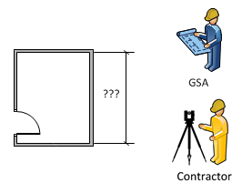

Contractor – Final Project Data Deliverable Report Checklist
This report, along with the final data, is required to be submitted by the Contractor to GSA and will summarize the overall results of the project in terms of quality management. This report shall be submitted along with final copies of the Data Acquisition Certification Report, the Data Processing Certification Report and, if performed, the Field Quality Demonstration Report (if required).

PHASE 6 – Final Submission
Final Project Data Deliverable Report
☐ Final Data Acquisition Certification Report
☐ Final Data Processing Certification Report
☐ Field Quality Demonstration Report (If required)

Data
☐ Complete point cloud data files in specified project format
☐ ASTM E57 data exchange format files
☐ Final control survey data point files in specified format
☐ Final required CAD, BIM and/or Imagery, deliverables in specified project format

Table of Figures

The following is a Table of Figures that can be found in this document with their respective page number for easy cross-referencing.

Figure 1 - Phase Diagram 5
Figure 2 - Laser Scanning Information Sheet on page 34 6
Figure 3 - Contractor - QA Project Plan Checklist on page 42 10
Figure 4 - GSA Representative - QA Project Plan Checklist on page 37 11
Figure 5 – Control points vs. quality control validation points 13
Figure 6 – Contractor - Data Acquisition Certification Report Checklist on page 43 14
Figure 7 - Sample Preliminary Scan Plan 16
Figure 8 – Contractor - Data Processing Certification Report Checklist on page 44 19
Figure 9 – Contractor - Field Quality Demonstration Report Checklist on page 46 21
Figure 10 – Contractor - Final Project Data Deliverable Report Checklist on page 47 22

Acknowledgements

The development of this version of the GSA 3D Laser Scanning Quality Management Program Guide has been a collaborative effort among a cadre of very knowledgeable consultants working with a number of Public Building Service (PBS) associates in the Office of the Chief Architect and different GSA regions. Significant contributors are listed below:

GSA Public Building Service
- Dr. Calvin Kam, PhD, AIA, PE, LEED AP
Senior Program Expert, National 3D-4D-BIM Program at GSA
- Dr. Peggy (Ho) Yee, PhD
National BIM Program Expert at GSA
- Regional BIM Champions

GSA Consultants
- Dr. Gene V. Roe, PhD, PE, LLS
MPN Components, Inc.
- Geraldine Cheok
Research Civil Engineer
National Institute of Standards and Technology (NIST)
- Jason Cisneros
Senior BIM Technician
Architectural Resource Consultants (ARC)
- John M. Russo, AIA
President/CEO
Architectural Resource Consultants (ARC)
- Michael R. Frecks, PLS
President/CEO
Terrametrix, LLC
- BIM & Laser Scanning IDIQ Contractors

