 U.S. General Services Administration

Federal Acquisition Service

GSA Transition Coordination Center
EIS Transition Progress Tracking Report
for the period ending August 31, 2026

Version 1.0

September 23, 2026

DTID: #TCC3-ASC-0500A-20260923-00

PREPARED FOR
Transition Coordination Center
General Services Administration
Federal Acquisition Service
1800 F Street NW
Washington, DC 20405

Contract Number: GS-35F-500CA
Order Number: 47QTCB24F0002

Executive Summary

This Executive Summary provides an overview of transition progress that will be discussed in detail within this report.

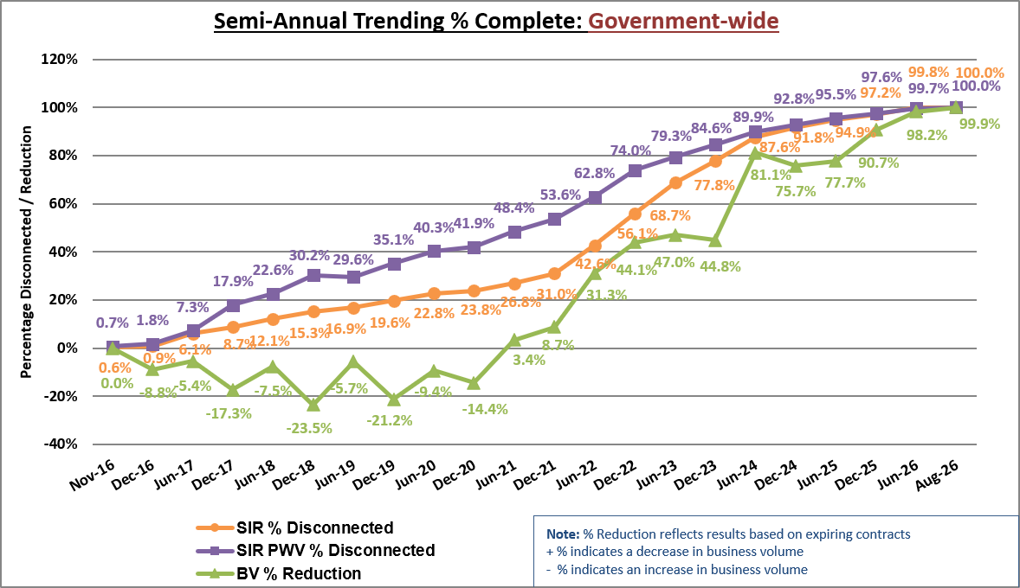
Semi-Annual Trending % Complete: Government-wide

Transition Progress Metrics Summary: Agency Category
Transition Progress Metrics Summary: Agency Category
Tracking Metric | Date Due | Percentage Complete | Total Count | Large Agencies Count | Medium Agencies Count | Small Agencies Count
Total EIS Solicitations Planned |  |  | 209 | 107 | 43 | 59
EIS Solicitations Passed GSA In-Scope Review | 3/31/2019 | 100.0% | 209 | 107 | 43 | 59
EIS Solicitations Issued to Industry | 3/31/2019 | 100.0% | 209 | 107 | 43 | 59
Task Orders Awarded (as defined by Key Metric) | 9/30/2019 | 100.0% | 209 | 107 | 43 | 59
Total Agencies |  |  | 221 | 17 | 25 | 179
Transition 50% Complete (PWV Disconnects ≥50% & <90%) | 3/31/2021 | 0.0% | 0 | 0 | 0 | 0
Transition 90% Complete (PWV Disconnects ≥90% & <100%) | 3/31/2022 | 0.0% | 0 | 0 | 0 | 0
Transition 100% Complete (Disconnects =100%) | 9/30/2022 | 100.0% | 221 | 17 | 25 | 179

This Key identifies the markings used in the EIS Transition Progress table below.

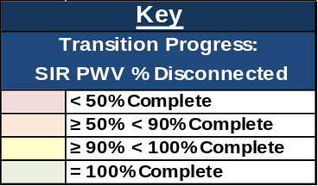

EIS Transition Progress: Large and Medium Agencies 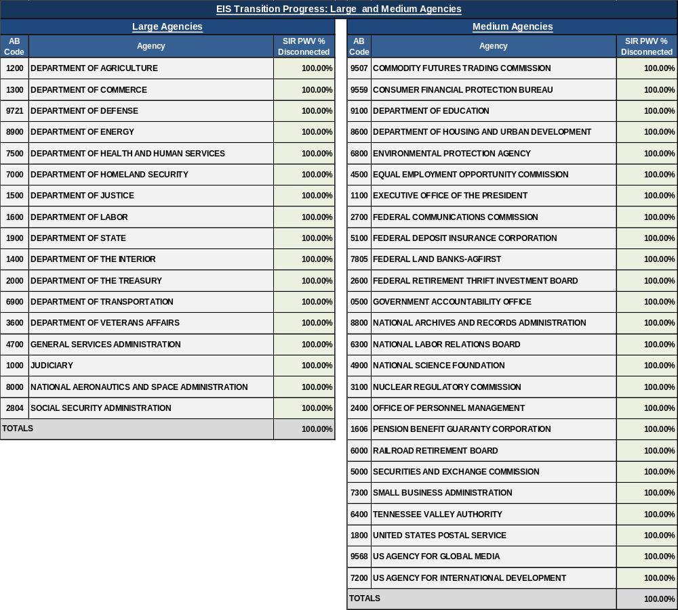
Document Change History

Version | Description | Date | Prepared By
1.0 | Original Submission | 09/23/2026 | Ken Palmer

Table of Contents

1 Introduction 6
1.1 Purpose 6
1.2 Understanding the TPTR 6
1.3 Agency Categories and Size Standards 6
1.4 Scope 6
2 Overall Status 7
2.1 Transition Summary 8
2.2 Transition Volume 8
2.3 Transition Progress - Large and Medium Agencies 10
3 Detailed Transition Progress Status Measurements 12
3.1 Transition Progress Metrics 12
3.2 Transition Progress – Government-wide 13
3.3 Transition Progress – Program 15
3.4 Transition Progress - Contractor 17
3.5 Transition Progress – Agency Category 19
3.5.1 Transition Progress - Large Agencies 21
3.5.2 Transition Progress – Medium Agencies 23
3.5.3 Transition progress - Small Agencies 25
3.6 Transition progress – Service Category 25
4 Risk Management 26
4.1 Lessons Learned 26
4.2 Risk Assessment 26
Appendix A – EIS Transition Progress: Small Agencies 27
Appendix B – Transition Completion Status 32
Appendix C – Key Metrics 38
Appendix D – Key Definitions 39
Appendix E – Acronyms 41
Appendix F – Service Type Standardization and Proportional Weighted Values 43

List of Tables

Table 1. Transition Progress Metrics Summary: Agency Category 8
Table 2. EIS Transition Progress: Large Agencies 10
Table 3. EIS Transition Progress: Medium Agencies 11
Table 4. EIS Transition Progress: Government-wide 13
Table 5. EIS Transition Progress: Program 15
Table 6. EIS Transition Progress: Contractor 17
Table 7. EIS Transition Progress: Agency Category 19
Table 8. EIS Transition Progress: Service Category 25

List of Figures

Figure 1. Transition Progress Milestones Gantt Chart 7
Figure 2. BV $ Current and % of Government-wide BV $ Current: Agency Category 9
Figure 3. Semi-Annual Trending % Complete: Government-wide 13
Figure 4. SIR # Active and SIR # Disconnected: Government-wide 14
Figure 5. BV $ Current and BV $ Reduction: Government-wide 14
Figure 6. Semi-Annual Trending – SIR PWV % Disconnected: Program 15
Figure 7. Semi-Annual Trending - BV % Reduction: Program 16
Figure 8. BV $ Current and % of Government-wide BV $ Current: Program 16
Figure 9. Semi-Annual Trending - SIR PWV % Disconnected: Contractor 18
Figure 10. Semi-Annual Trending - BV % Reduction: Contractor 18
Figure 11. BV $ Current and % of Government-wide BV $ Current: Contractor 19
Figure 12. Semi-Annual Trending - SIR % Disconnected: Agency Category 20
Figure 13. Semi-Annual Trending - SIR PWV % Disconnected: Agency Category 20
Figure 14. Semi-Annual Trending - BV % Reduction: Agency Category 21
Figure 15. SIR % and SIR PWV % Disconnected: Large Agencies 21
Figure 16. SIR # Active – Baseline to Current: Large Agencies 22
Figure 17. SIR PWV # Active – Baseline to Current: Large Agencies 22
Figure 18. SIR % and SIR PWV % Disconnected: Medium Agencies 23
Figure 19. SIR # Active – Baseline to Current: Medium Agencies 24
Figure 20. SIR PWV # Active – Baseline to Current: Medium Agencies 24
Figure 21. Current Status of Transition Metrics: Service Category 26

Introduction

Purpose
The General Services Administration (GSA) Enterprise Infrastructure Solutions (EIS) Transition Progress Tracking Report (TPTR) provides a monthly overview of transition progress from the expiring Networx, Washington Interagency Telecommunications System (WITS) 3, and GSA Regional local service (RLS) contracts to EIS or other contract vehicles. Progress is based upon an analysis of agency decisions and activities that indicate the level of preparedness for transition; the status of contract services agencies must disconnect; the business volume (BV) on each expiring contract; and challenges that may impact agencies’ timely completion of transition.

Understanding the TPTR
Stakeholders should refer to the Transition Progress Tracking Methodology (TPTM) for a more in-depth description of the process, tools, and metrics included in this report. A description of key metrics from the TPTM is provided in Appendix C.

Agency Categories and Size Standards
There are over 200 agencies with Transition Inventory (TI) and billing under the expiring contracts. For this report, agencies are categorized into three groups: large agencies, medium agencies, and small agencies as defined by their average annual BV on the Networx contracts in Fiscal Year (FY) 12 through FY15.
- Large agencies: 17 agencies with annual BV ≥ $10 million
- Medium agencies: 25 agencies with annual BV < $10 million but ≥ $1 million
- Small agencies: 179 agencies with annual BV < $1 million (Includes 117 agencies plus 62 Native American Tribes; Agency count [117] includes GSA-Regional Internal under AB code 0047).
For reporting, an “agency” is defined as a “transition entity.” Transition entities are specified in the Transition Entities List located on the EIS Transition webpage, under Resources (https://www.gsa.gov/technology/it-contract-vehicles-and-purchasing-programs/telecommunications-and-network-services/enterprise-infrastructure-solutions/eis-transition).

Scope
The TPTR uses actual and target metrics to track transition progress at various levels: Government-wide, Program, Contractor, Agency Category, and Service Category. This month’s report is derived from acquisition planning and decision data, TI data, and other supporting data as of August 31, 2026. BV reflects data as of July 31, 2026.

Overall Status
Figure 1 illustrates the established target dates for key milestones (defined in Appendix C) and other measurements for tracking transition progress. Subsequent subsections provide a snapshot of progress against transition metrics. For any extensions beyond the May 2024 deadline, GSA will continue to track those agencies to completion and meet with them regularly to monitor status.
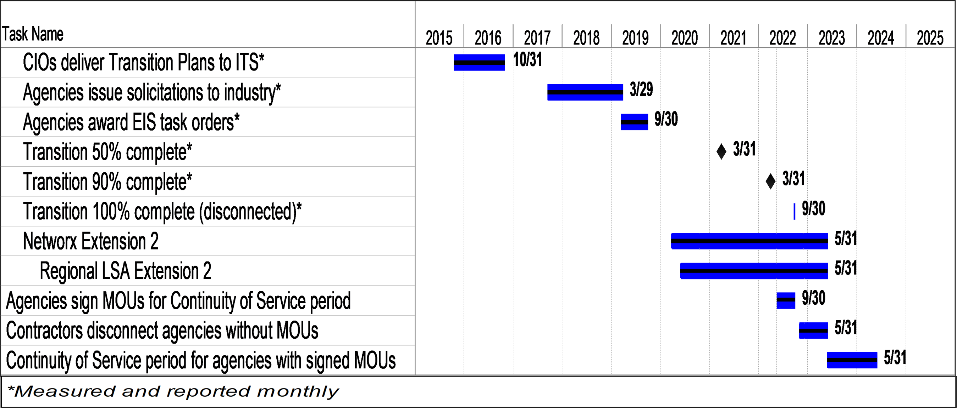
Figure 1. Transition Progress Milestones Gantt Chart

Transition Summary
Table 1 provides a summary of transition progress metrics by agency category. Agencies were to have disconnected 100% of services from expiring contracts as reported by Networx contractors, WITS 3 Project Management Office (PMO), and the Telecommunications Ordering and Pricing System (TOPS) by the date due listed. A service is represented as a “Service Instance Record (SIR),” which is a summarized rollup of a base service and the associated equipment, features, and other ancillary Contract Line-Item Numbers (CLINs). Transition entities and GSA use SIRs to track the progress of transition from Networx, WITS 3, and GSA RLS contracts. When SIRs are weighted based on their complexity to transition, it is referred to as SIR Proportional Weighted Value (PWV).
Table 1. Transition Progress Metrics Summary: Agency Category
Transition Progress Metrics Summary: Agency Category
Tracking Metric | Date Due | Percentage Complete | Total Count | Large Agencies Count | Medium Agencies Count | Small Agencies Count
Total EIS Solicitations Planned |  |  | 209 | 107 | 43 | 59
EIS Solicitations Passed GSA In-Scope Review | 3/31/2019 | 100.0% | 209 | 107 | 43 | 59
EIS Solicitations Issued to Industry | 3/31/2019 | 100.0% | 209 | 107 | 43 | 59
Task Orders Awarded (as defined by Key Metric) | 9/30/2019 | 100.0% | 209 | 107 | 43 | 59
Total Agencies |  |  | 221 | 17 | 25 | 179
Transition 50% Complete (PWV Disconnects ≥50% & <90%) | 3/31/2021 | 0.0% | 0 | 0 | 0 | 0
Transition 90% Complete (PWV Disconnects ≥90% & <100%) | 3/31/2022 | 0.0% | 0 | 0 | 0 | 0
Transition 100% Complete (Disconnects =100%) | 9/30/2022 | 100.0% | 221 | 17 | 25 | 179

Transition Volume
Transition volume provides a count of active SIRs in TI during the current period. Since the volume of active SIRs and current BV are indicators of agency transition completion status, GSA’s TCC will report on the volume of active services remaining on expiring contracts and the associated BV until both volumes are zero and there are no remaining charges.

The contracts have expired and there are no active services. Figure 2 illustrates the current BV amount ($) by agency category as a percentage of the Government-wide current BV amount ($).

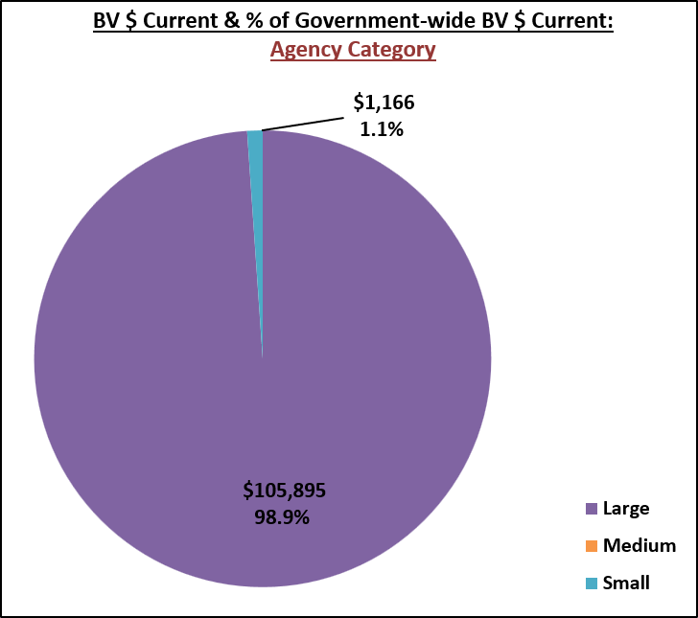
Figure 2. BV $ Current and % of Government-wide BV $ Current: Agency Category

Transition Progress - Large and Medium Agencies
Tables 2 and 3 provide the status of transition progress of the large and medium agencies. The difference between the total SIR count and the number of active SIRs is divided by the total SIR count to calculate the SIR percentage disconnected; this is shown alongside the SIR PWV percentage disconnected, which factors in complexity. The current BV amount ($) is compared to the initial BV amount ($) from November 2016 to calculate BV percentage reduction. Note that the BV % reduction can exceed 100% when the current month’s data contains credit adjustments greater than the billing charges.

This Key identifies the markings used in the EIS Transition progress tables.

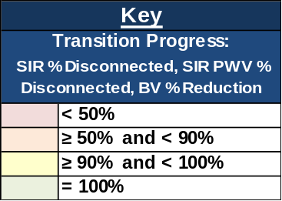
Table 2. EIS Transition Progress: Large Agencies 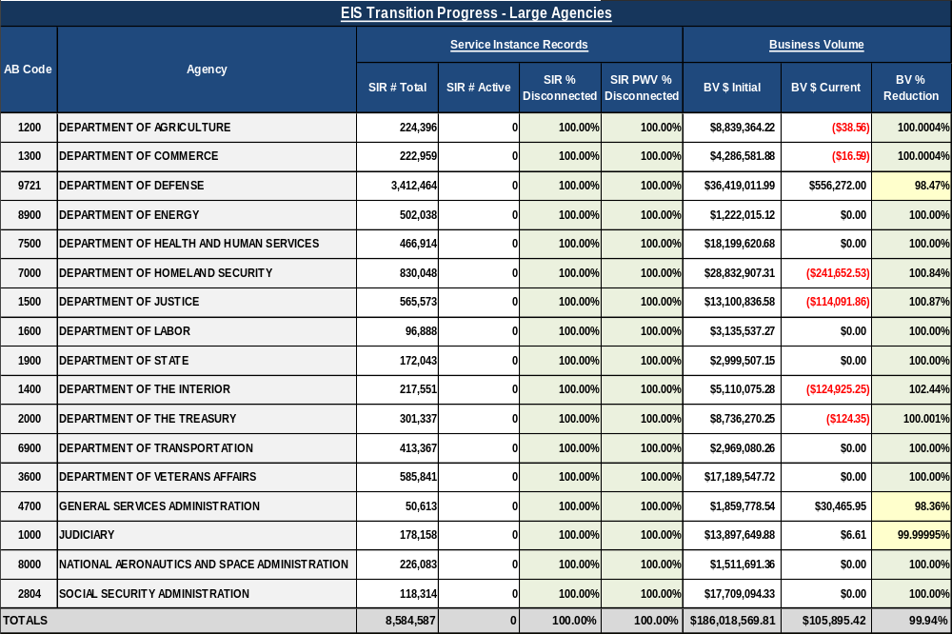

Table 3. EIS Transition Progress: Medium Agencies 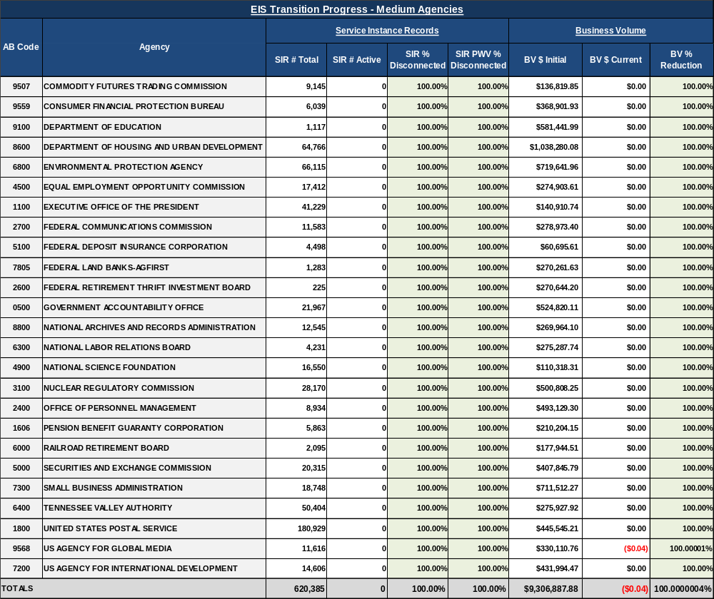

Detailed Transition Progress Status Measurements
This section provides additional details on the activities associated with each metric, driving the results on the EIS Transition Progress tables in Section 2.3 and at other tracking levels. Agencies were required to follow a fair opportunity (FO) process to issue solicitations to industry and award at least one task order (TO) against each FO solicitation. Once the EIS TOs are awarded, agencies work directly with EIS contractors to execute the transition of services. Transition is considered complete when all SIRs from expiring contracts have been disconnected and BV has been reduced to zero (also reported as BV reduction = 100%) and there are no remaining charges. These metrics are tracked at the following tracking levels: Government-wide, Program, Contractor, Agency Category (Large, Medium, Small), and Service Category.

Transition Progress Metrics
This section provides an overview of the metrics used to track and report transition progress.

Disconnect/Transition of SIRs: The SIR # Disconnected refers to the difference in the current month’s data of counts from the SIR # Total count and the SIR # Active count. The SIR % Disconnected is tracked and reported by dividing the current month SIR # Disconnected counts by the SIR # Total count. The SIR # Total includes all SIRs (active and disconnects) including new SIRs that were added to TI since the prior reporting period. Thus, the denominator for percent disconnected is always the most current SIR # Total, which allows the goal to remain 100% disconnected.

Disconnect/Transition of SIR PWV: Progress for SIRs with PWV is tracked and reported similarly to SIRs. PWV is assigned to services based on the relative difficulty of transitioning that service. The SIR # Disconnected counts for each service are multiplied by the appropriate weighted value for that service and the resulting values summed; that numerator is divided by the total weighted value of the SIRs to calculate the weighted percent disconnected. The SIR PWV % Disconnected is tracked and reported by dividing the current month SIR # Disconnected count, with weighted values applied, by the SIR # Total count, with weighted values applied. See Appendix F for the PWVs applied to each service.

Business Volume (BV) Reduction: The BV Reduction metric compares the initial BV to current BV monthly. The BV $ Initial refers to the BV total as of November 1, 2016. The BV $ Current refers to the BV total as of the end of the current reporting month. Note: Services could be 100% disconnected while BV is still > 0. Also, BV is affected by many factors other than disconnects, such as billing adjustments and usage fluctuations, and therefore could increase or decrease with no correlation to transition progress.

Transition Progress – Government-wide
This section identifies transition progress Government-wide for the following metrics: SIR disconnected, SIR PWV disconnected, and BV reduction.

Table 4 and Figure 3 illustrate the status and trending of transition progress Government-wide. The difference between the total SIR count and the number of active SIRs is divided by the total SIR count to calculate the SIR percentage disconnected; this is shown alongside the SIR PWV percentage disconnected which factors in complexity. The current BV amount ($) is compared to the initial BV amount ($) to calculate BV percentage reduction.
Table 4. EIS Transition Progress: Government-wide
EIS Transition Progress: Government-wide
Category | Service Instance Records |  |  |  | Business Volume
Category | SIR # Total | SIR # Active | SIR % Disconnected | SIR PWV % Disconnected | BV $ Initial | BV $ Current | BV % Reduction
Government-wide | 9,478,202 | 0 | 100.0% | 100.0% | $199,055,190 | $107,061 | 99.9%

Figure 3. Semi-Annual Trending % Complete: Government-wide

Figure 4 illustrates the number of active SIRs and the number of disconnected SIRs as percentages of the Government-wide total SIR count.

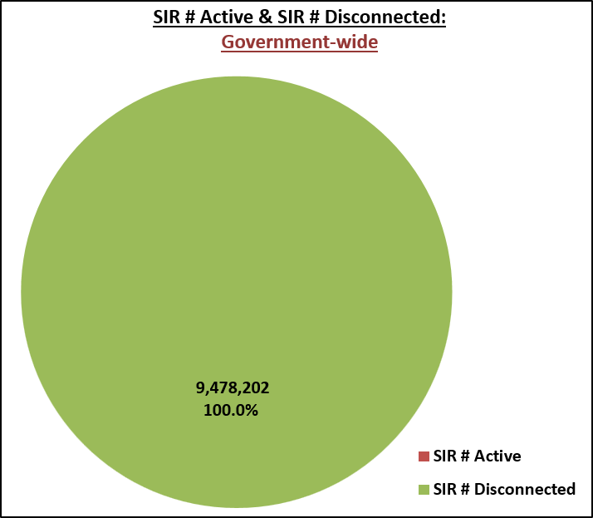
Figure 4. SIR # Active and SIR # Disconnected: Government-wide

Figure 5 illustrates the current BV amount ($) and the BV reduction amount ($) as percentages of the Government-wide total BV amount ($).

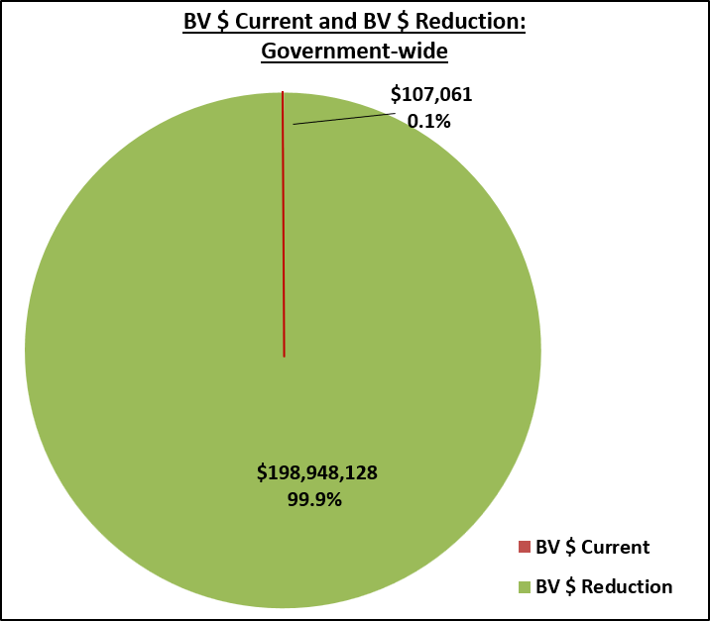
Figure 5. BV $ Current and BV $ Reduction: Government-wide

Transition Progress – Program
This section identifies transition progress by program including Networx (Universal and Enterprise), WITS 3, and the GSA RLS (where all GSA RLS contracts are grouped together) for the following metrics: SIR disconnected, SIR PWV disconnected, and BV reduction.

Table 5 and Figures 6-8 illustrate the status and trending of transition progress by program. The difference between the total SIR count and the number of active SIRs is divided by the total SIR count to calculate the SIR percentage disconnected; this is shown alongside the SIR PWV percentage disconnected which factors in complexity. The current BV amount ($) is compared to the initial BV amount ($) to calculate BV percentage reduction.
Table 5. EIS Transition Progress: Program
EIS Transition Progress: Program
Program | Service Instance Records |  |  |  | Business Volume
Program | SIR # Total | SIR # Active | SIR % Disconnected | SIR PWV % Disconnected | BV $ Initial | BV $ Current | BV % Reduction
Networx | 7,341,899 | 0 | 100.0% | 100.0% | $154,091,619 | -$1,795,387 | 101.2%
WITS 3 | 1,240,904 | 0 | 100.0% | 100.0% | $35,257,099 | $1,902,449 | 94.6%
GSA RLS | 895,399 | 0 | 100.0% | 100.0% | $9,706,472 | $0 | 100.0%
TOTALS | 9,478,202 | 0 | 100.0% | 100.0% | $199,055,190 | $107,061 | 99.9%

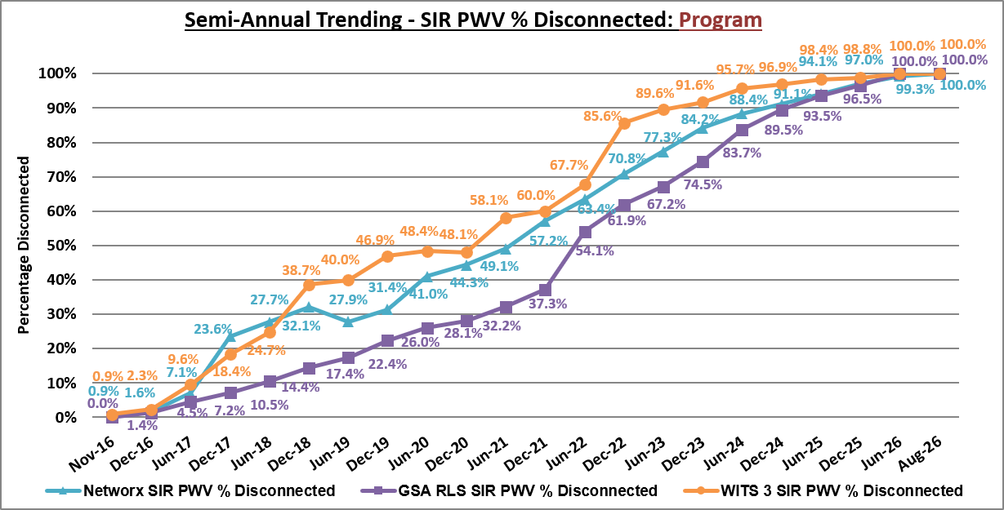
Figure 6. Semi-Annual Trending – SIR PWV % Disconnected: Program

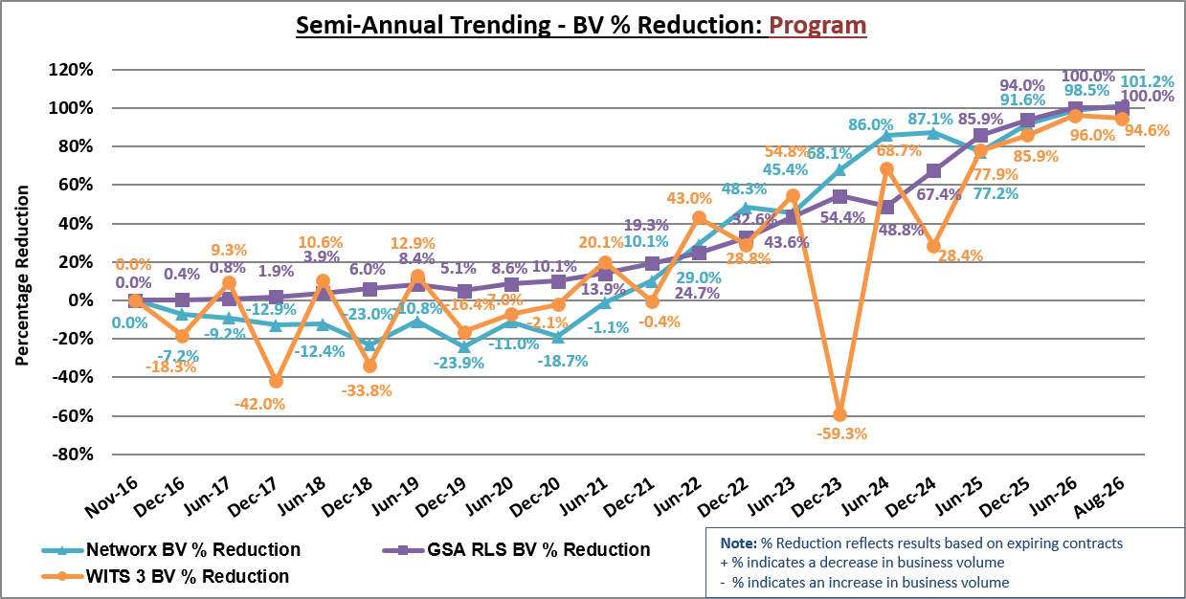
Figure 7. Semi-Annual Trending - BV % Reduction: Program

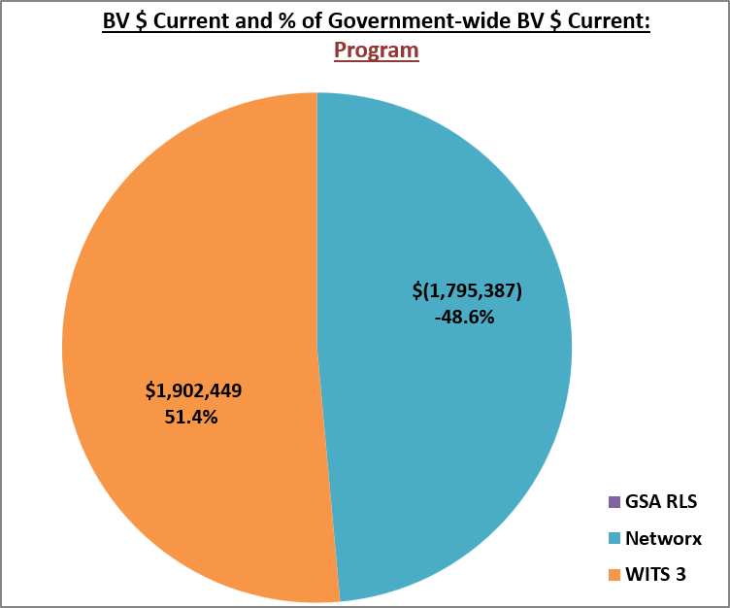
Figure 8. BV $ Current and % of Government-wide BV $ Current: Program

Transition Progress - Contractor
This section identifies transition progress by contractor including Networx and WITS 3 contractors (American Telephone & Telegraph (AT&T), CenturyLink, Level 3, Sprint, and Verizon), and GSA RLS contracts for the following metrics: SIR disconnected, SIR PWV disconnected, and BV reduction.

Note: WITS 3 and GSA RLS contracts include the local services that are interexchanged to long-distance services under the Networx program.

Table 6 and Figures 9-11 illustrate the status and trending of transition progress by contractor. The difference between the total SIR count and the number of active SIRs is divided by the total SIR count to calculate the SIR percentage disconnected; this is shown alongside the SIR PWV percentage disconnected which factors in complexity. The current BV amount ($) is compared to the initial BV amount ($) to calculate BV percentage reduction.

Note: The Sprint Networx Enterprise contract has expired; therefore, Sprint does not appear in the supporting quarterly trending figures as any fluctuations would be minor.

Table 6. EIS Transition Progress: Contractor
EIS Transition Progress: Contractor
Contractor | Service Instance Records |  |  |  | Business Volume
Contractor | SIR # Total | SIR # Active | SIR % Disconnected | SIR PWV % Disconnected | BV $ Initial | BV $ Current | BV % Reduction
Verizon | 5,970,649 | 0 | 100.0% | 100.0% | $91,952,661 | $120,959 | 99.9%
AT&T | 1,247,082 | 0 | 100.0% | 100.0% | $64,498,470 | -$11,891 | 100.02%
CenturyLink | 1,152,584 | 0 | 100.0% | 100.0% | $22,128,763 | -$2,007 | 100.01%
GSA RLS | 895,399 | 0 | 100.0% | 100.0% | $9,706,472 | $0 | 100.0%
Level 3 | 162,777 | 0 | 100.0% | 100.0% | $10,128,788 | $0 | 100.0%
Sprint | 49,711 | 0 | 100.0% | 100.0% | $640,035 | $0 | 100.0%
TOTALS | 9,478,202 | 0 | 100.0% | 100.0% | $199,055,190 | $107,061 | 99.9%

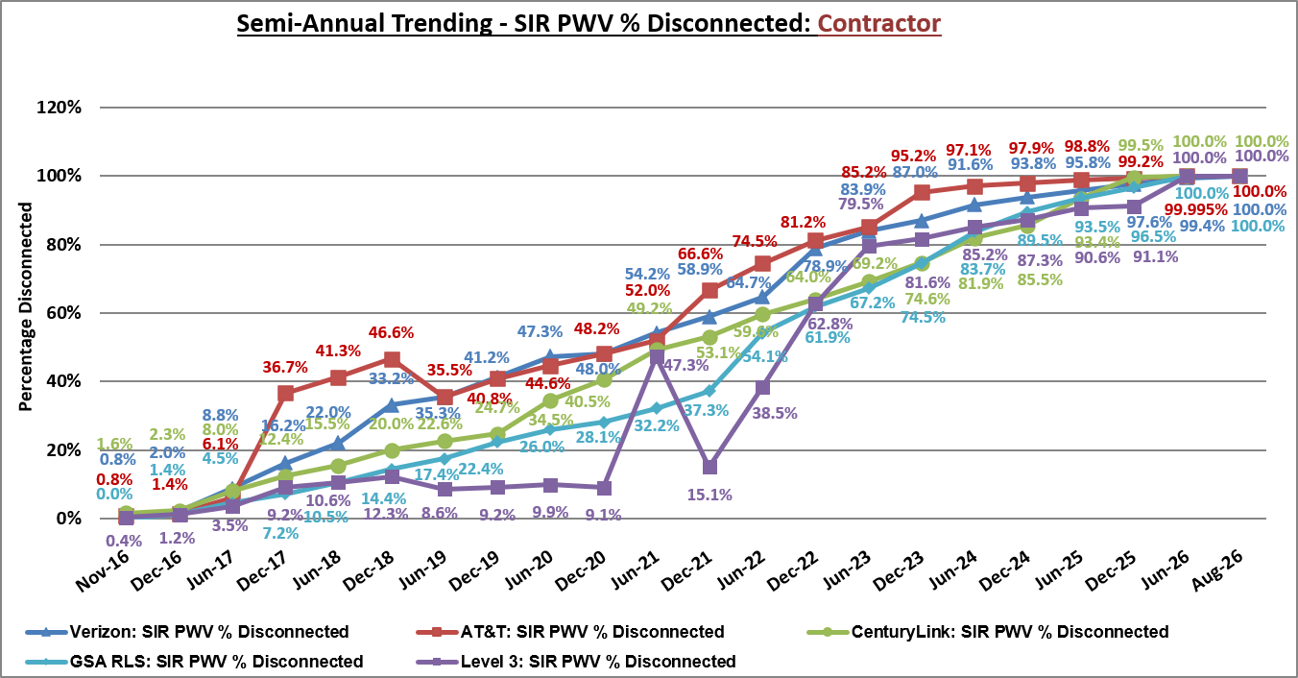
Figure 9. Semi-Annual Trending - SIR PWV % Disconnected: Contractor

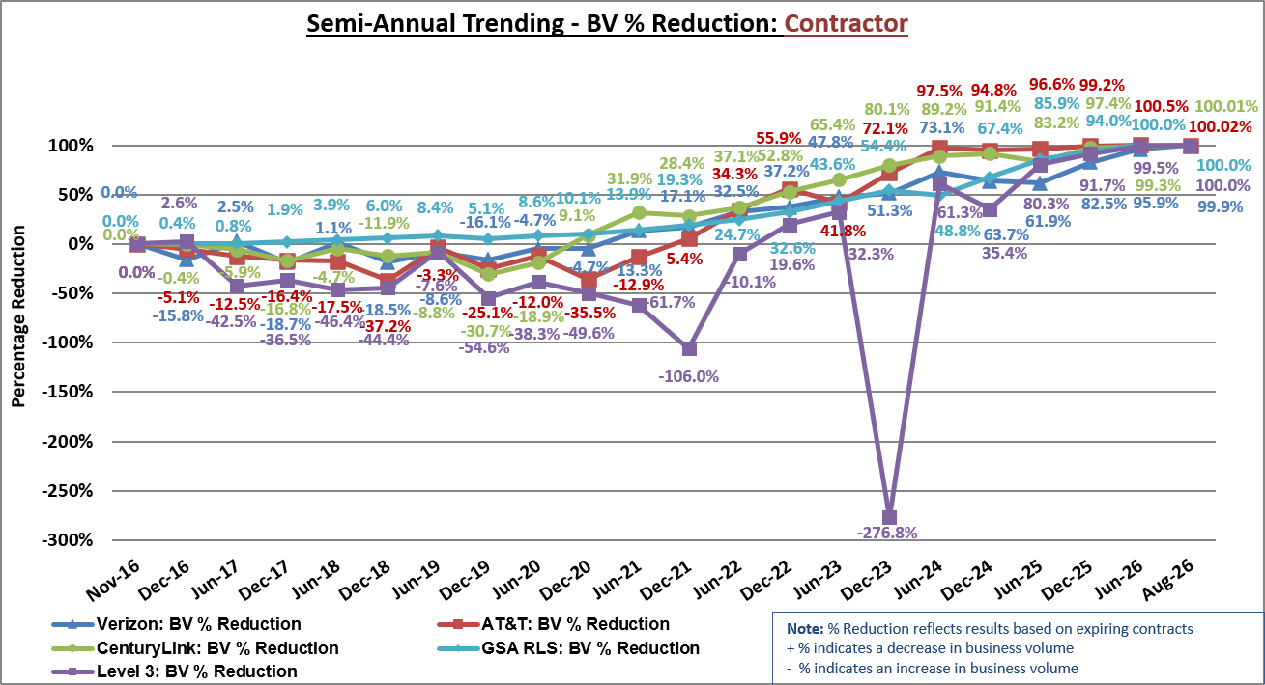
Figure 10. Semi-Annual Trending - BV % Reduction: Contractor

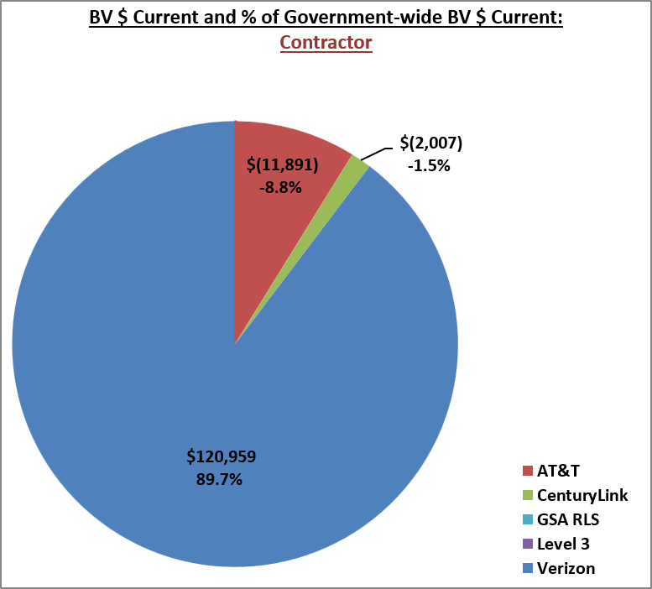
Figure 11. BV $ Current and % of Government-wide BV $ Current: Contractor

Transition Progress – Agency Category
This section identifies transition progress by agency category (see Section 1.3) for the following metrics: SIR disconnected, SIR PWV disconnected, and BV reduction. References to baseline active SIR values refer to the count of active SIRs in TI on November 1, 2016. Likewise, references to baseline active SIR PWV refer to the count of active SIRs in TI on November 1, 2016, where services were multiplied by the appropriate weighted value and resulting values were summed.

Table 7 and Figures 12-14 illustrate the status and trending of transition progress by agency category. The difference between the total SIR count and the number of active SIRs is divided by the total SIR count to calculate the SIR percentage disconnected; this is shown alongside the SIR PWV percentage disconnected which factors in complexity. The current BV amount ($) is compared to the initial BV amount ($) to calculate BV percentage reduction.

Table 7. EIS Transition Progress: Agency Category
EIS Transition Progress: Agency Category
Agency Category | Service Instance Records |  |  |  | Business Volume
Agency Category | SIR # Total | SIR # Active | SIR % Disconnected | SIR PWV % Disconnected | BV $ Initial | BV $ Current | BV % Reduction
Large | 8,584,587 | 0 | 100.0% | 100.0% | $186,018,570 | $105,895 | 99.9%
Medium | 620,385 | 0 | 100.0% | 100.0% | $9,306,888 | -$0.04 | 100.0000004%
Small | 273,230 | 0 | 100.0% | 100.0% | $3,729,732 | $1,166 | 99.97%
TOTALS | 9,478,202 | 0 | 100.0% | 100.0% | $199,055,190 | $107,061 | 99.9%

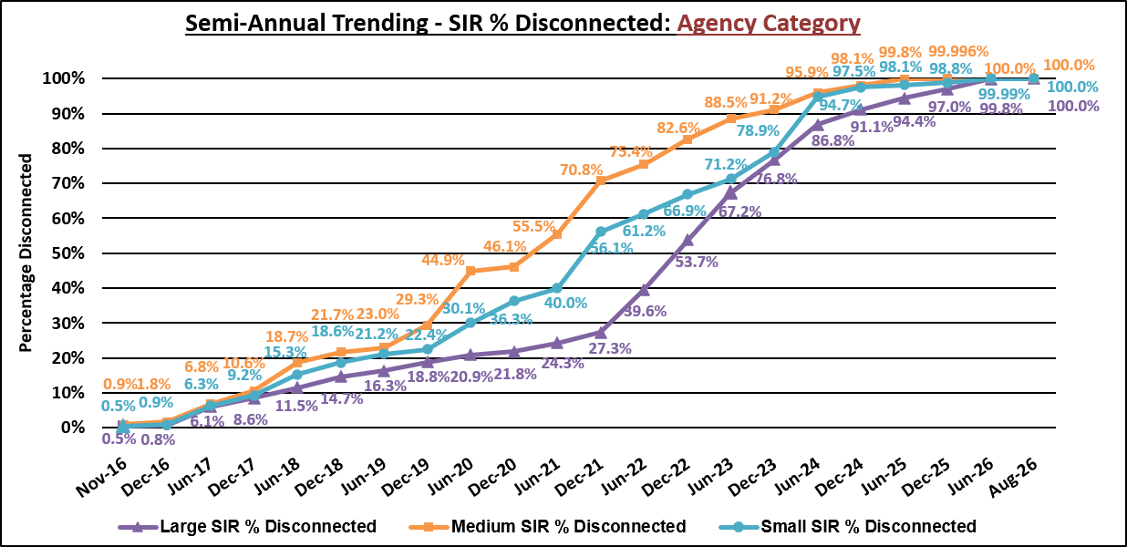
Figure 12. Semi-Annual Trending - SIR % Disconnected: Agency Category

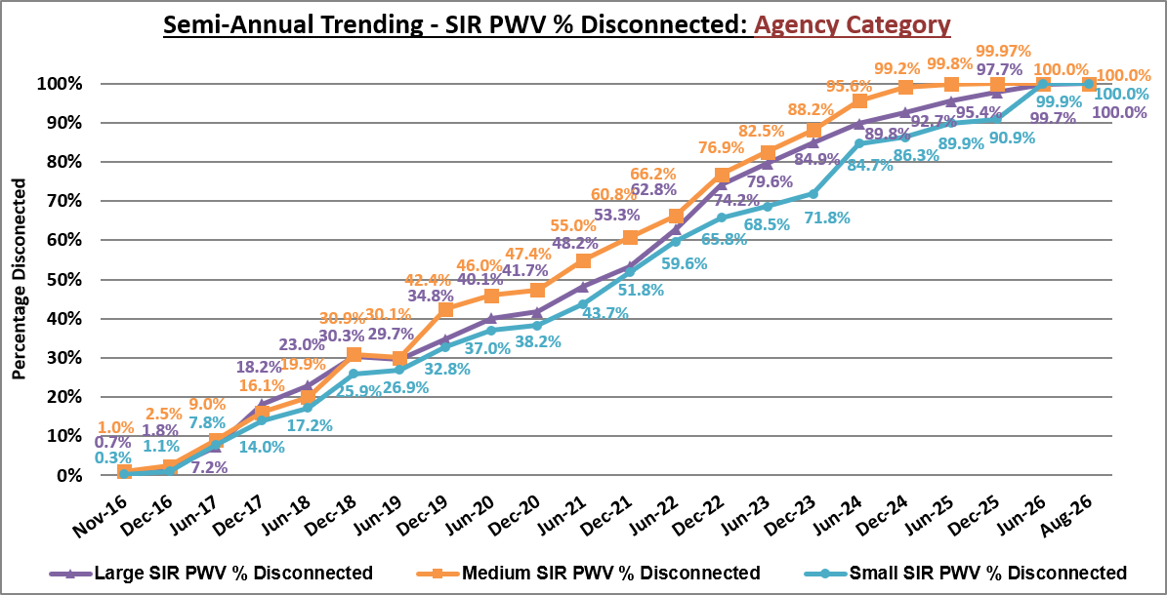
Figure 13. Semi-Annual Trending - SIR PWV % Disconnected: Agency Category

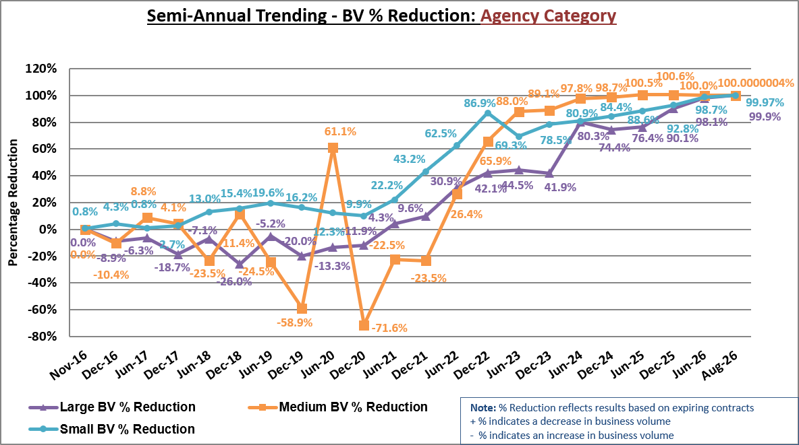
Figure 14. Semi-Annual Trending - BV % Reduction: Agency Category

3.5.1 Transition Progress - Large Agencies
Figure 15 illustrates SIR and SIR PWV percentages disconnected for each of the large agencies.

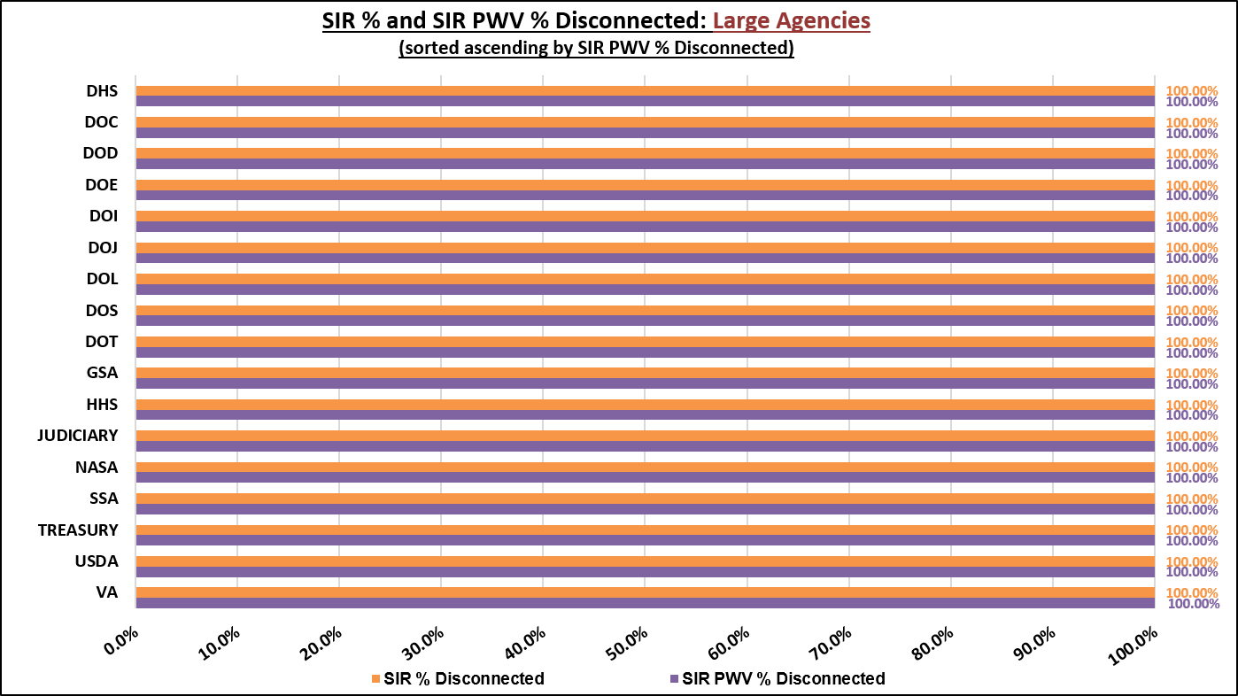
Figure 15. SIR % and SIR PWV % Disconnected: Large Agencies

Figure 16 illustrates the comparison between the baseline active SIR count and current active SIR count for each of the large agencies.

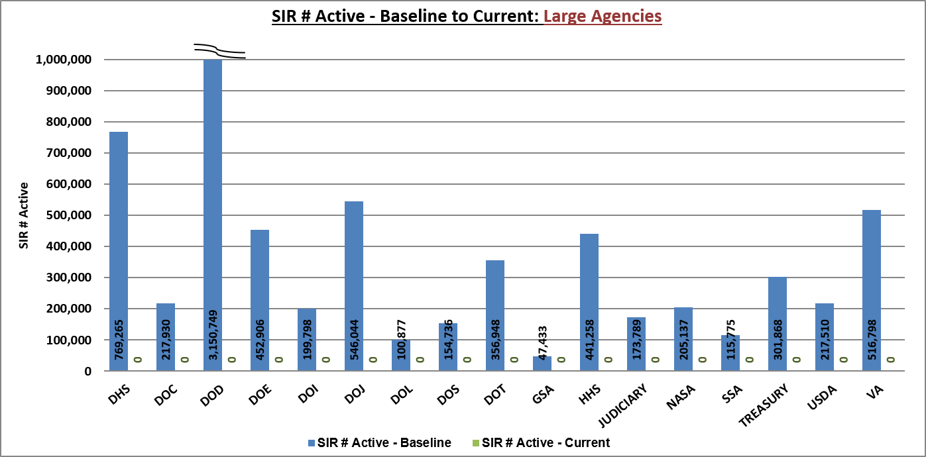
Figure 16. SIR # Active – Baseline to Current: Large Agencies

Figure 17 illustrates the comparison between the baseline active SIR PWV count and current active SIR PWV count for each of the large agencies.

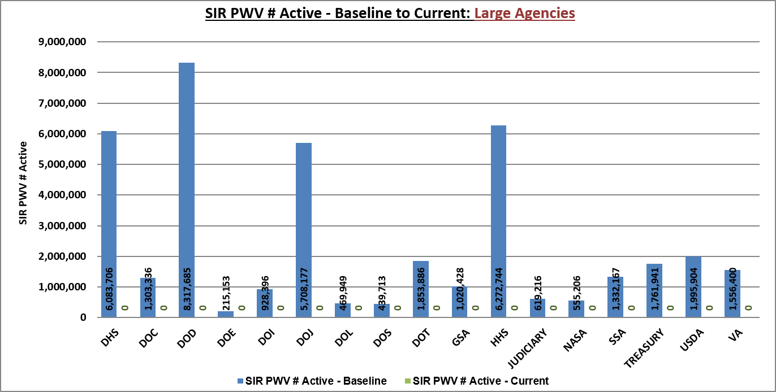
Figure 17. SIR PWV # Active – Baseline to Current: Large Agencies

3.5.2 Transition Progress – Medium Agencies
Figure 18 illustrates the SIR and SIR PWV percentages disconnected for each of the medium agencies.
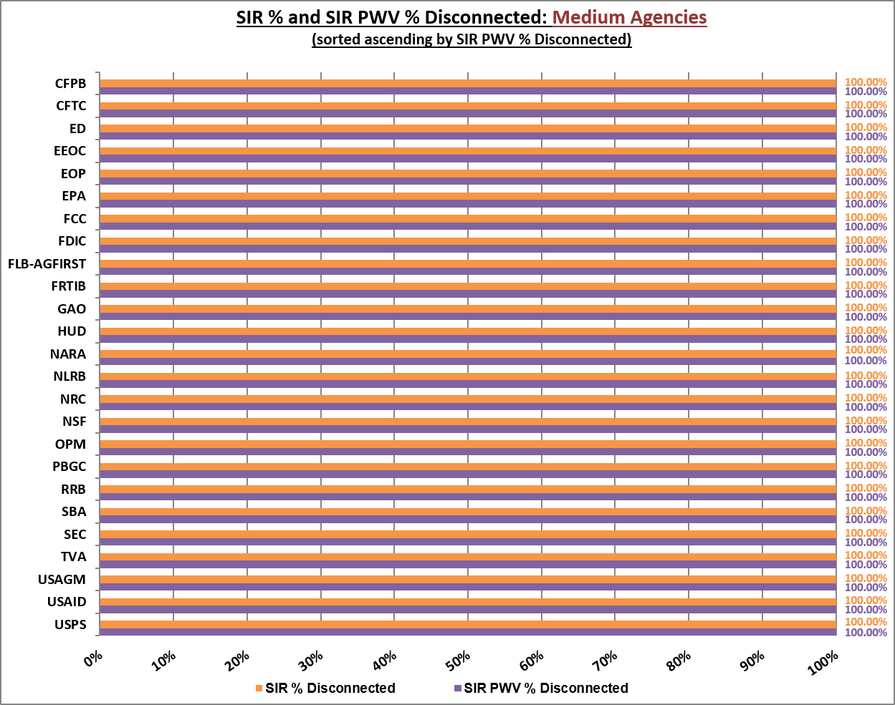
Figure 18. SIR % and SIR PWV % Disconnected: Medium Agencies

Figure 19 illustrates the comparison between the baseline active SIR count and current active SIR count for each of the medium agencies.

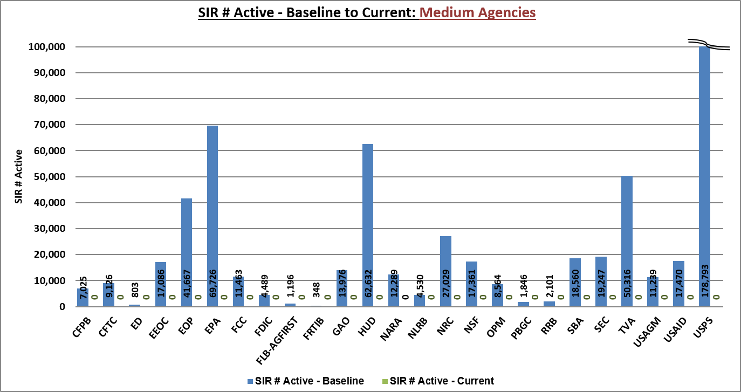
Figure 19. SIR # Active – Baseline to Current: Medium Agencies

Figure 20 illustrates the comparison between the baseline active SIR PWV count and current active SIR PWV count for each of the medium agencies.

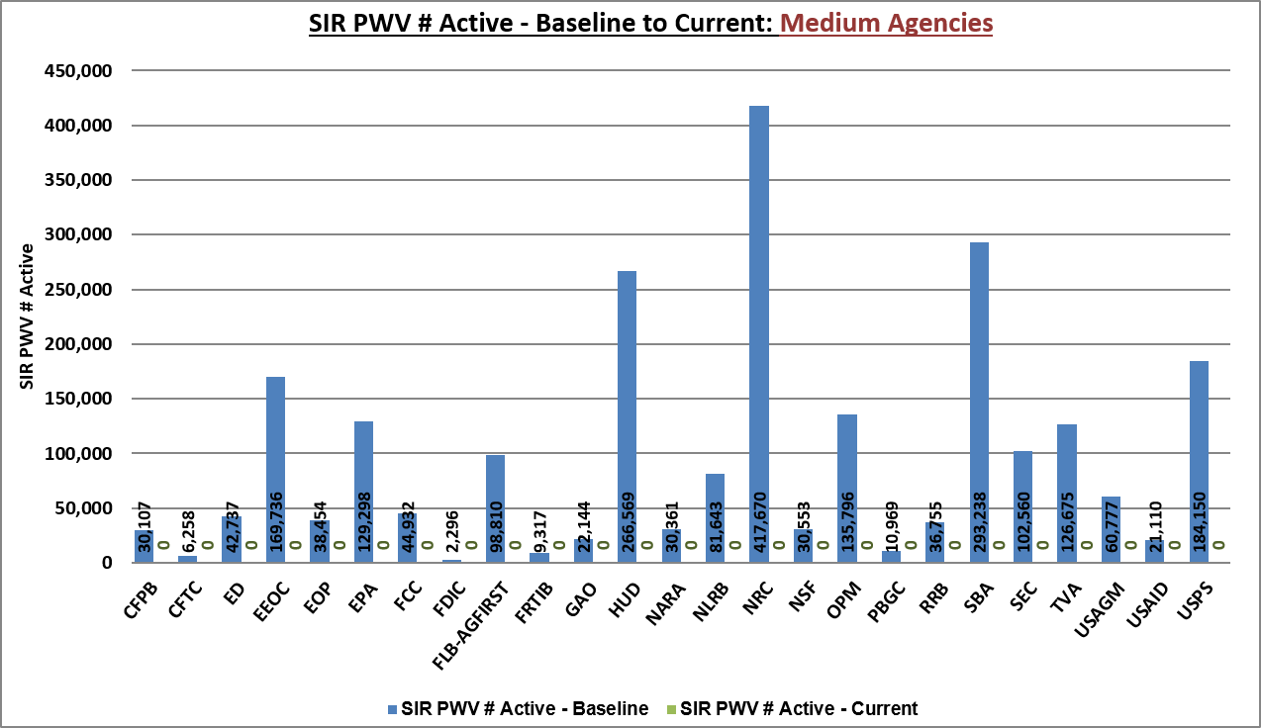
Figure 20. SIR PWV # Active – Baseline to Current: Medium Agencies

3.5.3 Transition progress - Small Agencies
Due to the large number of small agencies, the EIS Transition progress: Small Agencies table is in Appendix A.

Transition Progress – Service Category
This section identifies transition progress by service categories for SIR disconnected, SIR PWV disconnected, and BV reduction. For the purpose of reporting, services have been grouped into ten (10) main categories (including taxes). A full list of services is provided in Appendix F.

Table 8 illustrates the status of transition progress by service category. The difference between the total SIR count and the number of active SIRs is divided by the total SIR count to calculate the SIR percentage disconnected; this is shown alongside the SIR PWV percentage disconnected which factors in complexity. The current BV amount ($) is compared to the initial BV amount ($) to calculate BV percentage reduction.

Table 8. EIS Transition Progress: Service Category
EIS Transition Progress: Service Category
Service Category | Service Instance Records |  |  |  | Business Volume
Service Category | SIR # Total | SIR # Active | SIR % Disconnected | SIR PWV % Disconnected | BV $ Initial | BV $ Current | BV % Reduction
Access | 3,473 | 0 | 100.0% | 100.0% | $17,828,671 | -$1,334,993 | 107.5%
Comm Trans | 9,213,417 | 0 | 100.0% | 100.0% | $40,741,890 | -$1,635 | 100.004%
IP Based | 168,035 | 0 | 100.0% | 100.0% | $66,693,973 | -$148,294 | 100.2%
Mgt & App | 48,422 | 0 | 100.0% | 100.0% | $35,754,500 | -$156,504 | 100.4%
Misc | 36,152 | 0 | 100.0% | 100.0% | $23,510,379 | $1,881,866 | 92.00%
Optical | 359 | 0 | 100.0% | 100.0% | $1,800,499 | $0 | 100.0%
Security | 2,364 | 0 | 100.0% | 100.0% | $550,857 | $0 | 100.0%
Special | 513 | 0 | 100.0% | 100.0% | $502,166 | $0 | 100.0%
Taxes | 0 | 0 | 0.0% | 0.0% | $11,527,846 | -$133,378 | 101.2%
Wireless | 5,467 | 0 | 100.0% | 100.0% | $144,409 | $0 | 100.0%
TOTALS | 9,478,202 | 0 | 100.0% | 100.0% | $199,055,190 | $107,061 | 99.9%

Figure 21 illustrates a current snapshot of SIR and SIR PWV percentages disconnected, BV percentage reduction, and the number of active SIRs for service categories (excluding taxes).

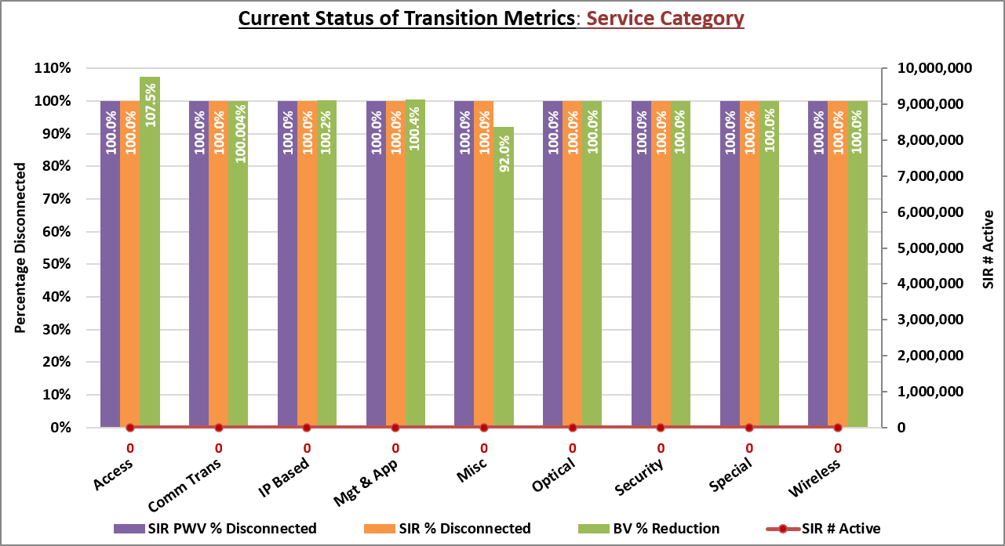
Figure 21. Current Status of Transition Metrics: Service Category

Risk Management
The TCC has established a risk management program to identify, track, monitor, and control risks associated with transition, particularly as they may affect and/or be affected by the TCC. Likewise, lessons learned that present a risk to the success of agency transition to EIS before the existing contracts expire are tied to the appropriate risk and monitored in parallel.

Lessons Learned
Lessons learned provide guidance to both current and future transition activities and assist stakeholders in minimizing impacts to service thus reducing transition delays and expenses.

Risk Assessment
The TCC documents and assesses risks using project management best-practices.

The TCC conducts a risk assessment monthly using the current Risk Register. Since all contracts expired on May 31, 2026, this report will no longer discuss transition risks.

Appendix A – EIS Transition Progress: Small Agencies 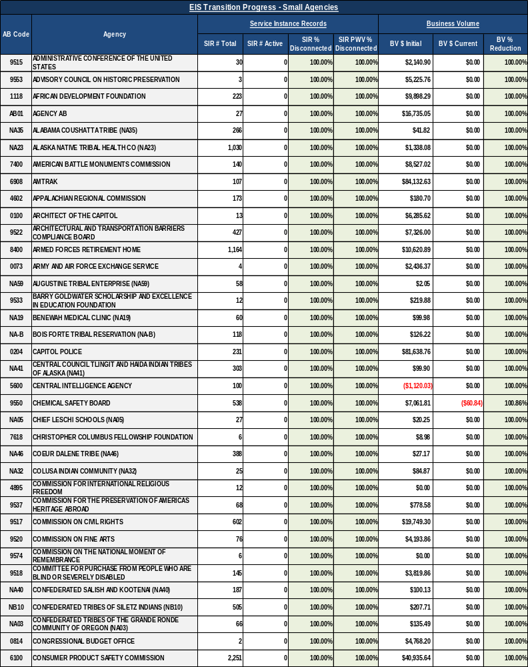
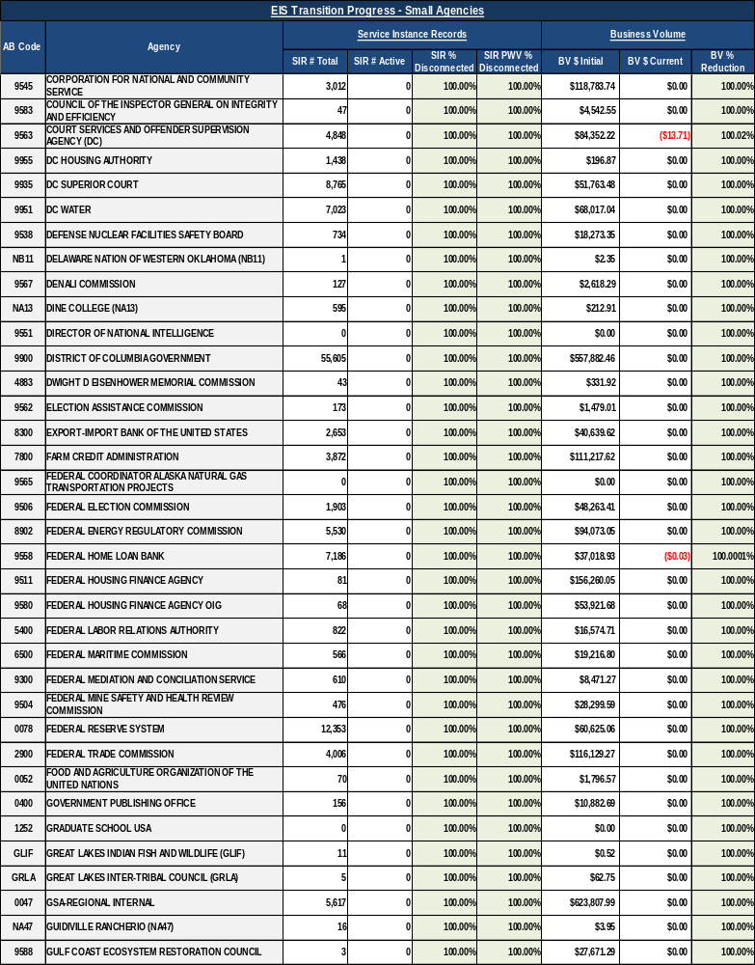
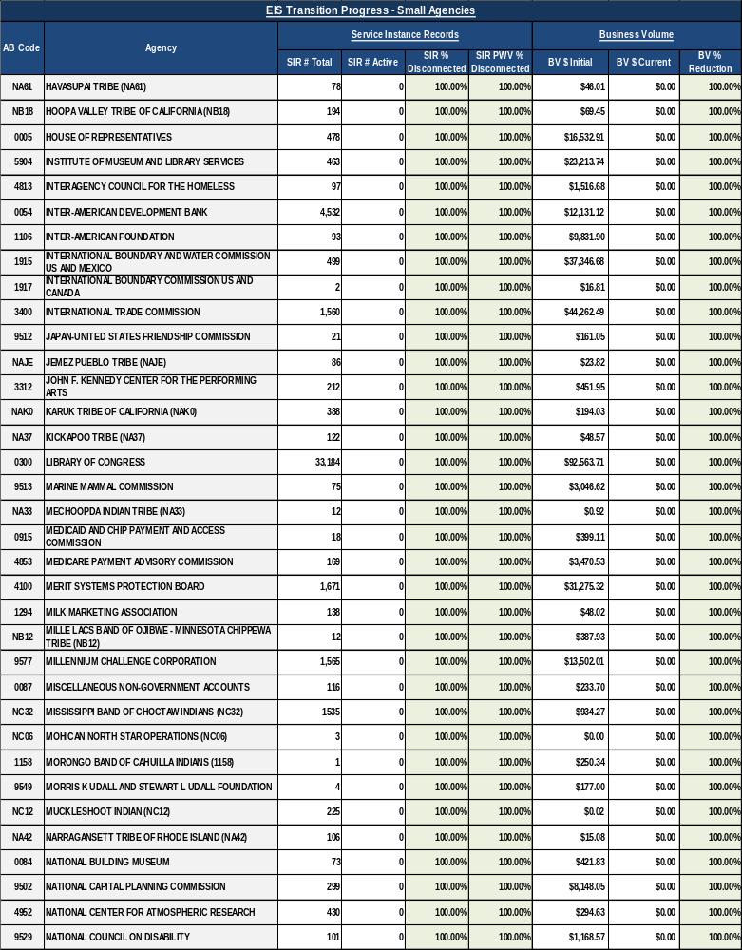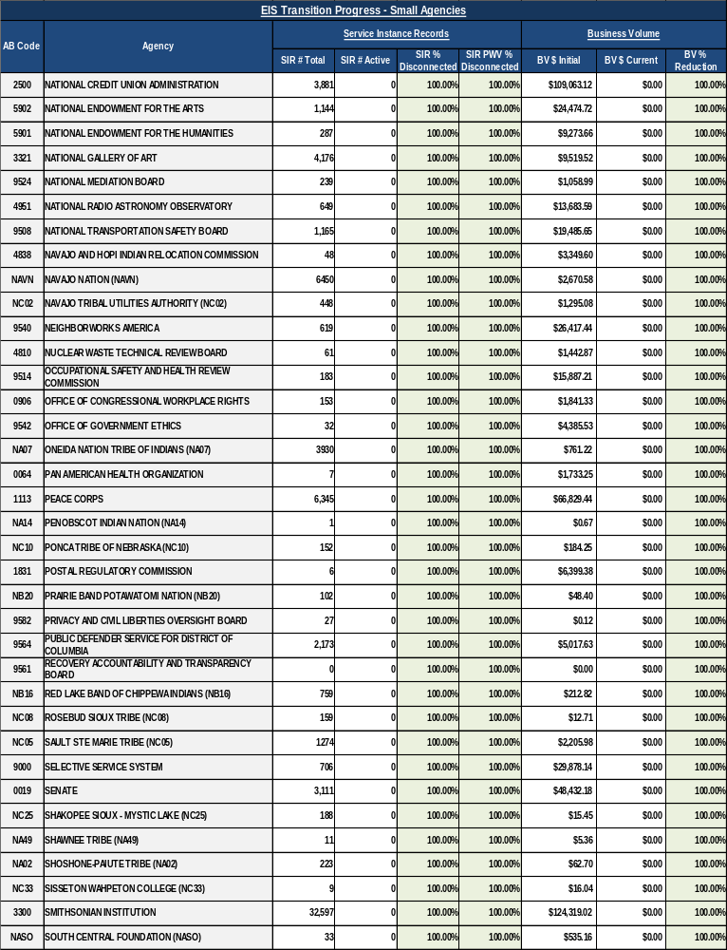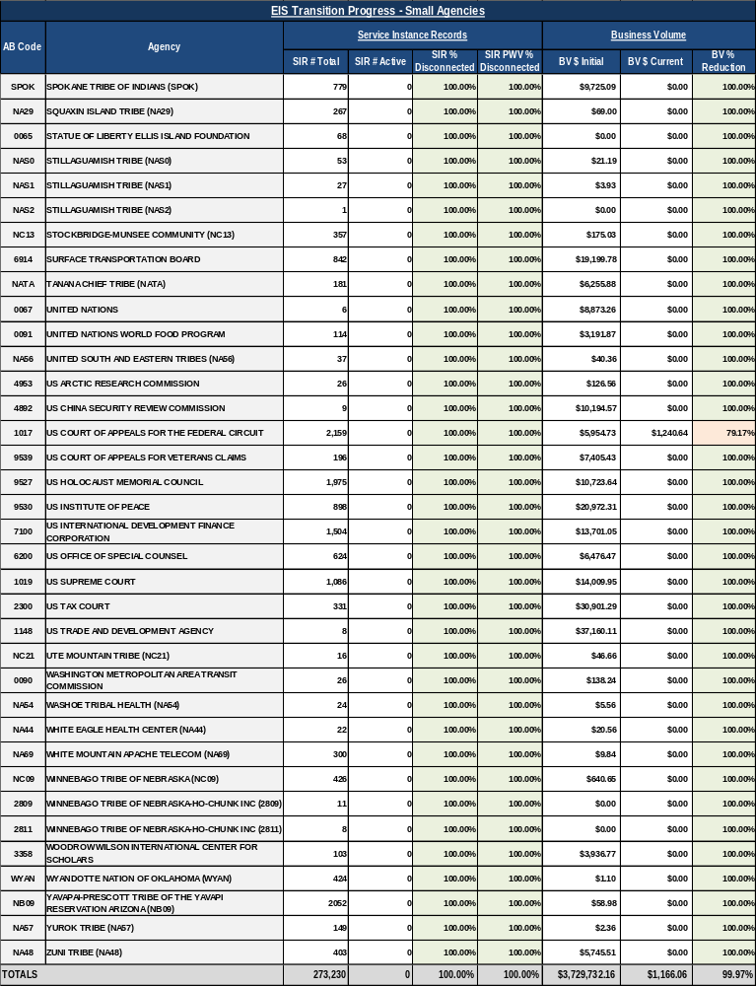

Appendix B – Transition Completion Status
Transition Completion Status
Agency Category | AB Code | Agency | Transition Complete Date
Large Agencies
L | 1300 | DEPARTMENT OF COMMERCE | Aug 2026
L | 7000 | DEPARTMENT OF HOMELAND SECURITY | Aug 2026
L | 1500 | DEPARTMENT OF JUSTICE | Aug 2026
L | 1400 | DEPARTMENT OF THE INTERIOR | Aug 2026
L | 6900 | DEPARTMENT OF TRANSPORTATION | Aug 2026
L | 1200 | DEPARTMENT OF AGRICULTURE | Jul 2026
L | 8900 | DEPARTMENT OF ENERGY | Jul 2026
L | 1000 | JUDICIARY | Jul 2026
L | 2000 | DEPARTMENT OF THE TREASURY | Mar 2025
L | 3600 | DEPARTMENT OF VETERANS AFFAIRS | Nov 2024
L | 8000 | NATIONAL AERONAUTICS AND SPACE ADMINISTRATION | Nov 2024
L | 7500 | DEPARTMENT OF HEALTH AND HUMAN SERVICES | Aug 2024
L | 1600 | DEPARTMENT OF LABOR | Jul 2024
L | 1900 | DEPARTMENT OF STATE | Jul 2024
L | 2804 | SOCIAL SECURITY ADMINISTRATION | Jul 2024
Medium Agencies
M | 8800 | NATIONAL ARCHIVES AND RECORDS ADMINISTRATION | Jun 2026
M | 0500 | GOVERNMENT ACCOUNTABILITY OFFICE | Jan 2026
M | 1800 | UNITED STATES POSTAL SERVICE | Dec 2025
M | 6000 | RAILROAD RETIREMENT BOARD | Oct 2025
M | 7300 | SMALL BUSINESS ADMINISTRATION | Jul 2025
M | 4500 | EQUAL EMPLOYMENT OPPORTUNITY COMMISSION | Jun 2025
M | 9568 | US AGENCY FOR GLOBAL MEDIA | Jun 2025
M | 7805 | FEDERAL LAND BANKS-AGFIRST | Mar 2025
M | 2400 | OFFICE OF PERSONNEL MANAGEMENT | Feb 2025
M | 6800 | ENVIRONMENTAL PROTECTION AGENCY | Sep 2024
M | 8600 | DEPARTMENT OF HOUSING AND URBAN DEVELOPMENT | Jul 2024
M | 4900 | NATIONAL SCIENCE FOUNDATION | Jul 2024
M | 6400 | TENNESSEE VALLEY AUTHORITY | Jun 2024
M | 3100 | NUCLEAR REGULATORY COMMISSION | Mar 2024
M | 2600 | FEDERAL RETIREMENT THRIFT INVESTMENT BOARD | Nov 2023
M | 9100 | DEPARTMENT OF EDUCATION | Oct 2023
M | 5000 | SECURITIES AND EXCHANGE COMMISSION | Jul 2023
M | 2700 | FEDERAL COMMUNICATIONS COMMISSION | Jun 2023
M | 9559 | CONSUMER FINANCIAL PROTECTION BUREAU | May 2023
M | 6300 | NATIONAL LABOR RELATIONS BOARD | Feb 2023
M | 1606 | PENSION BENEFIT GUARANTY CORPORATION | Feb 2023
M | 9507 | COMMODITY FUTURES TRADING COMMISSION | Dec 2022
M | 7200 | US AGENCY FOR INTERNATIONAL DEVELOPMENT | Mar 2022
M | 1100 | EXECUTIVE OFFICE OF THE PRESIDENT | Jul 2021
M | 5100 | FEDERAL DEPOSIT INSURANCE CORPORATION | May 2021
Small Agencies
S | 9545 | CORPORATION FOR NATIONAL AND COMMUNITY SERVICE | Jul 2026
S | 9900 | DISTRICT OF COLUMBIA GOVERNMENT | Jul 2026
S | 0047 | GSA-REGIONAL INTERNAL | Jul 2026
S | 0204 | CAPITOL POLICE | Jun 2026
S | 9517 | COMMISSION ON CIVIL RIGHTS | Jun 2026
S | 9506 | FEDERAL ELECTION COMMISSION | Apr 2026
S | 8902 | FEDERAL ENERGY REGULATORY COMMISSION | Apr 2026
S | 0906 | OFFICE OF CONGRESSIONAL WORKPLACE RIGHTS | Jan 2026
S | 9513 | MARINE MAMMAL COMMISSION | Jul 2025
S | 2300 | US TAX COURT | Jul 2025
S | 1118 | AFRICAN DEVELOPMENT FOUNDATION | Mar 2025
S | 7800 | FARM CREDIT ADMINISTRATION | Mar 2025
S | 9935 | DC SUPERIOR COURT | Feb 2025
S | 1915 | INTERNATIONAL BOUNDARY AND WATER COMMISSION US AND MEXICO | Jan 2025
S | 9558 | FEDERAL HOME LOAN BANK | Nov 2024
S | 9514 | OCCUPATIONAL SAFETY AND HEALTH REVIEW COMMISSION | Nov 2024
S | 6500 | FEDERAL MARITIME COMMISSION | Sep 2024
S | NB12 | MILLE LACS BAND OF OJIBWE - MINNESOTA CHIPPEWA TRIBE (NB12) | Sep 2024
S | 4100 | MERIT SYSTEMS PROTECTION BOARD | Aug 2024
S | NAVN | NAVAJO NATION (NAVN) | Aug 2024
S | SPOK | SPOKANE TRIBE OF INDIANS (SPOK) | Aug 2024
S | 9539 | US COURT OF APPEALS FOR VETERANS CLAIMS | Aug 2024
S | 9530 | US INSTITUTE OF PEACE | Aug 2024
S | 9955 | DC HOUSING AUTHORITY | Jul 2024
S | 9951 | DC WATER | Jul 2024
S | 9504 | FEDERAL MINE SAFETY AND HEALTH REVIEW COMMISSION | Jul 2024
S | 0078 | FEDERAL RESERVE SYSTEM | Jul 2024
S | NC32 | MISSISSIPPI BAND OF CHOCTAW INDIANS (NC32) | Jul 2024
S | 2500 | NATIONAL CREDIT UNION ADMINISTRATION | Jul 2024
S | 3321 | NATIONAL GALLERY OF ART | Jul 2024
S | 3300 | SMITHSONIAN INSTITUTION | Jul 2024
S | 9553 | ADVISORY COUNCIL ON HISTORIC PRESERVATION | Jun 2024
S | 9518 | COMMITTEE FOR PURCHASE FROM PEOPLE WHO ARE BLIND OR SEVERELY DISABLED | Jun 2024
S | 8400 | ARMED FORCES RETIREMENT HOME | May 2024
S | 9550 | CHEMICAL SAFETY BOARD | May 2024
S | 6100 | CONSUMER PRODUCT SAFETY COMMISSION | May 2024
S | 9564 | PUBLIC DEFENDER SERVICE FOR DISTRICT OF COLUMBIA | May 2024
S | 6914 | SURFACE TRANSPORTATION BOARD | May 2024
S | 1019 | US SUPREME COURT | May 2024
S | 0100 | ARCHITECT OF THE CAPITOL | Apr 2024
S | 9562 | ELECTION ASSISTANCE COMMISSION | Apr 2024
S | 1017 | US COURT OF APPEALS FOR THE FEDERAL CIRCUIT | Mar 2024
S | 9538 | DEFENSE NUCLEAR FACILITIES SAFETY BOARD | Feb 2024
S | 0087 | MISCELLANEOUS NON-GOVERNMENT ACCOUNTS | Feb 2024
S | 3358 | WOODROW WILSON INTERNATIONAL CENTER FOR SCHOLARS | Feb 2024
S | 0005 | HOUSE OF REPRESENTATIVES | Jan 2024
S | 4838 | NAVAJO AND HOPI INDIAN RELOCATION COMMISSION | Oct 2023
S | AB01 | AGENCY AB | Sep 2023
S | 9567 | DENALI COMMISSION | Sep 2023
S | 3400 | INTERNATIONAL TRADE COMMISSION | Sep 2023
S | 0019 | SENATE | Sep 2023
S | 9527 | US HOLOCAUST MEMORIAL COUNCIL | Sep 2023
S | 4813 | INTERAGENCY COUNCIL FOR THE HOMELESS | Aug 2023
S | 1106 | INTER-AMERICAN FOUNDATION | Aug 2023
S | 9522 | ARCHITECTURAL AND TRANSPORTATION BARRIERS COMPLIANCE BOARD | Jul 2023
S | 9520 | COMMISSION ON FINE ARTS | Jul 2023
S | 9508 | NATIONAL TRANSPORTATION SAFETY BOARD | Jul 2023
S | 1831 | POSTAL REGULATORY COMMISSION | Jul 2023
S | 9583 | COUNCIL OF THE INSPECTOR GENERAL ON INTEGRITY AND EFFICIENCY | Jun 2023
S | 8300 | EXPORT-IMPORT BANK OF THE UNITED STATES | Jun 2023
S | 9580 | FEDERAL HOUSING FINANCE AGENCY OIG | May 2023
S | 5400 | FEDERAL LABOR RELATIONS AUTHORITY | May 2023
S | 9563 | COURT SERVICES AND OFFENDER SUPERVISION AGENCY (DC) | Apr 2023
S | 2900 | FEDERAL TRADE COMMISSION | Apr 2023
S | 9502 | NATIONAL CAPITAL PLANNING COMMISSION | Apr 2023
S | 7400 | AMERICAN BATTLE MONUMENTS COMMISSION | Mar 2023
S | 4810 | NUCLEAR WASTE TECHNICAL REVIEW BOARD | Mar 2023
S | 1113 | PEACE CORPS | Mar 2023
S | 9529 | NATIONAL COUNCIL ON DISABILITY | Feb 2023
S | 4951 | NATIONAL RADIO ASTRONOMY OBSERVATORY | Feb 2023
S | 9524 | NATIONAL MEDIATION BOARD | Nov 2022
S | 9582 | PRIVACY AND CIVIL LIBERTIES OVERSIGHT BOARD | Nov 2022
S | 5904 | INSTITUTE OF MUSEUM AND LIBRARY SERVICES | Oct 2022
S | WYAN | WYANDOTTE NATION OF OKLAHOMA (WYAN) | Oct 2022
S | NA23 | ALASKA NATIVE TRIBAL HEALTH CO (NA23) | Sep 2022
S | 0400 | GOVERNMENT PUBLISHING OFFICE | Sep 2022
S | NC05 | SAULT STE MARIE TRIBE (NC05) | Sep 2022
S | NC13 | STOCKBRIDGE-MUNSEE COMMUNITY (NC13) | Sep 2022
S | 9300 | FEDERAL MEDIATION AND CONCILIATION SERVICE | Aug 2022
S | 9000 | SELECTIVE SERVICE SYSTEM | Jun 2022
S | NA59 | AUGUSTINE TRIBAL ENTERPRISE (NA59) | May 2022
S | 7100 | US INTERNATIONAL DEVELOPMENT FINANCE CORPORATION | May 2022
S | 9515 | ADMINISTRATIVE CONFERENCE OF THE UNITED STATES | Apr 2022
S | NA40 | CONFEDERATED SALISH AND KOOTENAI (NA40) | Apr 2022
S | 0300 | LIBRARY OF CONGRESS | Apr 2022
S | 9577 | MILLENNIUM CHALLENGE CORPORATION | Apr 2022
S | NA02 | SHOSHONE-PAIUTE TRIBE (NA02) | Mar 2022
S | 6200 | US OFFICE OF SPECIAL COUNSEL | Mar 2022
S | 4853 | MEDICARE PAYMENT ADVISORY COMMISSION | Feb 2022
S | NC10 | PONCA TRIBE OF NEBRASKA (NC10) | Feb 2022
S | NB20 | PRAIRIE BAND POTAWATOMI NATION (NB20) | Feb 2022
S | NA13 | DINE COLLEGE (NA13) | Jan 2022
S | 0091 | UNITED NATIONS WORLD FOOD PROGRAM | Jan 2022
S | 0915 | MEDICAID AND CHIP PAYMENT AND ACCESS COMMISSION | Dec 2021
S | NA54 | WASHOE TRIBAL HEALTH (NA54) | Dec 2021
S | NC09 | WINNEBAGO TRIBE OF NEBRASKA (NC09) | Dec 2021
S | 0073 | ARMY AND AIR FORCE EXCHANGE SERVICE | Oct 2021
S | 9512 | JAPAN-UNITED STATES FRIENDSHIP COMMISSION | Oct 2021
S | NAJE | JEMEZ PUEBLO TRIBE (NAJE) | Oct 2021
S | NA07 | ONEIDA NATION TRIBE OF INDIANS (NA07) | Oct 2021
S | 0090 | WASHINGTON METROPOLITAN AREA TRANSIT COMMISSION | Oct 2021
S | NA35 | ALABAMA COUSHATTA TRIBE (NA35) | Sep 2021
S | NA-B | BOIS FORTE TRIBAL RESERVATION (NA-B) | Sep 2021
S | NA46 | COEUR DALENE TRIBE (NA46) | Sep 2021
S | NB10 | CONFEDERATED TRIBES OF SILETZ INDIANS (NB10) | Sep 2021
S | NB11 | DELAWARE NATION OF WESTERN OKLAHOMA (NB11) | Sep 2021
S | 0054 | INTER-AMERICAN DEVELOPMENT BANK | Sep 2021
S | 5902 | NATIONAL ENDOWMENT FOR THE ARTS | Sep 2021
S | NASO | SOUTH CENTRAL FOUNDATION (NASO) | Sep 2021
S | NA19 | BENEWAH MEDICAL CLINIC (NA19) | Aug 2021
S | 5901 | NATIONAL ENDOWMENT FOR THE HUMANITIES | Aug 2021
S | 0067 | UNITED NATIONS | Aug 2021
S | NC25 | SHAKOPEE SIOUX-MYSTIC LAKE (NC25) | Jul 2021
S | NC33 | SISSETON WAHPETON COLLEGE (NC33) | Jul 2021
S | 0052 | FOOD AND AGRICULTURE ORGANIZATION OF THE UNITED NATIONS | Jun 2021
S | 2809 | WINNEBAGO TRIBE OF NEBRASKA-HO-CHUNK INC (2809) | Jun 2021
S | 2811 | WINNEBAGO TRIBE OF NEBRASKA-HO-CHUNK INC (2811) | Jun 2021
S | 9511 | FEDERAL HOUSING FINANCE AGENCY | May 2021
S | 9588 | GULF COAST ECOSYSTEM RESTORATION COUNCIL | May 2021
S | 4892 | US CHINA SECURITY REVIEW COMMISSION | May 2021
S | 1148 | US TRADE AND DEVELOPMENT AGENCY | May 2021
S | 9537 | COMMISSION FOR THE PRESERVATION OF AMERICAS HERITAGE ABROAD | Apr 2021
S | 9540 | NEIGHBORWORKS AMERICA | Apr 2021
S | NB09 | YAVAPAI-PRESCOTT TRIBE OF THE YAVAPI RESERVATION ARIZONA (NB09) | Apr 2021
S | NA48 | ZUNI TRIBE (NA48) | Mar 2021
S | NA32 | COLUSA INDIAN COMMUNITY (NA32) | Feb 2021
S | 1158 | MORONGO BAND OF CAHUILLA INDIANS (1158) | Feb 2021
S | NATA | TANANA CHIEF TRIBE (NATA) | Feb 2021
S | 6908 | AMTRAK | Jan 2021
S | 4602 | APPALACHIAN REGIONAL COMMISSION | Jan 2021
S | NA41 | CENTRAL COUNCIL TLINGIT AND HAIDA INDIAN TRIBES OF ALASKA (NA41) | Jan 2021
S | NA05 | CHIEF LESCHI SCHOOLS (NA05) | Jan 2021
S | 1294 | MILK MARKETING ASSOCIATION | Jan 2021
S | NC02 | NAVAJO TRIBAL UTILITIES AUTHORITY (NC02) | Jan 2021
S | 0065 | STATUE OF LIBERTY ELLIS ISLAND FOUNDATION | Jan 2021
S | NB18 | HOOPA VALLEY TRIBE OF CALIFORNIA (NB18) | Dec 2020
S | 9549 | MORRIS K UDALL AND STEWART L UDALL FOUNDATION | Dec 2020
S | 9542 | OFFICE OF GOVERNMENT ETHICS | Dec 2020
S | NB16 | RED LAKE BAND OF CHIPPEWA INDIANS (NB16) | Dec 2020
S | NA29 | SQUAXIN ISLAND TRIBE (NA29) | Dec 2020
S | NC21 | UTE MOUNTAIN TRIBE (NC21) | Dec 2020
S | NA47 | GUIDIVILLE RANCHERIO (NA47) | Nov 2020
S | NA61 | HAVASUPAI TRIBE (NA61) | Nov 2020
S | NAK0 | KARUK TRIBE OF CALIFORNIA (NAK0) | Nov 2020
S | NA37 | KICKAPOO TRIBE (NA37) | Nov 2020
S | NA42 | NARRAGANSETT TRIBE OF RHODE ISLAND (NA42) | Nov 2020
S | NC08 | ROSEBUD SIOUX TRIBE (NC08) | Nov 2020
S | NA49 | SHAWNEE TRIBE (NA49) | Nov 2020
S | NA44 | WHITE EAGLE HEALTH CENTER (NA44) | Nov 2020
S | NA69 | WHITE MOUNTAIN APACHE TELECOM (NA69) | Nov 2020
S | GRLA | GREAT LAKES INTER-TRIBAL COUNCIL (GRLA) | Oct 2020
S | NA14 | PENOBSCOT INDIAN NATION (NA14) | Oct 2020
S | 0084 | NATIONAL BUILDING MUSEUM | Sep 2020
S | 4952 | NATIONAL CENTER FOR ATMOSPHERIC RESEARCH | Sep 2020
S | 3312 | JOHN F. KENNEDY CENTER FOR THE PERFORMING ARTS | Aug 2020
S | NA33 | MECHOOPDA INDIAN TRIBE (NA33) | Aug 2020
S | NA57 | YUROK TRIBE (NA57) | Aug 2020
S | NA03 | CONFEDERATED TRIBES OF THE GRANDE RONDE COMMUNITY OF OREGON (NA03) | Feb 2020
S | NAS0 | STILLAGUAMISH TRIBE (NAS0) | Feb 2020
S | 0814 | CONGRESSIONAL BUDGET OFFICE | Dec 2019
S | GLIF | GREAT LAKES INDIAN FISH AND WILDLIFE (GLIF) | Dec 2019
S | 1917 | INTERNATIONAL BOUNDARY COMMISSION US AND CANADA | Sep 2019
S | 4953 | US ARCTIC RESEARCH COMMISSION | Aug 2019
S | NAS1 | STILLAGUAMISH TRIBE (NAS1) | Jun 2019
S | NAS2 | STILLAGUAMISH TRIBE (NAS2) | May 2019
S | 0064 | PAN AMERICAN HEALTH ORGANIZATION | Apr 2019
S | 4883 | DWIGHT D EISENHOWER MEMORIAL COMMISSION | Mar 2019
S | 9533 | BARRY GOLDWATER SCHOLARSHIP AND EXCELLENCE IN EDUCATION FOUNDATION | Feb 2019
S | NC06 | MOHICAN NORTH STAR OPERATIONS (NC06) | May 2018
S | NC12 | MUCKLESHOOT INDIAN (NC12) | May 2018
S | 5600 | CENTRAL INTELLIGENCE AGENCY | Nov 2017
S | 9574 | COMMISSION ON THE NATIONAL MOMENT OF REMEMBRANCE | Oct 2017
S | 7618 | CHRISTOPHER COLUMBUS FELLOWSHIP FOUNDATION | Sep 2017
S | 4895 | COMMISSION FOR INTERNATIONAL RELIGIOUS FREEDOM | Jul 2017
S | NA56 | UNITED SOUTH AND EASTERN TRIBES (NA56) | Jun 2017
S | 9551 | DIRECTOR OF NATIONAL INTELLIGENCE | Nov 2016
S | 9565 | FEDERAL COORDINATOR ALASKA NATURAL GAS TRANSPORTATION PROJECTS | Nov 2016
S | 1252 | GRADUATE SCHOOL USA | Nov 2016
S | 9561 | RECOVERY ACCOUNTABILITY AND TRANSPARENCY BOARD | Nov 2016

Appendix C – Key Metrics
Key Metrics
Metric | Target Date | Definition | Measurement
Solicitations Issued to Industry | 03/31/2019 | Agencies will issue Enterprise Infrastructure Solutions (EIS) solicitations, that have passed scope review, to industry for proposals | Agency reports to General Services Administration (GSA) as solicitations are issued to industry for proposals. Solutions Brokers will collect data and make available to the Transition Coordination Center (TCC) through the solicitation forecast by the end of each month.  Note: After this target date, GSA reserves the option to cut off GSA-funded Transition Ordering Assistance (TOA) support for agencies’ solicitation development. GSA will work with agencies unable to meet this date on an individual basis. GSA will process contract modifications on Networx and Washington Interagency Telecommunications System (WITS) 3 (direct order contracts) only for mission essential services
Task Orders TOs) Awarded | 09/30/2019 | At least one task order awarded for each solicitation as reported by EIS contractor through the Network Hosting Center (NHC) | As EIS contractors receive TOs, they report them to GSA, and the TOs are recorded in the NHC; GSA will track that at least one TO is awarded for each solicitation the agency has forecasted  Note: After this date, GSA will cease adding services on Regional Local Service Agreement (LSA) contracts that comprise the full-service program
Transition 50% Complete | 03/31/2021 | Proportional Weighted Value (PWV) percentage disconnected | 50% of Transition Inventory (TI) is disconnected as reported by Networx contractors, WITS 3 Program Management Office (PMO), and Telecommunications Ordering and Pricing System (TOPS) based on Service Instance Record (SIR) PWV disconnects
Transition 90% Complete | 03/31/2022 | Proportional Weighted Value (PWV) percentage disconnected | 90% of TI is disconnected as reported by Networx contractors, WITS 3 PMO, and TOPS based on SIR PWV disconnects
Transition 100% Complete (disconnected) | 09/30/2022 | 100% of services disconnected | 100% of TI is disconnected as reported by Networx contractors, WITS 3 PMO, and TOPS based on SIR PWV disconnects
Note: Transition is complete after TI is 100% disconnected and BV is reduced to $0 with no remaining charges.

Appendix D – Key Definitions
Key Definitions
Term | Definition
Baseline Service Instance Record (SIR) | The count of active SIRs in TI on November 1, 2016.
Baseline SIR Proportional Weighted Value (PWV) | The count of active SIRs in TI on November 1, 2016, where services were multiplied by the appropriate weighted value and resulting values were summed.
Business Volume (BV) | The amount billed by the contractors for services, including adjustments, taxes and fees; sometimes includes adjustments made by GSA
BV Reduction | A transition progress metric that compares current BV to the initial BV
Fair Opportunity (FO) Solicitations Expected/Planned | Count based on information agencies provided in their Agency Transition Plan (ATP) (or subsequently in a data call from Solutions Brokers).
FO Solicitations Issued to Industry | Count of solicitations that have been released to Enterprise Infrastructure Solutions (EIS) contractors
FO Solicitations Passed In-Scope Review | Count defined as passing a General Services Administration (GSA) in-scope review
Initial BV | The business volume as of November 1, 2016
Large, Medium, Small (LMS) Agency Categories | In the context of the transition program, agencies with inventory that must be transitioned are categorized into three main categories: Large agencies, Medium agencies, and Small agencies. The Large agencies represent a group of agencies each billing an average annual BV of more than $10 million in Fiscal Year (FY)12 through FY15 on the Networx contracts. The Medium agencies represent a group of agencies each with an average annual of less than $10 million, but over $1 million. Finally, the Small agencies represent a group of agencies each with an average annual of less than $1 million.
Proportional Weighted Value (PWV) | Values assigned to SIRs based on the complexity of transitioning that service (simple services, such as calling cards, reflect a low PWV, while more complex services such as Network Based Internet Protocol Virtual Private Network Service (NBIPVPNS) hold a higher value)
Service Instance Record (SIR) | Level of inventory tracking record that provides GSA and transition entities with a consistent measure to track services as they transition from expiring contracts; Represents a summarized rollup of a base service and the associated supporting/feature CLINs, supports transition entity transition planning, and provides a mechanism for the transition entities and GSA to track the progress of transition from Networx, Washington Interagency Telecommunications System (WITS) 3, and GSA Regional Local Service (RLS) contracts
SIR Disconnected | A transition progress metric that measures reductions in SIR counts until there are no active SIRs remaining (100% disconnected)
TPTR Grouping Levels | - Government-wide: This grouping represents the aggregate of all government agencies collectively.  - Program: The program category view reflects the three main contract groups that are expiring and must transition. These groups are:  - Networx (Universal and Enterprise)  - GSA RLS  - WITS 3  - Agency Category: This grouping represents the levels at which agencies are grouped for reporting purposes within this report. There are three categories: Large agencies, Medium agencies, and Small agencies (See LMS definition above).  - Contractor: The contractor category view reflects a grouping by individual contractor. All GSA RLS contractors are grouped together as “Other.” The contractor groups are:  - American Telephone & Telegraph (AT&T)  - CenturyLink  - Level 3  - GSA RLS  - Sprint  - Verizon  - Service Category: This represents all services under the expiring Networx, WITS 3, and RLS contracts; and are grouped into the following ten categories of services:  - Access  - Communications Transport Services  - Internet Protocol (IP) Based Services  - Management and Application Services  - Miscellaneous  - Optical Services  - Security Services  - Special Services  - Taxes  - Wireless Services
Transition | The movement from the expiring Networx, WITS 3 and GSA RLS vehicles to the replacement EIS contracts
Transition Complete | Transition Complete represents each transition entity’s achievement of transition including 100% of SIRs disconnected and 100% of BV reduction with no remaining charges.
Transition Entity | The level at which the agencies intend to manage their organization’s transition activities is referred to as a “transition entity.”  Some agencies may manage their transition activities at the agency level, while others may manage transition at the sub agency level. Still others may separate only one or two sub agencies from the overall parent and manage their transitions accordingly.  The Transition Entities List is located on the GSA EIS Transition webpage.
Transition Inventory (TI) | A collection of inventory records at the service instance level, reflecting services that must be transitioned off the expiring Networx, WITS 3 and GSA RLS contracts; TI will be updated, at least monthly, to reflect services as they are added, changed, or disconnected from the expiring contracts. This data is available to agency customers through the Enhanced Monthly Online Records and Reports of Information Technology Services (E-MORRIS) online application.

Appendix E – Acronyms
Acronyms
Acronym | Definition
AB | Agency Bureau
ATP | Agency Transition Plan
ATS | Agency Transition Sponsor
AT&T | American Telephone & Telegraph
BV | Business Volume
CAP | Corrective Action Plan
CFPB | Consumer Financial Protection Bureau
CFTC | Commodity Futures Trading Commission
CIO | Chief Information Officer
CLIN | Contract Line-Item Number
CPARS | Contractor Performance Assessment Reporting System
DHS | US Department of Homeland Security
DOC | US Department of Commerce
DOD | US Department of Defense
DOE | US Department of Energy
DOI | US Department of the Interior
DOJ | US Department of Justice
DOL | US Department of Labor
DOS | US Department of State
DOT | US Department of Transportation
DTID | Deliverable Tracking Identification
ED | US Department of Education
EEOC | US Equal Employment Opportunity Commission
EIS | Enterprise Infrastructure Solutions
E-MORRIS | Enhanced Monthly Online Records and Reports of Information Technology Services
EOP | Executive Office of the President
EPA | US Environmental Protection Agency
ETS | Enterprise Technology Solutions
FCC | Federal Communications Commission
FDIC | Federal Deposit Insurance Corporation
FLB | Federal Land Banks
FO | Fair Opportunity
FRTIB | Federal Retirement Thrift Investment Board
FS | Full Service
FY | Fiscal Year
GAO | US Government Accountability Office
GSA | General Services Administration
HHS | US Department of Health and Human Services
HUD | US Department of Housing and Urban Development
IP | Internet Protocol
ITC | Information Technology Category
ITS | Integrated Technology Services
JOFOC | Justification for Other than Full and Open Competition
LMS | Large, Medium, Small (Agency Categories)
LSA | Local Service Agreement
MOPS | Management and Operations
MOU | Memorandum of Understanding
NARA | US National Archives and Records Administration
NASA | National Aeronautics and Space Administration
NBIPVPNS | Network Based Internet Protocol Virtual Private Network Service
NHC | Network Hosting Center
NLRB | National Labor Relations Board
NRC | US Nuclear Regulatory Commission
NSF | National Science Foundation
NWR | Networx, WITS 3, Regional
OCO | Ordering Contracting Officer
OFPP | Office of Federal Procurement Policy
OGP | Office of Government Procurement
OMB | Office of Management and Budget
OPC | Office of the People’s Counsel
PBGC | Pension Benefit Guaranty Corporation
PBS | Public Buildings Service
PMO | Project Management Office
POC | Point of Contact
PWV | Proportional Weighted Value
QPMR | Quarterly Program Management Review
RLS | Regional Local Service
RMO | Resource Management Office
RRB | US Railroad Retirement Board
SBA | US Small Business Administration
SEC | US Securities and Exchange Commission
SIR | Service Instance Record
SLA | Service Level Agreement
SSA | US Social Security Administration
TCC | Transition Coordination Center
TI | Transition Inventory
TO | Task Order
TOA | Transition Ordering Assistance
TOPS | Telecommunications Ordering and Pricing System
TPTM | Transition Progress Tracking Methodology
TPTR | Transition Progress Tracking Report
TVA | Tennessee Valley Authority
USAGM | US Agency for Global Media
USAID | US Agency for International Development
USDA | US Department of Agriculture
USPS | US Postal Service
VA | US Department of Veterans Affairs
WITS | Washington Interagency Telecommunications System

Appendix F – Service Type Standardization and Proportional Weighted Values
Service Type Standardization and Proportional Weighted Values
Program | Category | Service | Line Service | Service Description | PWV
GSA RLS | ACCESS | ACCESS | WIRELINE | WIRELINE ACCESS | 50
GSA RLS | COMMUNICATIONS TRANSPORT SERVICES | ETHS |  | ETHERNET | 100
GSA RLS | COMMUNICATIONS TRANSPORT SERVICES | FRS |  | FRAME RELAY SERVICE | 100
GSA RLS | COMMUNICATIONS TRANSPORT SERVICES | PLS |  | PRIVATE LINE | 250
GSA RLS | COMMUNICATIONS TRANSPORT SERVICES | PRI | PRI | PRIMARY RATE INTERFACE | 75
GSA RLS | COMMUNICATIONS TRANSPORT SERVICES | T1 | T1 | COPPER BASED DIGITAL TRANSMISSION SYSTEM AND THE FIRST GENERATION OF TCARRIER DIGITAL SIGNAL | 50
GSA RLS | COMMUNICATIONS TRANSPORT SERVICES | T1 | T1 | DEDICATED TRANSMISSION CONNECTION | 50
GSA RLS | COMMUNICATIONS TRANSPORT SERVICES | TFS |  | TOLLFREE | 25
GSA RLS | COMMUNICATIONS TRANSPORT SERVICES | VS | ACS | AUDIO CONFERENCING | 1
GSA RLS | COMMUNICATIONS TRANSPORT SERVICES | VS | ANALOG | ANALOG LINE | 50
GSA RLS | COMMUNICATIONS TRANSPORT SERVICES | VS | ANALOGBUSINESS | ANALOG BUSINESS LINE | 50
GSA RLS | COMMUNICATIONS TRANSPORT SERVICES | VS | ANALOGCENTREX | ANALOG CENTREX LINE | 50
GSA RLS | COMMUNICATIONS TRANSPORT SERVICES | VS | BRI | BASIC RATE INTERFACEAN ISDN | 50
GSA RLS | COMMUNICATIONS TRANSPORT SERVICES | VS | BRI SPID | BASIC RATE INTERFACE SERVICE PROFILE IDENTIFIER | 0.1
GSA RLS | COMMUNICATIONS TRANSPORT SERVICES | VS | DID | DIRECT INWARD DIALING | 0.1
GSA RLS | COMMUNICATIONS TRANSPORT SERVICES | VS | PBX | PRIVATE BRANCH EXCHANGE LINE | 0.1
GSA RLS | IP BASED SERVICES | DSL | DSL | DIGITAL SUBSCRIBER LINE | 50
GSA RLS | IP BASED SERVICES | IP | VOIP | VOICE OVER IP | 50
GSA RLS | IP BASED SERVICES | IP | VOIPA | VOICE OVER IP AGENCY | 50
GSA RLS | IP BASED SERVICES | IP | VOIPG | VOICE OVER IP GSA | 50
GSA RLS | IP BASED SERVICES | IP | VOIPTA | VOICE OVER IP TRANSPORT AGENCY | 50
GSA RLS | IP BASED SERVICES | IP | VOIPTG | VOICE OVER IP TRANSPORT GSA | 50
GSA RLS | IP BASED SERVICES | IP |  | INTERNET PROTOCOL | 50
GSA RLS | IP BASED SERVICES | NBIPVPNS |  | NETWORKBASED IP VPN | 100
GSA RLS | MISCELLANEOUS | CPE |  | CUSTOMER PREMISES EQUIPMENT | 1
GSA RLS | MISCELLANEOUS | MISC | BA | BILLING ARRANGEMENT | 0.1
GSA RLS | MISCELLANEOUS | MISC | DATA CIRCUIT MISCELLANEOUS | DATA CIRCUIT MISCELLANEOUS | 50
GSA RLS | MISCELLANEOUS | MISC | DLS | DIGITAL LINE SERVICE | 50
GSA RLS | MISCELLANEOUS | MISC | OTHER | DATA CIRCUIT WIRING | 1
GSA RLS | MISCELLANEOUS | MISC | OTHER | MISCELLANEOUS OTHER | 50
GSA RLS | MISCELLANEOUS | MISC | PBXSYS | PRIVATE BRANCH EXCHANGE SYSTEM | 50
GSA RLS | MISCELLANEOUS | MISC | SAF | STAND ALONE FEATURE(S) | 50
GSA RLS | MISCELLANEOUS | MISC | TV | SATELLITE/CABLE TELEVISION SERVICE | 50
GSA RLS | OPTICAL SERVICES | DFS |  | DARK FIBER SERVICE | 100
GSA RLS | OPTICAL SERVICES | SONET |  | SYNCHRONOUS OPTICAL NETWORK (SONET) | 100
NETWORX | ACCESS | ACCESS | BROADBAND | BROADBAND ACCESS | 50
NETWORX | ACCESS | ACCESS | DEDICATED | DEDICATED ACCESS | 50
NETWORX | ACCESS | ACCESS | WIRELESS | WIRELESS ACCESS | 50
NETWORX | ACCESS | ACCESS | WIRELINE | WIRELINE ACCESS | 50
NETWORX | COMMUNICATIONS TRANSPORT SERVICES | ATM |  | ASYNCHRONOUS TRANSFER MODE | 100
NETWORX | COMMUNICATIONS TRANSPORT SERVICES | CSDS |  | CIRCUIT SWITCHED DATA SERVICE | 1
NETWORX | COMMUNICATIONS TRANSPORT SERVICES | ETHS |  | ETHERNET | 100
NETWORX | COMMUNICATIONS TRANSPORT SERVICES | FRS |  | FRAME RELAY SERVICE | 100
NETWORX | COMMUNICATIONS TRANSPORT SERVICES | PLS |  | PRIVATE LINE | 250
NETWORX | COMMUNICATIONS TRANSPORT SERVICES | PRI | PRI | PRIMARY RATE INTERFACE | 75
NETWORX | COMMUNICATIONS TRANSPORT SERVICES | T1 | T1 | DEDICATED TRANSMISSION CONNECTION | 50
NETWORX | COMMUNICATIONS TRANSPORT SERVICES | TFS |  | TOLLFREE | 25
NETWORX | COMMUNICATIONS TRANSPORT SERVICES | VS | ACS | AUDIO CONFERENCING | 1
NETWORX | COMMUNICATIONS TRANSPORT SERVICES | VS | CALLING CARD | CALLING CARD | 0.1
NETWORX | COMMUNICATIONS TRANSPORT SERVICES | VS | COMBINED | COMBINED (LOCAL AND LONG DISTANCE) | 50
NETWORX | COMMUNICATIONS TRANSPORT SERVICES | VS | COMBINEDDID | COMBINED DIRECT INWARD DIALING | 0.1
NETWORX | COMMUNICATIONS TRANSPORT SERVICES | VS | DEDICATED | DEDICATED VOICE SERVICE | 50
NETWORX | COMMUNICATIONS TRANSPORT SERVICES | VS |  | VOICE SERVICE | 0.1
NETWORX | IP BASED SERVICES | CDNS |  | CONTENT DELIVERY NETWORK | 50
NETWORX | IP BASED SERVICES | IP | CONVERGED IP | CONVERGED IP | 100
NETWORX | IP BASED SERVICES | IP | ECL | ECLOUD | 50
NETWORX | IP BASED SERVICES | IP | IPTELS | IP TELEPHONY | 50
NETWORX | IP BASED SERVICES | IP | IPVT | IP VIDEO TRANSPORT | 50
NETWORX | IP BASED SERVICES | IP | LAYER 2 | LAYER 2 VPN | 100
NETWORX | IP BASED SERVICES | IP | MTIPS | MANAGED TRUSTED INTERNET PROTOCOL SERVICES | 500
NETWORX | IP BASED SERVICES | IP | VOIP | VOICE OVER IP | 50
NETWORX | IP BASED SERVICES | IP | VOIPT | VOICE OVER IP TRANSPORT | 50
NETWORX | IP BASED SERVICES | IP |  | INTERNET PROTOCOL | 50
NETWORX | IP BASED SERVICES | MTIPS | MTIPS | MANAGED TRUSTED INTERNET PROTOCOL SERVICES | 500
NETWORX | IP BASED SERVICES | NBIPVPNS |  | NETWORKBASED IP VPN | 100
NETWORX | IP BASED SERVICES | PBIPVPNS |  | PREMISESBASED IP VPN | 100
NETWORX | MANAGEMENT AND APPLICATION SERVICES | CCC |  | CALL CENTER/CUSTOMER CONTACT CENTER | 500
NETWORX | MANAGEMENT AND APPLICATION SERVICES | CHS |  | COLOCATED HOSTING | 50
NETWORX | MANAGEMENT AND APPLICATION SERVICES | CSDES |  | CUSTOMER SPECIFIC DESIGN AND ENGINEERING | 50
NETWORX | MANAGEMENT AND APPLICATION SERVICES | DHS |  | DEDICATED HOSTING | 50
NETWORX | MANAGEMENT AND APPLICATION SERVICES | MNS |  | MANAGED NETWORK | 50
NETWORX | MANAGEMENT AND APPLICATION SERVICES | SS |  | STORAGE SERVICES | 50
NETWORX | MANAGEMENT AND APPLICATION SERVICES | VTS |  | VIDEO TELECONFERENCING SERVICE | 50
NETWORX | MANAGEMENT AND APPLICATION SERVICES | WCS |  | WEB CONFERENCING | 2
NETWORX | MISCELLANEOUS | CPE |  | CUSTOMER PREMISES EQUIPMENT | 1
NETWORX | MISCELLANEOUS | MISC | GVS | GVS MONTHLY RECURRING CHARGE | 0.1
NETWORX | MISCELLANEOUS | MISC | OTHER | MISCELLANEOUS OTHER | 50
NETWORX | MISCELLANEOUS | MISC |  | MISCELLANEOUS | 50
NETWORX | MISCELLANEOUS | VS |  | GVS MONTHLY RECURRING CHARGE | 0.1
NETWORX | OPTICAL SERVICES | DFS |  | DARK FIBER SERVICE | 100
NETWORX | OPTICAL SERVICES | OWS |  | OPTICAL WAVELENGTH | 100
NETWORX | OPTICAL SERVICES | SONET |  | SYNCHRONOUS OPTICAL NETWORK (SONET) | 100
NETWORX | SECURITY SERVICES | AVMS |  | ANTIVIRUS MANAGEMENT | 100
NETWORX | SECURITY SERVICES | IDPS |  | INTRUSION DETECTION AND PREVENTION | 100
NETWORX | SECURITY SERVICES | INRS |  | INCIDENT RESPONSE | 100
NETWORX | SECURITY SERVICES | MEAS |  | MANAGED EAUTHENTICATION | 100
NETWORX | SECURITY SERVICES | MFS |  | MANAGED FIREWALL | 100
NETWORX | SECURITY SERVICES | SMEMS |  | SECURE MANAGED EMAIL | 100
NETWORX | SECURITY SERVICES | VSS |  | VULNERABILITY SCANNING | 100
NETWORX | SPECIAL SERVICES | FSS |  | FIXED SATELLITE | 100
NETWORX | SPECIAL SERVICES | LMR |  | LAND MOBILE RADIO | 100
NETWORX | SPECIAL SERVICES | MSS |  | MOBILE SATELLITE | 100
NETWORX | WIRELESS SERVICES | CDPD |  | CELLULAR DIGITAL PACKET DATA | 2
NETWORX | WIRELESS SERVICES | CPCS |  | CELLULAR/PCS | 2
NETWORX | WIRELESS SERVICES | MWLANS |  | MULTIMODE/WIRELESS | 2
WITS 3 | ACCESS | ACCESS | INTERNET | INTERNET | 50
WITS 3 | ACCESS | ACCESS | INTERNET | INTERNET ACCESS | 50
WITS 3 | COMMUNICATIONS TRANSPORT SERVICES | ATM |  | ASYNCHRONOUS TRANSFER MODE | 100
WITS 3 | COMMUNICATIONS TRANSPORT SERVICES | CSDS |  | CIRCUIT SWITCHED DATA SERVICE | 1
WITS 3 | COMMUNICATIONS TRANSPORT SERVICES | DTS |  | DEDICATED TRANSMISSION SERVICE | 75
WITS 3 | COMMUNICATIONS TRANSPORT SERVICES | FRS |  | FRAME RELAY SERVICE | 100
WITS 3 | COMMUNICATIONS TRANSPORT SERVICES | GES |  | GIGABIT ETHERNET SERVICE | 100
WITS 3 | COMMUNICATIONS TRANSPORT SERVICES | PRI | PRI | PRIMARY RATE INTERFACE | 75
WITS 3 | COMMUNICATIONS TRANSPORT SERVICES | VS | ACS | AUDIO CONFERENCING | 1
WITS 3 | COMMUNICATIONS TRANSPORT SERVICES | VS | ANALOG | ANALOG LINE | 50
WITS 3 | COMMUNICATIONS TRANSPORT SERVICES | VS | BRI | BASIC RATE INTERFACEAN ISDN | 50
WITS 3 | COMMUNICATIONS TRANSPORT SERVICES | VS | DID | DIRECT INWARD DIALING | 0.1
WITS 3 | COMMUNICATIONS TRANSPORT SERVICES | VS | PBX | PRIVATE BRANCH EXCHANGE LINE | 0.1
WITS 3 | COMMUNICATIONS TRANSPORT SERVICES | VS |  | VOICE SERVICE | 0.1
WITS 3 | IP BASED SERVICES | DSL | DSL | DIGITAL SUBSCRIBER LINE | 50
WITS 3 | IP BASED SERVICES | IP | VOIP | VOICE OVER IP | 50
WITS 3 | IP BASED SERVICES | IP | VOIPT | VOICE OVER IP TRANSPORT | 50
WITS 3 | IP BASED SERVICES | VTP |  | VIDEO TRANSPORT SERVICE | 50
WITS 3 | MANAGEMENT AND APPLICATION SERVICES | CLS |  | CLOUD COMPUTING SERVICE | 100
WITS 3 | MANAGEMENT AND APPLICATION SERVICES | WCS |  | WEB CONFERENCING | 2
WITS 3 | MISCELLANEOUS | CPE |  | CUSTOMER PREMISES EQUIPMENT | 1
WITS 3 | MISCELLANEOUS | IW |  | INSIDE WIRING | 50
WITS 3 | MISCELLANEOUS | MISC | OTHER | MISCELLANEOUS OTHER | 50
WITS 3 | MISCELLANEOUS | MISC | OTHER | OTHER | 50
WITS 3 | MISCELLANEOUS | MISC | OTHER | OTHER DIRECT COSTS | 1
WITS 3 | MISCELLANEOUS | MISC | SAF | STAND ALONE FEATURE(S) | 50
WITS 3 | MISCELLANEOUS | NSEP |  | NATIONAL SECURITY AND EMERGENCY PREPAREDNESS | 1
WITS 3 | OPTICAL SERVICES | DFS |  | DARK FIBER SERVICE | 100

