GSA Green Building Advisory Committee

October 24, 2017

Kevin Kampschroer
Director, Office of Federal High-Performance Buildings
U.S. General Services Administration (GSA)

RE: Recommendations for adoption of health and wellness policies for Federal facilities

Dear Mr. Kampschroer,

The following recommendations were developed by the Health and Wellness Task Group (hereafter, “the HW Task Group”) of GSA’s Green Building Advisory Committee (hereafter “the Committee”) and accepted by the full Committee at its meeting on October 24, 2017. This document summarizes these recommendations, developed with the purpose of improving the health and well-being of Federal employees and others who occupy Federal buildings. These recommendations build upon existing efforts to improve health and wellness that many agencies have already begun to implement, as well as accelerating work within the private sector real estate community to integrate health and wellness into the built environment, utilizing criteria provided in various certification programs. Adoption of these recommendations as Federal policies will promote continued improvement in occupant health and wellness outcomes in buildings throughout the Federal building portfolio.

The overarching goal of the Committee recommendations is to integrate additional health and wellness criteria into all relevant aspects of the design, construction and operation of Federal workplaces. This goal can be achieved through the careful implementation of existing Federal guidance and expansion of this guidance to include additional considerations in design processes, construction approaches, and operational strategies.

The main audiences for the recommendations and criteria are planners and programmers, design professionals, building owners, facility managers, tenant agencies and building occupants. They are intended for application primarily in existing Federal buildings, because this is the largest portion of workplace portfolios. The recommendations also have applications in federal leased facilities and may be used to inform leasing decisions and renovation work in leased facilities. For existing buildings, there is an opportunity for building owners and facility managers to promote aspects of the built environment that may contribute to positive behaviors by creating and promoting health and wellness options clearly and broadly. Through education, signage and wayfinding, posting information, and various other means, building owners, facility managers, and tenant agencies can encourage occupants to be aware of healthier choices that can impact their overall wellness.

For existing buildings that are in the process of cyclical or major renovations, owners, designers, planners, and programmers have opportunities to make physical changes that encourage and support healthier choices for all Federal building users. Through providing guidance and potential criteria that meet health and wellness goals, design professionals, planners, and programmers can incorporate features that support healthy behaviors as part of an overall design, including connections to the community at large, as well as to nature and restorative spaces. Ultimately improving a building design is likely to enhance performance and productivity of building occupants.

The following Sections of this Advice Letter outline the Purpose, Goals & Recommendations, Resources & Tools – including the Guidance Crosswalk – the Business Case, and Conclusions, plus Appendices.

Section 1: Purpose of the Health and Wellness Task Group

The Committee approved a motion at its November 17, 2016 meeting to “Develop guidelines to integrate health and wellness features into all government facilities sustainability efforts, including programs such as Fitwel and biophilic design strategies”. In response, GSA established the Health and Wellness Task Group (HW Task Group) to recommend to the Committee how the Federal government can strengthen its approach to health and wellness across its existing building portfolio. The recommendations outlined in this document were presented by the Task Group to the Committee, and accepted by the Committee for delivery to GSA, on October 24, 2017.

The HW Task Group used the World Health Organization (WHO) definition of Health and Wellness as a starting point: “Health is a state of complete physical, mental and social well-being and not merely the absence of disease or infirmity. Wellness is an active process of becoming aware of and making choices toward a more successful existence.”

The Committee and HW Task Group recommend that the GSA and the Federal government take a leadership role in supporting health and wellness in the workplace by committing to the implementation of these recommendations for Federal facilities in support of the health and wellness goals outlined in the Guiding Principles for Sustainable Federal Buildings, especially for existing buildings. Although the recommended changes cannot guarantee specific improvements in health conditions and productivity, a supportive built environment enhances health and wellness while creating opportunities for employees to make healthier choices. These practices can promote improved cognitive function, staff satisfaction, improvement of health conditions, reduction of health care costs, reduction of absenteeism and presenteeism, and taxpayer savings.

Section 2: Goals and Recommendations for GSA and Federal Agencies.

The overarching goal recommended by the Committee is to integrate additional health and wellness criteria in all aspects of the design, construction, and operation of Federal buildings, where feasible. This can be achieved by identifying health and wellness considerations in the initial programming phase of all projects – raising awareness by requiring health and wellness characteristics to be part of all projects. The utilization of various existing tools and expanded Federal guidance provides design teams with strategies for including health and wellness design features in the built environment. Such tools and guidance also assist facility managers and tenant agencies to update operational policies and procedures to enhance potential occupant outcomes, including health and wellness goals.

Section 2a: Policy Recommendations for GSA and Federal Landholding Agencies

- The Committee fully supports the inclusion of health and wellness requirements within the 2016 Federal Guiding Principles and other Federal design guidelines (i.e. GSA’s P-100, VA Design Guides, DoD Unified Facilities Criteria, etc.). The Committee advises the Federal Government to consistently extend these health and wellness requirements to all Federal buildings where possible and applicable.

- The Committee recommends that the Federal government use the Guidance Crosswalk developed by the Health and Wellness Task Group to assist in supporting building project health and wellness goals and the Health and Wellness requirements in the current version of the Guiding Principles for Sustainable Federal Buildings.

- The Committee recommends that Federal building programs expand the existing integrated design process to include additional consideration of health impacts to assist project teams to understand and include the evaluation of human health outcomes alongside more familiar environmental outcomes.

- The Committee recommends that GSA support additional research into health and wellness behaviors of workplace occupants in relationship to spaces and systems to improve understanding of the impacts that the built environment has on human health and the productivity of the workforce. Recommended topics include:
  - Identify and research links among specific health outcomes, environmental design and interventions, and subsequent behavioral responses.
  - Identify and research economic links between built environment capital expenditures and return on investment (ROI) based on health outcomes.
  - Conduct research that demonstrates improved definition and measurement of “presenteeism” in relationship to environmental conditions and productivity.
  - Conduct research aimed at identifying and validating the environmental factors and the underlying physiological, cognitive and social mechanisms that are most likely to influence individual and group work effectiveness, including measuring the impacts of workplace conditions, such as exposure to daylight, on employee stress, worker performance, and satisfaction levels.

- The Committee recommends that GSA integrate additional health and wellness concepts into the Model Commercial Leasing Provisions previously recommended by the Committee on December 12, 2016.

Section 3: Resources and Tools for Implementing Recommendations

Section 3a: Health and Wellness Guidance Crosswalk
The Task Group reviewed and compiled various guidelines, standards and building rating systems focusing on high-performance building and health and wellness into a crosswalk for building professionals seeking resources to comply with Federal Guiding Principle IV. Enhance Indoor Environmental Quality/14. Occupant Health and Wellness:

“Promote opportunities for voluntary increased physical movement of building occupants such as making stairwells an option for circulation, active workstations, fitness centers, and bicycle commuter facilities; and support convenient access to healthy dining options, potable water, daylight, plants, and exterior views.”

The goal of the Guidance Crosswalk is to direct facility managers, design professionals, planners, programmers, tenants, and owners to provisions of readily available standards, guidelines, and building rating systems for meeting specific health and wellness goals, to assist them in making well-informed design and operational decisions. This Crosswalk is designed to help these stakeholders meet Federal requirements, establish operational health and wellness goals during cycle renovations, and/or explore options as part of the initial programming for re-positioning existing buildings/spaces. The Crosswalk is provided with the intent for the criteria to be chosen that best suit the conditions available – promoting health and wellness within existing building constraints as optimally as possible.

Resources Referenced in the Guidance Crosswalk
Numerous presentations were provided to the HW Task Group on the recently developed health and wellness focused rating systems, Fitwel and The WELL Building Standard. Information from the Centers for Disease Control and Prevention (CDC), the Center for Active Design, and the International WELL Building Institute informed the HW Task Group on these two rating systems. Appendix B provides Matrices of Credits Offered Under Fitwel and the WELL Building Standard. Including these two systems, the following guidelines, standards, and building rating systems are covered within the Crosswalk. (All standards and resources cited in this document are provided as useful sources of information without conveying any endorsement.)
- Fitwel
- The WELL Building Standard
- DoD Unified Facilities Criteria 1-200-02 (Dec 2016)
- GSA PBS-P100, Facilities Standards for the Public Buildings Service (April 2017)
- Green Globes – NC & Green Globes – EB
- LEED v4: BD+C: New Construction & LEED v4: EBOM
- ANSI/ASHRAE/USGBC/IES Standard 189.1-2014, Standard for the Design of High-Performance Green Buildings
      - Note: per the partnership agreement between ASHRAE and ICC, the 2017 edition of the ASHRAE Standard 189.1 will be available as part of the International Green Construction Code (IGCC).

Guidance Crosswalk
The Guidance Crosswalk is laid out using a framework that addresses each Health and Wellness Impact Area identified within the Guiding Principle, a Means for Achieving the Guiding Principle, and the specific Guiding Principle related to the Health and Wellness Impact Area – all contributing to the achievement of the overall health and wellness goals of an existing building project. It should be noted that the criteria in each of the resources named are frequently not equivalent in many ways -- employing different strategies, with different levels of stringency, etc. -- and should be evaluated for use based upon the specific health and wellness goals of a specific workplace setting or building project.

The Health & Wellness Impact Areas in the top sections of the Guidance Crosswalk are based upon feedback from the Centers for Disease Control and Prevention (CDC) about the interventions with the greatest impacts on public health, which include “Diet”, “Exercise”, and “Smoking Cessation”. Beyond these highest impact areas, the second section of the crosswalk – “Additional Supportive Occupant Health Attributes related to the Building Environment” addresses topics primarily focused on Indoor Environmental Quality and Materials and Resources from a life cycle perspective.

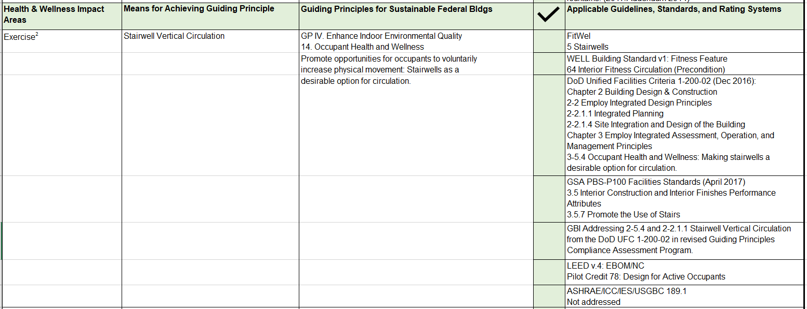

For example, as shown above, for the Health & Wellness Impact Area “Exercise” one Means for Achieving the Guiding Principle is “Stairwell Vertical Circulation”. The Applicable Guidelines, Standards, and Rating Systems column include the credits within the various documents that are most relevant to opportunities for including signage, visual cues, and related information to encourage building occupants to use “Stairwell Vertical Circulation” in lieu of using the elevator. Some suggestions are operational and others are directly relevant to the design of physical environmental interventions that can support “Stairwell Vertical Circulation”. If a guideline, standard, or building rating system does not have information that supports the Guiding Principle, it is noted as such.

The following example includes a Health & Wellness Impact Area: “Contribute to Improved Indoor Air Quality” and one Means for Achieving Potential Outcome, “Provide access to indoor and outdoor plants”. The list of Applicable Guidelines, Standards and Rating Systems contains relevant criteria to provide access to indoor and outdoor plants (shown below).

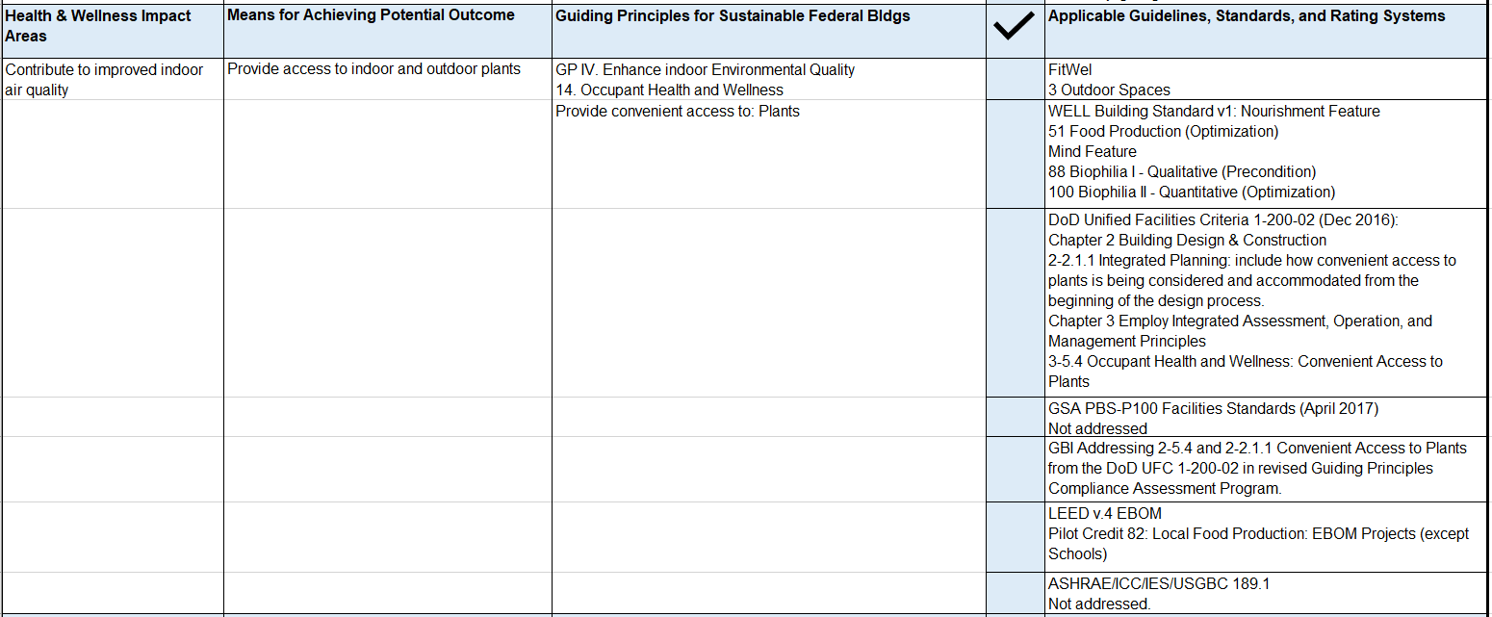

The entire Guidance Crosswalk is provided in Appendix A.

Section 3b: Integrated Design Process (IDP) with a focus on health and wellness
In the programming and planning stage of projects, health and wellness design and operational considerations should be included and prioritized from the onset of the design process to facilitate incorporating features that support health and wellness, including promoting healthy behaviors, IEQ, and material selections. An excerpt from the Guidance Crosswalk on utilizing an Integrated Team Approach is included below.

Prior to updating operational policies and procedures and completing the design of the built environment, it is recommended to establish an integrated team from various disciplines that will be involved in the design and operation of the spaces and systems under consideration. Including health and wellness experts and stakeholders within the planning process provides the opportunity for health and wellness goals to be identified and established as part of the program requirements for the project. This is not meant to be an additional process, but rather a set of considerations and discussions to be included in the Integrated Design Process already used for the design of high performance buildings. See Appendix C for a discussion of, and sample approach to, this concept.
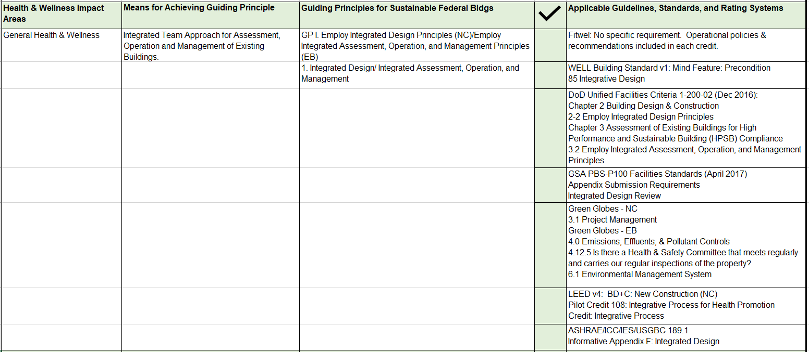

Section 3c: Model Leasing Provisions
In November 2016, the Committee recommended voluntary High-Performance Leasing criteria to GSA to provide to the commercial building market per the requirements of the Energy Efficiency Improvement Act of 2015. These criteria, drawing from a range of public and private sector sources, include IEQ standards and language for interested lessors to incorporate into leases. Based upon the work completed by the HW Task Group, the Committee further recommends tenants and owners evaluate their health and wellness goals and considerations at the onset of leasing a property using the recommendations provided herein and the Guidance Crosswalk for reference, tailoring the leasing language to the specific needs of the lessee and lessor.

Some large national real estate companies have formally embraced and adopted health and wellness concepts in their standard business practices and policies (for both owned and leased settings) which already include energy efficient and indoor environmental quality provisions from sources including:
- LEED Interior Design & Construction (ID&C) and Existing Buildings: Operation & Maintenance (EBOM) and Green Globes Sustainable Interiors (SI) and Existing Buildings (EB) building rating systems
- Green Operations and Management practices
- National and International sustainability protocols
- Use of additional green building rating systems, including Energy Star and BREEAM.

The advent and availability of Fitwel and the WELL Building Standard support the positive trend focusing on health and wellness. Therefore, it is anticipated that in the future, there will be more examples of health and wellness concepts incorporated into the workplace and opportunities to re-evaluate leasing language reflecting this trend.

Section 3d: Examples of Health and Wellness Interventions Integrating Design and Behavior within the Built Environment
Examples of interventions that positively impact the built environment include updating operational policies as well as providing the physical design elements that support these operational policies.

Example 1: In addressing “Smoking Cessation” there are operational policies and procedures that state a building is “smoke free” and does not allow smoking within any portion of a building and its related exterior spaces (i.e. courtyards accessed directly from the building). Operationally, there is an opportunity to provide access to education programs for occupants that do smoke, including resources on quitting smoking. In addressing those occupants that do choose to smoke, a designated outdoor space could be required. The design should include the evaluation and selection of locations that do not negatively impact outdoor air intakes and signage that dictates where smoking is and isn’t allowed in designated exterior areas.

Example 2: In addressing “Exercise” there are several aspects of the physical environment that can be considered in the design of a specific project. In an existing building, signage and cues that clearly show where the staircase is located to encourage occupant use coupled with building operations supplying a smart phone app or other device for occupants to utilize to measure their activity (such as steps, heart rate, etc.) is an example of a physical environmental intervention coupled with operational support to encourage healthy behaviors.

Example 3: In addressing “Diet” there is an opportunity for the built environment to provide filtered water stations for hydration in convenient and obvious locations with signage that assists occupants with access to water. This could be coupled with an operational policy that all food services available on-site, such as cafeterias, include healthy meals and beverages, identifying the amount of sugar and calories in each choice. Policies and/or postings could also include a listing of restaurants that are available within walking distance from the building location; supporting both exercise and diet.

Example 4: In addressing “Indoor Environmental Quality” it is important to specify materials that have low volatile organic compounds (VOCs) emissions into the indoor air. To avoid the emission of additional VOCs from operations and maintenance, operational policies and procedures (e.g., “green cleaning”) need to include maintenance and cleaning materials that are also low or no-VOC.

Overall, building design and operations working together provide a more complete and effective intervention to not only provide a healthy environment but further encourage positive healthy behaviors supporting wellness goals.

Section 4: The Business Case for Workplace Wellness

The Value of a Business Case
A business case is needed to explain the value of suggested changes in an organization’s direction. For buildings and health, the business case identifies specific investments that are intended: 1) to reduce health risks associated with known environmental factors, such as high indoor contaminant levels; or 2) to enhance factors known to be associated with health improvements, such as access to light for circadian functioning.

Regarding the first case – reducing risks -- extensive work has been done by the Lawrence Berkeley National Laboratory on air quality. In a macro-analysis of the economic benefits of improved air quality, Fisk and Rosenfeld (1997) estimated that productivity increases from reduced absenteeism and illness could be as high as $6 billion from reduced asthma and allergies, and $10 billion for reduction in sick building syndrome symptoms.

An example of the second case -- improving health outcomes – would be to calculate the economic value of improved sleep linked to circadian effective light exposures during the day. A GSA project on circadian light found that office workers who received the most circadian stimulation at work, during the daytime, slept on average 30 minutes longer at night. A recent RAND study on sleep (2016) estimated that the US loses an equivalent of about 1.23 million working days per year due to sleep loss, translating to an economic cost of $9.9 million/year. These data could support a business case for investing in circadian effective light in daytime work environments.

Challenges in Developing a Health & Wellness Business Case
Developing a business case for overall investments to improve health in buildings is difficult for a number of reasons, but particularly because it requires calculating the combined effects of multiple changes in design or operations to enhance health. Most current research on health in buildings focuses almost exclusively on single outcomes linked to a limited number of environmental factors, not combined health effects linked to the many environmental conditions people experience daily. There is no existing body of research on how these different strategies combine to affect the building occupants. For instance, a cluster of modest, positive impacts could have a significant overall effect on health. Or some single practices could have large effects that could swing investment decisions. And some health focused practices will likely benefit some occupants more than others.

To be useful to decision makers, the overall business case needs to prioritize investments and identify which of the many potential changes would have the greatest positive impacts on health and for whom. For renovations aimed at improving health, it’s also important to know which types of spaces are most likely to yield the highest payoff.

In addition to the challenge of measuring combined effects, the following two graphics outline why the business case for investing in workplaces that promote health and wellness, while qualitatively compelling, is complicated to demonstrate quantitatively. This complexity exists for two overarching reasons:

- The challenge of tying building conditions or features to individual health outcomes;
- The data and methodology gaps that make it difficult to calculate health cost savings and productivity gains.
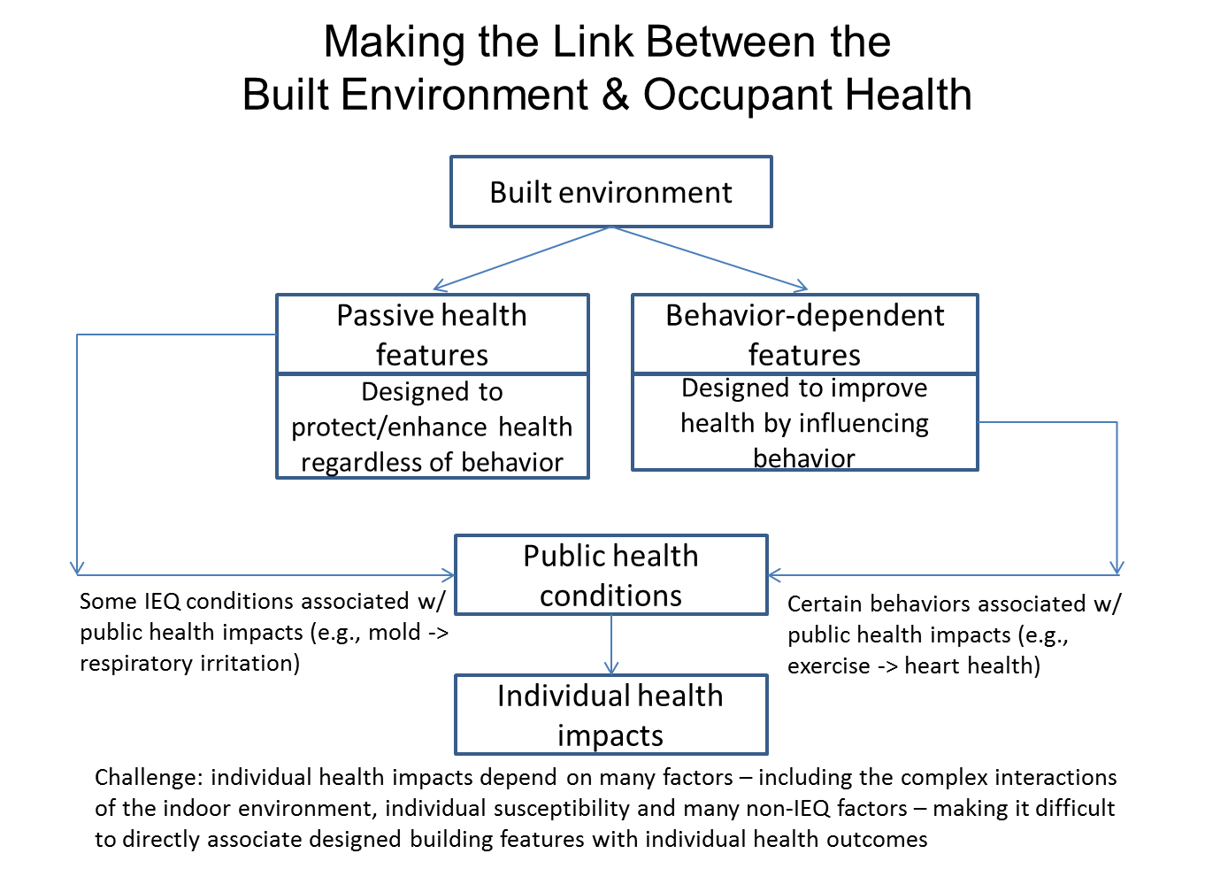

The two basic types of health and wellness-oriented building interventions are those intended to improve indoor environmental quality (IEQ) passively – i.e., regardless of occupant behavior – and those designed to encourage occupants to adopt healthier behaviors. Passive measures have been developed to ameliorate IEQ conditions known to impact health – e.g., using products which emit low levels of VOCs, managing moisture to reduce the likelihood of mold growth, improving the quality of ventilation, etc. Behavioral measures, on the other hand, aim to encourage occupant behaviors linked to better public health outcomes: e.g., reducing sedentary behaviors by increasing access to stairways, using more active transportation options, and working at sit-to-stand desks.

While evidence exists to support passive measures, both strategies, especially behavioral ones, require more research to prove that a particular intervention can be credited with achieving a specific outcome. Individual health outcomes are the product of many factors, including genetics, environment, age, stress level, and a broad range of behaviors performed both inside and outside the workplace. The impact of any particular intervention, therefore, is very hard to isolate.

The behavioral strategies add another layer of complexity by raising the question of whether particular designed building features actually induce a desired behavior, and thereby justify the investment in these strategies.
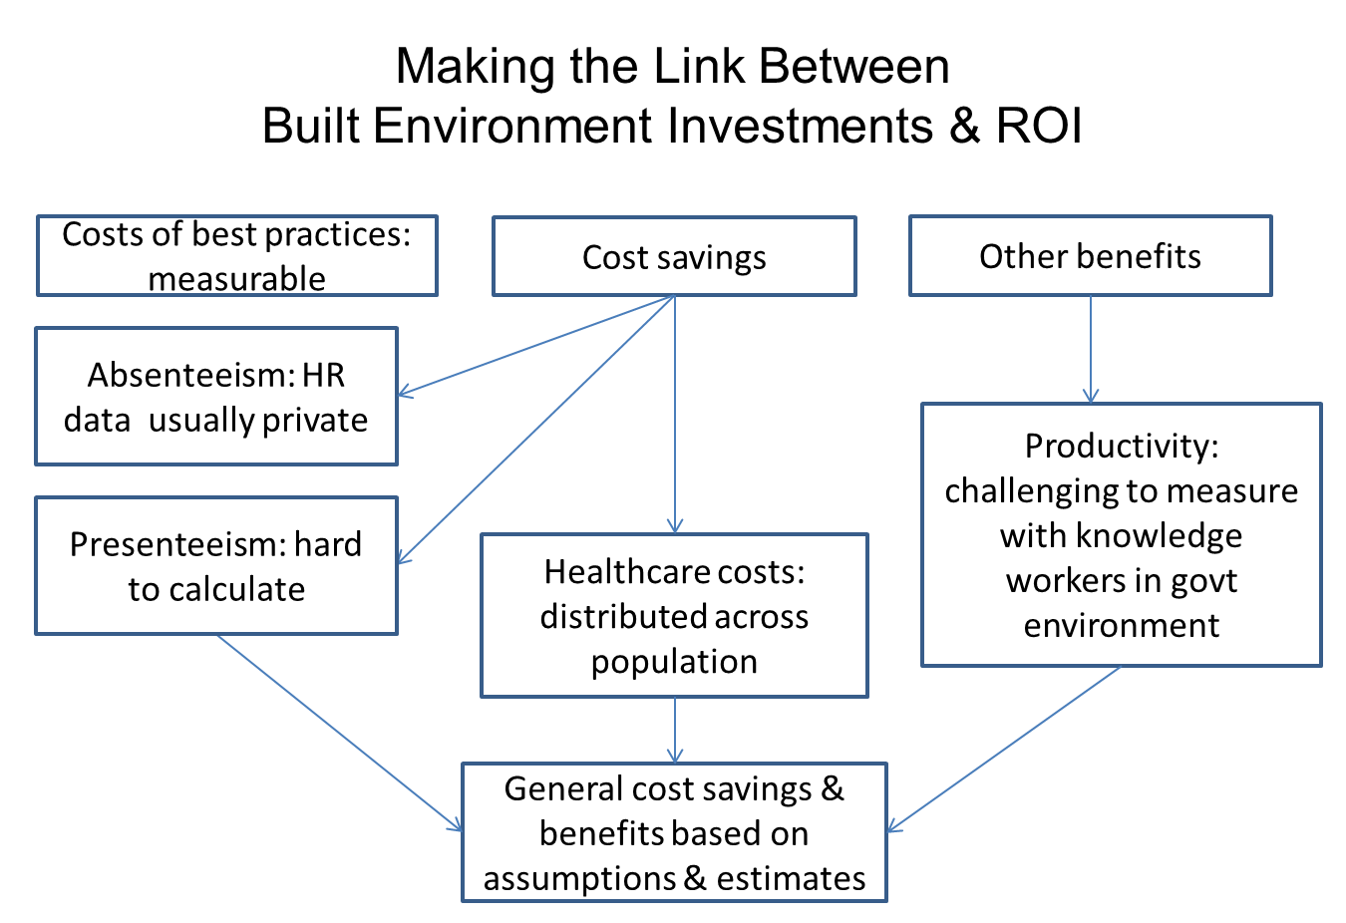

Even if causality is demonstrated, the next challenge is quantifying cost savings and productivity gains from such health and wellness improvements. Worker health unquestionably represents tremendous value and costs. The Federal government employs about 2.2 million civilian workers (1.5% of the US workforce), for which it spends $215 billion (FY2016) on compensation, including pay and benefits. Through the Federal Employees Health Benefits (FEHB) program, the government pays an average of 70% of the cost of health insurance premiums. The Federal employee absenteeism rate is 3.6%, of which 2.6% is due to illness or injury.

Measuring the impact of building improvements on these costs, however, is difficult for multiple reasons. Human resources records on absenteeism rates, health costs, etc. are shielded by privacy laws – and where aggregate information is available, it is not collected for the same purpose and may require significant interpretation. Healthcare costs and premiums are distributed across society through insurance and social programs like Medicare and Medicaid (CMS), making them difficult to attribute to particular building interventions.

Productivity is challenging to measure in an age of knowledge workers whose output is more complex than that of the classic factory setting. There has been research showing impacts of IEQ (particularly temperatures, sound, and air quality) on working memory, sustained attention, reasoning, decision making, and other high level cognitive functions. However, most of this research has been in controlled laboratory settings, not actual offices, making it hard to generalize from such findings to office work overall. Complexity is added when workers also telecommute, working from a home setting for part of their work week, in addition to working within an office environment.

Moving Forward on the Business Case
We can begin to make headway in resolving these business case challenges and creating greater investment certainty. Many building professionals and their clients are aware of the value of investments in health and wellness features, as indicated by the surveys conducted by Dodge Data & Analytics, finding that establishing and implementing goals for workplace health and wellness contributes to improved tenant/employee satisfaction, happier and healthier building occupants, improved financial benefits from greater productivity, and fulfilment of professional duty.

The increased interest in health and wellness features, as through use of the WELL Building Standard and Fitwel in new and renovated buildings, provides an excellent opportunity to assess how specific evidence-based design and operational practices influence changes in health outcomes. Although these programs do require data on health outcomes, their impacts can be assessed in pre- and post-evaluations using validated health assessment instruments and methodologies, with research conducted by neutral third parties. Similar evaluations could be conducted in buildings that are testing specific new wellness practices related to health outcomes.

A key area requiring additional research is methods and metrics for health and wellness outcomes based upon behavioral and active design. Work on this topic will require a joint effort of organizations and federal agencies that are currently working in the health and buildings arena. For example, NIH hosts a Health in Buildings Roundtable (HiBR) that could serve as a convener for such an effort. GSA’s new Buildings and Health Program focuses on creating a network of organizations that can move forward together to implement evidence-based practices to enhance health in buildings and to test the effectiveness of these new practices.

Reliable return on investment (ROI) of building health and wellness strategies is difficult to calculate without additional research on the impacts, costs and benefits of these strategies. In addition to healthcare economists evaluating healthcare outcomes, it is suggested that costs also be evaluated in conjunction with design and construction economists. We can state with confidence that:

- Federal employees represent an enormous investment and health and wellness can impact their performance.
- The conditions of workplaces can negatively or positively affect employees’ physical and mental conditions.
- Therefore, investing in workplaces that promote employee health and wellness is a valid and reasonable approach, even if an absolute ROI cannot be calculated at this time.

Mitchell and Bates conducted a study to determine the relationship between health conditions, absenteeism and presenteeism in a workplace, and then estimate and monetize lost work performance in productivity terms. Using survey data from 1.3 million employed Health Risk Assessment (HRA) participants for self-reported health conditions and work loss, they translated reported lost hours into costs to the employer of health-related absenteeism and presenteeism. The study concluded that an employer with 10,000 employees could face nearly $3.8 million in productivity loss each year, in addition to medical costs for these conditions. Additional research is needed to determine the effects of treatment on productivity loss and whether savings could be realized by optimally managing the health risks and conditions included in this analysis.

Another potential approach to estimating the costs of an unhealthy workplace would be to conservatively postulate an extremely low percentage impact on the Federal government’s costs – e.g., if the current 2.6% illness/injury absenteeism rate, representing $5.6 billion of lost output, were to be reduced by a mere 1% of the total, that would represent recovered value of $56 million per year, the equivalent of annual pay and benefits for about 573 employees. While not based on measures of specific effects, such estimates can convey the order of magnitude of impact that could potentially be achieved with health and wellness improvements in buildings.

These issues form part of a larger focus on Social Return on Investment (SROI), an emerging cost benefit analysis methodology for monetizing social and environmental impacts related to a specific investment or project. The similar concept of sustainable return on investment (S-ROI) refers to a methodology specifically focused on the environmental, economic and social impacts of infrastructure, community development, and public policy (e.g. bridges, highways, buildings, and zoning codes). The goal of S-ROI is to make risk-opportunity assessments more robust by providing new visibility into intangible internal costs and benefits, and externalities - social, economic, and environmental effects that are typically not considered in traditional cash-oriented project planning. Appendix D covers these concepts in more detail.

Section 5: Conclusion
GSA has made commendable efforts to promote wellness and evaluate workplace outcomes for employees. By implementing the recommendations herein, GSA and the Federal government could lead the building sector forward on these issues. It is recommended that GSA collaborate with health and wellness professionals, researchers and economists in the Federal government, the commercial sector, and throughout the country on the integration of health and wellness criteria into building design, construction, and operation. Through the recommendations identified by the Committee, the Federal government can improve the workplace environment to encourage healthy behaviors by occupants; in turn supporting positive health outcomes of the Federal workforce. The private sector looks to GSA for sustainability and environmental direction, and GSA making health and wellness a priority will encourage the private sector to follow suit. As GSA sets its future research agenda, there is an opportunity to foster additional research that supports the evolution of this critical effort to improve human health and wellness in the U.S.

Thank you for your careful consideration of this document and for the opportunity to share these important recommendations. On behalf of the Advisory Committee and the Health and Wellness Task Group, we respectfully submit these recommendations for your consideration.

Sincerely,

Greg Kats
Chair, GSA Green Building Advisory Committee

Jane Rohde Chris Garvin
Co-Chair Co-Chair
Health & Wellness Task Group Health & Wellness Task Group

TASK GROUP MEMBERS
Co-Chairs
Jane Rohde, JSR Associates, Co-Chair; Chris Garvin, Terrapin Bright Green, Co-Chair

Committee members and designees
Charlene Bayer, Hygieia Sciences; Dave Gibson, EPA; Brad Gustafson, DOE;
Jonathan Herz, HHS; Aidan Ganzert, Joel Kimmons, Liz York, HHS/CDC; Michael Myers, AST (for DOE); Brendan Owens, USGBC; Andrew Persily, NIST; Cyndi Vallina, OMB

GSA
Denise Funkhouser, Alexandra Kosmides, PBS
Kevin Kampschroer, Michael Bloom, Judith Heerwagen, Don Horn, Bryan Steverson, OFHPB

Additional Observers
Cristina Schulingkamp, EPA; Dave Walls, ICC; Michelle Martin, IWBI; Todd Sims, ACC

List of Appendices:

Appendix A: Guidance Crosswalk
Appendix B: Matrices of Credits Offered Under Fitwel and the WELL Building Standard
Appendix C: Integrative Design Process for Health and Wellness
Appendix D: Measuring Health and Wellness: Social and Sustainable Return on Investment
Appendix E: Additional Health and Wellness Resources

Appendix A: Guidance Crosswalk

Please see embedded document (in PDF and Excel):
Crosswalk Guidance Criteria for Existing Buildings

Appendix B: Matrices of Credits Offered Under Fitwel and the WELL Building Standard

Please see embedded documents:
Fitwel Multi-Tenant Buildings Scorecard
WELL Building Standard Features Matrix

Appendix C: Integrative Design Process for Health and Wellness

As building design has become more complex and owners’ requirements more demanding, integrated design processes and integrated project delivery methodologies have been developed to improve the outcomes of the design and construction process. This process has been extremely successful in realizing more energy efficient and better performing buildings. Recognizing the complexity of integrating strategies into building design that will encourage increased activity and/or support positive health outcomes, the design community has begun working with the public health community to integrate public health expertise into the design process. The integrated design process for health promotion developed by the USGBC is but one example of such a process.

The LEED credit for health promotion in the integrated design process outlines a step-by-step approach to integrating a public health partner into the design team. This allows the team to access and utilize public health data and community input to identify how the building may impact social, environmental, and economic factors that could, in turn, promote positive health outcomes or prevent unintended negative consequences for health. The pilot credit and similar efforts in the WELL certification system and ASHRAE guidelines aim to build on the industry’s move toward an integrative design process (IDP) that includes occupant health.
Building on the proven integrative design methodology, the process integrates learning from the public health sector’s health impact assessments (HIAs), a broadly used framework that helps guide systematic and comprehensive evaluation of potential public health impacts of proposed policies and actions. A health lens is added to existing analyses, rather than requiring a series of additional health related steps.

General Approach for IDP for Health Promotion

The following language has been borrowed and adapted from the LEED Innovation Credit for Integrative Process for Health Promotion. It has been edited and shorted to give an overview of a protocol to integrate a public health expertise into the design process.

STEP 1. Team with a public health partner
The first step is for the project team to identify a public health partner appropriate to engage in the process required by this credit. Good sources for public health partners include community health related non-profits, hospitals with community based programming, universities, or local health departments. The design team should work with the public health partner to introduce the concept of the integrative process and general concepts related to the design process.

STEP 2. Identify the communities impacted
Identify the communities that will be impacted by the project. As discussed in the Social Equity within the Community LEED pilot credit, “in building scale projects, communities have both geographic and functional definitions. Geographic communities start with your neighborhood—the people who live and work in and near your project and interact with it by proximity. The exact distance can depend on your setting. In urban environments, it may be everyone living or working within a few city blocks or within a ¼ mile. In rural areas, where the distance between neighbors might be much greater, the radius may be larger. Geographic communities extend further out beyond your neighborhood to include your town, city or county.”

“Functional communities include all of the people who come to your building to work or visit. These people may or may not live nearby. This category includes your employees, contractors, operations staff, and visitors. It may vary significantly depending on the type of project. For example, housing, offices, hotels, schools or retail projects will all have unique combinations of occupants, contractors and visitors.” Social determinants and social equity are important parts of public health; therefore projects pursuing social equity related credits can and should use the same communities to assess health within this credit.

STEP 3. Conduct preliminary research and analysis
In consultation with the public health partner, complete research and analysis on the health status of the communities identified in step 2 to support effective and informed decisions about potential integrative design opportunities. Conduct a scoping conversation with public health professionals and community stakeholders to identify the project’s potential connections to health, including evaluation of public health research from CDC and other sources. Identify strategies that could be implemented to enhance health-promoting features of the project and those that could minimize potential risks to health. Identify strategies that can be executed during the project’s design and/or construction that would promote health equity.

STEP 4. Convene goal-setting workshop
Engage the project owner and community stakeholders in a primary project team workshop (or series of workshops) to allow each stakeholder group to articulate their needs and requirements and to identify common goals. Determine the project schedule, functional programmatic requirements, scope, quality, performance, and occupants’ expectations. This workshop could be folded into existing design charrettes and should accomplish the following:
- Establish initial principles, benchmarks, metrics and performance targets.
- Generate potential integrative strategies for achieving performance targets.
- Determine the questions that must be answered to support project decisions.
- Identify initial responsibilities and deliverables.

STEP 5. Evaluate possible health strategies
Evaluate the proposed goals and performance targets for feasibility and impact by exploring potential strategies for health promotion for each community identified. While evaluation of design specific strategies is required, project teams are encouraged to optionally consider how their design strategies could support potential programmatic health strategies in collaboration with the owner and public health partner.

It is expected that some potential strategies identified in Step 5 will be eliminated and that there may be health related issues specifically not addressed due to the analysis and prioritization required by this process. Explanation for the selected strategies is documented in Step 6.

STEP 6. Integrate strategies into project design
The core requirement of this process is demonstrating that the final design was influenced by prioritizing design strategies in order to address specific health needs or best practices with specific outcomes and goals in mind. Document how the health analysis informed design and building form decisions in the project’s owner project requirements (OPR) and basis of design (BOD), including modifications that were made in response to the findings and strategies.

STEP 7. Develop a monitoring and evaluation plan
Based on the list of selected strategies from step 6, develop a continual improvement plan with performance metrics to evaluate the project’s impact on occupant and community health throughout the project life cycle (design, construction and operations). While the project team responsible for new construction will not be responsible for operations, it is important to consider how decisions made during the design and construction phase will translate into performance metrics controlled by the operations team.

STEP 8. Transparency
Share the outcomes from the benchmarking and evaluation with community partners and design team to identify lessons learned and support improved implementation in the future.

Resources:
- American Institute of Architects. (2007). Integrated Project Delivery: A Guide. Retrieved from: https://info.aia.org/SiteObjects/files/IPD_Guide_2007.pdf
- U.S. Green Building Council. (2017). LEED BD+C: New Construction v4: Integrative Process for Health Promotion. Retrieved from: https://www.usgbc.org/node/10241565?view=language
- International WELL Building Institute. (2017). Integrative Design. Retrieved from: http://standard.wellcertified.com/mind/integrative-design

Appendix D: Measuring Health and Wellness: Social and Sustainable Return on Investment (SROI/S-ROI)
Through the twentieth century, academics, investors, and communities have attempted to understand the impacts of development and investment beyond their monetary benefits. This led to the development of Cost Benefit Analysis, which is the systematic analysis of the costs and benefits of various alternatives for an action. The development of tools to conduct this analysis paralleled the development of the environmental and sustainable design movements and ultimately yielded the “Triple Bottom Line” focus on economic, environmental, and social impacts of development.
In 2000, Social return on investment (SROI), a method for measuring value beyond the direct financial value (i.e., environmental and social values) relative to resources invested, was developed to address investors’ need for a financial evaluation of non-financial impacts. The Social ROI methodology may be used to evaluate any investment, development, or policy in order to understand the impact on stakeholders.
The SROI method is a quantitative approach to identifying and evaluating the impacts of a project, organization, company, or public policy. It utilizes ‘proxy’ values to integrated stakeholders’ impacts into the accounting of the valuation of any effort. The goal is to include the voices and concerns of those stakeholders who are often excluded from the decision-making process.
A similar methodology stemming from the Total Cost Assessment (TCA) tools developed by the American Institute for Chemical Engineers, Sustainable return on investment (S-ROI) is specifically focused on the environmental, economic and social impacts of infrastructure, community development, and public policy (e.g. bridges, highways, buildings, and zoning codes). Unlike Social ROI, S-ROI integrates environmental impacts into the financial evaluation of a project. Unlike TCA, S-ROI looks at benefits in addition to costs. S-ROI aims to assess projects on a broader range of externalities’ costs and benefits in order to empower stakeholders to make better decisions that affect the broader public realm.
S-ROI integrates monetized models of non-financial benefits and costs with traditional cost models to develop a more robust view of a project’s total impact. These non-financial monetized models value such outcomes as emissions avoided, resource use avoided, public health improvements, and worker productivity. Quantifying these intangible values allows them to be incorporated into the traditional decision-making process.
Unlike S-ROI, Triple Bottom Line Cost Benefit Analysis (TBL-CBA) is an economic methodology that integrates cost benefit analysis (CBA) and life cycle cost analysis (LCCA) across the triple bottom line (TBL) to value costs and benefits of a particular project or policy. The TBL-CBA process evaluates total net present value, return on investment, and project payback. TBL-CBA uses data specific to a project’s unique location and characteristics to give stakeholders and design professionals the capability to evaluate multiple scenarios throughout the design process.
Similar to the other methodologies, TBL-CBA provides a financial proxy for social and environmental design impacts. When integrated with the economic evaluation of a scenario, it allows for the evaluation of the total impact of a project across the triple bottom line. Ideally, a project should have a positive Net Present Value (NPV). The NPV is the discounted monetary value of the expected net benefits after all costs are accounted. This valuation can be integrated with a simple payback period, ROI, and other financial metrics. Typically, this type of analysis is costly and time consuming due to the level of accounting complexity involved.
The Global Reporting Institute, an affiliate of the International Organization for Standardization (ISO), OECD, UN, works with more than 7500 organizations on the TBL-CBA standards. Many large multinational corporations are also using these tools, although they are often referenced as “Environmental, Social, and Governance” criteria instead.
An interesting development is the use of web-based databases to accelerate and reduce the cost of TBL-CBA analysis. One example is Autocase’s TBL-CBA software which has been integrated into a LCA Pilot Credit for the USGBC’s LEEDv4 certification program. Several entities now require it on design projects, including the State of California, the City of Phoenix, the San Francisco International Airport, and Prologis. In addition, the US Department of Defense has used it for prioritizing design projects at several bases around the world.
References
- Autocase. (2017). What is TBL-CBA? Retrieved from: https://autocase.com/tbl-cba
- Social Value UK. (2017). What is social value? Retrieved from: http://www.socialvalueuk.org/what-is-social-value/
- Wikipedia
  - Social ROI - https://en.wikipedia.org/wiki/Social_return_on_investment
  - Sustainable ROI - https://en.wikipedia.org/wiki/Sustainable_return_on_investment
  - TBL-CBA - https://en.wikipedia.org/wiki/Triple_Bottom_Line_Cost_Benefit_Analysis
- Williams, J. (2011). HDR & SROI How to Measure “Green”. Live Better Magazine. Retrieved from: http://livebettermagazine.com/article/hdr-sroi-how-to-measure-green/

Appendix E: Additional Health and Wellness Resources

General Health & Wellness

Dodge Data & Analytics. (2016). The Drive Towards Healthier Buildings 2016. Retrieved from: https://www.construction.com/toolkit/reports/drive-toward-healthier-buildings (Report based on industry surveys of U.S. building owners, developers and managers on their view of the impacts of buildings on health and well-being.)

Herz, J. (2006). Green Buildings: What’s Missing Making It Green and Fair. Presented at Rethinking Sustainable Construction 2006, Sarasota, FL, 19-22 September 2006. Retrieved from https://www.cce.ufl.edu/rethinking-sustainable-construction-2006/. (This paper discusses what is missing in today’s common application of sustainable development principles – equity; and argues that unless this issue is properly addressed, sustainable development cannot be achieved.)

Loftness, V., et al. (2007). Elements That Contribute to Healthy Building Design. Environmental Health Perspectives, 115(6), 965. DOI: https://dx.doi.org/10.1289%2Fehp.8988. (Three viewpoints of designing a healthy building are presented: the importance of sustainable development, the role of occupants for ensuring indoor air quality, and ongoing developments related to indoor finishes with low chemical emissions and good fungal resistance.)

Melton, P. (2017). Programming Buildings for Health: WELL, Fitwel, and Beyond. The Building Green Report. Volume 26, Number 3 · March 2017. Retrieved from: https://buildinggreen.com/downloads (A review and comparison of the WELL and Fitwel programs.)

National Institutes of Health. (2016). Health in Buildings Roundtable (HiBR). Retrieved from https://nems.nih.gov/teams/Pages/2016%20Webpage%20Content%20Archives/Health-in-Buildings-Roundtable.aspx. (HiBR provides a list of additional resources and references regarding health and building impacts.)

National Prevention Council. (2011). Healthy and Safe Community Environments. In National Prevention Strategy (pp. 14-17). Washington, D.C.: U.S. Department of Health and Human Services, Office of the Surgeon General. (The Surgeon General provides recommendations to achieve healthy and safe community environments for different stakeholders.)

Urban Land Institute. (2013) Intersections: Health and the Built Environment. Washington, D.C.: Urban Land Institute. Retrieved from https://uli.org/wp-content/uploads/ULI-Documents/Intersections-Health-and-the-Built-Environment.pdf. (This report explores the relationship between how healthy we are and the way our buildings and communities function.)

Business Case & Metrics

Ambrose, B., et al. (2016). Building the Business Case: Health, Wellbeing and Productivity in Green Offices. World Green Building Council, 1-50. Retrieved from http://www.worldgbc.org/sites/default/files/WGBC_BtBC_Dec2016_Digital_Low-MAY24_0.pdf. (This World Green Building Council report provides worldwide best practice examples of healthy, green offices, showing decreased absenteeism and better health for employees.)

Gilbreath J. (2007). IOM: The Economics of Better Environmental Health. Environmental Health Perspectives. 115(2), A80- A81. PMCID: PMC1817696. Retrieved from https://www.ncbi.nlm.nih.gov/pmc/articles/PMC1817696/. (Economists and public health analysts outlined developing methodologies to identify and quantify the health benefits of reduced air pollution and to pinpoint costs to industry of complying with air quality regulations during the November 14, 2006 Roundtable on Environmental Health Sciences, Research, and Medicine.)

Heerwagen, J. (2006). Investing in People: The Social Benefit of Sustainable Design. Presented at Rethinking Sustainable Construction 2006, Sarasota, FL, 19-22 September 2006. Retrieved from https://www.cce.ufl.edu/rethinking-sustainable-construction-2006/. (This paper provides an overview of theory and research on the human benefits of building design, which includes improved health outcomes, psychological well being, reduced stress, improved cognitive performance, and improved work and life satisfaction.)

Hertz, J. (n.d.). Going Beyond Traditional Economic Thinking, Gets Positive Health Outcomes. (This short paper discusses the need for human and environmental health to move to the front line of economic decision-making.)

Kramer, A., et al. (2014). Building for Wellness: The Business Case. Washington, D.C.: Urban Land Institute. Retrieved from http://americas.uli.org/wp-content/uploads/ULI-Documents/Building-for-Wellness-The-Business-Case.pdf. (In 13 sets of interviews, private sector developers explain their motivation, their intended wellness and health outcomes, the development process and operations as related to their health intentions, and the key issue in this publication—the metrics of market performance.)

Laurin, L., Hayashi, K. (n.d.) Sustainability Return on Investment: A Scenario-based Multicriteria Assessment Toll for Policy-Making. https://www.earthshiftglobal.com/docs/sroi-scenario-based-multi-criteria-assessment-tool-policy-japan.pdf

Project for Public Spaces. (2016). The Case for Healthy Places: Improving Health Outcomes through Placemaking. Retrieved from https://www.pps.org/wp-content/uploads/2016/12/Healthy-Places-PPS.pdf. (This article discusses the social determinants of health and how place making improves physical and mental health for all.)

Saari, A., et al. (2006). The effect of a redesigned floor plan, occupant density and the quality of indoor climate on the cost of space, productivity and sick leave in an office building–A case study. Building and Environment. 41(12), 1961-1972. DOI: https://doi.org/10.1016/j.buildenv.2005.07.012. (The study indicates that investment in the quality of indoor climate is cost-effective when the economic effect of indoor climate to health and productivity are taken into account in addition to the costs of investment, operation and maintenance.)

Sadler, B. L., et al. (2011). Fable Hospital 2.0: The Business Case for Building Better Health Care Facilities. Hastings Center Report. 41(1), 12-23. Retrieved from http://www.thehastingscenter.org/wp-content/uploads/SadleretalFableHospitalBusinessCase_HastingsJan111.pdf. (The Center for Health Design’s Fable Hospital, an imaginary facility, has shown ROI on evidence-based design elements.)

Healthy Food, Cafeterias, Concessions

Anderson, L. M., et al. (2009). The Effectiveness of Worksite Nutrition and Physical Activity Interventions for Controlling Employee Overweight and Obesity: A Systematic Review. American Journal of Preventive Medicine, 37(4), 340-357. DOI: http://dx.doi.org/10.1016/j.amepre.2009.07.003. (This report presents the results of a systematic review of the effectiveness of worksite nutrition and physical activity programs to promote healthy weight among employees.)

Bayne A. I., et al. (2012). The HHS Hubert H. Humphrey Building Cafeteria Experience: Incorporation of the Dietary Guidelines for Americans, 2010 into Federal Food Service Guidelines. Prepared by NORC at the University of Chicago. Washington, DC: U.S. Department of Health and Human Services, Office of the Assistant Secretary for Planning and Evaluation. Retrieved from https://aspe.hhs.gov/system/files/pdf/76606/rpt.pdf. (This case study describes the inception, development and implementation of the Health and Sustainability Guidelines for Federal Concessions and Vending Operations.)

Federal Health and Sustainability Team for Concessions and Vending. (2014). Health and Sustainability Guidelines for Federal Concessions and Vending Operations. Retrieved from https://www.gsa.gov/cdnstatic/guidelines_for_federal_concessions_and_vending_operations_corrected_version.pdf. (GSA and HHS worked collaboratively to create this document, which proposes specific food, nutrition, and sustainability guidelines.)

General Services Administration. (2017). Concessions and Cafeterias: Healthy Food in the Federal Workplace. Retrieved from https://www.gsa.gov/real-estate/facilities-management/tenant-services/concessions-and-cafeterias-healthy-food-in-the-federal-workplace. (GSA provides food service operations and vending facilities in federally owned and leased buildings through contracted, permitted and licensed business opportunities for commercial food service operators and blind merchants in support of the Randolph-Sheppard program.)

Physical Activity & Exercise

Anderson, L. M., et al. (2009). The Effectiveness of Worksite Nutrition and Physical Activity Interventions for Controlling Employee Overweight and Obesity: A Systematic Review. American Journal of Preventive Medicine, 37(4), 340-357. DOI: http://dx.doi.org/10.1016/j.amepre.2009.07.003. (This report presents the results of a systematic review of the effectiveness of worksite nutrition and physical activity programs to promote healthy weight among employees.)

Engelen, L., et al. (2017). Is Active Design changing the workplace? – A natural pre-post experiment looking at health behaviour and workplace perceptions. Work, 56(2), 229-237. DOI: 10.3233/WOR-172483. (The purpose of this research is to investigate Active Design influence on workplace physical activity, sedentary behaviour, musculoskeletal complaints, and perceptions of the workplace and productivity.)

General Services Administration. (2017). Consider the Stairs. Retrieved from https://www.gsa.gov/real-estate/facilities-management/tenant-services/health-and-wellness/consider-the-stairs. (GSA was directed to promote the use of stairs in all federal buildings in Public Law 109-115, Section 607 of GSA’s Appropriations Act for FY 2006.)

Leinberger, C. B., & Rodriguez, M. (2016). Foot Traffic Ahead: 2016. Smart Growth America. Retrieved from https://smartgrowthamerica.org/resources/foot-traffic-ahead-2016/. (Foot Traffic Ahead: 2016 shows that metros with the highest levels of walkable urbanism are also the most educated and wealthy (as measured by GDP per capita)— and, surprisingly, the most socially equitable.)

Pereira, M. J., et al. (2015). The Impact of Onsite Workplace Health-enhancing Physical Activity Interventions on Worker Productivity: A Systematic Review. Occupational Environmental Medicine, 72(6), 401-412. DOI: 10.1136/oemed-2014-102678. (The aim of this study is to investigate the effects of onsite workplace health-enhancing physical activity (HEPA) programmes on worker productivity.)

U.S. Department of Health and Human Services. (2015) Step It Up! The Surgeon General’s Call to Action to Promote Walking and Walkable Communities. Washington, D.C.: U.S. Department of Health and Human Services, Office of the Surgeon General. Retrieved from https://www.surgeongeneral.gov/library/calls/walking-and-walkable-communities/call-to-action-walking-and-walkable-communites.pdf. (This publication is intended to increase walking across the U.S. by calling for improved access to safe and convenient places to walk and wheelchair roll, as well as for a culture that supports these activities for people of all ages and abilities.)

Lactation Space

General Services Administration. (2017). Lactation Space Support. Retrieved from https://www.gsa.gov/real-estate/facilities-management/tenant-services/health-and-wellness/lactation-space-support. (The 2010 Patient Protection and Affordable Care Act (PPACA) amended Section 7 of the Fair Labor Standards Act of 1938 (FLSA), requiring an employer to provide employees with a reasonable break time to express breast milk for her nursing child and a place, other than a bathroom, that is shielded from view and free from intrusion from coworkers and the public.)

Hospital Built Environment

Nelson C., et al. (2005). The Hospital Built Environment: What Role Might Funders of Health Services Research Play? Prepared by The Lewin Group, Inc. Rockville, MD: U.S. Department of Health and Human Services, Agency for Healthcare Research and Quality. AHRQ Publication No. 05-0106-EF. Retrieved from https://archive.ahrq.gov/professionals/systems/hospital/hospbuilt/hospenv.pdf. (This environmental scan is intended to assess what is and is not known about the relationships between hospital design and construction—the built environment—and: 1. Patient outcomes, 2. Patient safety and satisfaction, 3. Hospital staff safety and satisfaction.)

Sadler, B. L., et al. (2011). Fable Hospital 2.0: The Business Case for Building Better Health Care Facilities. Hastings Center Report. 41(1), 12-23. Retrieved from http://www.thehastingscenter.org/wp-content/uploads/SadleretalFableHospitalBusinessCase_HastingsJan111.pdf. (The Center for Health Design’s Fable Hospital, an imaginary facility, has shown ROI on evidence-based design elements.)

Materials Selection & Toxic Chemicals

Endocrine Disrupting Chemicals in Drinking Water: Risks to Human Health and the Environment Hearing before the Subcommittee on Energy and Environment, of the Committee on Energy and Commerce, House of Representatives, 111th Cong. 16. (2010). Testimony by Linda Birnbaum. Retrieved from https://www.gpo.gov/fdsys/pkg/CHRG-111hhrg76011/pdf/CHRG-111hhrg76011.pdf. (Dr. Linda Birnbaum presented her testimony on the current understanding and ongoing research on endocrine disrupting chemicals.)

Institute of Medicine. (2014). Identifying and Reducing Environmental Health Risks of Chemicals in Our Society: Workshop Summary. Washington, D.C.: The National Academies Press. DOI: https://doi.org/10.17226/18710. (On November 7-8, 2013, the Institute of Medicine's Roundtable on Environmental Health Sciences, Research, and Medicine held a workshop to discuss approaches related to identifying and reducing potential environmental public health risks to new and existing industrial chemicals present in society.)

Healthy Building Network. (2008). Fact Sheet: Toxic Chemicals in Building Materials. Retrieved from https://healthybuilding.net/uploads/files/toxic-chemicals-in-building-materials.pdf. (This fact sheet provides an overview of toxic chemicals in building materials for health care organizations.)

Presenteeism is defined as days at work but limited in performing job tasks because of health (vs. absenteeism defined as days of work missed because of illness). Laurin, L., Hayashi, K. (n.d.), Sustainability Return on Investment: A Scenario-based Multicriteria Assessment Toll for Policy-Making. EarthShift Global. https://www.earthshiftglobal.com/docs/sroi-scenario-based-multi-criteria-assessment-tool-policy-japan.pdf
Figueiro MG. (2017). The impact of daytime light exposures on sleep and mood in office workers. Sleep Health. 2017 Jun;3(3):204-215. https://www.ncbi.nlm.nih.gov/pubmed/28526259
Thayer, J.F., et. al. (2010). Effects of the physical work environment on physiological measures of stress. European Journal of Preventive Cardiology. Vol 17, Issue 4, pp. 431 – 439. http://journals.sagepub.com/doi/abs/10.1097/HJR.0b013e328336923a#articleCitationDownloadContainer
Fisk, W.J. and A. H. Rosenfeld (1997). Estimates of Improved Productivity and Health from Better Indoor Environments. Indoor Air, 7:158-172. http://onlinelibrary.wiley.com/doi/10.1111/j.1600-0668.1997.t01-1-00002.x/abstract
Figueiro MG. (2017). The impact of daytime light exposures on sleep and mood in office workers. Sleep Health. 2017 Jun;3(3):204-215. https://www.ncbi.nlm.nih.gov/pubmed/28526259
RAND Corporation, 2016. Why Sleep Matters: The Economic Costs of Insufficient Sleep https://www.rand.org/randeurope/research/projects/the-value-of-the-sleep-economy.html
See, in particular, the research findings collected at Lawrence Berkeley National Lab’s Indoor Air Quality Scientific Findings Resource Bank, https://iaqscience.lbl.gov/
U.S. Congressional Budget Office (CBO) (2017). Testimony on the Costs of Federal Civilian Personnel: A Comparison with Private-Sector Employees. https://www.cbo.gov/publication/52706. (Excludes: 2.2 million uniformed personnel, about 1 million of whom are reservists; 700,000 employees of USPS and other enterprises not compensated through tax revenues; and contract and grant workers.)
U.S. Department of Labor, Bureau of Labor Statistics (DOE/BLS) (2017): Labor Force Statistics from the Current Population Survey, Household Data Annual Averages, 47. Absences from work of employed full-time wage and salary workers by occupation and industry. https://www.bls.gov/cps/cpsaat47.htm
Dodge Data & Analytics. (2016). The Drive Towards Healthier Buildings 2016. https://www.construction.com/toolkit/reports/drive-toward-healthier-buildings
Mitchell RJ, Bates P. (2011). Measuring Health-Related Productivity Loss. Population Health Management. 2011;14(2):93-98. doi:10.1089/pop.2010.0014.
https://en.wikipedia.org/wiki/Sustainable_return_on_investment

