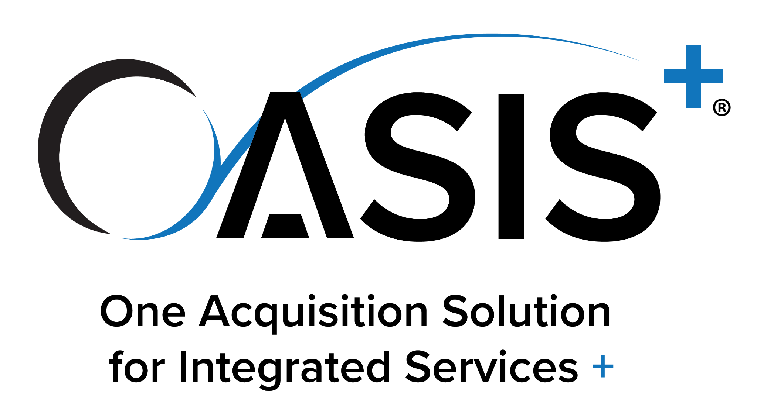
May 2025 Version

[Upon filling out the following template, please delete all instructional information in blue and any sections that do not apply. Also, this template format is not mandatory; however, the minimum information herein is necessary for a proper solicitation under OASIS]
Task Order Request for Proposal (RFP) No.: [Insert solicitation number]
Issued Under OASIS+ IDIQ: [Insert OASIS+ IDIQ Vehicle Name (Small Business, 8(a), HUBZone, SDVOSB, WOSB, Unrestricted), Domain (Management & Advisory, Technical & Engineering, Research & Development, Intelligence Services, Enterprise Solutions, Environmental, Facilities, Logistics), and CLIN/NAICS Code]
Solicitation Title: [Insert brief description of work]
Issuing Office: [Insert agency name and address]
Agency Contact(s): [Insert name(s), telephone number(s), email address(es) of OCO and/or Contract Specialist]
RFP Issue Date: [Insert date RFP was issued]
Questions Due Date: [Insert time, time zone, date questions are due, and where to send/email questions]
Proposal Due Date: [Insert time, time zone, date proposals are due, and where to send/email proposals]

1.0 OASIS+ TASK ORDER INFORMATION
  - OASIS+ Domain and Master Contract CLIN Being Solicited/Awarded: [Insert the Domain Name and CLIN]
  - NAICS Code and Small Business Size Standard: The principal nature of the requirements described in this solicitation is consistent with services performed by industries in the [Insert the NAICS code and title] with a small business size standard of [Insert small business size standard]
  - Product Service Code (PSC): The services in this solicitation are best represented by PSC [Insert the applicable PSC code and title (see PSC Manual.)]
  - Type of Contract: The primary type of contract resulting from this solicitation is: [Insert the predominant contract type (Cost Plus Fixed Fee, Firm Fixed Price, Time and Materials, etc.)
Note: If a hybrid contract type results from this solicitation identify Contract Type by CLIN in Section 2.0.]
  - Type of Services: Commercial Non-Commercial [Check the box that applies]
  - Extent of Competition: [Check the box that applies]
___ Fair opportunity procedures (FAR 16.505(b)(1))
___ Exception to fair opportunity procedures as designated below (FAR 16.505(b)(2))

[Check only one exception below]
___ FAR 16.505(b)(2)(A) The agency's need for the supplies or services is so urgent that providing a fair opportunity would result in unacceptable delays.
___ FAR 16.505(b)(2)(B) Only one awardee is capable of providing the supplies or services required at the level of quality required because the supplies or services ordered are unique or highly specialized.
___ FAR 16.505(b)(2)(C) The order must be issued on a sole-source basis in the interest of economy and efficiency because it is a logical follow-on to an order already issued under the contract, provided that all awardees were given a fair opportunity to be considered for the original order.
___ FAR 16.505(b)(2)(E) For orders exceeding the simplified acquisition threshold, a statute expressly authorizes or requires that the purchase be made from a specified source.
___ Sole-source 8(a) [Only available under OASIS+ 8(a); requires offer/acceptance process be completed at the task order level with SBA]
  - Security Clearances: [Check the box that applies]
    - The clearance level is: ___Unclassified ___Classified
    - The Facility Clearance Level (FCL) is: __Unclassified ___Secret ___Top Secret
[If N/A delete 1.7.2. Note: For individual security clearance levels and instructions, please identify in the PWS/SOW or labor category section of the solicitation.]
  - Performance Location(s): [Check the box that applies]
    - The performance locations for this PWS/SOW are: ____CONUS ___OCONUS ___Mix of Both
    - The labor will be performed at: ___Government Site(s) ___Contractor Site(s) ___ Mix of Both
    - Place(s) of Performance: The places of performance(s) for this PWS/SOW are:
[Identify city(ies), state(s), and/or country(ies) where services will be performed.
If performance will be in multiple locations and/or a mix of CONUS, OCONUS, government and contractor sites, then also identify these within the solicitation’s Section 3.0, Description of Services, which services are performed where. Also, identify if performance is at government or contractor sites.]
  - Period of Performance: The period of performance for this PWS/SOW is:
[Identify the Period of Performance for the task order.
Ex. “The period of performance for this task order is from date of award through 1 year thereafter, with 5 (1-year) options that may extend the cumulative term of this task order to 5 years” If the period of performance and options are different by CLIN, address the period of performance for each CLIN in Section 2.0 below.]
2.0. Task Order Contract Line Items (CLINs) and Contract Type by CLIN
[List the task order CLINs with their descriptions and pricing information. Use of separate, distinct CLINs for work with different pricing types is required. Use of a separate, Cost-Reimbursement CLIN, by period (Base, OY1, OY2. etc.) for the Contract Access Fee (CAF) is required.
See example CLINs below. Tailor CLINs as necessary to meet the requirement.]
CLIN 0001 (Firm Fixed-Price): Provide program management and oversight support services for the Citizens Assistance and Response to Emergencies (CARE) Program. The services are performed in CONUS, on a government site in Washington, D.C. Sections 3.1, 3.2, 3.3, 3.4, and 3.5 apply.
Total Firm Fixed Price: $XX.XX
CLIN 0002 (Cost Plus Fixed Fee): Provide engineering and logistics support services to the CARE Operations Centers in Washington, D.C., New York, NY, San Francisco, CA, and Chicago, IL. The services are performed in a mix of both government and contractor sites as delineated in Sections 3.0. 3.1, 3.6, 3.7, 3.8, and 3.9.
Total Estimated Cost: $XX.XX
Fixed Fee: $XX.XX
Total Estimated Cost Plus Fixed Fee: $XX.XX
CLIN 0003 Contract Access Fee (CAF): (Cost-Reimbursable)
[Note: The CAF CLIN must be a standalone CLIN by year (e.g.,. include one CLIN for the base year (0003) and one for each option year (e.g., 1003, 2003, …) as applicable).]
The total CAF Percentage for this task order is: 0.15% [Note: The CAF Percentage applies to all Price/Cost objectives, i.e., the total of labor, other direct costs, materials/equipment, travel, and subcontractor price/cost, as well as profit/fee.]
Total Not-To-Exceed CAF: [Note: For additional CLINs, identify any ancillary support by CLIN and contract type, such as, any labor subject to construction wage rates or service contract labor standards, travel, materials, equipment, and subcontracting.]

3.0. Description of Services
[Use the agency preferred format for the PWS/SOW/SOO; performance-based is preferred, for example:
  - Background
  - Scope
  - Performance Work Statement/Statement of Work
  - Places of performance and work conditions/hours ETC.]
4.0. Delivery and Performance Information
[Enter a table of deliverables, if applicable, and/or other applicable service delivery terms. Include performance standards and metrics that will apply to the performance-based statement of work, or performance measurements that will be used to verify non-performance-based services. Address quantity and quality considerations, due dates, deliverable submittal instructions, and similar information related to the basis for contractor performance evaluations.]
5.0. Labor Categories and Descriptions
[Identify the labor categories, definitions and skill requirements necessary for successful completion if applicable to the requirement. Identify security clearance levels, if applicable.]
6.0. Invoicing instructions
[Identify invoice instructions and procedures.]
[Note #1: The billing instructions must include for CAF to be billed on every invoice.]
[Note #2: Additionally, it is an OCO responsibility to ensure every invoice includes CAF billed at the contractual CAF percentage of 0.15%.]
[The OASIS+ Ordering Guide includes an example at Contract Access Fee. The OASIS+ contracts, Section G.3.2.6 Contract Access Fee Remittance, further detail how CAF must be remitted.]
7.0 Required/Agency-Specific Task Order Solicitation Provisions and Clauses
(Including fill in provisions/clauses)
The following task order provisions and clauses apply to this task order:
[The OASIS+ Ordering Guide includes task order clause and provision guidance in:
- Clauses and Provisions
- DoD Specific Clauses and Provisions
Insert any applicable solicitation provisions and clauses that apply to the OASIS+ task order.]
  - Optional/Agency-Specific Task Order Provisions and Clauses
(Including fill in provisions/clauses)
The following additional provisions and clauses apply to this task order:
[Insert any FAR optional and agency-specific provisions/clauses that will apply to the task order solicitation and resultant task order award. Remember to provide any fill ins to any flow down clauses or optional/agency specific clauses.]
[When preparing solicitations for T&M and/or LH task orders only, the OCO must identify one of the following provisions in the task order solicitation:
- FAR 52.216-29 Time-and-Materials/Labor-Hour Proposal Requirements—Non- Commercial Item Acquisition With Adequate Price Competition
- FAR 52.216-30 Time-and-Materials/Labor-Hour Proposal Requirements—Non- Commercial Item Acquisition Without Adequate Price Competition
- FAR 52.216-31 Time-and-Materials/Labor-Hour Proposal Requirements—Commercial Item Acquisition]
8.0. Proposal Preparation and Submission
[Insert instructions for preparation and submission of proposals. Keep submission requirements to a minimum]
9.0. Evaluation Factors and Basis of Award
[Identify the evaluation factors to be considered in selecting a proposal for award. Identify if a trade-off is going to be considered. Tailor this section based on the dollar value and complexity of the task order.

